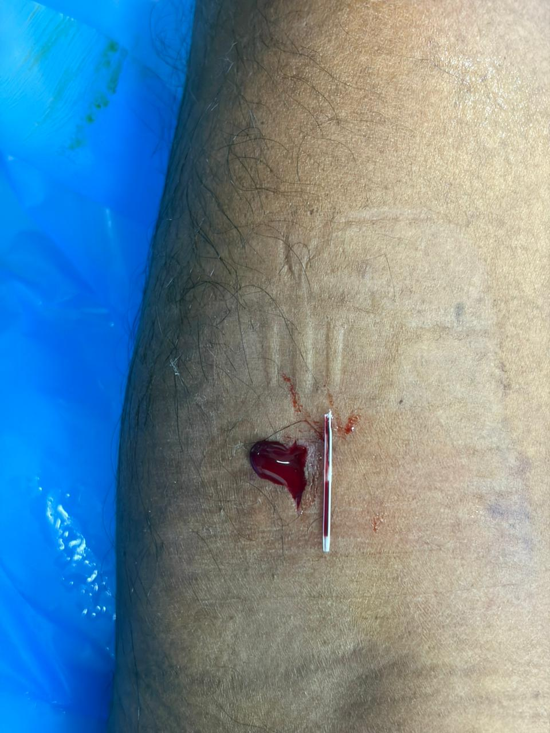figure 1: fragment of fractured intravenous cannula
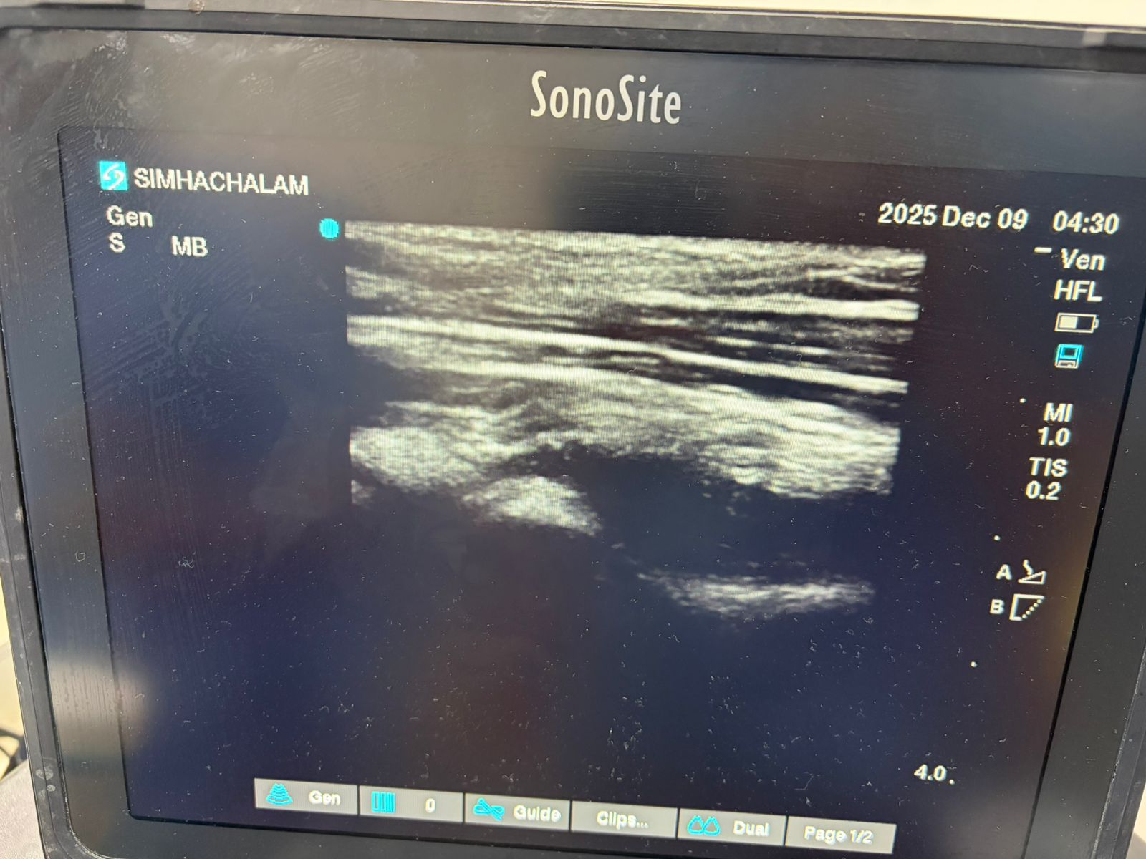
Figure2: ultrasound picture showing image of fractured cannula
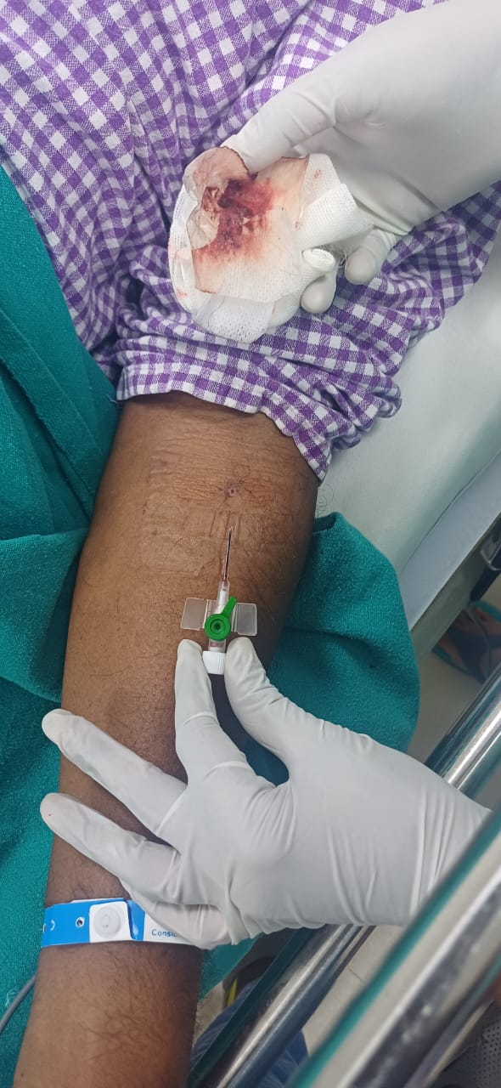
Figure 3: removed canula with broken fragment

