- Figures:
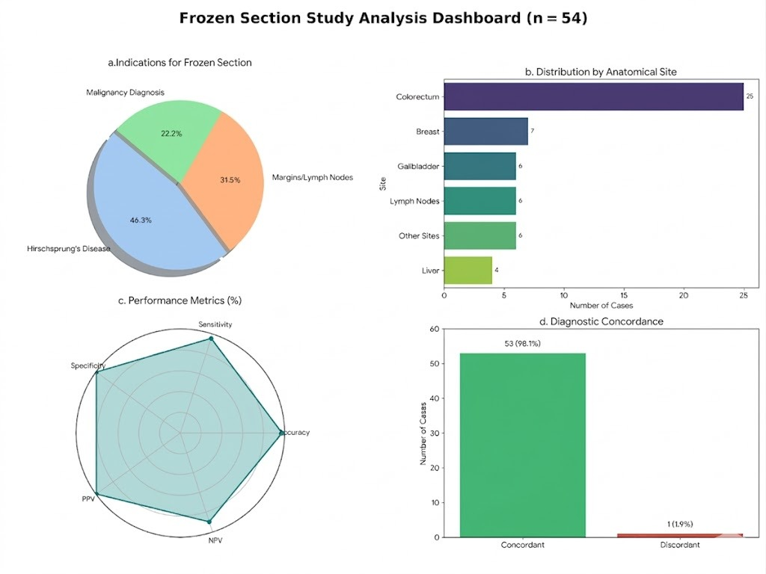

Figure 1: Diagnostic Performance and Clinicopathologic Distribution of Frozen Section Analysis (n=54). (a). Pie chart illustrating the primary indications for intraoperative frozen section consultation, with Hirschsprung’s disease comprising 46.3% of cases. (b) Bar diagram showing the distribution of cases by anatomical site, with colorectal specimens being the most frequent. (c) Radar plot depicting diagnostic performance, demonstrating 100% specificity and 98% overall accuracy. (d) Bar diagram comparing intraoperative frozen section and final diagnoses, showing an overall concordance rate of 98.1%.
a
b
, 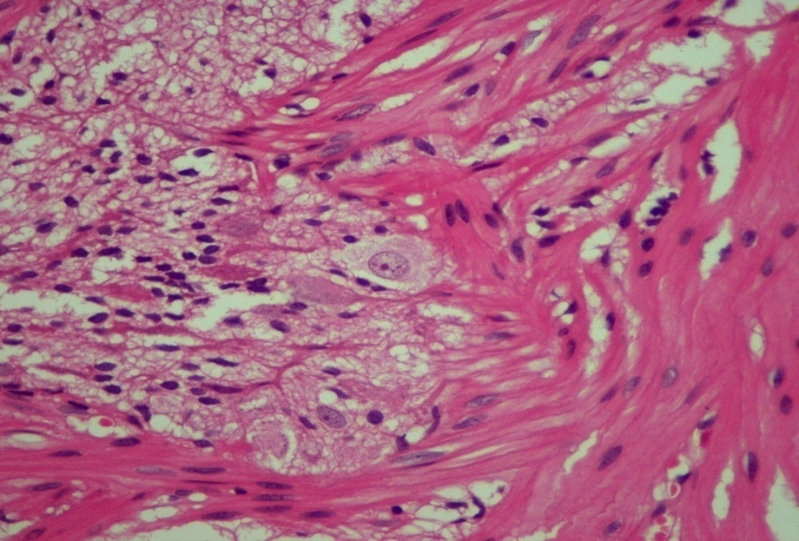
Figure 2: Microscopic examination demonstrating ganglion cells, essential for the diagnosis of Hirschsprung’s disease. (a) Intraoperative frozen section showing the presence of ganglion cells in the intermuscular plexus of the colon. (b) Routine histopathology section of the colon showing ganglion cells in the intermuscular (myenteric/Auerbach’s) plexus (H&E, 40x).
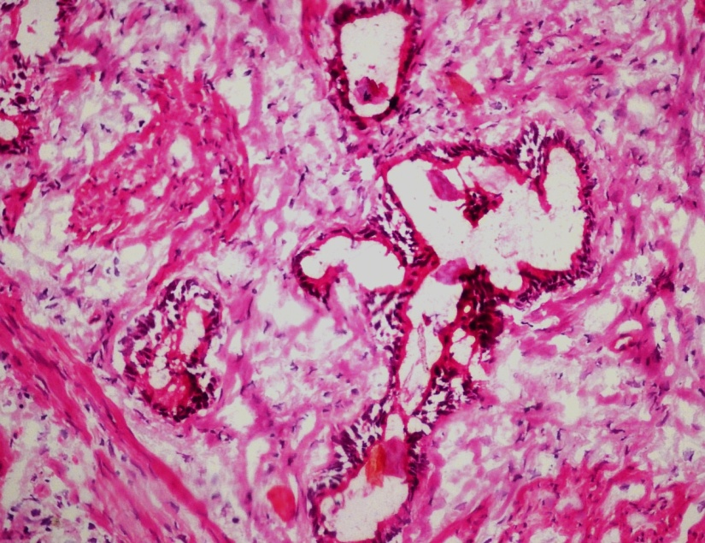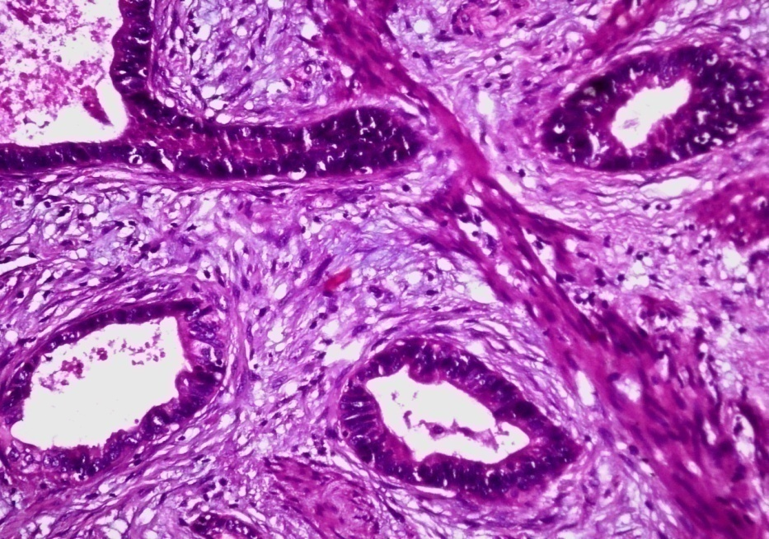
b
a
Figure 3: Microscopic examination showing gallbladder adenocarcinoma. (a) Frozen section from the gallbladder showing malignant cells arranged in a glandular architecture. (b)Histopathology section of the gallbladder wall infiltrated by well-differentiated tumour glands (H&E ,20x).
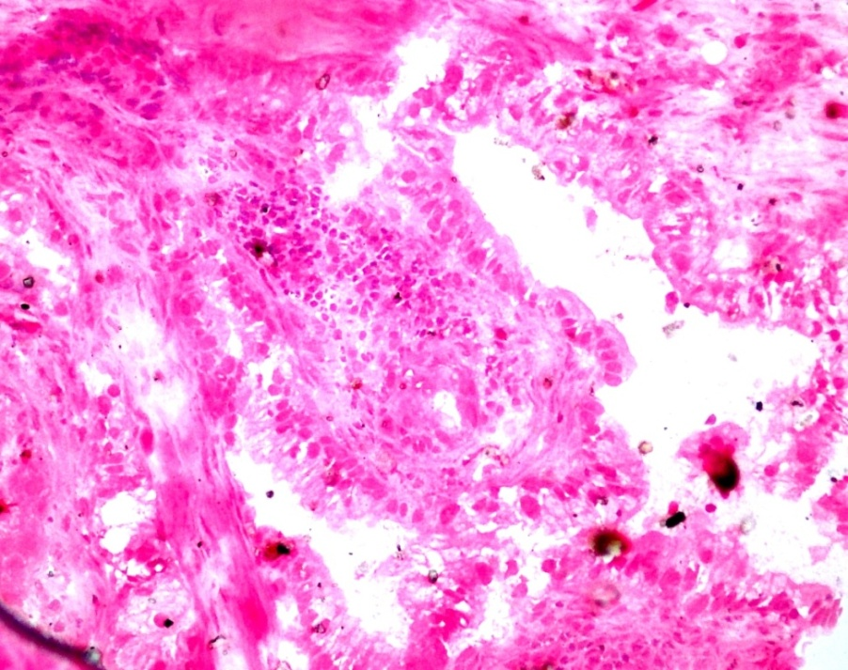, 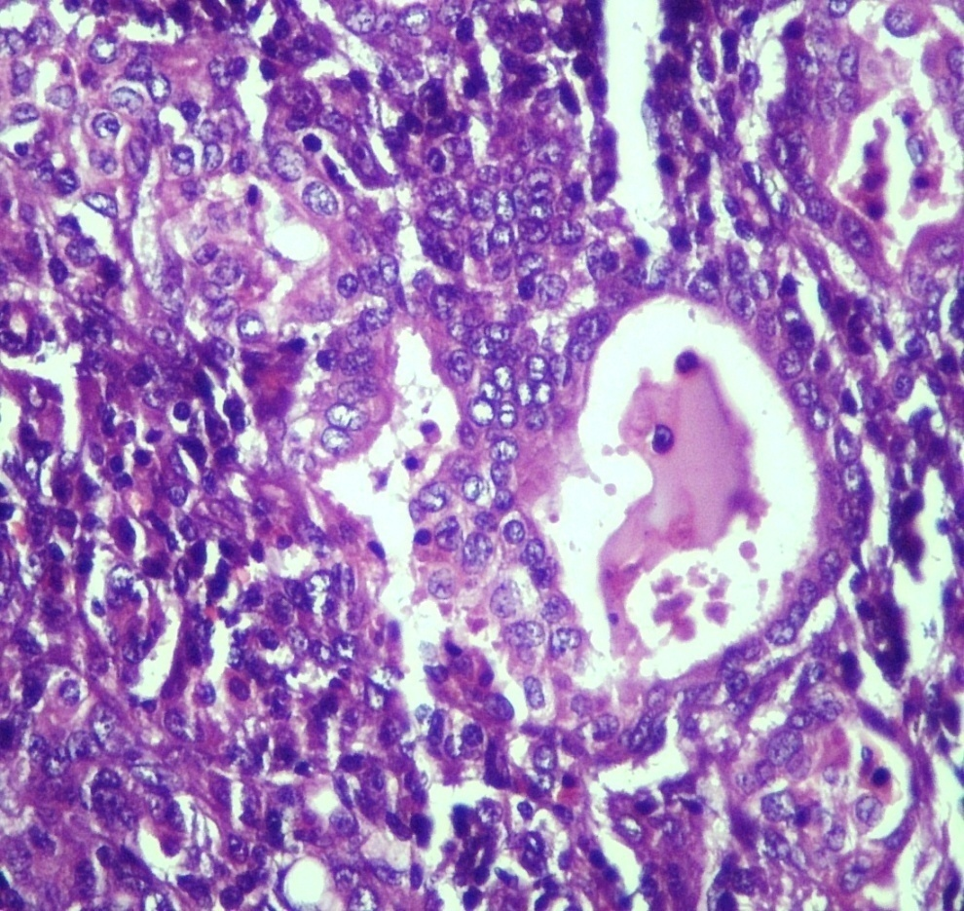
b
a
Figure 4: Microscopic examination showing metastatic deposits of adenocarcinoma in a lymph node. (a) Frozen section from a gastric lymph node showing infiltration by tumour cells forming glandular structures. (b) Permanent section from the lymph node showing effacement of nodal architecture by malignant glands (H&E, 20x).
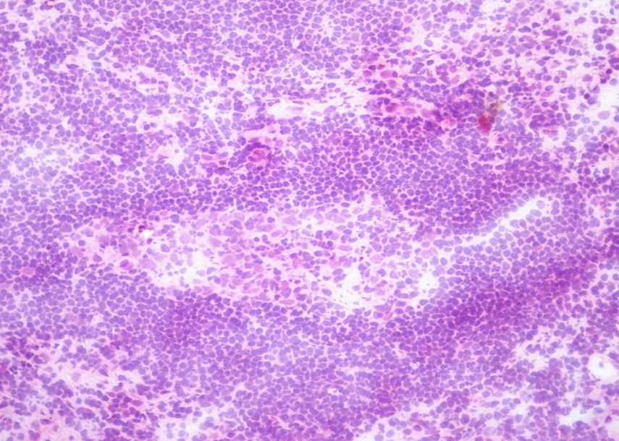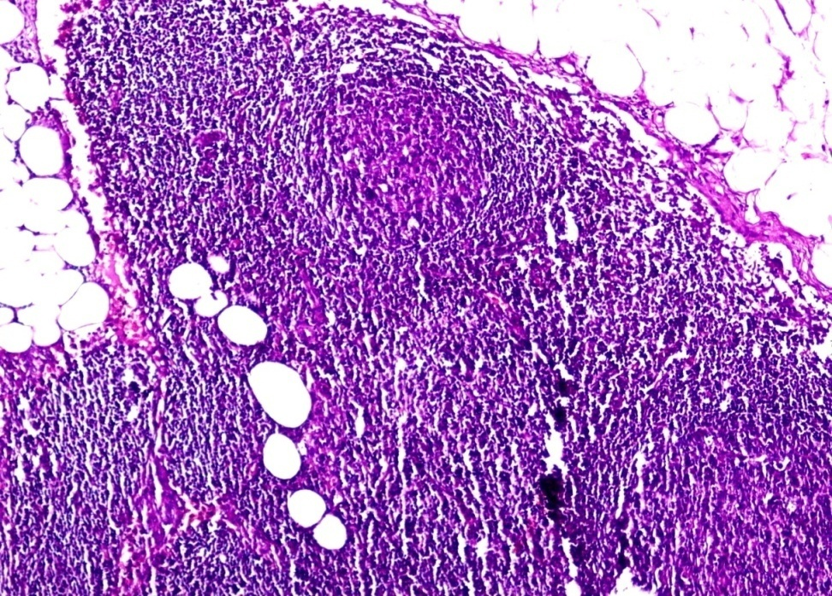
b
a
Figure 5: Microscopic examination showing preservation of normal lymph node architecture. (a) Intraoperative frozen section from a lymph node of the hepatoduodenal ligament demonstrating adequate tissue with preserved nodal architecture; no atypical cells identified. (b)Routine histopathology section of the lymph node showing a well-capsulated node with reactive follicles and surrounding fat; no evidence of tumour infiltration (H&E, 10x).
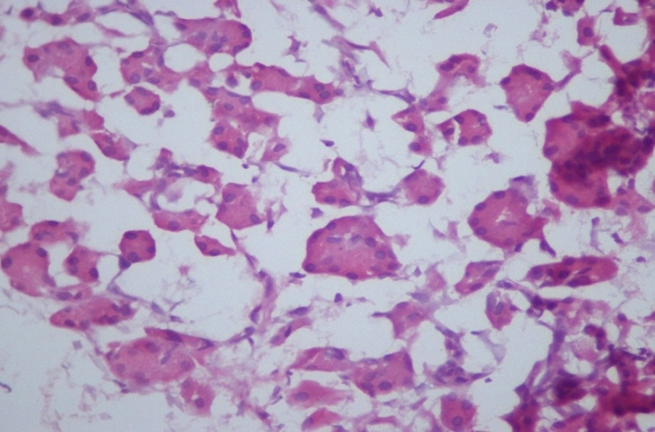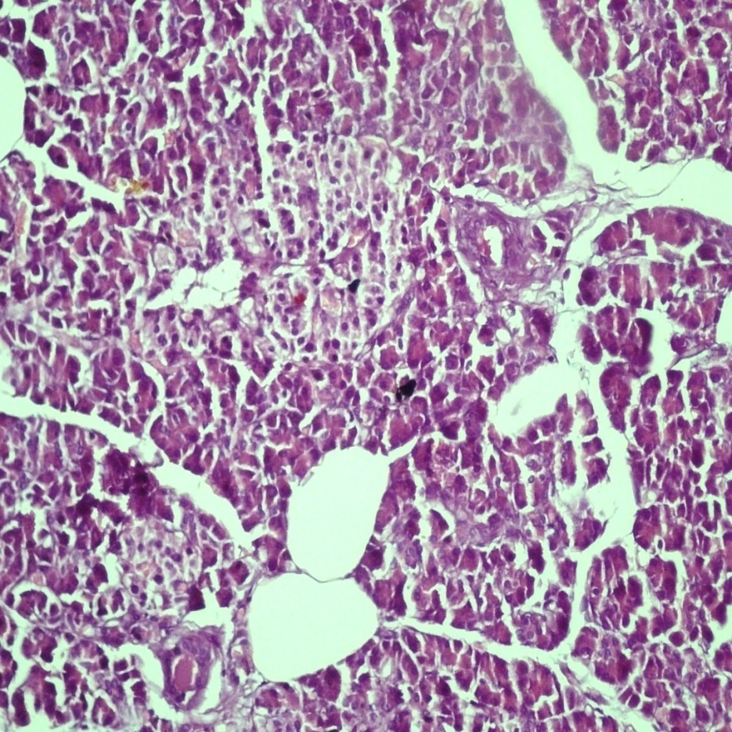
b
a
Figure 6: Microscopic examination showing normal pancreatic acini with no tumour infiltration. (a) Frozen section from the suspicious pancreatic margin showing normal pancreatic acini without atypical cells. (b) Routine histopathology section from pancreas showing normal parenchyma which is free of tumour (H&E, 20x).

