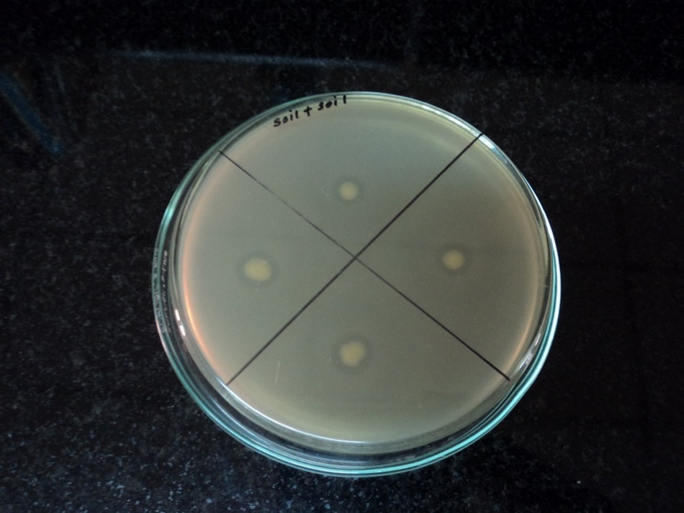
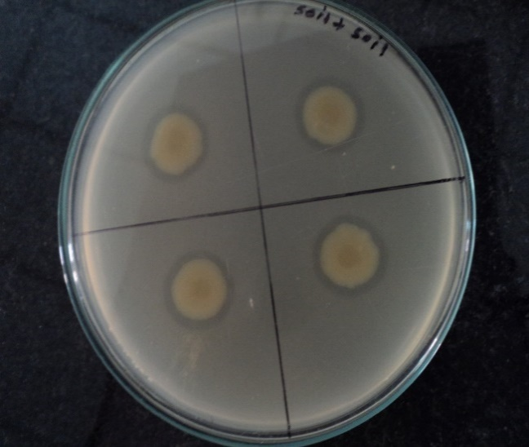
Fig. 1. (a) & (b): Transmission Electron Microscopic Structure of Bdellovibrio sp. MPR 17 & 18 lawn of E.coli-1 & 2
E. coli-1
E. coli-2
MPR 18
MPR 17
MPR 17
MPR 18
(a)
(b)
E. coli-1
MPR 17
E. coli-2
MPR 18
(a)
(b)

Fig.2. (a) & (b): Bdellovibrio sp. strain MPR 17 & 18 lawn of E.coli-1 & 2 with double layer agar plating techniques

Fig.3. The Lytic Potential of Bdellovibrio sp. strain MPR 17 compared to effective antibiotic in broth culture of E.coli-1 & 2

Fig.4. The Lytic Potential of Bdellovibrio sp. strain MPR 18 compared to effective antibiotic in broth culture of E.coli-1 & 2

Fig.5. Predatory efficacy comparison of Bdellovibrio sp. strain MPR 17 & 18 with Escherichia coli-1 & 2
Note: Azithromycin (AZM), Erythromycin (ERY), Streptomycin (S), Ampicillin (AMP), Tetracycline (TE), Ofloxacin (OF), Amikacin (AK) and Kanamycin (K)

