Case Report:
Accessory Phrenic Nerve: Case Report and Literature Review
Mohammed A.A.Abdelmotalab٭¹ , Ali QM ²

¹Assistant Professor of Human and Clinical Anatomy, Anatomy Department, Faculty of Medicine, International University of Africa, Sudan.
² Professor of Human Anatomy and Diagnostic Radiology, Anatomy Department, Faculty of Medicine National University, Sudan
Corresponding author: Dr. Mohammed Abdelsalam Ahmed Abdelmotalab , Assistant Professor of Human and Clinical Anatomy, Anatomy Department, Faculty of Medicine, International University of Africa, Sudan.

Abstract:
Anatomical variations are essential in the fields of surgery and anesthesia. It also assists in the evaluation of patient symptoms in cases of neuropathies and trauma. During the regional dissection of formalin-fixed male cadavers at the Department of Human Anatomy at National University Faculty of Medicine for undergraduate students of second and third classes, academic years 2016-2017, accessory phrenic nerve (APN) was observed join the phrenic nerve near the neck root. The knowledge of these anatomical variations helps the physicians in symptoms interpretation.
Key words: Accessory phrenic nerve, phrenic nerve and nerve to subclavius

Introduction:
The phrenic nerve is formed mainly from C4 root and contribution fibers from C3 and C5 roots, it crosses vertically and obliquely on the anterior surface of the scalenus anterior muscle, then passing under the prevertebral fascia and behind the subclavian vein on its way to reach the superior mediastinum ^{[1]}. The nerve to subclavius pass anterior to brachial plexus and the subclavian artery to innervate the subclavius muscle, sternoclavicular joint its accessory phrenic root innervates the diaphragm ^{[2]}.
A total of 17 studies on the accessory phrenic nerve existence Nine studies (36.5%.) of reported data showed present of APN. Most of the data revealed that APN originated from the ansa cervicalis (16.5%) followed by the nerve to the subclavius (15.8%)^{[3]}.
In a study of 80 cadavers the phrenic nerve was present in all cases, 99 (61.8%) had an accessory phrenic nerve. The accessory phrenic nerve arose from the nerve to subclavius muscle in 60 cases (60.6%), ansa cervicalis in 12 cases (12.1%) and nerve to sternohyoid muscle in 7 (7%)^{[4]}.
Case presentation:
An important anatomical variation present during the dissection of the head and neck region of about 75 years fixed formaldehyde male cadaver, on the left side of the neck after removing of the skin, fasciae and demonstrating of the structures of the anterior and posterior triangles, the nerve to the subclavius muscle was observed giving accessory phrenic nerve (APN), which forming a neural loop that anastomosing with the phrenic nerve near to the root of the neck above the clavicle in front of scalenius anterior and under cover of the prevertebral fascia as shown in fig (1) (2).

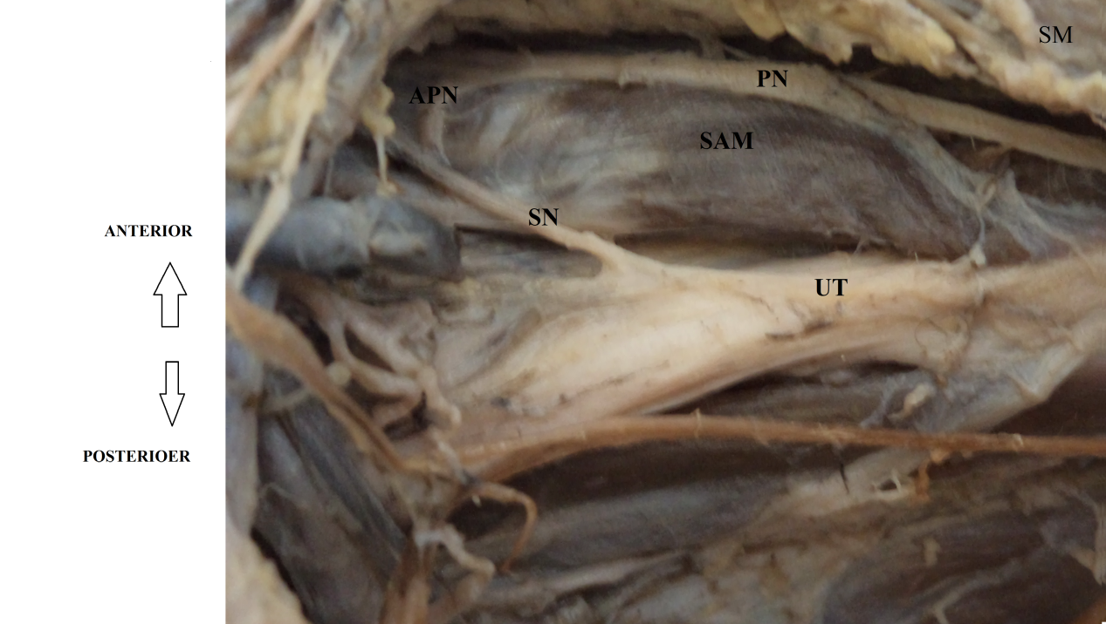

Fig (1): Viewed that subclavian nerve (SN) was giving accessory phrenic nerve (APN) which join the phernic nerve (PN) in front of scalenius anterior muscle (SAM). Upper trunk of the brachial plexsus (UT) and sternomastoid muscle (SM)

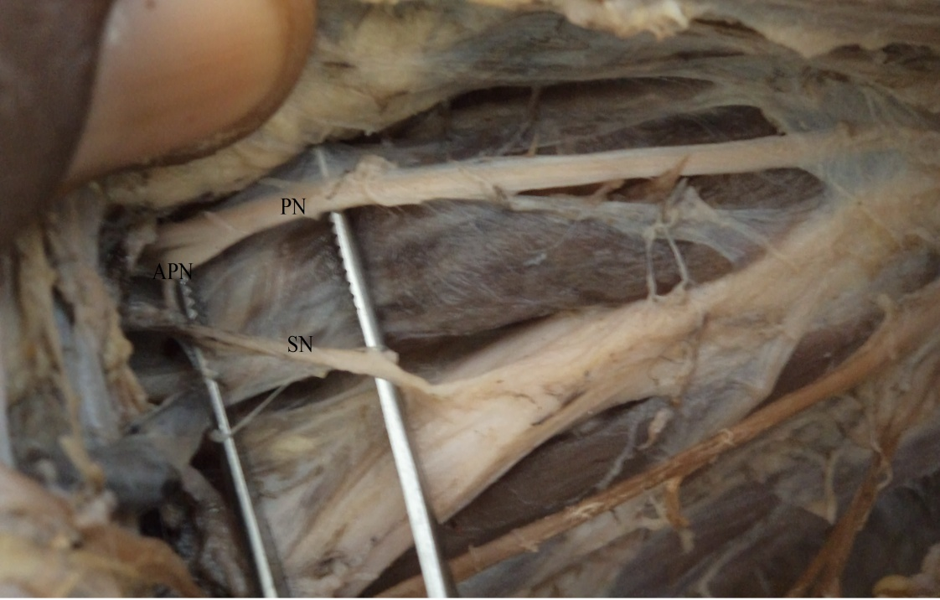
Fig (2):Viewed the phrenic nerve (PN), accessory phrenic nerve(APN) and subclavian nerve (SN).

Discussion:
The accessory phrenic nerve (APN) was present in 48(90) cases 53.3 % Soubhagya et al 2008. The APN was noted arising from the nerve to the subclavius or from C5 and C6 roots ^{[5.6]}. In 45.5% of the accessory phrenic nerve merge with the phrenic nerve inside the thoracic cavity anterior to the subclavian vein and in 22.2% was posterior to the subclavian vein ^{[4]}. The APA is cross anterior to the subclavian vein Soubhagya et al 2008^{[7]}. In the current study the observed accessory phrenic nerve was found in the cervical region, above the clavicle and near to the root of the neck. As it appears in most of previous documented cases. Paraskash et al 2007 were mentioned in their rare case report that a triangular loop of APN originating from the supraclavicular nerve. The phrenic nerve gave a communicating branch to the C5 root of the brachial plexus ^{[8]}.
The phrenic nerve may be joined below the subclavian vein by the accessory phrenic nerve from the nerve to subclavius ^{[1]}. In the present case the APN was noted joined the phrenic nerve above the subclavian vein near to the neck root on the left side. The phrenic nerve is main motor supply to the diaphragm, but motor fibers from other nerves were not excluded ^{[9]}. The accessory phrenic root of subclavius nerve innervates the diaphragm ^{[2]}. Present of the accessory the prevent paralysis of the diaphragm in case of damage of the phrenic nerve during catheterization ^{[10]}. Six lateral accessory phrenic nerves were identified in a study of 100 patients, when they directly stimulated they stimulate the diaphragm. Moreover, this variant course of the APN may expose it to damage during the neck surgical operations ^{[11]}.
Conclusion:
The knowledge of these anatomical variations helps the physicians in symptoms interpretation. The APN needs further anatomical studies as it may bring motor fibers to the phrenic nerve.

Acknowledgement:
We thank Fully for Prof Kamil Mohammed Abdalla the head of the anatomy department for his help and support.

References:
- McMinn RMH.(1994). Last's Anatomy.9th ELBS Ed. Churchill Livingstone, Singapore: p 81-424.
- Moore, Keith L.; Dalley, Arthur F.(2006). Clinically Oriented Anatomy, 5th Edition. Lippincott Williams & Wilkins. Toronto, Toronto, Ontario, Canada: p 774-776.
- Matthew J. Graves ,Brandon Michael Henry,Wan Chin Hsieh, Beatrice Sanna ,PrzemysŁaw A. PĘkala, Joe Iwanaga, Marios Loukas, Krzyszt and Tomaszewski. Origin and prevalence of the accessory phrenic nerve: A meta‐analysis and clinical appraisal. Clinical anatomy journal.2017;30(8):1077-1082.
- Loukas M, Kinsella CR Jr, Louis RG Jr, Gandhi S and Curry B. Surgical Anatomy of the Accessory Phrenic Nerve. Ann Thorac Surg J. 2006; 82(5):1870-5.
- Prates Júnior, Lívia Caetano and Leonardo Santos. Anatomical variations of the phrenic nerve: An actualized review. Journal of Morphological Sciences.2015; 32(1):53-56.
- Bigeleisen PE. Anatomical variations of the phrenic nerve and its clinical implication for supraclavicular block. Br J Anaesth. 2003;91:916-7.
- Soubhagya R. Nayak, Ashwin Krishnamurthy, Latha V. Prabhu, Lakshmi Ramanathan, Mangala M. Pai, Bhagath Kumar Potu, Srijit Das. Incidence Of Accessory Phrenic Nerve and its Clinical Significance: A Cadaveric Study. ACTA MEDICA (Hradec Králové) 2008;51(3):181–184.
- Prakash, Prabhu LV, Madhyastha S, Singh G.A. variation of the phrenic nerve: case report and review. Singapore Med J. 2008;48(12):1156-7.
- G. S. Muller Botha. The anatomy of phrenic nerve termination and the motor innervation of the diaphragm. Thorax J. 1957; 12(50).
- Paraskevas G, Koutsouflianiotis K, Kitsoulis P, Spyridakis. Abnormal Origin and Course of the Accessory Phrenic Nerve: Case Report. Acta Medica J.2016;59(2):70-1.
- Scott R. Golarz and Joseph M. White, Philadelphia, Pennsylvania, and Bethesda, Maryland. Anatomic Variation of the Phrenic Nerve and Brachial Plexus Encountered during 100 Supraclavicular Decompressions for Neurogenic Thoracic Outlet Syndrome with Associated Postoperative Neurologic Complications. Ann Vasc Surg 2020; 62: 70–75.

