Original article
Agreement Between Automated Red Cell Indices and Peripheral Blood Smear Morphology in the Classification of Anaemia in Adults
*Vivek Tukaram Bonde¹

Assistant Professor, Department of Pathology, IQ City Medical College, Durgapur
Corresponding author*

ABSTRACT
Background: Anaemia is classified in routine practice by automated red cell indices, while the peripheral blood smear remains the reference for red cell morphology. How closely the two agree determines when smear review can be safely limited.
Objectives: To describe the morphological types of anaemia in adults and to measure agreement between classification by mean corpuscular volume (MCV) and classification by peripheral smear examination.
Materials and Methods: This cross-sectional analysis uses a simulated dataset of 240 adults with haemoglobin below World Health Organization thresholds. Smears stained by the Leishman method were classified as microcytic hypochromic, normocytic normochromic, macrocytic or dimorphic, and compared with MCV-based classes (<80, 80–100, >100 fL). Agreement was assessed with Cohen's kappa.
Results: Women formed 63.3% of the cohort; mean age was 41.8 ± 14.3 years. Microcytic hypochromic anaemia was most frequent (49.2%), followed by normocytic normochromic (30.0%), dimorphic (11.7%) and macrocytic (9.2%) pictures. For the three monomorphic types, MCV and smear agreed in 194 of 212 cases (91.5%; κ = 0.85, 95% CI 0.78–0.92). Of 28 dimorphic smears, 22 had a normal MCV, whereas all 28 had an RDW-CV above 15%.
Conclusion: In this simulated analysis, MCV agreed closely with smear morphology for monomorphic anaemia but could not identify dimorphic blood pictures. A raised RDW with a normal MCV should prompt smear review. The design requires validation with real patient data.
Keywords: Anaemia; Erythrocyte indices; Mean corpuscular volume; Peripheral blood smear; Red cell distribution width; Haematology
INTRODUCTION
Anaemia is defined by the World Health Organization (WHO) as a haemoglobin concentration below 12 g/dL in non-pregnant women and below 13 g/dL in men, with severity graded as mild, moderate or severe [1]. It is among the most common conditions encountered in clinical practice; a systematic analysis estimated its global prevalence at 32.9% in 2010, with iron deficiency as the leading cause [2]. Clinical recognition is unreliable, because pallor has only limited accuracy for detecting anaemia at the bedside [3], so classification depends on laboratory investigation.
The first diagnostic step is usually morphological. Iron deficiency, the most frequent cause worldwide, produces a microcytic hypochromic picture [4], whereas vitamin B12 or folate deficiency and several non-megaloblastic disorders produce macrocytosis [5]. Bessman and colleagues showed that combining mean corpuscular volume (MCV) with red cell distribution width (RDW) improves the classification of anaemia beyond MCV alone [6]. Modern haematology analysers measure these indices with high precision and supply additional red cell parameters [7,8].
Examination of a stained peripheral blood smear nevertheless remains the reference for red cell morphology. It identifies features that an analyser can only flag, such as target cells, fragmented cells and mixed red cell populations [9]. Because smear review is labour-intensive, laboratories use defined criteria to decide which samples need a smear [10], and an international consensus group has proposed rules for action after automated blood counts [11].
Dimorphic anaemia, in which microcytic and macrocytic or normocytic populations coexist, is a recognised limitation of averaged indices. Opposing cell populations can yield a normal MCV and conceal the underlying disorder. Quantifying how often MCV-based classification agrees with smear morphology, and where it fails, therefore has direct implications for smear review policies.
The objective of this study design is to describe the distribution of morphological types of anaemia in adults and to measure agreement between MCV-based classification and peripheral smear examination. It gives particular attention to dimorphic blood pictures and to the role of RDW.
MATERIALS AND METHODS
The protocol describes a hospital-based cross-sectional study in the haematology section of a diagnostic pathology laboratory. Consecutive adult samples meeting the inclusion criteria would be analysed over a defined period. The study setting, period and investigators are left as placeholders to be completed with verified information.
Adults aged 18 years or older with haemoglobin below the WHO thresholds [1] would be eligible. Pregnant women, patients transfused within the preceding three months, patients on haematinic therapy, and samples with clots, haemolysis or delayed processing would be excluded. Assuming an expected proportion of microcytic anaemia of 50%, an absolute precision of 6.5% and 95% confidence, a minimum sample of 228 is required; the simulated dataset contains 240 participants.
Laboratory investigations. Venous blood would be collected in K2-EDTA tubes and analysed within four hours on a calibrated automated haematology analyser under internal quality control. Haemoglobin, red cell count, MCV, mean corpuscular haemoglobin (MCH), mean corpuscular haemoglobin concentration and RDW-CV would be recorded. Thin smears would be prepared from the same sample, stained by the Leishman method and examined under oil immersion according to standard practice [12].
Morphological classification. Smears would be classified independently by two pathologists, blinded to the analyser indices, into four categories: microcytic hypochromic, normocytic normochromic, macrocytic, and dimorphic (two distinct red cell populations). Morphological features would be described using International Council for Standardization in Haematology (ICSH) nomenclature and grading [13]. Disagreements would be resolved by joint review. In parallel, MCV-based classes would be assigned as microcytic (<80 fL), normocytic (80–100 fL) or macrocytic (>100 fL), and RDW-CV above 15% would be considered raised. Severity would be graded by WHO criteria [1].
Statistical analysis. Categorical variables are presented as numbers and percentages with Wilson 95% confidence intervals (CI). Continuous variables are presented as mean ± standard deviation and compared using the Mann–Whitney U test (two groups) or the Kruskal–Wallis test (four groups). Associations between categorical variables were tested with the chi-square test. Agreement between MCV-based and smear-based classification for the three monomorphic types was measured with Cohen's kappa [14] and interpreted using the Landis and Koch benchmarks [15]. A two-sided p < 0.05 was considered significant. The analysis was performed in Python (SciPy).
Ethical considerations. No human data were used for this00000manuscript. Before any real study, approval from the Institutional Ethics Committee would be required, with a waiver or informed consent as appropriate. Data would be anonymised before analysis.
RESULTS

Table 1. Baseline characteristics of the simulated study population by sex (N = 240)
Characteristic | Category | Female (n = 152) | Male (n = 88) | Total (N = 240) | p value
Age, mean ± SD (years) |  | 41.3 ± 14.4 | 42.6 ± 14.1 | 41.8 ± 14.3 | 0.487†
Age group (years) | 18–30 | 37 (24.3) | 19 (21.6) | 56 (23.3) | 0.744‡
 | 31–45 | 60 (39.5) | 31 (35.2) | 91 (37.9)
 | 46–60 | 39 (25.7) | 28 (31.8) | 67 (27.9)
 | >60 | 16 (10.5) | 10 (11.4) | 26 (10.8)
Haemoglobin, mean ± SD (g/dL) |  | 9.0 ± 1.5 | 9.2 ± 1.4 | 9.1 ± 1.4 | 0.189†
Severity of anaemia* | Mild | 15 (9.9) | 10 (11.4) | 25 (10.4) | 0.934‡
 | Moderate | 104 (68.4) | 59 (67.0) | 163 (67.9)
 | Severe | 33 (21.7) | 19 (21.6) | 52 (21.7)
Total |  | 152 (63.3) | 88 (36.7) | 240 (100.0)
Values are n (%) unless stated otherwise; percentages are column percentages. SD, standard deviation.
*WHO grading for non-pregnant adults: mild, 11.0–11.9 g/dL (women) or 11.0–12.9 g/dL (men); moderate, 8.0–10.9 g/dL; severe, <8.0 g/dL [1].
†Mann–Whitney U test. ‡Chi-square test.
On peripheral smear examination, microcytic hypochromic anaemia was the predominant pattern (118; 49.2%, 95% CI 42.9–55.5), followed by normocytic normochromic (72; 30.0%), dimorphic (28; 11.7%) and macrocytic (22; 9.2%) pictures (Table 2). The distribution by sex is shown in Figure 1. Women accounted for most of the microcytic group, whereas the macrocytic group was more evenly divided.
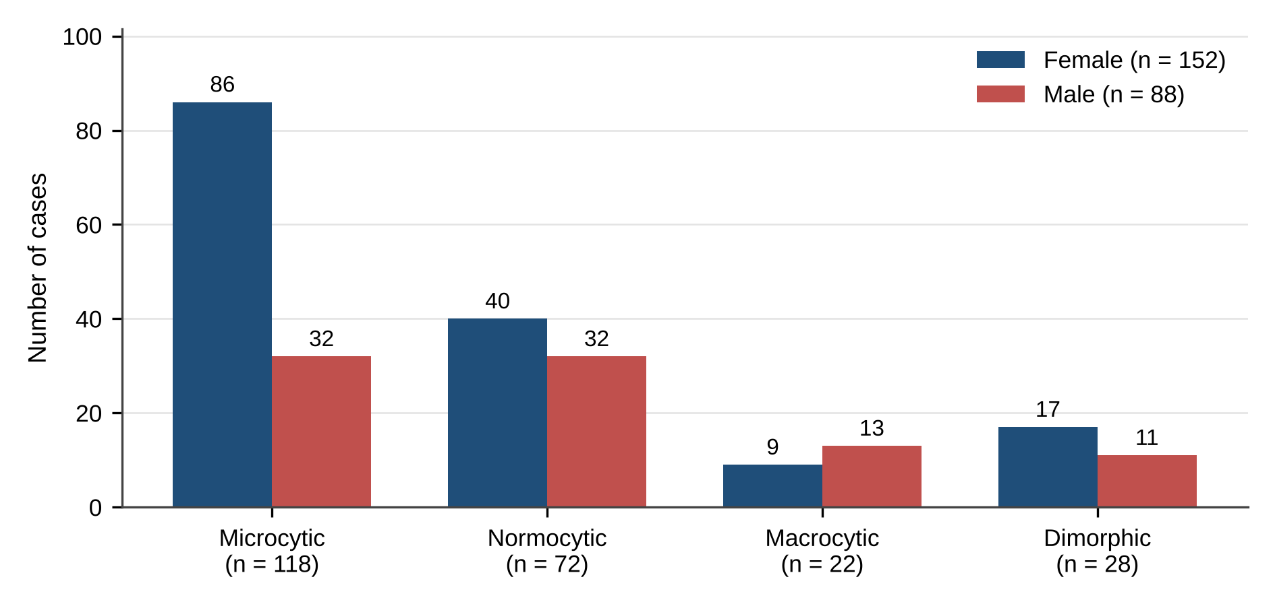
Figure 1. Distribution of peripheral smear morphological types by sex ( N = 240). Numbers above the bars are case counts.
Haematological indices differed significantly among the four morphological types (Table 2). MCV and MCH were lowest in the microcytic group and highest in the macrocytic group (both p <0.001). Mean haemoglobin was lowest in dimorphic anaemia (8.3 ± 1.6 g/dL). RDW-CV was raised in every group except normocytic normochromic anaemia and was highest in the dimorphic group (21.4 ± 2.4%).
Table 2. Distribution of peripheral smear morphological types and their haematological indices
Smear morphology | n (%) | Hb (g/dL) | MCV (fL) | MCH (pg) | RDW-CV (%)
Microcytic hypochromic | 118 (49.2) | 8.8 ± 1.3 | 71.4 ± 5.3 | 21.9 ± 3.0 | 18.0 ± 2.1
Normocytic normochromic | 72 (30.0) | 9.9 ± 1.2 | 88.1 ± 5.6 | 28.7 ± 1.8 | 14.7 ± 1.1
Macrocytic | 22 (9.2) | 8.6 ± 1.8 | 107.5 ± 7.2 | 34.7 ± 2.2 | 17.1 ± 2.2
Dimorphic | 28 (11.7) | 8.3 ± 1.6 | 88.2 ± 7.6 | 27.5 ± 3.5 | 21.4 ± 2.4
p value* |  | <0.001 | <0.001 | <0.001 | <0.001
Indices are mean ± SD. Hb, haemoglobin; MCV, mean corpuscular volume; MCH, mean corpuscular haemoglobin; RDW-CV, red cell distribution width (coefficient of variation).
*Kruskal–Wallis test across the four morphological types.
Table 3 cross-tabulates smear morphology against MCV-based class. For the three monomorphic types, the two methods agreed in 194 of 212 cases (91.5%, 95% CI 87.0–94.6), giving κ = 0.85 (95% CI 0.78–0.92). Agreement was highest for microcytic hypochromic smears (94.1%) and lowest for normocytic normochromic smears (87.5%). Of the 18 discordant monomorphic cases, 7 microcytic smears had an MCV of 80.2–84.1 fL and 8 normocytic smears had an MCV of 72.9–79.8 fL, most of them within 3 fL of the 80 fL cut-off.
Table 3. Cross-tabulation of peripheral smear morphology against MCV-based classification
Smear morphology | MCV <80 fL | MCV 80–100 fL | MCV >100 fL | Total | Agreement, n (%)
Microcytic hypochromic | 111 | 7 | 0 | 118 | 111 (94.1)
Normocytic normochromic | 8 | 63 | 1 | 72 | 63 (87.5)
Macrocytic | 0 | 2 | 20 | 22 | 20 (90.9)
Dimorphic | 4 | 22 | 2 | 28 | —§
Total | 123 | 94 | 23 | 240
Agreement for the three monomorphic types: 194/212 (91.5%); Cohen's κ = 0.85 (95% CI 0.78–0.92).
§Dimorphic morphology has no MCV equivalent and is excluded from κ. MCV, mean corpuscular volume.
Dimorphic smears could not be identified by MCV: 22 of 28 (78.6%) had a normal MCV and would have been classed as normocytic. All 28 dimorphic cases, however, had an RDW-CV above 15%. Figure 2 shows that the MCV of dimorphic cases overlapped the normocytic range, whereas their RDW-CV was clearly separated from the normocytic group.
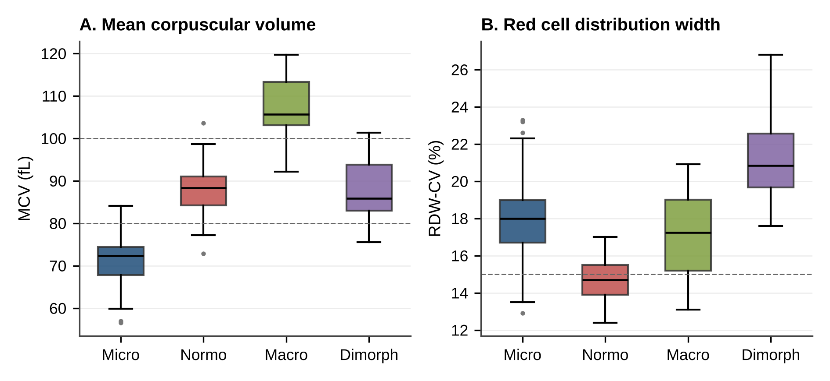
Figure 2. Mean corpuscular volume (A) and red cell distribution width (B) by smear morphological type (simulated data). Boxes show the interquartile range with the median; whiskers extend to 1.5 × IQR. Dashed lines mark the MCV cut-offs of 80 and 100 fL and the RDW-CV cut-off of 15%.
DISCUSSION
This analysis compared the automated MCV with peripheral smear morphology as the basis for classifying anaemia in adults. In the simulated dataset, microcytic hypochromic anaemia predominated, MCV showed almost perfect agreement with the smear for monomorphic anaemia, and MCV failed to detect dimorphic blood pictures, which were consistently accompanied by a raised RDW.
The predominance of microcytic hypochromic anaemia, particularly among women, matches the epidemiological picture in which iron deficiency is the leading cause of anaemia worldwide [2,4]. Macrocytic anaemia was less common. In practice, a macrocytic finding opens a differential diagnosis that ranges from megaloblastic anaemia due to vitamin B12 or folate deficiency to alcohol use, liver disease, hypothyroidism and drug effects [5], so the smear contributes features such as oval macrocytes and hypersegmented neutrophils that indices cannot provide [9].
A kappa of 0.85 falls in the 'almost perfect' band described by Landis and Koch [15]. Discordant cases clustered near the 80 fL boundary, which is expected when a continuous measurement is converted into categories and when early iron deficiency produces a mixed population before the MCV falls. This pattern supports the observation of Bessman and colleagues that MCV alone is an incomplete classifier and that the addition of RDW improves discrimination [6]. Modern analysers provide precise indices and further red cell parameters [7,8], but averaged values cannot describe the shape of the red cell population.
The dimorphic group illustrates this limitation most clearly. When microcytic and macrocytic populations coexist, as in combined iron and vitamin B12 or folate deficiency, or after partial treatment or transfusion, the averaged MCV may fall within the normal range. In this simulation, most dimorphic cases would have been reported as normocytic on the basis of MCV, yet every one had a raised RDW. This is the pattern that smear review criteria are designed to catch [10,11]. RDW is a sensitive but non-specific marker of anisocytosis and is raised in a wide range of conditions [16]. A raised RDW with a normal MCV is therefore best used as a trigger for smear examination rather than as a diagnosis.
The findings also bear on the screening of microcytosis. Indices such as the Mentzer index, the ratio of MCV to red cell count, were proposed to separate iron deficiency from thalassaemia trait [17]. Such indices are useful for triage but do not replace morphological assessment or confirmatory tests. Standardized ICSH terminology and grading [13] would further improve the reproducibility of smear reporting in a real study.
CONCLUSION
This analysis outlines a practical method for testing whether automated red cell indices can stand in for peripheral smear morphology when classifying anaemia. In the simulated dataset, MCV-based classification agreed almost perfectly with the smear for microcytic, normocytic and macrocytic anaemia but missed dimorphic blood pictures. These were reliably accompanied by a raised RDW. The expected clinical message is that indices are adequate for initial classification, while a raised RDW with a normal MCV warrants smear review. Before these conclusions can be drawn, the study must be conducted on real, ethically approved patient data with aetiological work-up. Future research should assess analyser-specific RDW thresholds and the added value of newer red cell parameters.

REFERENCES
1. World Health Organization. Haemoglobin concentrations for the diagnosis of anaemia and assessment of severity. Vitamin and Mineral Nutrition Information System. Geneva: World Health Organization; 2011 (WHO/NMH/NHD/MNM/11.1). ↑
2. Kassebaum NJ, Jasrasaria R, Naghavi M, Wulf SK, Johns N, Lozano R, et al. A systematic analysis of global anemia burden from 1990 to 2010. Blood. 2014;123(5):615-24.
3. Kalantri A, Karambelkar M, Joshi R, Kalantri S, Jajoo U. Accuracy and reliability of pallor for detecting anaemia: a hospital-based diagnostic accuracy study. PLoS One. 2010;5(1):e8545.
4. Camaschella C. Iron-deficiency anemia. N Engl J Med. 2015;372(19):1832-43. doi:10.1056/NEJMra1401038 ↑
5. Aslinia F, Mazza JJ, Yale SH. Megaloblastic anemia and other causes of macrocytosis. Clin Med Res. 2006;4(3):236-41.
6. Bessman JD, Gilmer PR Jr, Gardner FH. Improved classification of anemias by MCV and RDW. Am J Clin Pathol. 1983;80(3):322-6. ↑
7. Buttarello M, Plebani M. Automated blood cell counts: state of the art. Am J Clin Pathol. 2008;130(1):104-16.
8. Briggs C. Quality counts: new parameters in blood cell counting. Int J Lab Hematol. 2009;31(3):277-97.
9. Bain BJ. Diagnosis from the blood smear. N Engl J Med. 2005;353(5):498-507
10. Gulati G, Song J, Florea AD, Gong J. Purpose and criteria for blood smear scan, blood smear examination, and blood smear review. Ann Lab Med. 2013;33(1):1-7.
11. Barnes PW, McFadden SL, Machin SJ, Simson E. The international consensus group for hematology review: suggested criteria for action following automated CBC and WBC differential analysis. Lab Hematol. 2005;11(2):83-90.
12. Bain BJ, Bates I, Laffan MA, editors. Dacie and Lewis practical haematology. 12th ed. London: Elsevier; 2017.
13. Palmer L, Briggs C, McFadden S, Zini G, Burthem J, Rozenberg G, et al. ICSH recommendations for the standardization of nomenclature and grading of peripheral blood cell morphological features. Int J Lab Hematol. 2015;37(3):287-303. doi:10.1111/ijlh.12327 ↑
14. Cohen J. A coefficient of agreement for nominal scales. Educ Psychol Meas. 1960;20(1):37-46.
15. Landis JR, Koch GG. The measurement of observer agreement for categorical data. Biometrics. 1977;33(1):159-74.
16. Lippi G, Plebani M. Red blood cell distribution width (RDW) and human pathology. One size fits all. Clin Chem Lab Med. 2014;52(9):1247-9.
17. Mentzer WC Jr. Differentiation of iron deficiency from thalassaemia trait. Lancet. 1973;1(7808):882.

