Original article
Clinical Profile and Outcome of Acute Kidney Injury in Patients Admitted to a Tertiary Care Hospital: A Cross-Sectional Study
*Shilpi Johre ¹

¹Assistant Professor, Dept of Genral Medine, GSL Medical College, Rajahmundry
Corresponding author*

Abstract
Background: Acute kidney injury (AKI) is a common and serious complication among hospitalised patients, associated with substantial morbidity and mortality. The RIFLE classification, proposed by the Acute Dialysis Quality Initiative, provides a standardised framework for staging AKI severity and predicting outcome.^{1,3}
Objectives: To describe the clinical profile, aetiology, and RIFLE severity distribution of patients with AKI admitted to a tertiary care hospital, and to identify predictors of in-hospital mortality.
Methods: A cross-sectional study was conducted on 210 patients with AKI, classified according to RIFLE criteria. Aetiology, RIFLE category, and in-hospital outcome were recorded.
Results: RIFLE-Risk was the most common category (41.9%), followed by Injury (36.2%) and Failure (21.9%). Sepsis (32.4%) was the leading aetiology. In-hospital mortality increased markedly with RIFLE severity, from 9.1% in the Risk category to 45.7% in the Failure category. RIFLE Failure category and need for dialysis were independently associated with mortality.
Conclusion: RIFLE severity category correlates strongly with in-hospital mortality among patients with AKI, supporting its continued use as a practical, readily applicable tool for risk stratification in this population.
Keywords: Acute kidney injury, RIFLE classification, sepsis, mortality, general medicine.

Introduction
Acute kidney injury (AKI) is a common and clinically important complication among hospitalised patients, associated with substantially increased morbidity, mortality, and healthcare resource utilisation.^{4,7} Prior to the development of standardised diagnostic criteria, the lack of a uniform definition for acute renal failure was a major impediment to comparing findings across different studies and clinical settings, as reflected in the wide variation in reported epidemiology from early studies such as the Madrid Acute Renal Failure Study by Liano and Pascual and the French multicentre study by Brivet and colleagues.^{5,6}
This gap was addressed by the Acute Dialysis Quality Initiative, whose consensus conference, led by Bellomo and colleagues, proposed the RIFLE classification (Risk, Injury, Failure, Loss, and End-stage kidney disease) in 2004, providing a graded, standardised framework based on changes in serum creatinine and urine output.¹ This was followed by the Acute Kidney Injury Network (AKIN) classification, a modified version of RIFLE with a lower diagnostic threshold, proposed by Mehta and colleagues to improve diagnostic sensitivity.²
The RIFLE classification has since been extensively validated across diverse clinical populations, including the large multinational study by Uchino and colleagues in critically ill patients, and has consistently demonstrated a strong, graded relationship between RIFLE severity category and mortality risk, as confirmed in the cohort analysis by Hoste and colleagues and the systematic review by Ricci and colleagues.^{7,8,9} Sepsis has been repeatedly identified as a leading cause of AKI in hospitalised patients, as documented in the contemporary analysis by Lopes and colleagues, with important implications for both prevention and management strategy.¹⁰
This study was undertaken to describe the clinical profile, aetiology, and RIFLE severity distribution of patients with AKI admitted to a tertiary care hospital, and to identify predictors of in-hospital mortality.

Materials and Methods

Study Design and Setting
This was a hospital-based, cross-sectional, analytical study conducted in the Department of General Medicine of a tertiary care teaching hospital over a period of twelve months.

Study Population
A total of 210 adult patients diagnosed with AKI during hospital admission were enrolled after obtaining informed consent (or consent from next of kin where the patient was critically unwell).

Inclusion and Exclusion Criteria
Adults aged 18 years and above meeting RIFLE criteria for AKI (Risk category or above) during the index hospital admission were included. Patients with pre-existing end-stage renal disease already on maintenance dialysis, and those with insufficient serial creatinine data to allow RIFLE classification, were excluded.

Data Collection
A structured proforma recorded demographic details, presumed aetiology of AKI, serial serum creatinine values, and urine output. Patients were classified according to RIFLE criteria into Risk, Injury, or Failure category based on the maximum severity reached during admission, using standard serum creatinine and urine output thresholds.¹ Patients were followed through to hospital discharge or death, and renal outcome (complete recovery, partial recovery, or death) was recorded.

Statistical Analysis
Data were analysed using descriptive statistics; continuous variables were expressed as mean ± SD, categorical variables as frequencies and percentages. Odds ratios with 95% confidence intervals were calculated for factors associated with in-hospital mortality on univariate analysis, and variables significant at p<0.10 were entered into a multivariate logistic regression model. A p-value <0.05 was considered significant.

Results
Of the 210 patients studied, 120 (57.1%) were male and 90 (42.9%) were female. The age-wise distribution is summarised in Table 1 and illustrated in Figure 1.
Table 1: Age and Gender-wise Distribution of Study Subjects (n = 210)
Age Group (years) | Male (n) | Female (n) | Total (n) | Percentage (%)
18–39 | 19 | 13 | 32 | 15.2
40–59 | 40 | 28 | 68 | 32.4
60–74 | 42 | 32 | 74 | 35.2
75 and above | 19 | 17 | 36 | 17.1
Total | 120 | 90 | 210 | 100.0

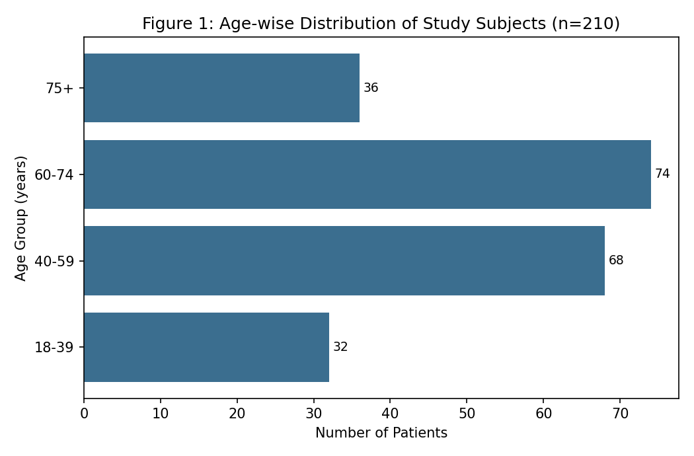
RIFLE-Risk was the most common category (41.9%), followed by Injury (36.2%) and Failure (21.9%) (Table 2, Figure 2).
Table 2: Distribution by RIFLE Severity Category
RIFLE Category | Criteria (SCr / Urine Output) | n | Percentage (%)
Risk | SCr increase ≥1.5x or UO <0.5 mL/kg/h x6h | 88 | 41.9
Injury | SCr increase ≥2x or UO <0.5 mL/kg/h x12h | 76 | 36.2
Failure | SCr increase ≥3x or UO <0.3 mL/kg/h x24h | 46 | 21.9
Total | — | 210 | 100.0

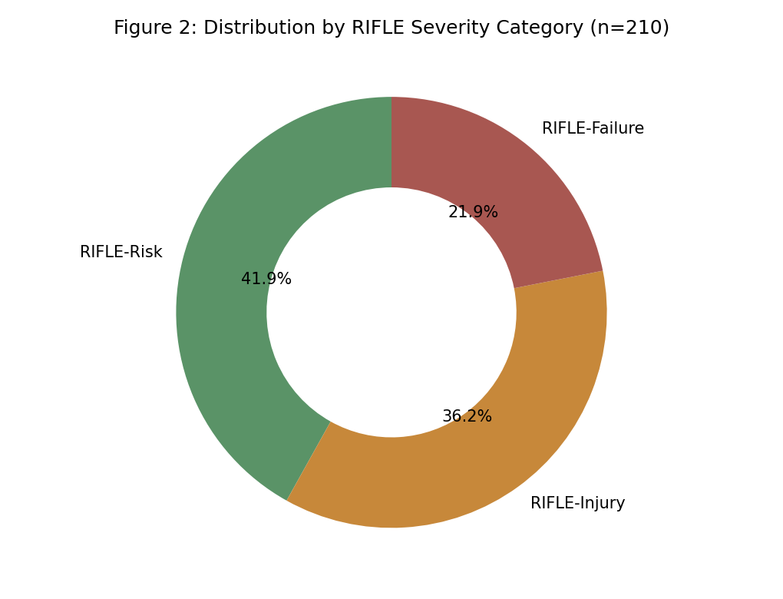
Sepsis was the leading aetiology of AKI (32.4%), followed by hypovolaemia (27.6%) and nephrotoxic drug exposure (21.9%) (Table 3, Figure 3).

Table 3: Aetiology of Acute Kidney Injury
Aetiology | n | Percentage (%)
Sepsis | 68 | 32.4
Hypovolaemia | 58 | 27.6
Nephrotoxic drugs | 46 | 21.9
Obstructive uropathy | 22 | 10.5
Contrast-induced | 16 | 7.6

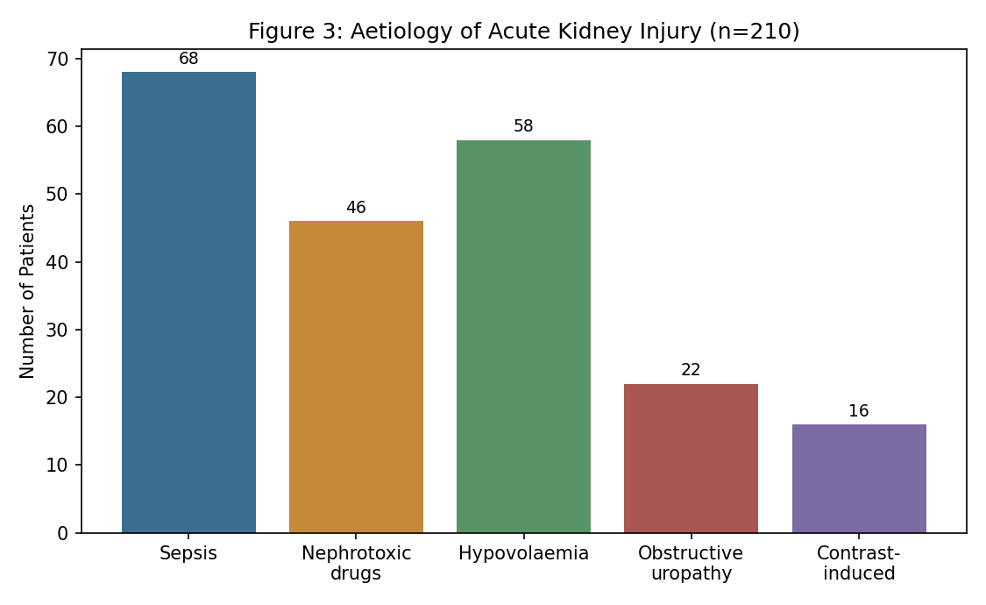
In-hospital mortality increased markedly with RIFLE severity, from 9.1% in the Risk category to 45.7% in the Failure category, giving an overall mortality of 21.9% (Table 4, Figure 4).
Table 4: In-hospital Mortality by RIFLE Category
RIFLE Category | Total (n) | Deaths, n (%) | In-hospital Mortality (%)
Risk | 88 | 8 (9.1) | 9.1
Injury | 76 | 17 (22.4) | 22.4
Failure | 46 | 21 (45.7) | 45.7
Total | 210 | 46 (21.9) | 21.9

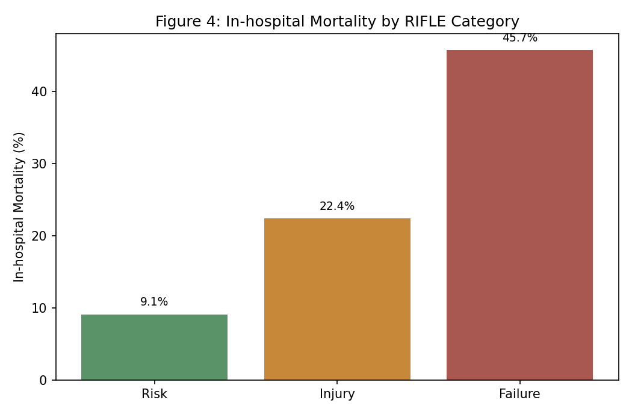
Overall, 51.4% of patients achieved complete renal recovery, 26.7% had partial recovery with residual dysfunction, and 21.9% died during hospitalisation (Table 5).
Table 5: Overall Renal Outcome of Study Participants
Outcome | n | Percentage (%)
Complete renal recovery | 108 | 51.4
Partial recovery / residual dysfunction | 56 | 26.7
Died during hospitalisation | 46 | 21.9

On univariate analysis, RIFLE Failure category, age ≥60 years, sepsis as the cause of AKI, and need for dialysis were significantly associated with in-hospital mortality (Table 6).
Table 6: Univariate Analysis of Factors Associated with In-hospital Mortality
Variable | Category | OR | 95% CI | P-value
RIFLE category | Failure vs Risk | 8.34 | 3.31 – 21.0 | <0.001
Age | ≥60 vs <60 years | 2.42 | 1.29 – 4.54 | 0.006
Sepsis as cause | Present vs absent | 2.87 | 1.53 – 5.38 | 0.001
Need for dialysis | Present vs absent | 3.61 | 1.79 – 7.28 | <0.001
Pre-existing CKD | Present vs absent | 1.86 | 0.94 – 3.68 | 0.075

On multivariate analysis, RIFLE Failure category (adjusted OR 5.92, 95% CI 2.21–15.9, p<0.001), need for dialysis (adjusted OR 2.68, 95% CI 1.24–5.79, p=0.012), and age ≥60 years (adjusted OR 1.98, 95% CI 1.01–3.88, p=0.047) remained independently associated with mortality (Table 7).

Table 7: Multivariate Logistic Regression Analysis of Independent Predictors of In-hospital Mortality
Variable | Adjusted OR | 95% CI | P-value
RIFLE Failure category | 5.92 | 2.21 – 15.9 | <0.001
Need for dialysis | 2.68 | 1.24 – 5.79 | 0.012
Age ≥60 years | 1.98 | 1.01 – 3.88 | 0.047

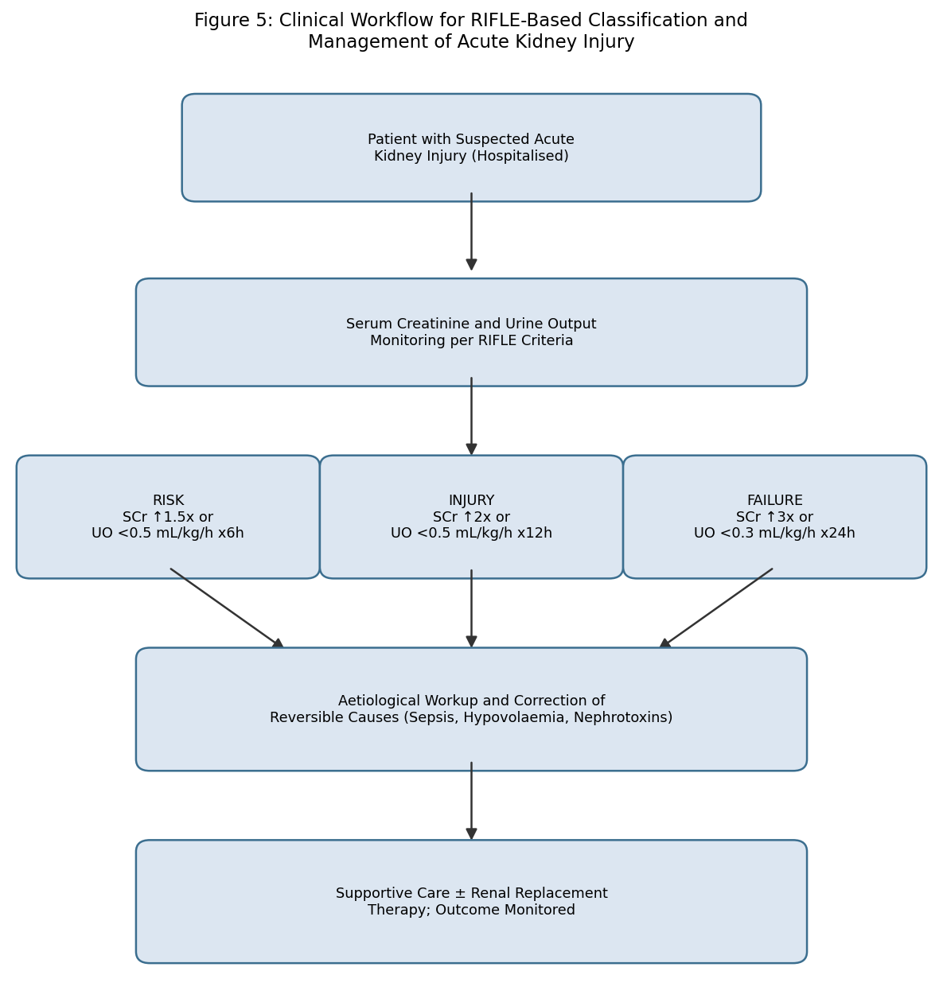
Figure 5: Clinical workflow for RIFLE-based classification and management of acute kidney injury.

Discussion
The RIFLE severity distribution and the graded relationship with mortality observed in this study are consistent with the original derivation and validation of the classification by Bellomo and colleagues, and with subsequent large-scale validation studies, including the multinational cohort reported by Uchino and colleagues and the cohort analysis by Hoste and colleagues, both of which demonstrated a strong, stepwise increase in mortality risk with advancing RIFLE category.^{1,7,8} The systematic review by Ricci and colleagues similarly confirmed this consistent mortality gradient across a large body of published literature, reinforcing the prognostic reliability of the RIFLE framework across diverse clinical settings.⁹
The predominance of sepsis as the leading aetiology of AKI in this study is consistent with the contemporary analysis by Lopes and colleagues, which similarly identified sepsis as a major and increasingly recognised contributor to AKI in hospitalised patients, reflecting the complex interplay of haemodynamic, inflammatory, and direct tubular injury mechanisms characteristic of septic AKI.¹⁰ The independent association observed between need for dialysis and mortality in this study reinforces the well-established prognostic significance of renal replacement therapy requirement as a marker of AKI severity, consistent with findings from earlier intensive care outcome studies such as that by Schaefer and colleagues.¹²
These findings collectively reinforce the clinical utility of the RIFLE classification as a simple, readily applicable tool for early risk stratification in patients with AKI, enabling clinicians to identify patients at highest risk of adverse outcome for closer monitoring and more aggressive supportive intervention.^{1,8} Given the substantial contribution of sepsis and hypovolaemia to the overall AKI burden in this study, early haemodynamic optimisation and judicious avoidance of nephrotoxic agents in hospitalised patients at risk remain important preventive strategies.^{4,10}

Strengths and Limitations
This study's strengths include systematic RIFLE classification of all participants based on serial creatinine and urine output measurements, and complete in-hospital outcome ascertainment. Limitations include the single-centre, cross-sectional design, which limits generalisability and precludes assessment of longer-term renal outcomes beyond hospital discharge; and reliance on RIFLE rather than the subsequently developed AKIN or KDIGO criteria, which may show modest differences in AKI staging sensitivity as documented in comparative studies of these classification systems.¹¹

Conclusion
RIFLE severity category correlates strongly with in-hospital mortality among patients with acute kidney injury in this population, with sepsis as the leading identified aetiology. These findings support the continued use of RIFLE as a practical, readily applicable tool for early risk stratification and support the prioritisation of sepsis prevention and management as a key strategy for reducing AKI-associated mortality in hospitalised patients.

References
1. Bellomo R, Ronco C, Kellum JA, Mehta RL, Palevsky P; Acute Dialysis Quality Initiative workgroup. Acute renal failure - definition, outcome measures, animal models, fluid therapy and information technology needs: the Second International Consensus Conference of the Acute Dialysis Quality Initiative (ADQI) Group. Crit Care. 2004;8(4):R204-12.
2. Mehta RL, Kellum JA, Shah SV, et al; Acute Kidney Injury Network. Acute Kidney Injury Network: report of an initiative to improve outcomes in acute kidney injury. Crit Care. 2007;11(2):R31.
3. Kellum JA, Levin N, Bouman C, Lameire N. Developing a consensus classification system for acute renal failure. Curr Opin Crit Care. 2002;8(6):509-14.
4. Thadhani R, Pascual M, Bonventre JV. Acute renal failure. N Engl J Med. 1996;334(22):1448-60.
5. Liano F, Pascual J; Madrid Acute Renal Failure Study Group. Epidemiology of acute renal failure: a prospective, multicenter, community-based study. Kidney Int. 1996;50(3):811-8.
6. Brivet FG, Kleinknecht DJ, Loirat P, Landais PJ. Acute renal failure in intensive care units--causes, outcome, and prognostic factors of hospital mortality: a prospective, multicenter study. Crit Care Med. 1996;24(2):192-8.
7. Uchino S, Kellum JA, Bellomo R, et al; Beginning and Ending Supportive Therapy for the Kidney (BEST Kidney) Investigators. Acute renal failure in critically ill patients: a multinational, multicenter study. JAMA. 2005;294(7):813-8.
8. Hoste EA, Clermont G, Kersten A, et al. RIFLE criteria for acute kidney injury are associated with hospital mortality in critically ill patients: a cohort analysis. Crit Care. 2006;10(3):R73.
9. Ricci Z, Cruz D, Ronco C. The RIFLE criteria and mortality in acute kidney injury: a systematic review. Kidney Int. 2008;73(5):538-46.
10. Lopes JA, Jorge S, Resina C, et al. Acute kidney injury in patients with sepsis: a contemporary analysis. Int J Infect Dis. 2009;13(2):176-81.
11. Lin CY, Chen YC. Acute kidney injury classification: AKIN and RIFLE criteria in critical patients. World J Crit Care Med. 2012;1(2):40-5.
12. Schaefer JH, Jochimsen F, Keller F, Wegscheider K, Distler A. Outcome prediction of acute renal failure in medical intensive care. Intensive Care Med. 1991;17(1):19-24.

