Original article
Clinical Profile and Risk Factors of Hypertension Among Adults Attending a Tertiary Care Hospital: A Cross-Sectional Study
Sachin Vithalrao Jibhakate ¹, Tameem Fazil Mukhtar Ahmad²

¹Assistant Professor,Dept of medicine, Sri Lakshmi Narayana Institute of Medical Sciences, Pondicherry
²Assistant Professor,Dept of Medicine,
Sri Venkateswaraa Medical College, Hospital & Research Centre, Pondicherry
Corresponding Author-Tameem Fazil Mukhtar Ahmad, Assistant Professor,Dept of Medicine,
Sri Venkateswaraa Medical College, Hospital & Research Centre, Pondicherry

Abstract
Background: Hypertension is one of the leading modifiable risk factors for cardiovascular disease, stroke, and renal failure worldwide, and its prevalence continues to rise with urbanisation and lifestyle changes.
Objectives: To study the clinical profile, severity grading, and risk factor distribution of hypertension among adult patients attending the general medicine outpatient department of a tertiary care hospital.
Methods: A cross-sectional observational study was carried out among 245 adult hypertensive patients. Demographic data, blood pressure readings, and known risk factors were recorded and analysed using descriptive statistics.
Results: The highest prevalence of hypertension was observed in the 50–59 year age group (29.8%). High dietary salt intake (35.9%), sedentary lifestyle (32.2%), and obesity (29.0%) were the most frequent risk factors. Stage 1 hypertension was the most common grade (49.8%).
Conclusion: Hypertension in this population is closely linked to modifiable lifestyle factors such as high salt intake, obesity, and physical inactivity, emphasising the importance of lifestyle intervention alongside pharmacological management.
Keywords: Hypertension, blood pressure, risk factors, cross-sectional study, general medicine.

Introduction
Hypertension, defined as a sustained elevation of systemic arterial blood pressure, is one of the most common chronic conditions encountered in general medical practice and remains a leading contributor to the global burden of cardiovascular disease, stroke, and chronic kidney disease.
Epidemiological data have shown that the global burden of hypertension is substantial and disproportionately affects populations in low- and middle-income countries, where awareness, treatment, and control rates remain suboptimal. In India specifically, both urban and rural surveys have documented a steadily rising prevalence of hypertension over recent decades, attributed to demographic transition, dietary changes—particularly increased salt intake—and reduced physical activity.
Hypertension is often referred to as a 'silent killer' because of its largely asymptomatic course, with many individuals remaining undiagnosed until the occurrence of a cardiovascular or cerebrovascular event, or the incidental detection of target organ damage such as left ventricular hypertrophy, hypertensive retinopathy, or chronic kidney disease. The insidious nature of the disease, combined with variable adherence to antihypertensive therapy once diagnosed, contributes to persistently poor rates of blood pressure control even in treated populations.
A wide range of modifiable and non-modifiable risk factors contribute to the development of hypertension. Non-modifiable factors include advancing age, family history, and genetic predisposition, while modifiable factors—including excessive dietary salt intake, obesity, physical inactivity, smoking, and alcohol consumption—represent important targets for both primary prevention and adjunctive management alongside pharmacotherapy.
Given the silent and often asymptomatic nature of hypertension, early identification of at-risk groups and their associated risk factors is essential for effective prevention and control. This study was undertaken to describe the clinical and demographic profile, severity grading, risk factor distribution, and blood pressure control status of hypertension among adults attending a tertiary care hospital, and to examine the relationship between disease duration and target organ damage.

Review of Literature
Landmark epidemiological analyses have established hypertension as one of the leading global causes of cardiovascular morbidity and mortality, with estimates suggesting that elevated blood pressure contributes to a substantial proportion of deaths from ischaemic heart disease and stroke worldwide. Regional analyses have further shown that the burden of blood-pressure-related disease is disproportionately concentrated in developing countries, where healthcare systems often lack the infrastructure for widespread screening and long-term management.
Within India, several state-level and national surveys—including studies from Jaipur, Chennai, and multiple rural community settings—have documented a consistent rise in hypertension prevalence over successive decades, with urban populations generally showing higher rates than rural populations, though this gap has narrowed considerably in more recent surveys. A systematic review and meta-analysis of hypertension prevalence, awareness, and control in India found that while prevalence has risen substantially, awareness and adequate control rates remained disappointingly low across most regions studied, highlighting persistent gaps in the healthcare delivery chain from detection to sustained management.
The role of dietary sodium intake in blood pressure regulation has been extensively studied, with the DASH-Sodium trial demonstrating a clear dose-dependent relationship between reduced sodium intake and lower blood pressure, independent of other dietary modifications. This evidence has informed public health recommendations for population-wide sodium reduction strategies as a cost-effective means of reducing hypertension prevalence. Similarly, the INTERHEART study identified hypertension as one of several potentially modifiable risk factors strongly associated with myocardial infarction across diverse populations, reinforcing the centrality of blood pressure control to cardiovascular risk reduction.
With regard to target organ damage, longstanding hypertension has been repeatedly shown to be associated with left ventricular hypertrophy, hypertensive retinopathy, and progressive renal impairment, with risk increasing proportionally with both the severity and duration of uncontrolled disease. These findings underscore the importance of not only diagnosing hypertension early but ensuring sustained blood pressure control over time to prevent irreversible end-organ injury.

Materials and Methods

Study Design and Setting
A hospital-based cross-sectional observational study was conducted in the Department of General Medicine of a tertiary care teaching hospital over a period of twelve months.

Study Population
A total of 245 adult patients (aged 30 years and above) diagnosed with hypertension as per Joint National Committee (JNC-7) criteria (systolic blood pressure ≥140 mmHg and/or diastolic blood pressure ≥90 mmHg, or those on antihypertensive therapy) were enrolled after obtaining informed consent.

Sample Size
The sample size was calculated based on an expected prevalence of key risk factors of approximately 30% among hypertensive outpatients, with 95% confidence and an absolute precision of 6%, yielding a minimum required sample size of approximately 224 patients. A total of 245 patients were enrolled to account for possible incomplete records.

Inclusion Criteria
Adults aged 30 years and above with a confirmed diagnosis of essential hypertension who provided informed consent to participate were included.

Exclusion Criteria
Patients with secondary hypertension (due to renal, endocrine, or vascular causes), pregnancy-induced hypertension, and those unwilling to provide consent were excluded from the study.

Data Collection
A structured proforma was used to record demographic details, anthropometric measurements, blood pressure readings (average of three readings taken in a seated position after five minutes of rest), dietary salt intake, smoking and alcohol history, physical activity levels, duration of hypertension, coexisting comorbidities such as diabetes mellitus, and presence of target organ damage assessed through electrocardiography, echocardiography, fundus examination, and renal function tests where indicated.

Operational Definitions
Blood pressure grading was performed according to JNC-7 criteria: prehypertension (systolic 120–139 mmHg or diastolic 80–89 mmHg), Stage 1 hypertension (systolic 140–159 mmHg or diastolic 90–99 mmHg), and Stage 2 hypertension (systolic ≥160 mmHg or diastolic ≥100 mmHg). High dietary salt intake was defined based on self-reported frequent use of added salt and high consumption of processed or preserved foods. Blood pressure control among treated patients was categorised as well controlled (<140/90 mmHg), partially controlled, or poorly controlled (≥160/100 mmHg).

Ethical Considerations
The study was conducted after obtaining approval from the Institutional Ethics Committee. Written informed consent was obtained from all participants prior to enrolment, and confidentiality of patient data was maintained throughout the study.

Statistical Analysis
Data were entered into a spreadsheet and analysed using descriptive statistics. Categorical variables were expressed as frequencies and percentages, while continuous variables were expressed as means with standard deviation where applicable. Results were tabulated and represented graphically to facilitate interpretation.

Results
Of the 245 patients studied, 135 (55.1%) were male and 110 (44.9%) were female. The age and gender-wise distribution is summarised in Table 1.
Table 1: Age and Gender-wise Distribution of Study Subjects (n = 245)
Age Group (years) | Male (n) | Female (n) | Total (n) | Percentage (%)
30–39 | 12 | 9 | 21 | 8.6
40–49 | 28 | 22 | 50 | 20.4
50–59 | 40 | 33 | 73 | 29.8
60–69 | 35 | 30 | 65 | 26.5
70 and above | 20 | 16 | 36 | 14.7
Total | 135 | 110 | 245 | 100.0

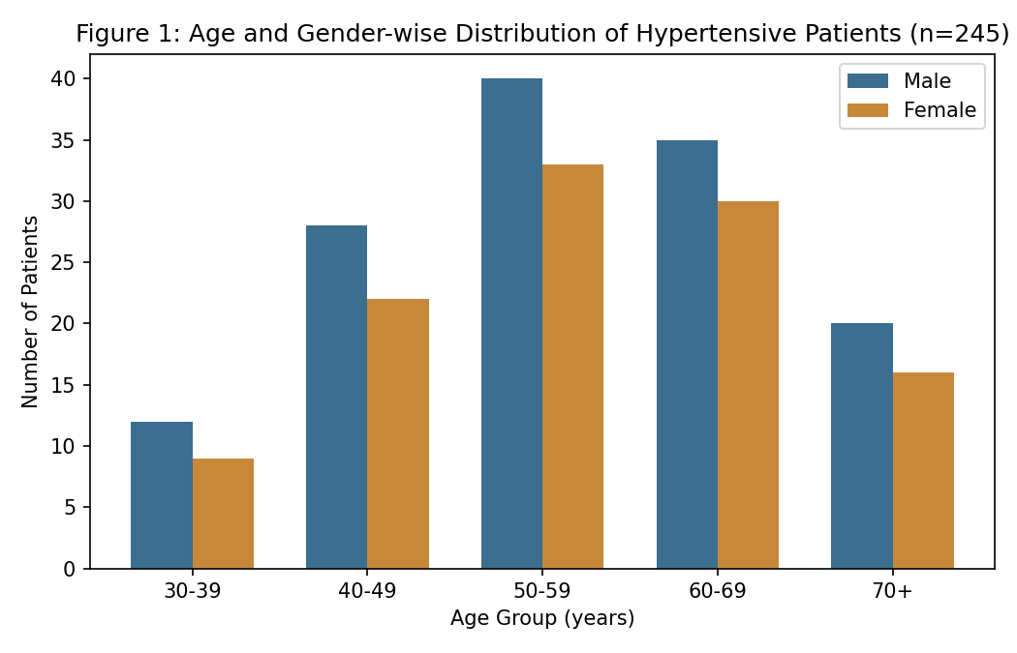
The 50–59 year age group showed the highest burden of hypertension (29.8%), followed by the 60–69 year group (26.5%), with a slight male preponderance across all age groups.
Table 2: Distribution of Risk Factors Among Study Subjects
Risk Factor | Number (n) | Percentage (%)
Family history of hypertension | 62 | 25.3
Obesity (BMI ≥ 25 kg/m²) | 71 | 29.0
High dietary salt intake | 88 | 35.9
Sedentary lifestyle | 79 | 32.2
Current smoking | 34 | 13.9
Alcohol consumption | 41 | 16.7
Coexisting diabetes mellitus | 47 | 19.2

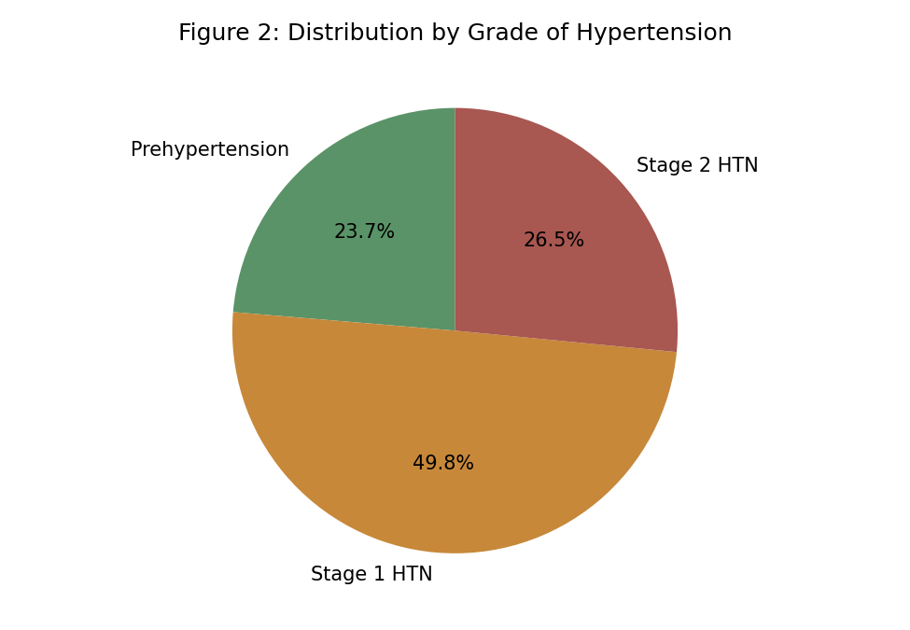
On grading, Stage 1 hypertension was seen in 49.8% of patients, Stage 2 hypertension in 26.5%, and prehypertension in the remaining 23.7%. High dietary salt intake (35.9%) was the most common modifiable risk factor, followed by sedentary lifestyle (32.2%) and obesity (29.0%).
Table 3: Duration of Hypertension vs Target Organ Damage
Duration of Hypertension | LVH (n) | Retinopathy (n) | CKD (n) | Total (n)
Less than 5 years | 10 | 5 | 4 | 74
5–10 years | 26 | 14 | 12 | 82
More than 10 years | 38 | 24 | 22 | 89

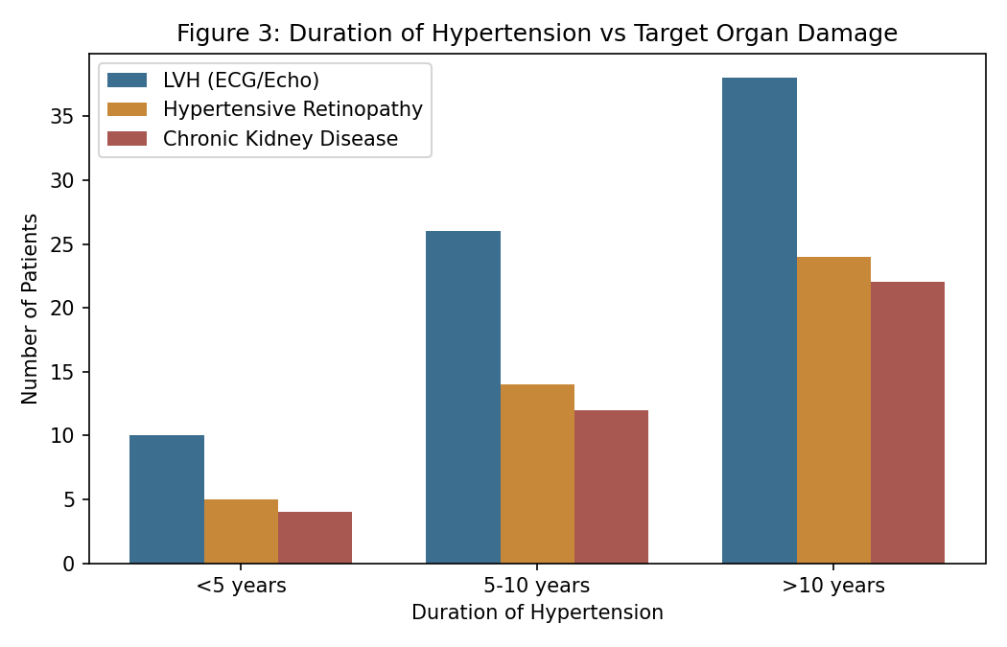
A clear trend was observed between duration of hypertension and the prevalence of target organ damage. Among patients with disease duration exceeding 10 years, left ventricular hypertrophy was present in 42.7%, hypertensive retinopathy in 27.0%, and chronic kidney disease in 24.7% of cases, compared to substantially lower rates among those with disease duration under 5 years. This finding reinforces the well-established relationship between duration of uncontrolled hypertension and progressive end-organ injury.

Table 4: Blood Pressure Control Status Among Treated Patients
Blood Pressure Control Status | Number (n) | Percentage (%)
Well controlled (BP < 140/90 mmHg) | 71 | 29.0
Partially controlled | 96 | 39.2
Poorly controlled (BP ≥ 160/100 mmHg) | 78 | 31.8

Among patients already on antihypertensive therapy, only 29.0% achieved well-controlled blood pressure, while nearly a third (31.8%) remained poorly controlled despite treatment. This finding points to substantial gaps in the effectiveness of ongoing hypertension management within the study population.

Discussion
The findings of this study, showing peak prevalence of hypertension in the 50–59 year age bracket, are consistent with earlier epidemiological surveys demonstrating a progressive age-related rise in blood pressure attributable to arterial stiffening and cumulative exposure to cardiovascular risk factors. This age-related pattern has been observed consistently across both Indian and international hypertension surveys, supporting the rationale for age-targeted screening programmes.
The predominance of high dietary salt intake as a risk factor aligns with a substantial body of literature linking sodium consumption to blood pressure elevation, including controlled dietary intervention trials demonstrating a clear dose-response relationship between sodium reduction and blood pressure lowering. This supports dietary sodium restriction as a key, low-cost public-health intervention, particularly relevant in Indian dietary contexts where processed and preserved foods, along with liberal use of added salt, are common. Similarly, the high prevalence of sedentary lifestyle and obesity mirrors findings from other Indian community-based and hospital-based studies, reflecting the broader lifestyle transition associated with urbanisation and reduced occupational physical activity.
The considerable overlap between hypertension and diabetes mellitus observed in this study (19.2%) reinforces the concept of shared cardiometabolic risk pathways, wherein insulin resistance and endothelial dysfunction contribute to the co-occurrence of both conditions. This highlights the importance of screening hypertensive patients for glycaemic abnormalities and vice versa, as recommended in contemporary cardiovascular risk assessment guidelines.
The observed relationship between disease duration and target organ damage in this study is consistent with the pathophysiological understanding that sustained elevated arterial pressure leads to progressive vascular and end-organ injury through mechanisms including arterial remodelling, increased left ventricular afterload, and microvascular damage in the retina and kidney. This underscores the clinical importance of early diagnosis and sustained control, rather than treatment initiated only after the appearance of symptoms or complications.
The finding that fewer than one-third of treated patients achieved well-controlled blood pressure is of particular concern and is consistent with reports from Indian and international studies documenting persistently low hypertension control rates even among treated populations. Potential contributing factors include poor treatment adherence, clinical inertia in therapy intensification, inadequate patient education regarding the asymptomatic but progressive nature of the disease, and barriers to regular follow-up and monitoring.
These findings collectively suggest that while hypertension is readily diagnosed in clinical settings, achieving sustained blood pressure control remains a considerable challenge. Addressing this gap will likely require a combination of improved patient education, simplified treatment regimens, and structured long-term follow-up systems.

Summary
This cross-sectional study of 245 adults with hypertension attending a tertiary care general medicine department found that the disease burden was highest in the 50–59 year age group, with high dietary salt intake, sedentary lifestyle, and obesity being the leading modifiable risk factors. Stage 1 hypertension was the most common severity grade. A strong association was observed between longer disease duration and the presence of target organ damage, particularly left ventricular hypertrophy. Blood pressure control among treated patients was suboptimal, with fewer than one-third achieving well-controlled status.

Limitations
This study has several limitations that merit consideration. First, its single-centre, hospital-based, cross-sectional design limits generalisability to the wider community and precludes causal inference regarding risk factor associations. Second, the relatively modest sample size, while adequate for the primary objectives, may not have been sufficient to detect associations for less common forms of target organ damage or subgroup analyses. Third, some data—particularly regarding dietary salt intake and physical activity—relied on patient self-report, which is subject to recall and social desirability bias. Finally, the cross-sectional design did not allow assessment of temporal trends in blood pressure control or complication development over time.

Conclusion
Hypertension in this hospital-based population predominantly affects middle-aged and elderly adults and is strongly associated with modifiable risk factors such as high dietary salt intake, sedentary lifestyle, and obesity. A clear relationship was observed between disease duration and the development of target organ damage, while blood pressure control remained suboptimal in a large proportion of treated patients. These findings underscore the importance of integrating lifestyle-modification counselling with sustained pharmacological management and structured follow-up in routine clinical practice.

References
1. Chobanian AV, Bakris GL, Black HR, et al. Seventh report of the Joint National Committee on Prevention, Detection, Evaluation, and Treatment of High Blood Pressure (JNC 7). Hypertension. 2003;42(6):1206-52.
2. World Health Organization. A Global Brief on Hypertension: Silent Killer, Global Public Health Crisis. Geneva: WHO; 2013.
3. Kearney PM, Whelton M, Reynolds K, Muntner P, Whelton PK, He J. Global burden of hypertension: analysis of worldwide data. Lancet. 2005;365(9455):217-23.
4. Lawes CM, Vander Hoorn S, Rodgers A; International Society of Hypertension. Global burden of blood-pressure-related disease, 2001. Lancet. 2008;371(9623):1513-8.
5. Gupta R. Trends in hypertension epidemiology in India. J Hum Hypertens. 2004;18(2):73-8.
6. Anchala R, Kannuri NK, Pant H, et al. Hypertension in India: a systematic review and meta-analysis of prevalence, awareness, and control of hypertension. J Hypertens. 2014;32(6):1170-7.
7. Gupta R, Gupta VP. Hypertension epidemiology in India: lessons from Jaipur Heart Watch studies. Curr Sci. 2009;97(3):349-55.
8. Mohan V, Deepa M, Farooq S, Datta M, Deepa R. Prevalence, awareness and control of hypertension in Chennai—the Chennai Urban Rural Epidemiology Study (CURES-52). J Assoc Physicians India. 2007;55:326-32.
9. Whelton PK, He J, Appel LJ, et al. Primary prevention of hypertension: clinical and public health advisory from the National High Blood Pressure Education Program. JAMA. 2002;288(15):1882-8.
10. He FJ, MacGregor GA. Salt intake, plasma sodium, and blood pressure regulation. Am J Hypertens. 2009;22(3):251-3.
11. Sacks FM, Svetkey LP, Vollmer WM, et al; DASH-Sodium Collaborative Research Group. Effects on blood pressure of reduced dietary sodium and the Dietary Approaches to Stop Hypertension (DASH) diet. N Engl J Med. 2001;344(1):3-10.
12. Reddy KS, Yusuf S. Emerging epidemic of cardiovascular disease in developing countries. Circulation. 1998;97(6):596-601.
13. Fields LE, Burt VL, Cutler JA, Hughes J, Roccella EJ, Sorlie P. The burden of adult hypertension in the United States 1999 to 2000: a rising tide. Hypertension. 2004;44(4):398-404.
14. Yusuf S, Hawken S, Ounpuu S, et al; INTERHEART Study Investigators. Effect of potentially modifiable risk factors associated with myocardial infarction in 52 countries (the INTERHEART study). Lancet. 2004;364(9438):937-52.
15. Mancia G, Fagard R, Narkiewicz K, et al. 2013 ESH/ESC guidelines for the management of arterial hypertension. J Hypertens. 2013;31(7):1281-357.
16. Kokiwar PR, Gupta SS, Durge PM. Prevalence of hypertension in a rural community of central India. J Assoc Physicians India. 2012;60:26-9.
17. Das SK, Sanyal K, Basu A. Study of urban community survey in India: growing trend of high prevalence of hypertension in a developing country. Int J Med Sci. 2005;2(2):70-8.
18. Sarma PS, Bhattacharyya S, Mathur M. Hypertension prevalence in India: a systematic review. Indian Heart J. 2013;65(3):286-93.
19. Bansal SK, Saxena V, Kandpal SD, Gray WK, Walker RW, Goel D. The prevalence of hypertension and hypertension risk factors in a rural Indian community. Int J Med Sci Public Health. 2012;1(2):50-8.
20. Deshmukh PR, Gupta SS, Dongre AR, et al. Relationship of anthropometric indicators with blood pressure levels in rural Wardha. Indian J Med Res. 2006;123(5):657-64.

