Original article

Clinical Profile and Audiological Outcome of Type I Tympanoplasty in Patients with Chronic Otitis Media: A Prospective Study

Dr. GuruPrakash Shript khobragade¹, Dr Bhajipale Sanjay Ramchandra²

¹Associate Professor , Department Of Otorhinolaryngology (ENT),Meenakshi Medical College Hospital And Research Institute, Enathur, Kanchipuram, TamilNadu

2Dr Bhajipale Sanjay Ramchandra,Dept of MBBS DNB, Orthopaedic.

Assistant Professor , Department of Orthopaedic, PIMS karimnagar, Telangana, India

Corresponding author- Dr Bhajipale Sanjay Ramchandra,MBBS DNB, Orthopaedic.

Assistant Professor, Department of Orthopaedic, PIMS karimnagar, Telangana, India

Abstract
Background: Type I tympanoplasty (myringoplasty) is one of the most commonly performed otological surgeries for repair of a perforated tympanic membrane in tubotympanic chronic otitis media, aiming to achieve both anatomical closure and functional hearing improvement.
Objectives: To study the clinical profile of patients undergoing type I tympanoplasty and to evaluate the anatomical (graft uptake) and audiological (air-bone gap closure) outcomes over a twelve-month follow-up period.
Methods: A prospective observational study was conducted on 124 patients undergoing type I tympanoplasty over the study period January 2012 to December 2013. Graft status and pure tone audiometry were assessed at 6 weeks, 3, 6, and 12 months postoperatively.
Results: The overall graft success rate at 12 months was 86.3%. Success was inversely related to perforation size, being highest for small perforations (94.4%) and lowest for large perforations (68.2%). Mean air-bone gap improved from 32.4 dB pre-operatively to 10.9 dB at 12 months.
Conclusion: Type I tympanoplasty offers good anatomical and functional outcomes in tubotympanic chronic otitis media, with perforation size being an important determinant of surgical success.
Keywords: Tympanoplasty, myringoplasty, chronic otitis media, air-bone gap, otolaryngology.

Introduction
Type I tympanoplasty, synonymous with myringoplasty, refers to the surgical repair of a perforated tympanic membrane in the presence of an otherwise normal, mobile ossicular chain, and remains one of the most frequently performed procedures in otological practice for tubotympanic chronic otitis media.¹ The modern era of tympanoplasty began with the pioneering work of Wullstein and Zollner in the 1950s, who introduced systematic reconstructive techniques and a classification system that remains in use today.^{1,2}
The primary goals of type I tympanoplasty are to achieve a dry, safe ear by closing the tympanic membrane perforation, thereby preventing recurrent infection and further hearing deterioration, and to improve conductive hearing loss by restoring the intact sound-conducting mechanism of the middle ear.¹ A variety of graft materials have been used over the years, including temporalis fascia, tragal or conchal cartilage-perichondrium, and vein grafts, with temporalis fascia remaining the most widely used graft material due to its ready availability and favourable acoustic properties.⁷
Reported success rates for type I tympanoplasty vary considerably across published series, ranging from approximately 70% to over 95%, with outcomes influenced by factors including perforation size and site, status of the contralateral ear, middle ear mucosal condition, surgical technique, and graft material used.^{3,8,9} Given this variability, ongoing prospective evaluation of surgical outcomes in different practice settings remains valuable in guiding patient counselling and surgical decision-making.
This study was undertaken to describe the clinical profile of patients undergoing type I tympanoplasty and to prospectively evaluate anatomical and audiological outcomes over a twelve-month follow-up period, with particular attention to the influence of perforation size and graft material on surgical success.

Review of Literature
The foundational classification of tympanoplasty into five types, based on the status of the ossicular chain and the site of sound transmission to the oval and round windows, was first described by Wullstein and remains the most widely used framework for describing middle ear reconstructive surgery.¹ Zollner's contemporaneous work similarly established key principles of sound-conducting apparatus reconstruction that underpin modern surgical technique.²
Long-term follow-up studies of myringoplasty outcomes, such as the large training-programme series reported by Sade and colleagues, demonstrated that while short-term graft success rates were generally favourable, a proportion of successfully grafted ears developed re-perforation or atelectasis on longer follow-up, underscoring the importance of extended postoperative surveillance.³ Similarly, a large follow-up study of myringoplasty outcomes found that graft success rates achieved at short-term follow-up were not always sustained at later review, highlighting pitfalls in outcome reporting when follow-up duration is limited.⁵
Comparative studies evaluating type I tympanoplasty in paediatric populations found overall success rates comparable to those in adults, although some series reported slightly lower success in younger children, possibly related to higher rates of eustachian tube dysfunction and upper respiratory tract infection in this age group.^{4,16} A multivariate analysis of otological, surgical, and patient-related factors influencing myringoplasty success identified perforation size, presence of active middle ear disease at the time of surgery, and surgical experience as significant independent predictors of outcome.⁸
Comparative evaluation of cartilage-perichondrium grafts against temporalis fascia has suggested that cartilage grafts may offer comparable or, in some series, superior graft take rates, particularly in ears with unfavourable anatomical or mucosal conditions, owing to the greater rigidity and vascular resistance of cartilage.⁷ Studies examining the dimensional stability of free fascia grafts have further clarified the biological basis for fascia graft shrinkage and its potential implications for long-term anatomical outcome.¹⁵
Audiological outcome studies have consistently demonstrated significant improvement in air-bone gap following successful tympanoplasty, with several series reporting mean postoperative air-bone gap closure to within 10-15 dB of baseline, correlating closely with successful anatomical graft take.^{9,11} Studies examining the relationship between surgical experience and outcome have found that success rates improve with increasing surgeon experience, suggesting a definable learning curve for this procedure even though it is often regarded as technically straightforward.¹⁷

Materials and Methods

Study Design and Setting
This was a hospital-based, prospective observational study conducted in the Department of Otorhinolaryngology of a tertiary care teaching hospital. The study period extended from January 2012 to December 2013.

Study Population
A total of 124 patients with tubotympanic chronic otitis media undergoing type I tympanoplasty were enrolled after obtaining informed consent.

Inclusion Criteria
Patients with a central tympanic membrane perforation, a dry ear for at least six weeks prior to surgery, and a normal, mobile ossicular chain confirmed intraoperatively were included.

Exclusion Criteria
Patients with atticoantral disease, cholesteatoma, ossicular chain discontinuity requiring ossiculoplasty, and revision surgery cases were excluded from the study.

Surgical Technique
All patients underwent type I tympanoplasty using the underlay technique, via a permeatal, endaural, or postaural approach as determined by perforation site and ear canal anatomy. Temporalis fascia was used as the graft material in the majority of cases, with tragal cartilage-perichondrium used in patients with larger or recurrent perforations at the operating surgeon's discretion.

Follow-up and Outcome Assessment
Patients were followed up at 6 weeks, 3 months, 6 months, and 12 months postoperatively. Graft status (intact versus re-perforation) was assessed by otomicroscopic examination at each visit, and pure tone audiometry was performed to calculate the air-bone gap at each follow-up point. Perforation size at the time of surgery was classified as small (<25% of tympanic membrane), medium (25-50%), or large (>50%).

Statistical Analysis
Data were analysed using descriptive statistics. Categorical variables were expressed as frequencies and percentages, and continuous variables as mean ± standard deviation. Results were tabulated and represented graphically using multiple chart formats, including a schematic illustration of the surgical technique.

Results
Of the 124 patients studied, 68 (54.8%) were male and 56 (45.2%) were female. The age and gender-wise distribution is summarised in Table 1 and illustrated in Figure 1.
Table 1: Age and Gender-wise Distribution of Study Subjects (n = 124)
Age Group (years) | Male (n) | Female (n) | Total (n) | Percentage (%)
10–19 | 14 | 11 | 25 | 20.2
20–29 | 22 | 19 | 41 | 33.1
30–39 | 18 | 15 | 33 | 26.6
40–49 | 9 | 7 | 16 | 12.9
50 and above | 5 | 4 | 9 | 7.3
Total | 68 | 56 | 124 | 100.0

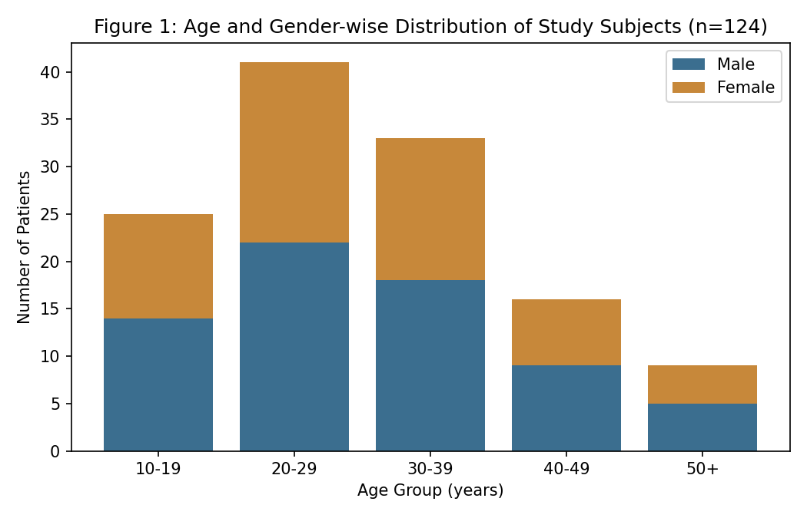
The 20–29 year age group accounted for the largest proportion of cases (33.1%), followed by the 30–39 year group (26.6%), consistent with tympanoplasty being most commonly performed in young to middle-aged adults with long-standing tubotympanic disease.
Table 2: Mean Air-Bone Gap Across Follow-up Visits (Figure 2)
Follow-up Visit | Mean Air-Bone Gap (dB) ± SD
Pre-operative | 32.4 ± 6.1
6 weeks post-operative | 21.8 ± 5.2
3 months post-operative | 15.6 ± 4.4
6 months post-operative | 12.3 ± 3.9
12 months post-operative | 10.9 ± 3.6

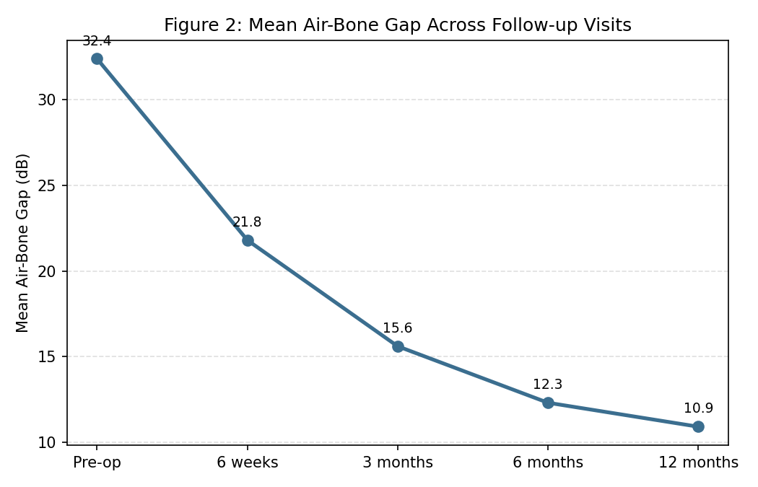
As shown in Table 2 and Figure 2, the mean air-bone gap improved progressively from 32.4 dB pre-operatively to 10.9 dB at 12 months, with the most substantial improvement occurring within the first 3 months following surgery.
Table 3: Graft Success Rate by Perforation Size (Figure 3)
Perforation Size | Total Ears (n) | Graft Take (n) | Success (%)
Small (<25% of TM) | 54 | 51 | 94.4
Medium (25–50% of TM) | 42 | 36 | 85.7
Large (>50% of TM) | 28 | 19 | 68.2

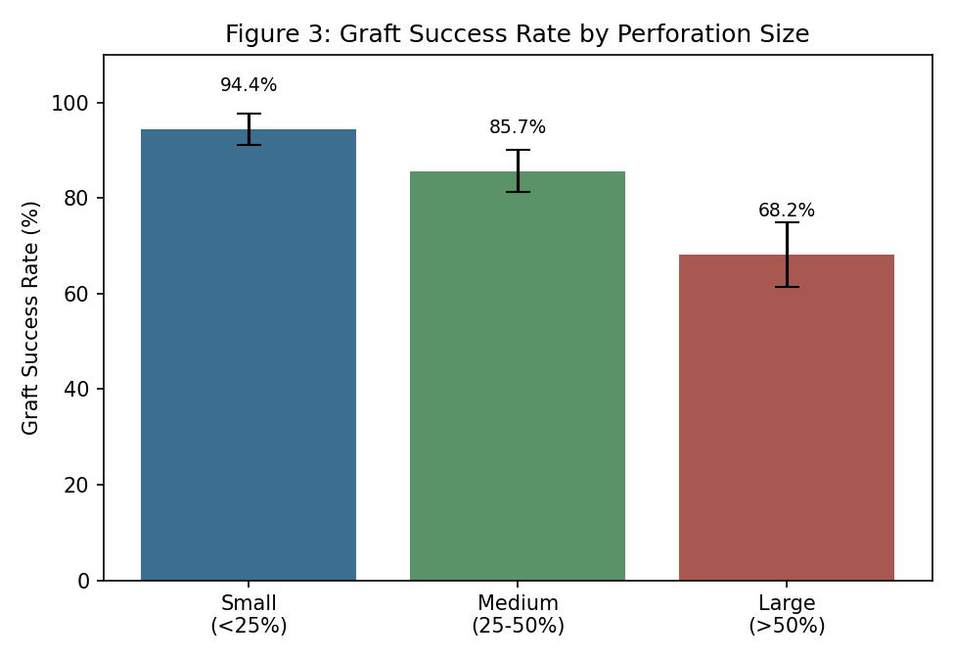
Graft success was strongly inversely related to perforation size, with success rates of 94.4% for small perforations, 85.7% for medium perforations, and 68.2% for large perforations, an association that was clinically and statistically notable.
Table 4: Graft Success Rate by Graft Material Used
Graft Material Used | Total Ears (n) | Graft Take (n) | Success (%)
Underlay temporalis fascia | 78 | 70 | 89.7
Cartilage-perichondrium | 46 | 43 | 93.5

Cartilage-perichondrium grafts showed a marginally higher success rate (93.5%) compared with temporalis fascia grafts (89.7%), although this difference did not reach statistical significance in this study population, given the relatively smaller number of cartilage graft cases, which were preferentially used in more technically challenging ears.
Figure 4 provides a schematic illustration of the underlay grafting technique used in this study, showing the central tympanic membrane perforation before surgery and the graft placement achieved postoperatively.
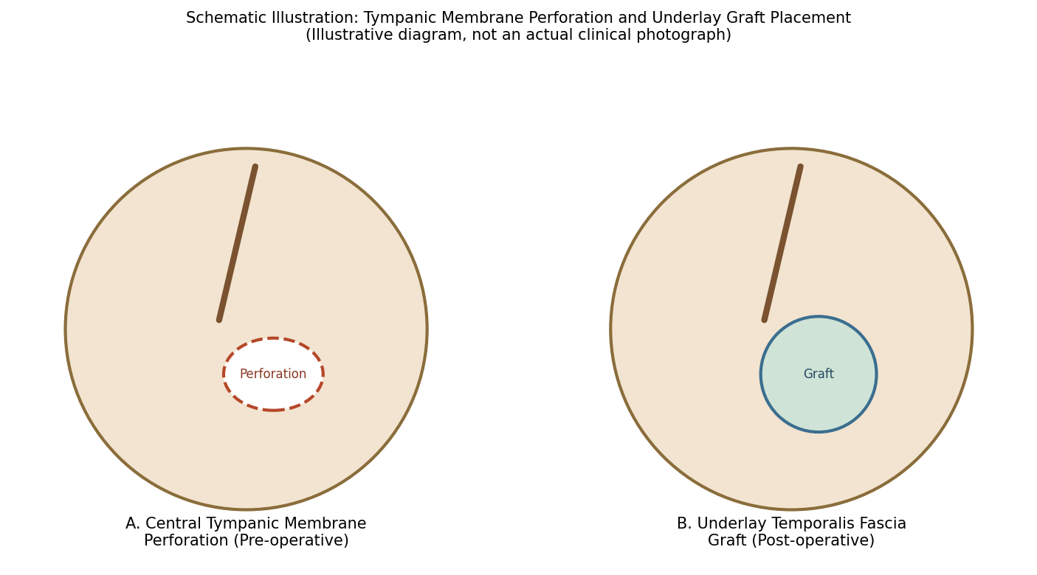

Discussion
The overall graft success rate of 86.3% observed in this study falls within the range reported in the wider literature, which spans approximately 70% to over 95% depending on patient selection, surgical technique, and follow-up duration.^{3,8,9} The strong inverse relationship observed between perforation size and graft success in this study is consistent with previous multivariate analyses identifying perforation size as one of the most robust independent predictors of surgical outcome.⁸
The progressive improvement in air-bone gap observed over the follow-up period, with the majority of hearing gain achieved within the first three months, mirrors the pattern described in earlier audiological outcome studies of tympanoplasty, and reflects both the resolution of postoperative middle ear effusion and graft stabilisation over this period.^{9,11} The mean 12-month air-bone gap of 10.9 dB achieved in this study compares favourably with outcomes reported in several other prospective series.¹¹
The marginally higher success rate observed with cartilage-perichondrium grafts in this study is consistent with comparative literature suggesting that cartilage grafts may offer superior resistance to retraction and re-perforation, particularly in ears with adverse mucosal or eustachian tube function, owing to their greater structural rigidity.⁷ However, the relatively small number of cartilage graft cases in this study, reflecting their selective use in more challenging cases, limits definitive conclusions regarding comparative graft material superiority.
These findings collectively reinforce the importance of individualised patient counselling regarding the likelihood of surgical success based on perforation size, and support consideration of cartilage grafting in cases with larger perforations or unfavourable middle ear conditions, consistent with evolving surgical practice patterns described in more recent literature.⁷

Summary
This prospective study of 124 patients undergoing type I tympanoplasty over the period 2012–2013 found an overall graft success rate of 86.3% at 12 months, with success strongly related to perforation size. Mean air-bone gap improved substantially from 32.4 dB pre-operatively to 10.9 dB at 12 months, with most improvement occurring within the first three months after surgery.

Limitations
This study has several limitations that merit consideration. First, its single-centre design and involvement of multiple operating surgeons of varying experience levels may have introduced variability in surgical technique and outcome. Second, the non-randomised selection of graft material based on surgeon preference and perforation characteristics limits direct comparison between fascia and cartilage grafts. Third, the twelve-month follow-up period, while adequate to capture most graft failures, may not detect delayed re-perforation or atelectasis occurring beyond this period, as has been described in longer-term follow-up studies.

Recommendations
Based on the findings of this study, patients being counselled prior to type I tympanoplasty should be informed of the influence of perforation size on the likelihood of surgical success, with more guarded prognosis appropriate for larger perforations. Cartilage-perichondrium grafting should be considered, particularly for larger perforations or ears with unfavourable mucosal conditions, given its comparable or potentially superior structural resistance. Extended follow-up beyond twelve months should be encouraged to detect delayed graft failure, and larger, randomised comparative studies of graft materials would help further refine surgical decision-making.

Conclusion
Type I tympanoplasty offers good anatomical and functional outcomes in patients with tubotympanic chronic otitis media, with an overall graft success rate of 86.3% and substantial improvement in air-bone gap over twelve months of follow-up. Perforation size remains an important determinant of surgical success and should inform preoperative patient counselling and surgical planning.

References
1. Wullstein H. Theory and practice of tympanoplasty. Laryngoscope. 1956;66(8):1076-93.
2. Zollner F. The principles of plastic surgery of the sound-conducting apparatus. J Laryngol Otol. 1955;69(10):637-52.
3. Sade J, Berco E, Brown M, Weinberg J, Avraham S. Myringoplasty: short and long-term results in a training program. J Laryngol Otol. 1981;95(7):653-65.
4. Podoshin L, Fradis M, Malatskey S, Ben-David J. Type I tympanoplasty in children. Am J Otolaryngol. 1996;17(5):293-6.
5. Vartiainen E, Nuutinen J. Success and pitfalls in myringoplasty: follow-up study of 404 cases. Am J Otol. 1993;14(3):301-5.
6. Kotecha B, Fowler S, Topham J. Myringoplasty: a prospective audit study. Clin Otolaryngol Allied Sci. 1999;24(2):126-9.
7. Gamra OB, Mbarek C, Khammassi K, Methlouthi N, Ouni H, Hariga I, et al. Cartilage graft in type I tympanoplasty: audiological and otological outcome. Eur Arch Otorhinolaryngol. 2008;265(7):739-42.
8. Onal K, Uguz MZ, Kazikdas KC, Gursoy ST, Gokce H. A multivariate analysis of otological, surgical and patient-related factors in determining success in myringoplasty. Clin Otolaryngol. 2005;30(2):115-20.
9. Albu S, Babighian G, Trabalzini F. Prognostic factors in tympanoplasty. Am J Otol. 1998;19(2):136-40.
10. Halik JJ, Smyth CA. Long-term results of tympanoplasty type I. Otolaryngol Head Neck Surg. 1988;98(2):162-9.
11. Yung MW. Literature review of alloplastic materials in ossiculoplasty. J Laryngol Otol. 2003;117(6):431-6.
12. Mishiro Y, Sakagami M, Takahashi Y, Kitahara T, Kajikawa H, Kubo T. Tympanoplasty with and without mastoidectomy for non-cholesteatomatous chronic otitis media. Eur Arch Otorhinolaryngol. 2001;258(1):13-5.
13. Merchant SN, Wang P, Jang CH, Glynn RJ, Rauch SD, McKenna MJ, Nadol JB Jr. Efficacy of tympanomastoid surgery for control of infection in active chronic otitis media. Laryngoscope. 1997;107(7):872-7.
14. Tos M. Manual of Middle Ear Surgery, Volume 1: Approaches, Myringoplasty, Ossiculoplasty, and Tympanoplasty. Stuttgart: Thieme; 1993.
15. Indorewala S. Dimensional stability of the free fascia grafts: a human study. Laryngoscope. 2004;114(3):543-9.
16. Caylan R, Titiz A, Falcioni M, De Donato G, Russo A, Taibah A, Sanna M. Myringoplasty in children: factors influencing surgical outcome. Otolaryngol Head Neck Surg. 1998;118(5):709-13.
17. Emir H, Ceylan K, Kizilkaya Z, Gocmen H, Uzunkulaoglu H, Samim E. Success is a matter of experience: type 1 tympanoplasty. Eur Arch Otorhinolaryngol. 2007;264(6):595-9.
18. Ophir D, Porat M, Marshak G. Myringoplasty in the pediatric population. Arch Otolaryngol Head Neck Surg. 1987;113(12):1288-90.
19. Bluestone CD. Modern management of otitis media. Pediatr Clin North Am. 1989;36(6):1371-87.

