Original article
Comparison of two phenotypic with genotypic method in metallo beta lactamase producing Pseudomonas aeruginosa in tertiary care hospital.
Dr. Hemant Kumar*, Dr. Bibhabati Mishra, Dr. Vinita Dogra, Dr.Gyaneshwar Tiwari, Dr. Usha Bhoria,
Dr. Deepak Kumar Singh
- IG ESIC Hospital, Block D, Jhilmil Colony, Jhilmil, Delhi - 110095.
- G.B. Pant Institute of Post Medical Education and Research, India.
- Gut Biology research laboratory, University of Delhi, India.
Corresponding author - Dr.Hemant Kumar

Abstract:
Metallo-beta-lactamase producing Pseudomonas aeruginosa (P. aeruginosa) is an important emerging pathogen in the intensive care units (ICUs ) ofhealth care setups. The aim of this study was to evaluate metallo beta lactamase production in P. aeruginosa by two phenotypic methods namely combined disk synergy test (CDST - CAZ) and double disk synergy test (DDST-CAZ) along with genotypic PCR method. A total 167 isolates were of P. aeruginosawere screened for metallo beta lactamase productionby disk diffusion method using carbapenems and ceftazidime disk. Out of the 100 (one hundred)P. aeruginosastrains, which were suspected for metallo beta lactamase producers were further comparison for metallo beta lactamase production by two phenotypic method.(1) combined disk synergy test (CDST CAZ) (2) double disk synergy test (DDST CAZ) and Genotypic by PCR. Out of 100 strains77%, and 68% were MBL producers by combined disk synergy test (CDST - CAZ) and double disk synergy test (DDST- CAZ).Verona Intigron-borne metallo beta lactamase (VIM) gene was only gene detected in 29% ofthe isolates, but none ofthese were positive for Sao Paulo metallo beta lactamase(SPM) and Imipenemase (IMP) gene by Genotypic PCR method.Therefore identification of the drug resistance pattern and detection of MBL production in P. aeruginosais of great importance in the prevention and control of hospital acquired infections particularly in the ICUs.In this study it was observed that among two phenotypic methods, CDST-CAZ was superior to DDST-CAZ. Though detection of MBL gene by the genotypic method-PCR is the gold standard method, it is not possible to perform this test in most of the laboratories due to lack of the testing facility and cost.Thereforefor the prevention and control of hospital acquired infections particularly in the Intensive Care Units(ICUs)in a tertiary health center detection of drug resistance pattern and MBL production in P. aeruginosais has significant role.
Keywords: P. aeruginosa,CDST-CAZ,DDST-CAZ,PCR, MBL.

Introduction
Pseudomonas aeruginosa is a common cause of hospital-associated infections, including pneumonia, septicemia, urinary tract infections, and surgical site infections¹. Drug resistance is much more common in the nosocomial isolates of P. aeruginosa. Recently, multidrug-resistant (MDR) P. aeruginosa has been found to be resistant to nearly all antibiotics, including aminoglycosides, cephalosporins, fluoroquinolones, and carbapenems. Consequently, treatment options are narrowed down to only a few antibiotics (CDC)¹.
Although carbapenems are the antibiotics of choice for several Pseudomonas infections, resistance to these drugs is also increasing worldwide. The development of carbapenem resistance in P. aeruginosa is most commonly due to the production of metallo-beta-lactamases (MBL). Overuse of this group of antibiotics has led to a rise in MBL-producing P. aeruginosa (Hammami et al.)².
In tertiary health care centers, MBL-producing P. aeruginosa is a leading cause of nosocomial infections in intensive care units (ICUs) (Mohanasundram et al.)³. These strains are responsible for 3–7% of septicemia cases and are associated with mortality rates ranging from 27% to 48% among critically ill patients⁴.
Various phenotypic methods are available for the detection of MBL production, including CDST-IMP, DDST-IMP, ceftazidime-EDTA combined disk synergy test (CDST-CAZ), ceftazidime-EDTA double disk synergy test (DDST-CAZ), Epsilometer test (E-test), and Modified Hodge Test (MHT). However, none of these methods are recommended by CLSI guidelines. Although different researchers have used one or more phenotypic methods for MBL detection, most of these methods have not been standardized.
Polymerase chain reaction (PCR) is considered the gold standard for MBL detection in P. aeruginosa. Although PCR is highly accurate and reliable, its accessibility is often limited to reference and research laboratories, and the cost per test is high (Navneeth et al.)⁴.
The present study was conducted to detect MBL production in P. aeruginosa isolated from ICUs in a tertiary care hospital setting. A comparative evaluation of two currently used phenotypic methods, namely CDST-CAZ and DDST-CAZ, was performed along with detection of MBL gene production using PCR.

Methods
A prospective study was carried out at the G.B. Pant Institute of Postgraduate Medical Education and Research (PGIMER), New Delhi, a tertiary care hospital in North India, and at the Gut Research Laboratory, University of Delhi, over a period of one year from January 2016 to December 2016.
A total of one hundred sixty-seven (167) consecutive non-duplicate isolates of Pseudomonas aeruginosa, obtained from different clinical samples of patients admitted to various intensive care units (ICUs), were included in the study. Identification of P. aeruginosa was performed according to standard laboratory procedures described by Mackie et al.⁵
Antimicrobial susceptibility testing was performed for all P. aeruginosa isolates using commercially available antibiotic disks (HiMedia, Mumbai, India) on Mueller–Hinton agar (MHA) plates by the Kirby–Bauer disk diffusion method (Bauer et al.)⁶.
The antibiotics tested in accordance with CLSI guidelines⁷ included piperacillin/tazobactam (100 µg/10 µg) (TZ), ceftazidime (30 µg) (CAZ), amikacin (30 µg) (AK), ciprofloxacin (5 µg) (CF), imipenem (10 µg) (IMP), gentamicin (10 µg) (GM), netilmicin (30 µg) (NET), meropenem (10 µg) (MEM), colistin (10 µg) (CT), levofloxacin (5 µg) (L), ticarcillin + clavulanic acid (75/10 µg) (TC), tobramycin (10 µg) (TB), and cefepime (10 µg) (CPM).
Pseudomonas aeruginosa ATCC 27853 was used as the control strain. The zone of inhibition for each antibiotic was measured and interpreted according to CLSI guidelines.

Screening for MBL Production
Resistance to imipenem (IMP), meropenem (MEM), and ceftazidime (CAZ) was considered as a screening test to identify suspected metallo-beta-lactamase (MBL) producing Pseudomonas aeruginosa. The strains showing resistance to imipenem (10 µg), meropenem (10 µg), or ceftazidime (30 µg), or resistance to any two of these antibiotics, or resistance to all three antibiotics were considered suspected MBL producers.

Confirmation of MBL Production
MBL production by P. aeruginosa was further confirmed by the Ceftazidime-EDTA Combined Disk Synergy Test (CDST-CAZ) and Ceftazidime-EDTA Double Disk Synergy Test (DDST-CAZ) methods. The ceftazidime disks were supplemented with 0.5 M EDTA. The ethylenediaminetetraacetic acid (EDTA) solution was prepared by dissolving 186.1 g of EDTA in 1 litre of distilled water. The pH of the solution was adjusted to 8.0 using NaOH, and the solution was sterilized by autoclaving. Subsequently, 10 µl of this solution was added to the ceftazidime disk as described by Yong et al.⁸

Ceftazidime-EDTA Combined Disk Synergy Test (CDST-CAZ)
Principle:
EDTA acts as a chelating agent that removes zinc ions from the active site of the MBL enzyme, thereby inactivating the enzyme and making the organism sensitive to carbapenems.
Procedure:
The test was performed according to Galani et al.⁹ The isolates were inoculated into 5 ml of sterile peptone water and incubated for approximately 30 minutes to obtain 0.5 McFarland turbidity standard. Lawn culture was prepared on Mueller–Hinton agar (MHA) plates using a sterile cotton swab. Two ceftazidime (30 µg) discs were placed on the surface of the MHA plate, and 5 µl of previously prepared 0.5 M EDTA solution was added to one of the discs and marked as “E”. The plates were incubated at 37°C for 16–18 hours in ambient air to obtain the desired concentration of 750 µg.
Interpretation:
An increase in the zone of inhibition of ≥7 mm around the ceftazidime-EDTA disc compared to ceftazidime alone was considered MBL positive. P. aeruginosa ATCC 27853 was used as a negative control with each test.

Ceftazidime-EDTA Double Disk Synergy Test (DDST-CAZ)
Principle: EDTA removes zinc ions from the active site of the MBL enzyme, resulting in enzyme inactivation and increased sensitivity of the organism to carbapenems.
Procedure: The test was performed according to Lee et al.¹⁰ The isolates were inoculated into 5 ml sterile peptone water and incubated for approximately 30 minutes to obtain a 0.5 McFarland standard. Lawn culture was prepared on MHA plates using a sterile cotton swab. A ceftazidime (30 µg) disk was placed on the MHA plate, and a blank disk containing 10 µl of previously prepared 0.5 M EDTA solution was placed at a distance of 20 mm (center to center) and marked as “E”. The plates were incubated at 37°C for 16–18 hours in ambient air.
Interpretation:
Enhancement of the zone of inhibition between the ceftazidime disk and EDTA blank disk was interpreted as MBL positive. P. aeruginosa ATCC 27853 was used as a negative control.

Detection of MBL Gene by Polymerase Chain Reaction (PCR)
MBL-producing isolates were ribotyped and screened for MBL gene production by PCR using primers specific for blaIMP, blaVIM, and blaSPM. Detection of MBL genes was performed as described by Khosravi et al.¹¹
For PCR analysis, 0.5 ml of overnight grown culture was pelleted and washed with an equal volume of sterile double-distilled water and centrifuged at 12,000 rpm for 5 minutes. Fifty microliters of the washed pellet was boiled with 50 µl distilled water at 100°C for 10 minutes. The samples were further centrifuged at 12,000 rpm for five minutes, and 10 µl of the supernatant was used as the DNA template for PCR.
The PCR reaction was performed in a 25 µl reaction mixture containing 1 mM dNTP mix (3 µl), forward and reverse primers (5 ng/µl, 2.5 µl each), 2.0 units of Taq polymerase (MBI Fermentas, USA), 2 µl DNA solution from P. aeruginosa (30 ng), and 10× Taq reaction buffer (2.5 µl). Sterile double-distilled water was added to make the final volume 25 µl.
The PCR programme consisted of initial denaturation at 95°C for 5 minutes, followed by 32 cycles of denaturation at 94°C for 30 seconds, annealing at 52°C for 1 minute, and extension at 72°C for 2 minutes. Final elongation was carried out at 72°C for 10 minutes, and the reaction was stored at 4°C until further use.
The amplified products were resolved on 0.7% agarose gel prepared in Tris-acetate-EDTA buffer by horizontal gel electrophoresis. The presence of MBL gene-specific bands was detected on ethidium bromide-stained gels using a UV transilluminator and photographed using a gel documentation system. The size of individual bands was determined by comparison with a co-migrating 100 bp DNA ladder (MBI Fermentas, USA).

RESULTS:
During the study period of one year, 167 strains of P. aeruginosa were isolated from culture of various clinical samples of patients admitted in the different ICUs of the hospital.They were screened for MBL production by observing their resistance to carbapenems by the disc diffusion technique. Out of 167strains, 67 strains which were sensitive to carbapenems and ceftazidime discs were excluded from the study. One hundred P.aeruginosawhich were suspected as MBL producers were included in the study for further evaluation.
Sixty percent of the isolates studied were resistant to IMP+MEM+CAZ followed by13% to IMP alone,12% to IMP+MEM,6% to CAZ alone, while Two strains each were resistant to MEM and IMP+CAZ respectively.
Of the 100 isolates, maximum numbers were isolated from General Intensive Care Unit(30), followed by Neurosurgery ICUs (29), Gastrointestinal surgery ICUs (20), Neurology ICUs (10), High Dependency Unit (4) Gastrointestinal medicine ICUs (3) and CTVS ICUs (3) andLiver ICUs (1).

Table 1: Primer name
Primer Name | Primersequence5'to3'('= prime)
IMPForward | 5'GAAGGCGTTTATGTTCATAC3'
IMPReverse | 5'GTATGTTTCAAGAGTGATGC3'
VIM Forward | 5'GTTTGGTCGCATATCGCAAC3'
VIM Reverse | 5'AATGCGCAGCACCAGGATAG3'
SPMForward | 5'CCTACAATTCTAACGGCGACC3'
SPMReverse | 5'TCGCCGTGTCCAGGTATAAC3'

Table 2: Denaturation results
Target  Gene | First  Denaturation | Denaturation | Annealing | Extension | Number  Ofcycle | FinalExtension | Base  pairs
BlaIMP | 95˚C-5min | 94˚C-30sec | 52˚C-1min | 70˚C-2min | 32 | 72˚C-10min | 587
BlaVIM | 95˚C-5min | 94˚C-30sec | 52˚C-1min | 70˚C-2min | 32 | 72˚C-10min | 382
BlaSPM | 95˚C-5min | 94˚C-30sec | 52˚C-1min | 70˚C-2min | 32 | 72˚C-10min | 600

The maximum number of suspected metallo-beta-lactamase (MBL) producing Pseudomonas aeruginosa isolates were obtained from pus and tracheal aspirates (27 each), followed by endotracheal aspirates (22), blood and cerebrospinal fluid (CSF) (6 each), bile (5), body fluids and stent samples (3 each), and arterial line tip (1).
Among the suspected MBL-producing P. aeruginosa isolates, 89% were sensitive to colistin (CT). This was followed by sensitivity to aminoglycosides, including amikacin (AK) (35%), tobramycin (TB) (30%), gentamicin (GM) (23%), and netilmicin (NET) (22%). Sensitivity to piperacillin/tazobactam (TZ) and ticarcillin–clavulanic acid (TC) was observed in 28% and 9% of isolates, respectively. Sensitivity to quinolones such as levofloxacin (L) and ciprofloxacin (CF) was observed in 12% and 10% of isolates, respectively, while cefepime (CPM) showed sensitivity in only 8% of the isolates.
Confirmation of MBL production was performed in all 100 suspected MBL-producing P. aeruginosa isolates using two phenotypic methods, namely Ceftazidime-EDTA Combined Disk Synergy Test (CDST-CAZ) and Ceftazidime-EDTA Double Disk Synergy Test (DDST-CAZ).
The maximum positivity by both phenotypic and genotypic methods was observed in isolates showing resistance to all three screening drugs, namely imipenem (IMP), meropenem (MEM), and ceftazidime (CAZ), compared to isolates showing resistance to a single drug or combined drug resistance. Two phenotypic methods (CDST-CAZ and DDST-CAZ) along with one genotypic method were evaluated for detection of MBL-producing P. aeruginosa, and both phenotypic methods detected the maximum number of MBL producers.
Out of the 29 VIM positive isolates, (18%) were positive by both the phenotypic methods while (8%) were negative by both methods. Only three isolates positive by CDST-CAZ method were found to be negative by DDST-CAZ method.
Of the 71 VIM negative isolates, 47 were positive by both methods while 12 were negative by both methods. nine isolates positive by CDST-CAZ method were seen to be negative by DDST-CAZ method. It was further observed that three strains which were positive by the DDST-CAZ method were negative by CDST-CAZ method.
Out of hundred suspected MBL producingP. aeruginosa, 77 isolates were found to be MBL producers and 23 non- producers by CDST-CAZ method.Among these, 77 MBL producers, 21tested positive and 56 tested negative for MBL gene by PCR.Out of the 23 no MBL producers by CDST – CAZ, 8 were positive and 15negative by PCRfor MBL gene.
For MBL detection,CDST-CAZ (72.4%), DDST-CAZ (62.1%) was the most sensitivity method, whereas highestspecificity for MBL detection was in DDST-CAZ (29.60%) and CDST-CAZ (21.10%)

Table 3. Distribution of Carbapenems Resistance pattern of suspected MBLP. aeruginosa (n=100)

IMP | MEM | CAZ | IMP+MEM | IMP+CAZ | MEM+CAZ | IMP+MEM+CAZ | Total
13 | 2 | 6 | 12 | 2 | 5 | 60 | 100

Abbreviations:IMP-imipenem,MEM -meropenem,CAZ-ceftazidime.
Table 4:DistributionofP.aeruginosainvariousclinicalsamples.

Pus | Tracheal aspirate | Endotr-  acheal aspirate | Blood | CSF | Bile | Body fluids | Stent | Arterial line tip | Total
27 | 27 | 22 | 6 | 6 | 5 | 3 | 3 | 1 | 100

Table 5:SensitivitypatternofMBLP.aeruginosatov
MBLP. aeruginosa | Number | AK | CPM | CF | NET | GM | TB | TC | TZ | L | CT
IMP+MEM+CAZ | 60 | 12 | 1 | 0 | 5 | 5 | 10 | 2 | 10 | 2 | 60
IMP | 13 | 5 | 0 | 1 | 4 | 4 | 6 | 1 | 7 | 1 | 8
IMP+MEM | 12 | 11 | 4 | 5 | 8 | 9 | 9 | 3 | 5 | 7 | 9
CAZ | 6 | 1 | 0 | 1 | 0 | 0 | 0 | 0 | 0 | 0 | 7
MEM+CAZ | 5 | 4 | 2 | 2 | 2 | 3 | 3 | 2 | 4 | 2 | 4
MEM | 2 | 0 | 0 | 0 | 1 | 0 | 0 | 0 | 0 | 0 | 0
IMP+CAZ | 2 | 2 | 1 | 1 | 2 | 2 | 2 | 1 | 2 | 0 | 1
Total | 100 | 35 | 8 | 10 | 22 | 23 | 30 | 9 | 28 | 12 | 89

Table6: Correlation of screening method Versus confirmatory method for MBL detection
Test | Total | IPM Resistant.  n=4 | MEM Resistant  n=2 | CAZ Resistant  n=12 | IPM+MEM Resistant  n=7 | IPM+CAZ Resistant  n=1 | MEM+CAZ Resistant  n=15 | IPM+MEM+ CAZ Resistant  n=59
VIM Gene | 29 | 0 | 0 | 3 | 3 | 0 | 6 | 17
CDST-CAZ | 77 | 4 | 2 | 9 | 4 | 1 | 12 | 45
DDST-CAZ | 68 | 4 | 1 | 7 | 3 | 1 | 10 | 42

Table 7: Genotypic Versus CDST-CAZ and DDST-CAZ methods for MBL detection
Genotypic testn=100 | CDST-CAZ +veDDST-CAZ +ve | CDST-CAZ +veDDST-CAZ -ve | DDST-CAZ +ve CDST-CAZ -ve | CDST-CAZ-veDDST-CAZ –ve
VIM positive (29) | 18 | 3 | Nil | 8
VIM negative (71) | 47 | 9 | 3 | 12

Table 8: Comparative analysis of CDST-CAZ vs PCR for MBL detection
S no | Phenotypic test(100) n=100 | PCR positive | PCR positive
1. | CDST- CAZ positive (77) | 21 | 56
2. | CDST-CAZ negative(23) | 8 | 15

Table 9:Sensitivity and specificity of phenotypic tests in comparison to PCR method for MBL detection
Phenotypic test |  | VIM |  | Total | Sensitivity | Specificity | PPV | NPV | Accuracy
 |  | Positive | Negative
CDST-CAZ | Positive | 21 | 56 | 77 | 72.4% | 21.1% | 27.3% | 65.2% | 36.0%
CDST-CAZ | Negative | 8 | 15 | 23
DDST-CAZ | Positive | 18 | 50 | 68 | 62.1% | 29.6% | 26.5% | 65.6% | 39.0%
DDST-CAZ | Negative | 11 | 21 | 32
Total |  | 29 | 71 | 100

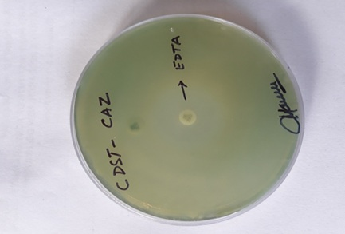
Figure 1: MBL production by (CDST-CAZ)
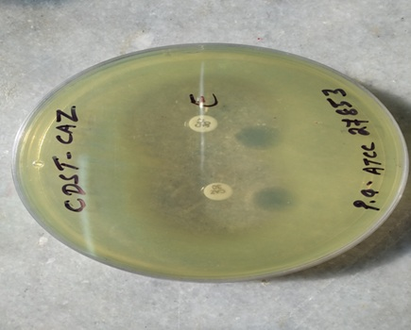
Figure 2 : MBL production by CDST-CAZ (ATCC 27853 strain)
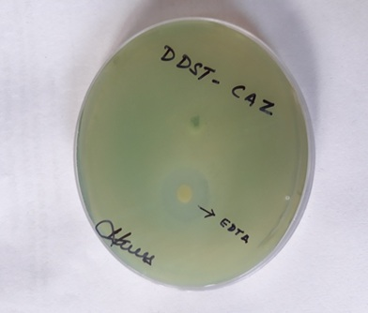
Figure3 :MBL production by (DDST-CAZ)
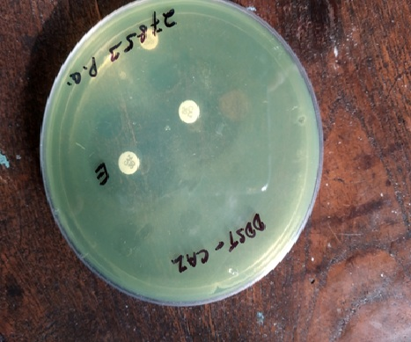
Figure 4 : MBL production by (DDST-CAZ) (ATCC strains)
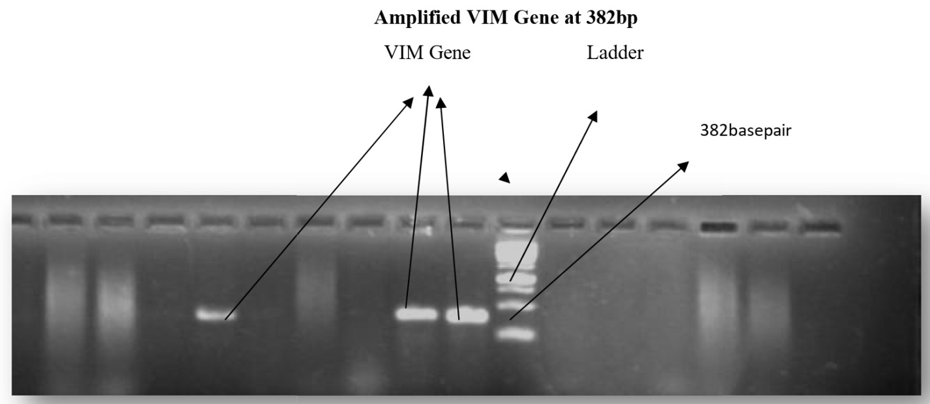
Figure 5: Amplified VIM Geneat 382 bp
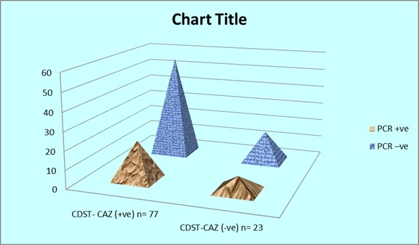
Figure 6: Comparative analysis of CDST-CAZ vs PCR for MBL detection

DISCUSSION:
Pseudomonas aeruginosa is a versatile nosocomial opportunistic pathogen that is frequently resistant to multiple antibiotics. Over the past few decades, metallo-beta-lactamase (MBL) producing P. aeruginosa isolates have emerged in hospital settings, leading to poor therapeutic outcomes and increased mortality. Therefore, early detection of MBL production in P. aeruginosa is essential for optimal treatment of critically ill patients. Early identification also helps in implementing strict infection control measures and preventing nosocomial spread. The present study was undertaken to compare two phenotypic methods, namely Ceftazidime-EDTA Combined Disk Synergy Test (CDST-CAZ) and Ceftazidime-EDTA Double Disk Synergy Test (DDST-CAZ), for detection of MBL production in P. aeruginosa and to correlate the findings with polymerase chain reaction (PCR), a genotypic method.
During the study period, 167 P. aeruginosa isolates obtained from various clinical samples were screened for MBL production based on their resistance to carbapenems and ceftazidime disks. Out of 167 isolates, 100 (59.8%) were identified as suspected MBL producers. Imipenem resistance was detected in 87% of isolates, meropenem resistance in 79%, and ceftazidime resistance in 73% of isolates. Yongwei et al.¹² reported that 51.6% of isolates were suspected MBL-producing P. aeruginosa using ceftazidime disk screening, which is lower than the findings of the present study. They also reported that 73.3% and 63.9% of their isolates were resistant to imipenem and meropenem, respectively. Fallah et al.¹³ reported 83% resistance to imipenem using imipenem disk screening, which is comparable to the present study, whereas Ahmed et al.¹⁴ reported only 25% resistance to imipenem.
In the present study, the majority of suspected MBL-producing P. aeruginosa isolates were sensitive to colistin (89%), followed by aminoglycosides ranging from 22% to 35%, including amikacin (35%), tobramycin (30%), gentamicin (23%), and netilmicin (22%). Sensitivity to piperacillin–tazobactam and ticarcillin–clavulanic acid was observed in 28% and 9% of isolates, respectively. Sensitivity to quinolones such as levofloxacin and ciprofloxacin was 12% and 10%, respectively, while cefepime sensitivity was observed in only 8% of isolates.
Mehta et al.¹⁵ reported that polymyxin-B was the most effective antibiotic, with 90% sensitivity among carbapenem-resistant isolates. They also reported sensitivity rates of 30% for amikacin, 10% for gentamicin, 10% for ciprofloxacin, 40% for piperacillin–tazobactam, and 10% for cefepime, which are comparable with the findings of the present study. Kali et al.¹⁶ reported that imipenem-resistant P. aeruginosa showed 100% sensitivity to polymyxin-B and colistin. However, all strains were resistant to gentamicin (100%), while 36.3% and 27.2% sensitivity was observed for netilmicin and amikacin, respectively. A high degree of resistance to gentamicin (100%) and ciprofloxacin (99.1%) was also reported. In a recent Indian study, John et al.¹⁷ reported resistance to imipenem, gentamicin, ciprofloxacin, netilmicin, piperacillin, and amikacin among MBL-producing P. aeruginosa isolates as 77.5%, 77%, 72.1%, 67.3%, 57.7%, and 56.1%, respectively. Tsakris et al.¹⁸ and De et al.¹⁹ reported 100% resistance to most tested antibiotics, including aminoglycosides, beta-lactams, and quinolones.
Dwivedi et al.²⁰ reported P. aeruginosa as the most common pathogen (23.3%) among ICU infections. They found resistance rates of 46.7% to piperacillin, 51.7% to ceftazidime, 47.3% to gentamicin, 32% to amikacin, 47.3% to ciprofloxacin, 28.3% to piperacillin–tazobactam, 37% to meropenem, and 37.7% to imipenem. All isolates were uniformly sensitive to colistin. Variations in resistance patterns reported by different authors reflect differences in antibiotic usage practices across various healthcare settings.
The prevalence of MBL production in India ranges from 7% to 65% among carbapenem-resistant P. aeruginosa. Jesudason et al.²¹ from Vellore reported that 75% of their P. aeruginosa isolates were MBL producers by EDTA disk synergy test. The imipenem disk diffusion screening test was found to be more effective than ceftazidime and meropenem for selecting probable MBL-producing strains.
In the present study, confirmation of MBL production was performed using CDST-CAZ and DDST-CAZ methods. Seventy-seven percent of isolates were positive by CDST-CAZ, while 68% were positive by DDST-CAZ, and 72.5% of isolates were positive by both methods. These findings are comparable to Reshi et al.²², who reported positivity rates of 97% and 92% by CDST-CAZ and DDST-CAZ, respectively. Similarly, Neerav et al.²³ reported 85.19% MBL positivity by CDST-CAZ and 44.44% by DDST-CAZ.
In Asia, blaIMP and blaVIM genes are more prevalent. The blaIMP gene is commonly reported in China, Iran, Brazil, and Malaysia¹²˒¹³˒²⁴˒²⁵. Sader et al.²⁴ reported the presence of SPM-1-like genes in 55.6%, VIM-2-like genes in 30.6%, and IMP-1-like genes in 8.3% of P. aeruginosa isolates. Khosravi et al.²⁵ detected MBL genes by PCR in 32 out of 90 imipenem-resistant isolates, including blaIMP-4, blaIMP-7, blaVIM-2, and blaVIM-11. Yongwei et al.¹² reported that 84.1% of isolates showed the presence of blaVIM genes and 76.1% showed blaIMP genes, consistent with the findings of Pitout et al.²⁶.
In the present study, 29 out of 100 isolates were positive for the blaVIM gene, which was lower than previously reported studies, while blaIMP and blaSPM genes were not detected. Amudhan et al.²⁸ detected blaVIM genes in 36 out of 61 isolates, and Kali et al.¹⁶ also reported VIM-2 gene-positive MBL-producing P. aeruginosa. Castanheira et al.²⁹ collected 301 Pseudomonas isolates from 10 hospitals in India, of which 107 were carbapenem-resistant and 97 were P. aeruginosa. The most common gene detected was blaVIM-2, followed by blaVIM-6, with other variants including VIM-5, VIM-11, and VIM-18.
In the present study, 24 out of 29 (82.7%) VIM-positive P. aeruginosa isolates were detected as MBL producers by both phenotypic methods (CDST-CAZ and DDST-CAZ). In three isolates, only the VIM gene was detected by PCR, but MBL production was not identified phenotypically. In two isolates, MBL production was detected by PCR and CDST-CAZ but not by DDST-CAZ. Yongwei et al.¹² also reported that 84.1% of their P. aeruginosa isolates were MBL producers by CAZ-EDTA and also carried VIM genes by PCR. In the present study, the sensitivity and specificity of CDST-CAZ were 77% and 68%, respectively, compared with PCR, which was considered the gold standard.
Thus, the present study demonstrates that both phenotypic methods, CDST-CAZ and DDST-CAZ, showed comparable predictive values for detection of MBL production in P. aeruginosa. However, CDST-CAZ detected MBL production in a higher proportion of isolates (77%) compared to DDST-CAZ (68%).

Conclusion

The rapid dissemination of metallo-beta-lactamase (MBL) producing Pseudomonas aeruginosa in hospital settings is an important cause of morbidity and necessitates the implementation of effective surveillance measures, along with the judicious selection and appropriate use of antibiotics, particularly carbapenems, for the treatment of infections caused by multidrug-resistant (MDR) P. aeruginosa. Although polymerase chain reaction (PCR) is considered the gold standard method for detection of MBL genes, phenotypic detection of MBL-producing P. aeruginosa by the Ceftazidime-EDTA Combined Disk Synergy Test (CDST-CAZ) remains a preferred method due to its simplicity, low cost, and ease of performance in routine laboratory settings. Furthermore, the method is reliable and minimizes the possibility of visual misinterpretation.

References:
- Centers for Disease Control and Prevention (CDC). Antibiotic resistance threats in the United States, 2013.
- Hammami S, Boubaker BB, Ghozzi R, Saidani M, Amine S, Redjeb SB. Nosocomial outbreak of imipenem-resistant Pseudomonas aeruginosa producing VIM-2 metallo-beta-lactamase in a kidney transplantation unit. Diagn Pathol. 2011;6:106.
- Mohanasundram KM. The antimicrobial resistance pattern in the clinical isolates of Pseudomonas aeruginosa in a tertiary care hospital: a 3-year study (2008–2010). J Clin Diagn Res. 2011;5(3):491–494.
- Navneeth BV, Sridaran D, Sahay D, Belwadi MR. A preliminary study on metallo-beta-lactamase producing Pseudomonas aeruginosa in hospitalized patients. Indian J Med Res. 2002;264–267.
- Collee JG, Duguid JP, Fraser AG, Marmion BP. Mackie and McCartney Practical Medical Microbiology. 13th ed. Vol. 2. Edinburgh: Churchill Livingstone; 1989. p. 491–503.
- Bauer AW, Kirby WM, Sherris JC, Turck M. Antibiotic susceptibility testing by a standardized single disk method. Am J Clin Pathol. 1966;45:493–496.
- Clinical and Laboratory Standards Institute (CLSI). Performance standards for antimicrobial susceptibility testing. 26th ed. CLSI supplement M100. Wayne, PA: CLSI; 2016. p. 62–63.
- Yong D, Lee K, Yum JH, Shin HB, Rossolini GM, Chong Y. Imipenem–EDTA disk method for differentiation of metallo-beta-lactamase-producing clinical isolates of Pseudomonas spp. and Acinetobacter spp. J Clin Microbiol. 2002;40:3798–3801.
- Galani I, Rekatsina PD, Hatzaki D, Plachouras D, Souli M, Giamarellou H. Evaluation of different laboratory tests for the detection of metallo-beta-lactamase production in Enterobacteriaceae. J Antimicrob Chemother. 2008;61:548–553.
- Lee K, Lim YS, Yong D, Yum JH, Chong Y. Evaluation of the Hodge test and the imipenem–EDTA double-disk synergy test for differentiating metallo-beta-lactamase-producing isolates of Pseudomonas spp. and Acinetobacter spp. J Clin Microbiol. 2003;41:4623–4629.
- Khosravi AD, Mihani F. Detection of metallo-beta-lactamase-producing Pseudomonas aeruginosa strains isolated from burn patients in Ahvaz, Iran. Diagn Pathol. 2008;1:125–128.
- Li Y, Zhang X, Wang C, Hu Y, Niu X, Pei D, et al. Characterization by phenotypic and genotypic methods of metallo-beta-lactamase-producing Pseudomonas aeruginosa isolated from patients with cystic fibrosis. Mol Med Rep. 2015;11:494–498.
- Fallah F, Borhan RS, Hashemi A. Detection of blaIMP and blaVIM metallo-beta-lactamase genes among Pseudomonas aeruginosa strains. Int J Burn Trauma. 2013;3(2):122–124.
- Ahmed W, El-Shafei E, El-Mosallamy M, Osman AS, et al. Phenotypic and genotypic methods for detection of metallo-beta-lactamase producing Pseudomonas aeruginosa. Egypt J Med Microbiol. 2015;24(3):27–35.
- Mehta A, Tukaram P. Detection and characterization of metallo-beta-lactamase producing Pseudomonas aeruginosa clinical isolates at a tertiary care hospital of Bhopal, India. Int J Res Med Sci. 2016;4:4084–4088.
- Kali A, Srirangaraj S, Kumar S, Divya HA, Kalyani A, Devi US. Detection of metallo-beta-lactamase producing Pseudomonas aeruginosa in intensive care units. Australas Med J. 2013;6(12):686–693.
- John S, Balagurunathan R. Metallo-beta-lactamase producing Pseudomonas aeruginosa and Acinetobacter baumannii. Indian J Med Microbiol. 2011;29:302–304.
- Tsakris A, Poulou A, Kristo I, Pittaras T, Spanakis N, Pournaras S, et al. Large dissemination of VIM-2 metallo-beta-lactamase-producing Pseudomonas aeruginosa strains causing healthcare-associated community-onset infections. J Clin Microbiol. 2009;47:3524–3529.
- De AS, Kumar SH, Baveja SM. Prevalence of metallo-beta-lactamase producing Pseudomonas aeruginosa and Acinetobacter species in intensive care areas in a tertiary care hospital. Indian J Crit Care Med. 2010;14:217–219.
- Dwivedi M, Mishra A, Singh RK, Azim A, Baronia AK, Prasad KN. Nosocomial cross-transmission of Pseudomonas aeruginosa between patients in a tertiary care unit. J Hosp Infect. 2009;52(4):509–513.
- Jesudason MV, Dathil AJK, Balaji V. Comparison of two methods to detect carbapenemase and metallo-beta-lactamase production in clinical isolates. Indian J Med Res. 2005;121:780–783.
- Reshi S, Bali N, Manzoor M, Farooq S, Kakru DK. Comparison of various phenotypic methods for the detection of metallo-beta-lactamases in Pseudomonas aeruginosa. J Adv Med Med Res. 2017;23(3):1–8.
- Pandya NP, Prajapati SB, Mehta SJ, Kikani KM, Jani PJ. Evaluation of various methods for detection of metallo-beta-lactamase production in gram-negative bacilli. Int J Biol Med Res. 2011;2(3):775–777.
- Sader HS, Reis AO, Silbert S, Gales AC. IMPs, VIMs and SPMs: the diversity of metallo-beta-lactamases produced by carbapenem-resistant Pseudomonas aeruginosa in a Brazilian hospital. Clin Microbiol Infect. 2005;11:73–76.
- Khosravi Y, Loke MF, Chua EG, Tay ST, Vadivelu J. Phenotypic detection of metallo-beta-lactamase in imipenem-resistant Pseudomonas aeruginosa. ScientificWorldJournal. 2012;2012:654939.
- Pitout JD, Gregson DB, Poirel L, McClure JA, Le P, Church DL. Detection of Pseudomonas aeruginosa producing metallo-beta-lactamases in a large centralized laboratory. J Clin Microbiol. 2005;43:3129–3135.
- Manoharan A, Chatterjee S, Mathai D. Detection and characterization of metallo-beta-lactamase producing Pseudomonas aeruginosa. Indian J Med Microbiol. 2010;28:241–244.
- Amudhan MS, Sekar U, Kamalanathan A, Balaraman S. blaIMP and blaVIM mediated carbapenem resistance in Pseudomonas and Acinetobacter species in India. J Infect Dev Ctries. 2012;6(11):757–762.
- Castanheira M, Bell JM, Turnidge JD, Mathai D, Jones RN. Carbapenem resistance among Pseudomonas aeruginosa strains from India: evidence for nationwide endemicity of multiple metallo-beta-lactamase clones (VIM-2, VIM-5, VIM-6, VIM-11 and VIM-18). Antimicrob Agents Chemother. 2009;53(3):1225–1227.

