Case Report:
An exceptionally rare case of duodenoduodenal intussusception
* Dr Bhagyashree Sajjan, ** Dr Jeevika M U, ***Dr Kiran Kumar

* Junior Resident, Department of Radiodiagnosis, JJM Medical College, Davangere, Karnataka
** Professor and HOD, Department of Radiodiagnosis, JJM Medical College, Davangere, Karnataka
*** Senior Resident, Department of Radiodiagnosis, JJM Medical College, Davangere, Karnataka
Corresponding author*

Abstract:
Small bowel intussusception is a rare occurrence, with occurrences of duodenoduodenal intussusception being even rarer due to the duodenum's fixed position. The presence of benign tumours as a lead point generally causes duodenal intussusception. Adult intussusception is uncommon and has a different clinical presentation, cause, and different therapy than paediatric intussusception. In the literature, only a few occurrences of duodenoduodenal intussusception in adults have been reported. We herein report an exceptionally rare case of duodenoduodenal intussusception encountered in our institute in a 39 year old male patient. The duodenoduodenal intussusception was reduced, duodenal polypoidal mass was identified as lead point and then resected. The mass was diagnosed as a hyperplastic polyp after a pathological examination.
Keywords: Duodenoduodenal, intussusception, benign

Introduction
A condition known as intussusception occurs when the entire thickness of the gut wall is telescoped into the distal colon. Adults seldom develop this disorder, which accounts for fewer than 0.1 percent of all adult hospital admissions. Due to the duodenum's fixed, retroperitoneal position throughout embryological intestinal rotation and the rarity of duodenal malignancies leading to intussusception, duodenal intussusception is a very rare occurrence. As a result, intussusception of this organ within itself is very uncommon. Sunderlin initially characterised duodenal intussusception in 1830, and only 48 cases have been published since then. The majority of the 48 recorded cases of duodenal intussusceptions are gastroduodenal or distal duodenoduodenal (DDJ) intussusceptions.

Case report
A 39-year-old male patient presented with abdominal pain and vomiting since last 2-3 months aggravated since last 3 days. Pain was mild to moderate in intensity, intermittent, and colicky. Vomiting occurred within few minutes of food intake, non bilious and non-projectile. There was associated significant weight loss in last few months.
Rest of the history, physical examination, and organ system evaluation was normal. His routine blood investigations were unremarkable. Upper GI endoscopy was done which revealed a dilated first part of duodenum however no obvious mass/tumour was identified.
Present ultrasonography and contrast CT abdomen and pelvis was done in the Department of Radiodiagnosis, JJM Medical College Davangere, Karnataka, India.
Imaging analysis
Ultrasound abdomen revealed telescoping of proximal duodenum with CBD, MPD and head of pancreas into distal jejunum giving a donut appearance.
Patient underwent CECT abdomen which confirmed duodenoduodenal intussusception in the form of telescoping of D2 segment, MPD, CBD and head, uncinate process of pancreas into D3 and D4 segment of duodenum giving bowel within bowel/donut appearance. There was upstream dilatation of D1 segment and stomach. MPD and CBD were dilated and were pulled into the intussusception which was later confirmed on MRCP study. No intrahepatic biliary radical dilatation was noted. However, no obvious lead point could be identified.
Results:
Duodenoduodenal intussusception with D2 segment of duodenum, MPD, CBD and uncinate process of pancreas as intussuceptum and D3,D4 segment of duodenum as intussuscipiens.
Our patient underwent an exploratory laparotomy after thorough explanation and consent, on which the D2 segment, MPD, CBD and head, uncinate process of pancreas were found to be going into D3 and D4 segment of duodenum causing duodenoduodenal intussusception which was reduced and mass was palpated within the distal duodenum. Excision was done and a polypoidal mass found to be arising from the 3 ^{rd} part of duodenum wall .The segment was resected and duodenoduodenal anastomosis was done. The mass was 1.3 cm in size. Histology was suggestive of hyperplastic duodenal polyp with no other evidence of high-grade dysplasia or malignancy.
Discussion:
The invagination of one intestinal segment into another is known as an intussusception. In children, it is prevalent, but in adults, it is uncommon. In general, ileoecolic intussusception is the most common, and enteroenteric intestinal intussusception is uncommon, but because the duodenum is fixed in the retroperitoneal position¹, duodenoduodenal intussusception is extremely rare. Intussusception can be difficult to diagnose and is more likely to be discovered when symptoms are present². Adult intussusception is uncommon and differs from paediatric intussusception in terms of symptoms, causes, and treatment. The majority of cases are discovered during an emergency laparotomy. The condition can be diagnosed more reliably if computed tomography is used more frequently in the examination of individuals with abdominal pain. In most cases, treatment consists of a simple bowel resection. ³. When compared to children, intussusception is uncommon in adults, and 90 percent of occurrences may be traced back to a specific cause⁴. A benign lead point, such as a lipoma, hamatomatous polyp, or Brunner's gland hamartoma, is almost invariably linked with Duodenoduodenal intussusception. The length of the intussusception is the most important feature in distinguishing the majority of self-limiting small-bowel intussusceptions from the minority of intussusception that require surgical reduction and excision. A self-limiting intussusception is one that is less than 3.5 cm long ⁹.Small intestinal intussusceptions with no obvious lead point, wall thickness within normal limits, and length of < 3.5cm,normal proximal bowel, normal vascularity will reduce spontaneously¹⁰
Duodenal intussusception is treated surgically, with the extent of procedure varying depending on the severity of the duodenal pathology and the characteristics of the tumour that caused the intussusception. It can range from excision of causative lead point to resection of the entire or part of the duodenum with anastomosis to reduce intussusception. The treatment in our case required local excision of duodenal polyp and duodenoduodenal anastomosis.
Conclusion:
Diagnosing intussusception is important as there are high risk of complications in intussusception such as bowel ischemia, bowel obstruction, and intraluminal bleeding requiring rapid treatment. Diagnosis is usually missed or delayed because of nonspecific and often chronic or recurrent symptoms. Hence, clinicians and surgeons should be suspicious of intussusception if they encounter a clinical picture suggesting intestinal obstruction, gastric outlet obstruction, duodenal stricture, pancreatitis, or obstructive jaundice.
The imaging findings may help clinch the diagnosis for better management of these patients.
Images
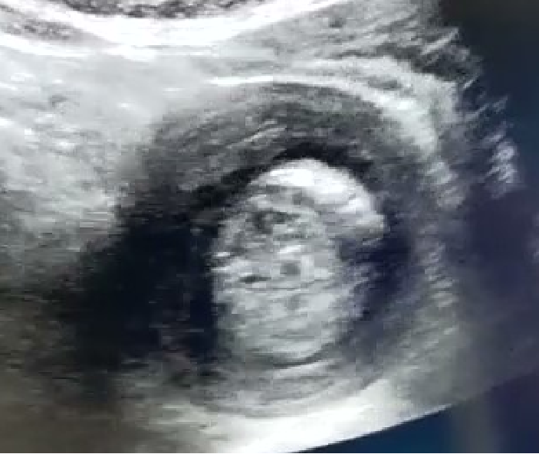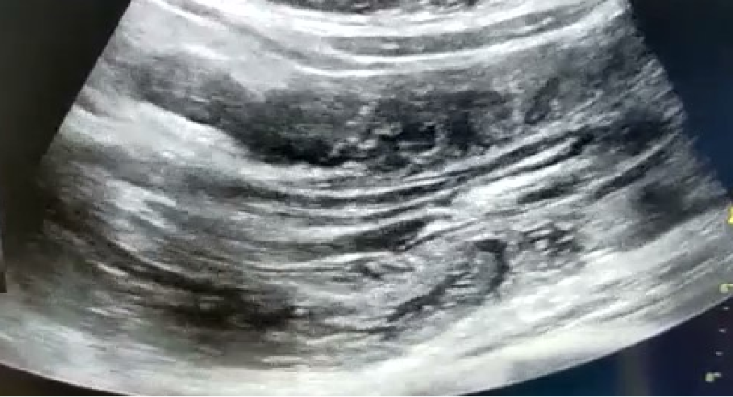
FIGURE 1 : Ultrasonography images (A and B) depicts telescoping of proximal duodenum, MPD and CBD (arrow) into distal duodenum (arrow head) forming a sausage shaped mass in left hypochondrium giving donut sign or bowel within bowel appearance

FIGURE 2: Axial contrast enhanced CT images taken at the level of upper abdomen (A to D) shows dilated MPD , CBD (black arrows) along with proximal duodenum and uncinate process of pancreas (white arrow) which is telescoping into distal duodenum (white arrowhead) forming a sausage shaped mass (white arrow heads) in left hypochondrium.
Figure C demonstrates proximal mild dilatation of D2 segment (white arrow) with beaking as it enters the intussusception

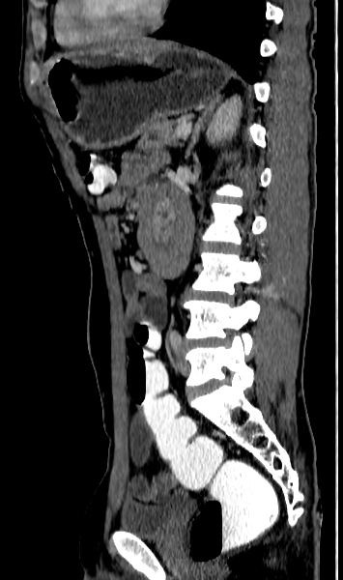
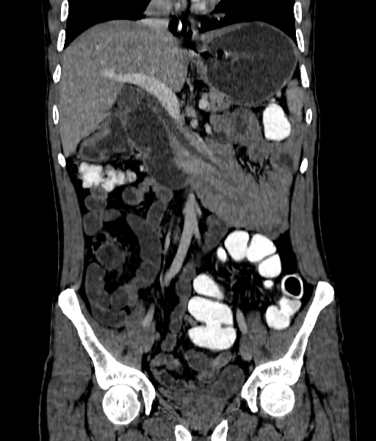
FIGURE 3: Contrast enhanced CT abdomen in coronal and sagittal reformatted images (A and B) shows sausage shaped mass in left hypochondrium forming a bowel within bowel appearance or donut sign on sagittal reformatted images (arrow)

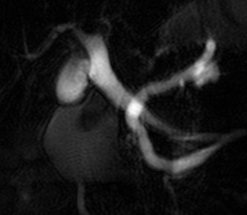
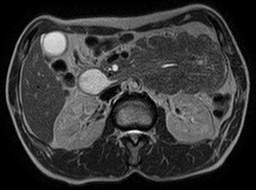
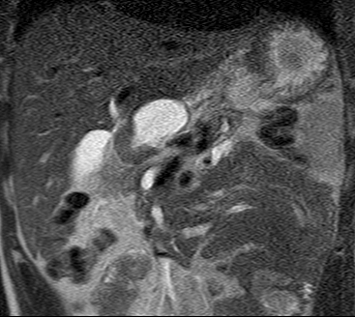
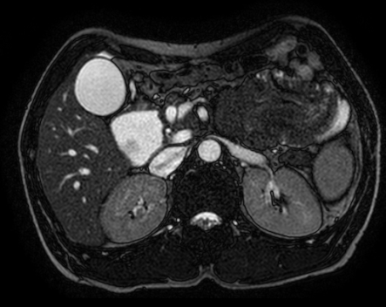)
FIGURE 4: Axial T2 (A) ,BTFE (B) and coronal T2 (D) images show dilated MPD and CBD (White arrow heads) with D2 segment of duodenum (black arrow) telescoping into the distal duodenum and jejunum forming a sausage shaped mass (black arrow).
Coronal reformatted MRCP MIP image (Image C) shows dilated CBD and MPD (white arrows) pulled into the intussusception.

References:
- Jeon SJ, Yoon SE, Lee YH, Yoon KH, Kim EA, Juhng SK. Acute pancreatitis secondary to duodenoduodenal intussusception in Peutz-Jegher syndrome. Clin Radiol 2007;62:88-91.
- O'Connor PA, McGrath FP, Lane BE. Duodenal intussusception secondary to an internal duodenal duplication. Clin Radiol 1999;54:69-70.
- Yalamarthi S, Smith RC. Adult intussusception: Case reports and review of literature Postgrad Med J 2005;81:174-7.
- Gayer G, Apter S, Hofmann C, Nass S, Amitai M, Zissin R, et al. Intussusception in adults: CT diagnosis. Clin Radiol 1998;53:53-7.
- Stubenbord WT, Thorbjarnarson B. Intussusception in adults. Ann Surg 1970;172:306-10.
- Reijnen HA, Joosten HJ, de Boer HH. Diagnosis and treatment of adult intussusception. Am J Surg 1989;158:25-8.
- Uggowitzer M, Kugler C, Aschauer M, Hausegger K, Mischinger H, Klimpfinger M. Duodenoduodenal intussusception with biliary obstruction and atrophy of the pancreas. Abdom Imaging 1996;21:240-2.
- Warshauer DM, Lee JK. Adult intussusception detected at CT or MR Imaging: Clinical-imaging correlation. Radiology 1999;212:853-60.
- Lvoff N, Breiman RS, Coakley FV, Lu Y, Warren RS. Distinguishing features of self-limiting adult small-bowel intussusception identified at CT. Radiology 2003;227:68-72.
- Mateen MA, Saleem S, Rao PC, Gangadhar V, Reddy DN. Transient small bowel intussusceptions: Ultrasound findings and clinical significance. Abdom Imaging 2006;31:410-16.
- Sandrasegaran K, Kopecky KK, Rajesh A, Lappas J. Proximal small bowel intussusceptions in adults: CT appearance and clinical significance. Abdom Imaging 2004;29:653-55

