Original article:
The neuroimaging of leighs syndrome: a case series and review of literature
*DR. HITESH TYAGI, **DR JEEVIKA M U, ***DR. DEEKSHA SINGH

*Junior Resident, Department of Radiodiagnosis , JJM Medical College , Davangere , Karnataka , India.
** HOD and Professor, Department Of Radio diagnosis, JJM Medical College, Davangere, Karnataka, India. Corresponding author **
*** Junior Resident, Department of Radiodiagnosis , JJM Medical College , Davangere , Karnataka , India.
* Corresponding author: Dr. Hitesh Tyagi

ABSTRACT:
Introduction: The first case and the disease of leigh syndrome was first described by Denis leigh in 1951 (1). Leigh syndrome, also known as subacute necrotizing encephalomyelopathy or leighs disease, is a rare inherited progressive neurometabolic disorder which also affects the central nervous system (2). The areas involved are the thalami, basal ganglia, brainstem, and posterior column of spinal cord (2). Alterations or mutations of mitochondrial respiratory enzyme complex or pyruvate dehydrogenase complex are believed to be cause of the development of leigh syndrome (3,4). Initially the clinical diagnosis is based clinical manifestations family history, and imaging are the major criteria for diagnosis; other methods are laboratory assessments, muscle biopsy with histochemical staining, activity of the mitochondrial respiratory chain enzyme, and identification of mitochondrial DNA (mtDNA) or nuclear DNA (nDNA) mutations (4).
Objective Of Study: To demonstrate different pattern of MRI findings in spectrum of Leigh syndrome
Material And Method: This was a retrospective study conducted in the Department of Radio Diagnosis, JJMMC, Davangere. The study was done for a period of 12 months with pediatric cases with clinical suspicion of leighs syndrome with history of delayed milestones and hypotonia. Philips 1.5 T magnet was used.
Results: Out of 15 cases with clinically suspicion of Leighs syndrome, 7 cases had characteristics MRI findings with involvement of bilateral caudate and putamen, followed by brainstem. In all 7 cases, there was sparing of thalami. In 1 case out of 7 also had HIE changes. Post imaging, all cases were confirmed to be leighs with raised serum and CSF lactate levels.
Conclusions: Involvement of bilateral basal ganglia is the most common finding , followed by mid brain with sparing of thalami in all our cases of leighs in our institute.

INTRODUCTION:
Leigh syndrome is a progressive neurodegenerative disorder of childhood with an estimated incidence of 1:40,000 births [5]. In 1951, Denis Archibald leigh described the first case of subacute necrotizing encephalopathy or leigh syndrome. OMIM 2014 describes leigh syndrome as [6], a neurodegenerative disease with variable symptoms, (2) caused by mitochondrial dysfunction from a hereditary genetic defect, and (3) accompanied by bilateral central nervous system (CNS) lesions. Clinical symptoms include psychomotor delay or regression , muscular hypotonia , brainstem signs (strabismus, nystagmus, and difficulty in feeding), pyramidal signs , cerebral ataxia , respiratory insufficiency and lactate acidaemia. [4]
When there are atypical symptoms, atypical imaging findings are present or the above criteria is not met , it is called Leigh-like syndrome [6-10]. The term “genetically confirmed Leigh syndrome” refers to the cases of leigh syndrome with genetic mutation is confirmed (approximately 50 % of all patients) [7]. There can be considerable heterogenicity in clinical, genetic and biochemistry findings, the neuropathological features in patients are almost identical which are focal , bilateral and symmetric necrotic lesions associated with demyelination , vascular proliferations and gliosis in the brainstem , basal ganglia and cerebellum [7] .
Here we review the imaging studies and investigations of Leigh syndrome and describe the neuroimaging findings in 7 children with clinical symptoms of leighs syndrome. MRI examinations obtained using 1.5 T Philips machine. Magnetic resonance spectroscopy (MRS) was available, and performed in 7 patients, with single voxels placed in the basal ganglia and with short echo time (33ms) and Long TE (144ms). MR spectra were assessed for abnormalities in metabolic ratios, and evidence of abnormal lactate was recorded.
MATERIAL AND METHODS:
This was a retrospective study conducted in the Department of Radio Diagnosis, JJMMC, Davangere. The study was done for a period of 12 months with pediatric cases with clinical suspicion of leighs syndrome with history of delayed milestones and hypotonia. Philips 1.5 T magnet was used.
OBSERVATIONS:
Case 1:
A 2 years 4months old patient came with chief complaints of developmental delay.
On MRI , there were T2/FLAIR symmetrical hyperintensities in bilateral caudate and putamen which are showing diffusion restriction on DWI and no blooming on GRE sequence. Symmetrical T2/FLAIR hyperintensities were also seen in in bilateral medullary white matter tracts. MRS data was not available. Serology showed increased serum and CSF lactate in the baby.
Fig 1a : T2WI Axial section shows symmetrical hyperintensities in bilateral putamen
Fig 1b: DWI axial image shows symmetrical hyperintensities in bilateral putamen , which is corresponding to the hyperintensities in T2WI

Case 2:
A 6 month old male patient came to pediatric OPD with complaint of delayed development.
Bilateral symmetrical diffusion restriction with T2/FLAIR hyperintensities noted in bilateral caudate and lentiform nuclei and crus cerebri of mid brain; few areas within the lesion shows minimal post contrast enhancement.
The lesion shows (NAA/Cr -0.9) (decreased), Choline and creatine normal, (choline/Cr 1.2) (choline/NAA-1.3).
Choline peak with decreased NAA and double lactate peak.

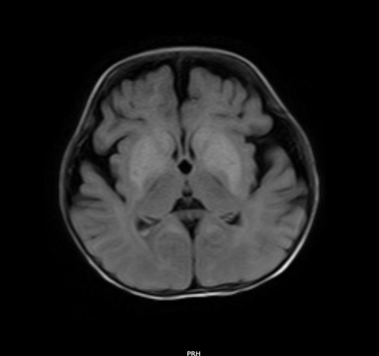
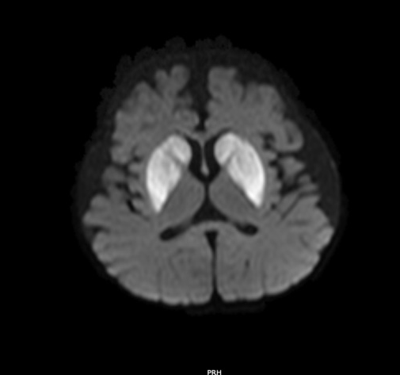
Fig 2a : T2WI Axial section shows symmetrical hyperintensities in caudate and lentiform nuclei
Fig 2b: DWI Axial section shows symmetrical hyperintensities in caudate and lentiform nuclei, which are corresponding to the hyperintensities in T2WI
Fig 2c: Spectroscopy Decreased NAA and double lactate peak

Case 3:
A 4 year old male came for MRI in regards to delayed development.
Bilateral symmetrical T2/FLAIR hyperintense and T1 hypointense areas noted involving the bilateral putamen, caudate, corticospinal tracts, red nuclei & tegmentum of midbrain and pons, cerebellar dentate nuclei, and peri aqueductal region. small foci of restriction on DWI noted in left putamen and cerebellar hemispheres. MRS shows double lactate peak.

Fig 3a : T2WI Axial section shows symmetrical hyperintensities in caudate and lentiform nuclei.
Fig 3b: DWI Axial section shows symmetrical hyperintensities in corticospinal tracts, red nuclei & tegmentum of midbrain
Fig 3c: DWI Axial section shows symmetrical hyperintensities in caudate and lentiform nuclei
Fig 3d: Spectroscopy shows double lactate peak

Case 4:

Bilateral symmetrical T2/FLAIR hyperintensities noted in basal ganglia (head and body of caudate nucleus, putamen) which is showing diffusion restriction on DWI with corresponding ADC matching. No blooming noted on GRE. MR spectroscopy: The lesion shows NAA/Cr -0.8 (decreased), Cho/Cr – 5 (Increased), Increased choline peak with decreased NAA and double lactate peak.

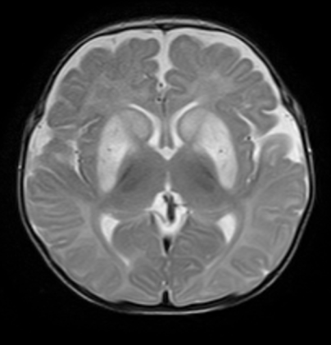

Fig 4a : DWI Axial section shows symmetrical hyperintensities in in head and body of caudate nucleus.
Fig 4b: ADC Axial section shows symmetrical hyperintensities in caudate and lentiform nuclei
Fig 4c: T2WI Axial section shows symmetrical hyperintensities in caudate and lentiform nuclei
Fig 4d: Spectroscopy shows double lactate peak

Case 5:
Bilateral symmetrical T2/FLAIR hyperintensity showing true diffusion restriction are noted in bilateral lentiform and caudate nuclei. no enhancement noted on post contrast study.
On MRS: reduced NAA & NAA/Cr ratio (0.7), double lactate peak noted.
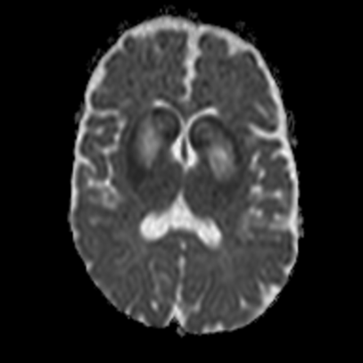
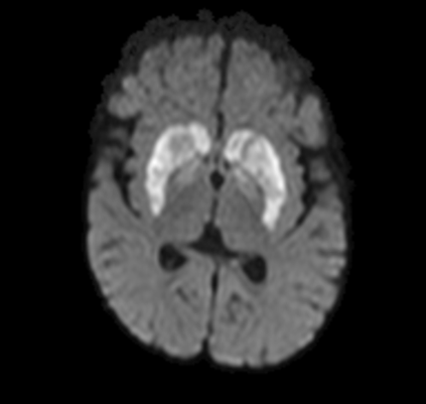
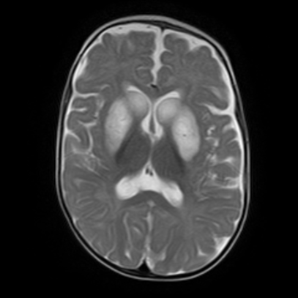

Fig 5a : DWI Axial section shows symmetrical hyperintensities in in head and body of caudate nucleus.
Fig 5b: ADC Axial section shows symmetrical hyperintensities in caudate and lentiform nuclei
Fig 5c: T2WI Axial section shows symmetrical hyperintensities in caudate and lentiform nuclei
Fig 5d: Spectroscopy shows double lactate peak

Case 6:
Multiple areas of T2/ FLAIR hyperintensities showing diffusion restriction with corresponding ADC matching and T1 hypointensity noted in cerebral peduncles tegmentum of midbrain, peri aqueductal grey matter, dorsal pons and brain stem following the tracts.
MRS double lactate peak
Fig 6a : DWI Axial section shows symmetrical hyperintensities in midbrain, peri aqueductal grey matter, dorsal pons and brain stem.
Fig 6b: ADC Axial section shows symmetrical hyperintensities in midbrain, peri aqueductal grey matter, dorsal pons and brain stem
Fig 6d: Spectroscopy shows double lactate peak
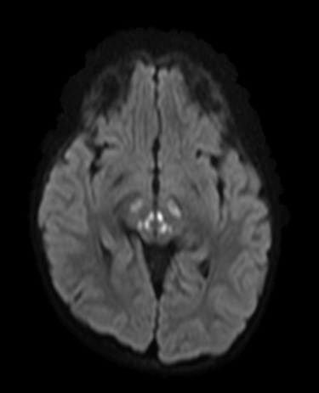
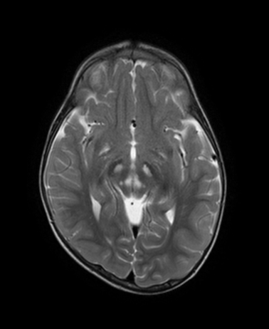

Case 7:
Symmetrical altered signal intensities noted involving the bilateral caudate, dorsomedial aspect of the thalamus, sub thalamic, external capsule , cerebral peduncle, periaqueductal, dentate nucleus, subcortical (involving the U-fibers) & periventricular white matter of cerebral & cerebellar hemisphere which are T2/FLAIR hyperintense & T1 hypointense, showing true diffusion restriction and patchy enhancement on post contrast study.
Bilateral putamen are atrophied and shows cystic changes which are T2 hyperintense and shows suppression on FLAIR.
Diffuse periventricular and subcortical white matter loss with dilatation of bilateral lateral & 3rd ventricle.
Diffuse thinning of corpus callosum (genu-1.6mm, body1mm, splenium-2.82mm).
ON MRS:
Deep grey nucleus and subcortical white matter shows decreased choline peak at 3.3ppm reduced NAA peak at 2ppm and double lactate peak at 1.3ppm . However NAA/CHO appears increased(3.3)

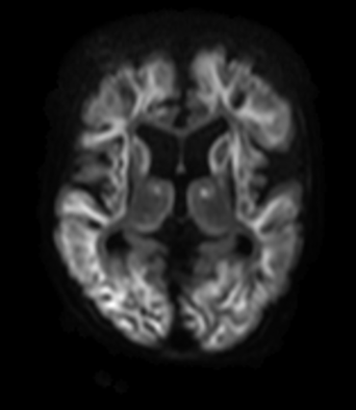
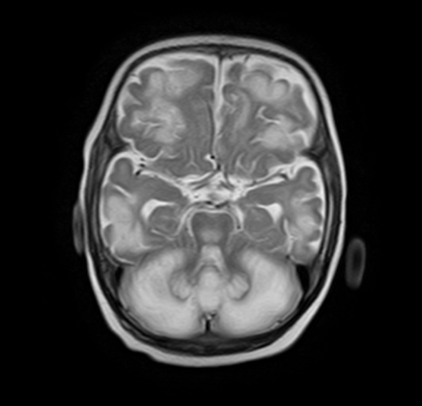
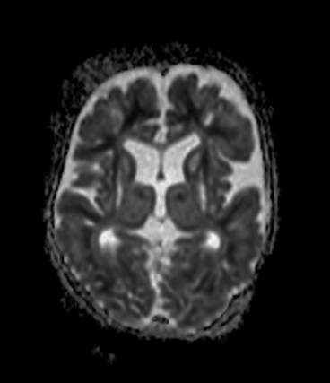
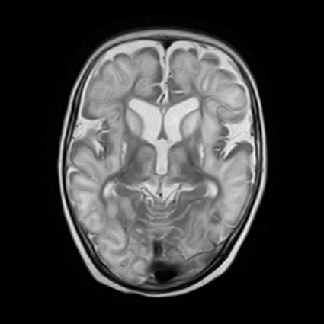

Fig 7a & 7c : T2 Axial section shows bilateral caudate, dorsomedial aspect of the thalamus, sub thalamic, external capsule , cerebral peduncle, periaqueductal, dentate nucleus, subcortical (involving the U-fibers) & periventricular white matter of cerebral & cerebellar hemisphere
Fig 7b & 7d: DWI & ADC Axial section shows symmetrical hyperintensities in thalamus, external capsule, subcortical (involving the U-fibers) & periventricular white matter of cerebral & cerebellar hemisphere
Fig 7d: Spectroscopy shows double lactate peak

﻿

DISCUSSION
Leigh syndrome is the most common clinical phenotype of mitochondrial disorders in pediatric patients. According to Rehman S. et al , The diagnostic criteria are (1) Neurological disease which is progressive in nature with delay in motor and intellectual development; (2) clinical manifestation of disease of brainstem and/or basal ganglia; (3) characteristic symmetric lesions in the basal ganglia and/or brainstem ; and (4) Elevated blood and/or cerebrospinal fluid lactate levels [5].
The neuroradiological findings on MRI are reflected as high T2 signals due the vacuolation and spongiform changes occurred in affected areas of brain structures [11-13]. With the progression of disease upper brainstem will be affected followed by the lower brainstem. Involvement of lower brainstem suggests the progression of disease into advanced stage and may lead into occurrence of respiratory failure and sudden death. Involvement of cerebral white matter is also indicator of progression of disease into the late stage. Other lesser common neuroimaging findings may include unifocal or multifocal infarctions, diffuse supratentorial leukodystrophy, diffuse or focal cortical atrophy or may also show prominent cerebellar atrophy. (14) In cases done in our dept out of 15 cases with the suspicion of leighs syndrome, 7 cases show characteristics of leighs syndrome. Most of the cases came to the dept of radiodiagnosis with the complaint of delayed development. There were 5 male and 2 female cases. The average age of presentation was 17 months. All the cases were serologically proven to be leighs syndrome with raised serum and CSF lactate levels. Most common location of involvement was the basal ganglia , then brain strem and other location. In all our cases, except the one with HIE changes , all the cases show sparing of thalamus . Thalamus is the second most common location of involvement which is not seen in out cases.
OTHER |  |  |  |  |  |  | HIE
MRS | Reduced NAA and Double lactate peak | Reduced NAA , Choline peak and Double lactate peak | Double lactate peak | Double lactate peak , Reduced NAA and Increased Choline peak | Double lactate , Reduced NAA | Double lactate | Double lactate , Reduced NAA and Decrease Choline peak
DELAYED MYLENATION
ATROPHY |  |  |  |  |  |  | +
DENTATE NUCLIE |  |  | + |  |  |  | +
CORTEX | + |  |  |  |  |  | +
CEREBRAL WHITE MATER | + |  |  |  |  |  | +
THALAMI |  |  |  |  |  |  | ss+
PUTAMEN |  | + | + | + | + |  | +
GLOBUS PALIDUS |  | + |  |  | +
CAUDATE |  | + | + | + | + |  | +
MIDBRAIN  (TEGMENTUM) | + | + | + |  |  | +
MIDBRAIN (PERIAUEDUCTAL) | + |  | + |  |  | + | +
PONS |  |  | + |  |  | +
MEDULLA
AGE OF ONSET | 26 months | 6mo | 4 years | 3mo/m | 6yr | 2y/m | 5mo/m
ID | 1 | 2 | 3 | 4 | 5 | 6 | 7

REFERENCES:
- Leigh D. Subacute necrotizing encephalomyelopathy in an infant. J Neurol Neurosurg Psychiatry 1951;14:216–21.
- Leigh D. Subacute necrotizing encephalomyelopathy in an infant. J Neurol Neurosurg Psychiatry 1951;14:216-221.
- Finsterer J. Leigh and Leigh-like syndrome in children and adults. Pediatr Neurol 2008;39:223–35.
- Baertling F, Rodenburg RJ, Schaper J, et al. A guide to diagnosis and treatment of Leigh syndrome. J Neurol Neurosurg Psychiatry 2014;85:257–65.
- Rahman S, Blok RB, Dahl HH et al. Leigh syndrome: clinical features and biochemical and DNA abnormalities. Ann Neurol 1996; 39(3):343-51.
- Fabian B, Rodenburg RJ, Schaper J et al (2014) A guide to diagnosis and treatment of Leigh syndrome. J Neurol Neurosurg Psychiatry 85:257–265
- Finsterer J (2008) Leigh and Leigh-like syndrome in children and adults. Pediatr Neurol 39:223–235
- Koenig MK (2008) Presentation and diagnosis of mitochondrial disorders in children. Pediatr Neurol 38:305–313
- Finsterer J (2009) Central nervous system imaging in mitochondrial disorders. Can J Neurol Sci 36:143–153
- Finsterer J (2006) Central nervous system manifestations of mito- chondrial disorders. Acta Neurol Scand 114:217–238
- Savoiardo M, Ciceri E, D'Incerti L et al. Symmetric lesions of the subthalamic nuclei in mitochondrial encephalopathies: an almost distinctive Mark of Leigh disease with COX deficiency. AJNR Am J Neuroradiol 1995; 16(8):1746-7.
- Savoiardo M, Zeviani M, Uziel G et al. MRI in Leigh syndrome with SURF1 gene mutation. Ann Neurol 2002; 51(1):138-9.
- Rossi A, Biancheri R, Bruno C et al. Leigh Syndrome with COX deficiency and SURF1 gene mutations: MR imaging findings. AJNR Am J Neuroradiol 2003; 24(6):1188-91.
- Sofou K, Steneryd K, Wiklund LM et al (2013) MRI of the brain in childhood-onset mitochondrial disorders with central nervous system involvement. Mitochondrion 13:364–371

