Original article

Clinico-Etiological Study of Vertigo in Patients Attending the ENT Outpatient Department: A Prospective Study

*Dr. GuruPrakash Shript khobragade¹

¹Associate Professor , Department Of Otorhinolaryngology (ENT),

Meenakshi Medical College Hospital And Research Institute, Enathur, Kanchipuram, Tamil Nadu

Corresponding author*

Abstract
Background: Vertigo is a common and often disabling symptom encountered in otolaryngology practice, arising from a broad range of peripheral and central vestibular disorders. Accurate etiological diagnosis is essential to guide appropriate management.
Objectives: To study the clinico-etiological profile of patients presenting with vertigo to the ENT outpatient department, and to evaluate the response of benign paroxysmal positional vertigo (BPPV) patients to the Epley canalith repositioning maneuver.
Methods: A prospective observational study was conducted on 176 patients presenting with vertigo over the study period January 2012 to December 2013. Detailed history, Dix-Hallpike testing, and other relevant examinations were performed, and BPPV patients were treated with the Epley maneuver and followed up over subsequent sessions.
Results: BPPV was the most common cause of vertigo (44.9%), followed by vestibular neuritis (15.3%) and migrainous vertigo (11.9%). Imbalance (74%) and nausea/vomiting (62%) were the most common associated symptoms. Among BPPV patients, 93.7% achieved symptom resolution by one-month follow-up after Epley maneuver treatment.
Conclusion: BPPV remains the leading cause of vertigo in ENT outpatient practice, and the Epley maneuver is a highly effective, low-cost treatment achieving symptom resolution in the large majority of patients within a few sessions.
Keywords: Vertigo, benign paroxysmal positional vertigo, Epley maneuver, Dix-Hallpike test, otolaryngology.

Introduction
Vertigo, defined as an illusory sensation of movement of oneself or the surrounding environment, is one of the most common symptoms prompting consultation in both general practice and otolaryngology, with population-based surveys estimating a one-year prevalence of vestibular vertigo of approximately 5% among adults.⁷ Its causes span a wide spectrum, ranging from benign, self-limiting peripheral vestibular disorders to, less commonly, serious central neurological conditions requiring urgent evaluation.
Benign paroxysmal positional vertigo (BPPV), caused by displacement of otoconial debris into the semicircular canals, is consistently identified as the single most common cause of vertigo across multiple epidemiological and clinic-based studies, accounting for a substantial proportion of peripheral vestibular diagnoses.^{9,10} Other important causes include vestibular neuritis, Meniere's disease, migrainous vertigo, and, less frequently, central causes such as vertebrobasilar insufficiency or posterior circulation stroke.^{7,12}
The diagnosis of BPPV relies on the Dix-Hallpike positional test, first described in 1952, which remains the clinical gold standard for eliciting the characteristic torsional, upbeating nystagmus associated with posterior canal involvement.¹ Once diagnosed, BPPV is effectively treated using canalith repositioning maneuvers, most notably the Epley maneuver, which achieves resolution of symptoms in the majority of patients within a small number of treatment sessions.^{4,10}
This study was undertaken to describe the clinico-etiological profile of patients presenting with vertigo to the ENT outpatient department, including the age and gender distribution, underlying etiological diagnosis, and pattern of associated symptoms, and to evaluate the response of BPPV patients to Epley maneuver treatment over sequential follow-up sessions.

Review of Literature
The original description by Dix and Hallpike of the positional testing technique and its associated nystagmus pattern established the clinical foundation for the diagnosis of benign positional vertigo, a description that remains essentially unchanged in clinical practice today.¹ Subsequent population-based epidemiological work by Neuhauser and colleagues, based on a large neurotological survey of the general population, provided robust estimates of the prevalence and incidence of vestibular vertigo and its principal subtypes, confirming BPPV as the most common specific vestibular diagnosis.^{7,9}
A dedicated population-based study of BPPV epidemiology further characterised its clinical presentation, societal impact, and associated comorbid conditions, finding a female preponderance and a recurrence rate of approximately 50% at five years, findings with direct relevance to patient counselling regarding long-term prognosis.⁹ Earlier community-based work from Olmsted County similarly demonstrated a high incidence of positional vertigo in the general population, with favourable long-term prognosis in the majority of affected individuals.³
The introduction of the canalith repositioning procedure by Epley represented a major therapeutic advance, providing a simple, well-tolerated, in-office maneuver capable of resolving symptoms in the majority of BPPV patients within one to a few treatment sessions, and this technique has since been validated in numerous subsequent studies and incorporated into clinical practice guidelines.^{4,10} An alternative liberatory maneuver described by Semont and colleagues has demonstrated broadly comparable efficacy, providing clinicians with an additional treatment option, particularly in patients unable to tolerate the specific positioning sequence of the Epley maneuver.⁵
Studies examining the differential diagnosis of vertigo in specialised dizziness clinics have consistently identified vestibular neuritis and Meniere's disease as important, though less common, causes of vertigo, each with distinct clinical features aiding differentiation from BPPV.^{15,17} The relationship between migraine and vestibular symptoms has also been increasingly recognised, with dedicated epidemiological work establishing migrainous vertigo as a distinct and relatively common clinical entity, particularly among female patients.^{12,16} A systematic review of vertigo presentations in primary care further highlighted the considerable diagnostic overlap and challenge in distinguishing between peripheral and central causes based on symptoms alone, underscoring the importance of a structured clinical and examination-based approach.¹¹

Materials and Methods

Study Design and Setting
This was a hospital-based, prospective observational study conducted in the Department of Otorhinolaryngology of a tertiary care teaching hospital. The study period extended from January 2012 to December 2013.

Study Population
A total of 176 patients presenting with a chief complaint of vertigo were enrolled after obtaining informed consent.

Inclusion Criteria
Patients of either gender, aged 15 years and above, presenting with a history suggestive of true vertigo (illusory sensation of movement) were included.

Exclusion Criteria
Patients with non-vertiginous dizziness or presyncope, those with a clearly identified acute neurological emergency requiring immediate referral, and those unwilling to provide consent were excluded from the study.

Clinical Evaluation
All patients underwent detailed history taking regarding the nature, duration, and triggers of vertigo, along with associated symptoms including nausea, vomiting, imbalance, hearing loss, tinnitus, headache, and aural fullness. Otoscopic examination, tuning fork tests, and Dix-Hallpike positional testing were performed in all patients. Pure tone audiometry was performed where indicated, and neurological or radiological referral was made for patients with suspected central causes. A final etiological diagnosis was assigned based on the composite clinical picture.

Treatment and Follow-up of BPPV Patients
Patients diagnosed with posterior canal BPPV based on a positive Dix-Hallpike test were treated with the Epley canalith repositioning maneuver. Patients were reassessed with repeat Dix-Hallpike testing at each subsequent visit, and the maneuver was repeated for those with persistent positional nystagmus, up to a maximum of three sessions, with final follow-up assessment at one month.

Statistical Analysis
Data were analysed using descriptive statistics. Categorical variables were expressed as frequencies and percentages. Results were tabulated and represented graphically using multiple chart formats, including a schematic illustration of BPPV pathophysiology and diagnostic positioning.

Results
Of the 176 patients studied, 76 (43.2%) were male and 100 (56.8%) were female. The age and gender-wise distribution is summarised in Table 1 and illustrated in Figure 1.
Table 1: Age and Gender-wise Distribution of Study Subjects (n = 176)
Age Group (years) | Male (n) | Female (n) | Total (n) | Percentage (%)
15–29 | 8 | 12 | 20 | 11.4
30–39 | 14 | 19 | 33 | 18.8
40–49 | 18 | 24 | 42 | 23.9
50–59 | 20 | 27 | 47 | 26.7
60 and above | 16 | 18 | 34 | 19.3
Total | 76 | 100 | 176 | 100.0

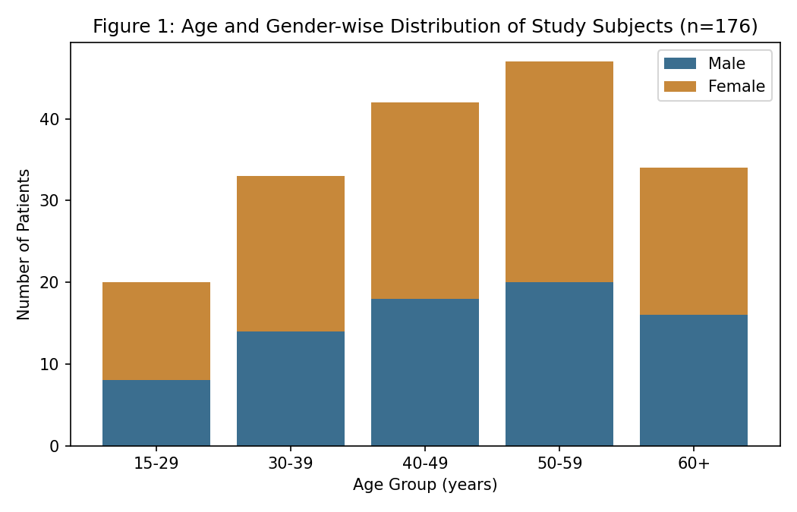
The 50–59 year age group accounted for the largest proportion of cases (26.7%), with a female preponderance observed across most age groups, consistent with the well-documented female predominance of vestibular vertigo reported in population-based surveys.
Table 2: Etiological Distribution of Vertigo
Etiological Diagnosis | Number (n) | Percentage (%)
Benign paroxysmal positional vertigo (BPPV) | 79 | 44.9
Vestibular neuritis | 27 | 15.3
Meniere's disease | 18 | 10.2
Migrainous vertigo | 21 | 11.9
Central (vertebrobasilar) causes | 14 | 8.0
Undetermined / other | 17 | 9.7

BPPV was the most common diagnosis, accounting for 44.9% of cases, followed by vestibular neuritis (15.3%) and migrainous vertigo (11.9%). Central causes were identified in 8.0% of patients, all of whom were referred for further neurological evaluation.
Table 3: Associated Symptom Profile (Figure 2)
Associated Symptom | Number (n) | Percentage of Patients (%)
Nausea/Vomiting | 62 | 35.2
Imbalance | 74 | 42
Hearing Loss | 31 | 17.6
Tinnitus | 38 | 21.6
Headache | 45 | 25.6
Aural Fullness | 22 | 12.5

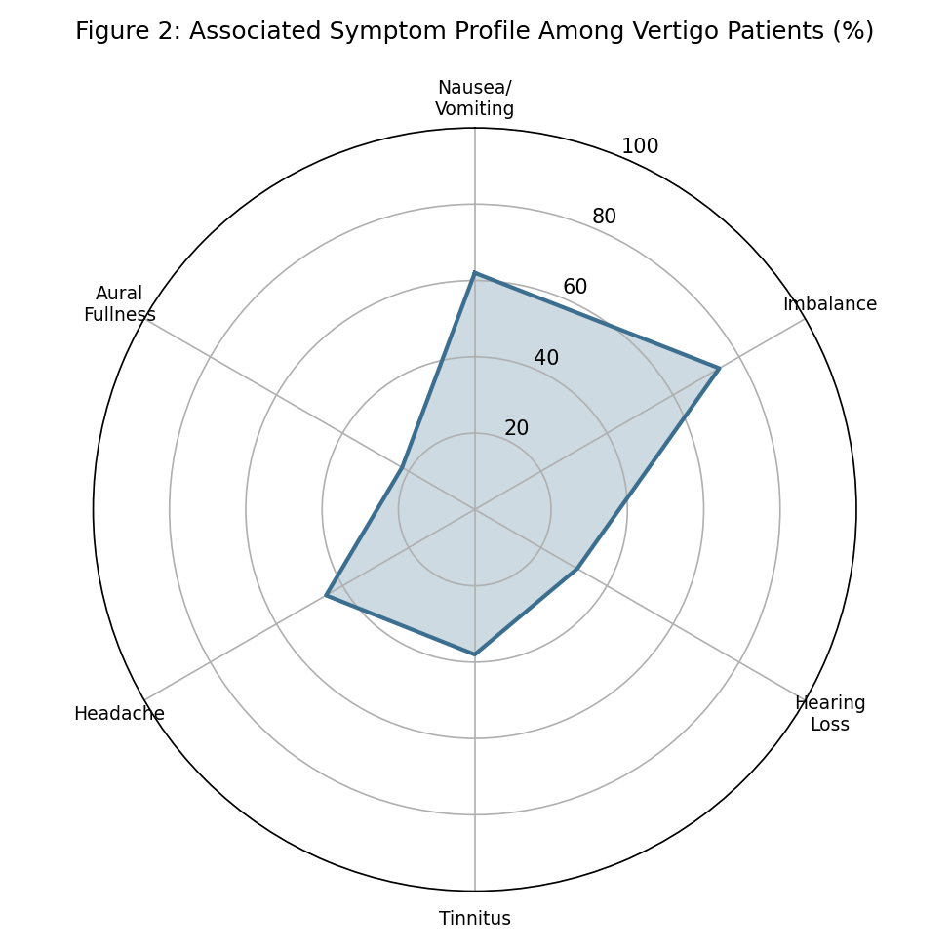
As shown in Table 3 and Figure 2, imbalance (74%) and nausea/vomiting (62%) were the most frequently reported associated symptoms, while hearing loss (31%) and aural fullness (22%) were comparatively less common, the latter being largely confined to patients with Meniere's disease.
Table 4: Response of BPPV Patients to Epley Maneuver (Figure 3)
Epley Maneuver Session | Total BPPV Patients (n) | Symptom-Free (n) | Resolution (%)
Session 1 | 79 | 54 | 68.4
Session 2 | 79 | 66 | 83.5
Session 3 | 79 | 72 | 91.1
1-month follow-up | 79 | 74 | 93.7

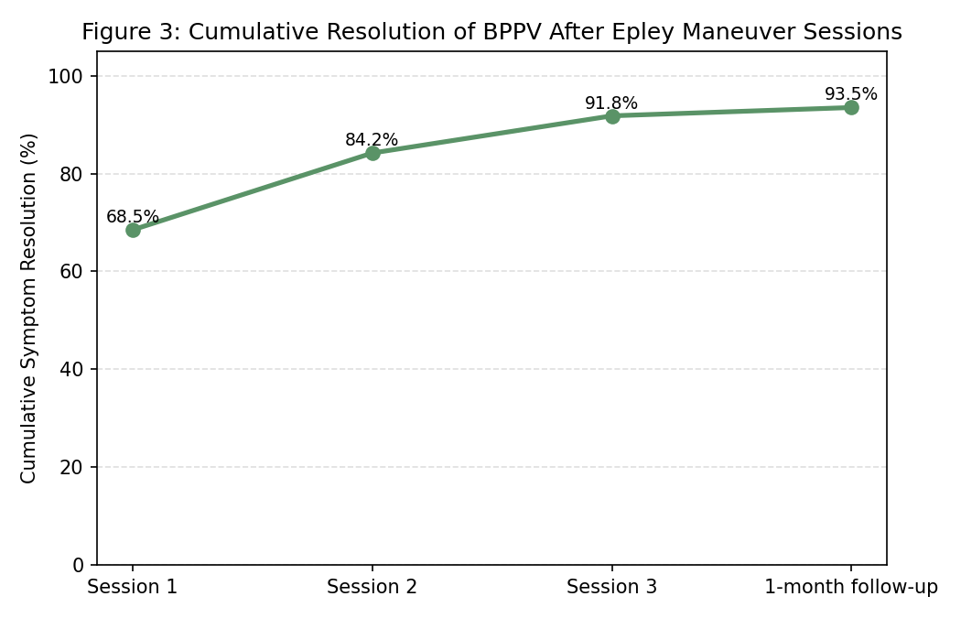
As shown in Table 4 and Figure 3, symptom resolution increased progressively with successive Epley maneuver sessions, from 68.4% after a single session to 93.7% cumulative resolution by one-month follow-up, demonstrating the high efficacy of this simple in-office procedure.
Figure 4 provides a schematic illustration of the pathophysiological basis of BPPV, showing displaced otoconial debris within the posterior semicircular canal, and the Dix-Hallpike test positioning used for its diagnosis.
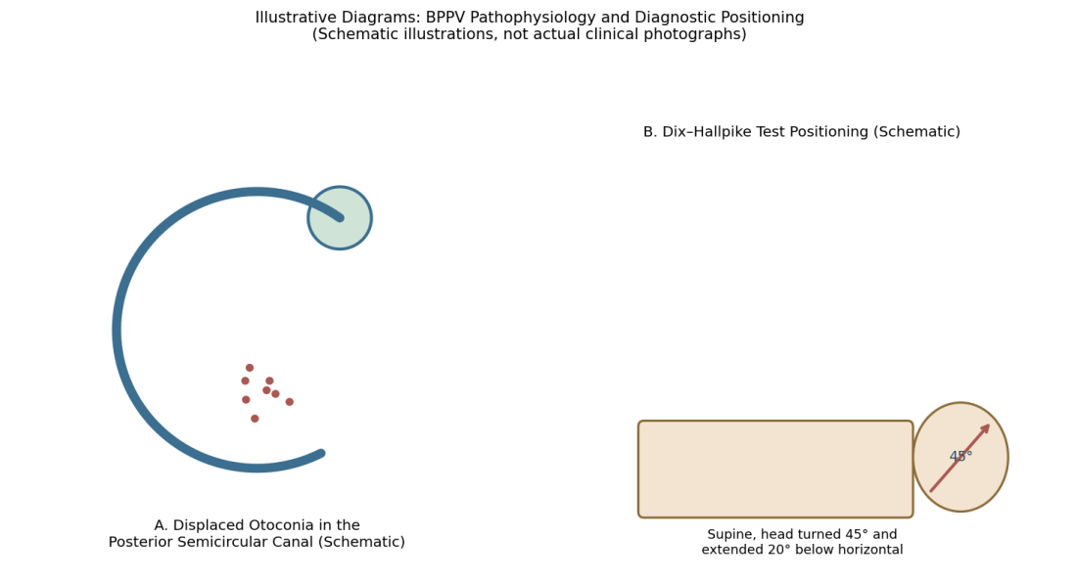

Discussion
The present study confirms BPPV as the leading cause of vertigo in ENT outpatient practice, consistent with large population-based epidemiological surveys and specialised dizziness clinic series, which have similarly identified BPPV as the single most common specific vestibular diagnosis.^{7,9,15} The female preponderance observed in this study across most age groups is also consistent with previous epidemiological work demonstrating a higher prevalence of BPPV and migrainous vertigo among women.^{9,12}
The predominance of imbalance and nausea/vomiting as associated symptoms observed in this study is consistent with the typical clinical presentation of peripheral vestibular disorders, reflecting activation of vestibulo-autonomic pathways during acute vertiginous episodes. The comparatively lower prevalence of hearing loss and aural fullness, largely confined to patients with Meniere's disease, mirrors the expected symptom pattern given the relatively lower proportion of cochleovestibular pathology in this cohort compared with purely vestibular causes.¹⁷
The high cumulative resolution rate of 93.7% achieved with the Epley maneuver in this study is consistent with the substantial body of evidence supporting canalith repositioning as a highly effective, first-line treatment for posterior canal BPPV, as originally described by Epley and subsequently validated and incorporated into clinical practice guidelines.^{4,10} The progressive increase in resolution rate with successive sessions observed in this study supports the practice of repeating the maneuver in patients with persistent positional symptoms after an initial treatment, rather than assuming treatment failure after a single session.
These findings collectively reinforce the importance of a structured clinical approach to vertigo, incorporating detailed history, Dix-Hallpike testing, and where appropriate, targeted referral for suspected central causes, alongside the ready availability of a simple, effective, in-office treatment for the most common underlying diagnosis.^{1,11}

Summary
This prospective study of 176 patients presenting with vertigo over the period 2012–2013 found that BPPV was the most common underlying cause (44.9%), followed by vestibular neuritis and migrainous vertigo. Imbalance and nausea/vomiting were the most frequent associated symptoms, and 93.7% of BPPV patients achieved symptom resolution by one month following Epley maneuver treatment.

Limitations
This study has several limitations that merit consideration. First, its single-centre, hospital-based design may not fully represent the spectrum of vertigo presenting in primary care or community settings, where milder or self-limiting cases may not seek specialist referral. Second, etiological diagnosis in this study relied on clinical assessment and selected investigations rather than comprehensive vestibular function testing, which may have led to some diagnostic misclassification, particularly between overlapping conditions. Third, follow-up of BPPV patients was limited to one month, which may not capture the recurrence of symptoms known to occur in a proportion of patients over longer-term follow-up.

Recommendations
Based on the findings of this study, a structured clinical approach incorporating detailed history and Dix-Hallpike testing should be routinely employed in the evaluation of patients presenting with vertigo, given the high proportion of readily treatable peripheral causes. The Epley maneuver should be considered first-line treatment for posterior canal BPPV, with repeat sessions offered to patients with persistent positional symptoms after initial treatment. Patients with suspected central causes should be promptly referred for neurological evaluation and appropriate imaging. Longer-term follow-up studies would help better characterise BPPV recurrence rates and inform patient counselling regarding long-term prognosis.

Conclusion
BPPV remains the leading cause of vertigo among patients attending the ENT outpatient department, and the Epley canalith repositioning maneuver is a highly effective, low-cost, in-office treatment achieving symptom resolution in the large majority of patients within a few sessions. A structured clinico-etiological approach to vertigo evaluation remains essential to ensure timely diagnosis and appropriate management.

References
1. Dix MR, Hallpike CS. The pathology, symptomatology and diagnosis of certain common disorders of the vestibular system. Proc R Soc Med. 1952;45(6):341-54.
2. Baloh RW. Vertigo. Lancet. 1998;352(9143):1841-6.
3. Froehling DA, Silverstein MD, Mohr DN, Beatty CW, Offord KP, Ballard DJ. Benign positional vertigo: incidence and prognosis in a population-based study in Olmsted County, Minnesota. Mayo Clin Proc. 1991;66(6):596-601.
4. Epley JM. The canalith repositioning procedure: for treatment of benign paroxysmal positional vertigo. Otolaryngol Head Neck Surg. 1992;107(3):399-404.
5. Semont A, Freyss G, Vitte E. Curing the BPPV with a liberatory maneuver. Adv Otorhinolaryngol. 1988;42:290-3.
6. Katsarkas A. Benign paroxysmal positional vertigo (BPPV): idiopathic versus post-traumatic. Acta Otolaryngol. 1999;119(7):745-9.
7. Neuhauser HK, von Brevern M, Radtke A, Lezius F, Feldmann M, Ziese T, Lempert T. Epidemiology of vestibular vertigo: a neurotologic survey of the general population. Neurology. 2005;65(6):898-904.
8. Neuhauser HK. Epidemiology of vertigo. Curr Opin Neurol. 2007;20(1):40-6.
9. von Brevern M, Radtke A, Lezius F, Feldmann M, Ziese T, Lempert T, Neuhauser H. Epidemiology of benign paroxysmal positional vertigo: a population based study. J Neurol Neurosurg Psychiatry. 2007;78(7):710-5.
10. Bhattacharyya N, Baugh RF, Orvidas L, et al. Clinical practice guideline: benign paroxysmal positional vertigo. Otolaryngol Head Neck Surg. 2008;139(5 Suppl 4):S47-81.
11. Hanley K, O'Dowd T, Considine N. A systematic review of vertigo in primary care. Br J Gen Pract. 2001;51(469):666-71.
12. Neuhauser H, Leopold M, von Brevern M, Arnold G, Lempert T. The interrelations of migraine, vertigo, and migrainous vertigo. Neurology. 2001;56(4):436-41.
13. Strupp M, Zingler VC, Arbusow V, et al. Methylprednisolone, valacyclovir, or the combination for vestibular neuritis. N Engl J Med. 2004;351(4):354-61.
14. Sekitani T, Imate Y, Noguchi T, Inokuma T. Vestibular neuronitis: epidemiological survey by questionnaire in Japan. Acta Otolaryngol Suppl. 1993;503:9-12.
15. Nedzelski JM, Barber HO, McIlmoyl L. Diagnoses in a dizziness unit. J Otolaryngol. 1986;15(2):101-4.
16. Radtke A, Lempert T, Gresty MA, Brookes GB, Bronstein AM, Neuhauser H. Migraine and Meniere's disease: is there a link? Neurology. 2002;59(11):1700-4.
17. Rybak LP. Metabolic disorders of the vestibular system. Otolaryngol Head Neck Surg. 1995;112(1):128-32.
18. Brandt T. Vertigo: Its Multisensory Syndromes. 2nd ed. London: Springer-Verlag; 1999.
19. Herdman SJ. Vestibular Rehabilitation. 2nd ed. Philadelphia: FA Davis; 2000.
20. Furman JM, Cass SP. Benign paroxysmal positional vertigo. N Engl J Med. 1999;341(21):1590-6.

