Original article

Bacteriological And Fungal Profile of Blood Stream Infections in a Tertiary Care Hospital in North India: A Retrospective Study
¹Dr Urvashi Tiwari , ²Dr Varuna Gupta

Department of Microbiology, Name of the Institute/College: KD Medical college, Mathura
Corresponding author: Dr Urvashi Tiwari

Abstract
Background- Bloodstream infections (BSIs) are an important cause of morbidity and mortality, particularly with the rising burden of antimicrobial resistance. Knowledge of prevalent pathogens and their resistance profiles is essential for appropriate empirical therapy and infection control.
Aim- To determine the prevalence of bloodstream infections and analyze the antimicrobial resistance patterns of bacterial and fungal isolates obtained from blood cultures in a tertiary care hospital.
Materials and Methods- A retrospective observational study was conducted in the Department of Microbiology of a tertiary care hospital from July 2024 to December 2024. Blood samples received for culture and sensitivity testing were processed using standard microbiological techniques. Identification of isolates and antimicrobial susceptibility testing were performed according to standard laboratory protocols.
Results- Among 478 blood samples processed, 142 showed positive growth, yielding a positivity rate of 29.7%. The predominant isolates were Pseudomonas aeruginosa (21.1%), followed by Staphylococcus aureus (20.4%), Klebsiella pneumoniae (17.6%), Escherichia coli (15.5%), and Acinetobacter baumannii (13.4%). Less frequently isolated organisms included Salmonella Typhi (3.5%), Streptococcus pneumoniae (2.8%), Enterococcus species (2.1%), and Candida species (2.1%). ESBL production was observed in 31.8% of E. coli isolates and 16% of Klebsiella pneumoniae isolates. Carbapenem resistance was noted in 72% of Klebsiella pneumoniae isolates and 78.9% of Acinetobacter baumannii isolates. Among Staphylococcus aureus isolates, MRSA constituted 93.5%, while MSSA accounted for 6.5%. All Enterococcus isolates were sensitive to vancomycin, and no VRE isolate was detected. Among Candida isolates, 33.3% were Candida albicans and 66.7% were non-albicans Candida species.
Conclusion-The study demonstrates a high prevalence of multidrug-resistant organisms in bloodstream infections, particularly among Gram-negative bacilli. Continuous antimicrobial surveillance, rational antibiotic use, and strict infection control measures are essential to reduce the burden of resistant pathogens and improve patient outcomes.
Keywords- Bloodstream infection; Antimicrobial resistance; ESBL; MRSA; Carbapenem resistance; Blood culture.

Introduction
Bloodstream infections (BSIs) are among the most serious infectious diseases encountered in clinical practice and are caused by the presence of viable microorganisms in the bloodstream, either continuously or intermittently⁽¹⁾. BSIs are associated with significant morbidity and mortality, prolonged hospitalization, increased healthcare expenditure, and poor patient outcomes^{(2,3)}. The reported mortality rate ranges from 20% to 50%, particularly in critically ill and immunocompromised patients⁽⁴⁾.
The increasing incidence of multidrug-resistant (MDR) organisms has become a major global health concern. Factors such as inappropriate hand hygiene practices, irrational and excessive use of antibiotics, inadequate infection control measures, and failure to adhere to barrier nursing protocols contribute significantly to the emergence and spread of resistant pathogens. The rapid evolution of antimicrobial resistance has complicated the management of bloodstream infections and limited the effectiveness of empirical antimicrobial therapy⁽⁵⁾.
Blood culture remains the gold standard for the diagnosis of bloodstream infections and plays a crucial role in identifying the causative organisms and determining their antimicrobial susceptibility patterns. Knowledge regarding the prevalence of bacterial pathogens and their resistance profiles is essential for guiding empirical therapy, formulating hospital antibiotic policies, and implementing effective infection prevention and control strategies^{(6,7)}.
In tertiary care hospitals, continuous surveillance of bloodstream pathogens and antimicrobial resistance patterns is necessary to monitor changing trends and support antimicrobial stewardship programs. Such data assist clinicians in selecting appropriate antibiotics, reducing treatment failure, and preventing the further emergence of resistant strains.
Therefore, the present study was undertaken to evaluate the spectrum of pathogens isolated from blood cultures and to analyze their antimicrobial resistance patterns in a tertiary care hospital.

Materials and Methods
Study Design
A retrospective observational study was conducted to analyze blood culture isolates and their antimicrobial susceptibility patterns.
Study Setting: The study was carried out in the Department of Microbiology of a tertiary care teaching hospital.
Study Duration: The study was conducted over a period of six months from July 2024 to December 2024.
Study Population:All blood samples received in the microbiology laboratory for culture and antimicrobial susceptibility testing during the study period were included.
Inclusion Criteria
All blood samples received for culture and sensitivity testing during the study period.
Exclusion Criteria
- Repeated blood culture samples from the same patient yielding identical isolates.
- Samples with incomplete patient details or inadequate volume.
Sample Collection and Processing
Blood samples were collected under strict aseptic precautions by trained healthcare personnel before initiation of antimicrobial therapy whenever possible. Samples were inoculated into blood culture bottles and processed according to standard microbiological procedures.
Positive cultures were identified based on colony morphology, Gram staining characteristics, and standard biochemical tests. Antimicrobial susceptibility testing was performed using the Kirby–Bauer disk diffusion method on Mueller–Hinton agar, and results were interpreted according to Clinical and Laboratory Standards Institute (CLSI) guidelines.
Data Collection
Relevant demographic and laboratory details including age, sex, ward/ICU distribution, isolated organisms, and antimicrobial susceptibility patterns were collected from laboratory records and entered into a structured proforma.
Statistical Analysis
Data were entered into Microsoft Excel and analyzed using descriptive statistics. Results were expressed as frequencies, percentages, tables, and charts wherever appropriate.
Ethical Considerations
The study was conducted after obtaining approval from the Institutional Ethics Committee (IEC). Patient confidentiality and anonymity were maintained throughout the study in accordance with National Medical Commission (NMC) ethical guidelines and the Declaration of Helsinki.
Results
A total of 478 blood samples were processed during the study period. Out of these, 142 samples showed positive growth, yielding a positivity rate of 29.7% (Table 1).
The most common isolate was Staphylococcus aureus (21.8%), followed by Pseudomonas aeruginosa (21%), Klebsiella pneumoniae (17.6%), Escherichia coli (15.5%), and Acinetobacter baumannii (13.4%) (Figure 1).
ESBL production and carbapenem resistance were common among Gram-negative isolates(Figure 2).
Among 31 Staphylococcus aureus isolates, MRSA accounted for 29 isolates while MSSA accounted for 2 isolates. All Enterococcus isolates were vancomycin-sensitive (Figure 3). No vancomycin-resistant Enterococcus (VRE) isolate was identified. Among Candida isolates, non-albicans Candida predominated (Figure 4).

TABLE 1
SAMPLE | TOTAL SAMPLES | POSITIVE | PERCENTAGE POSITIVITY
BLOOD | 478 | 142 | 29.7%

FIGURE 1
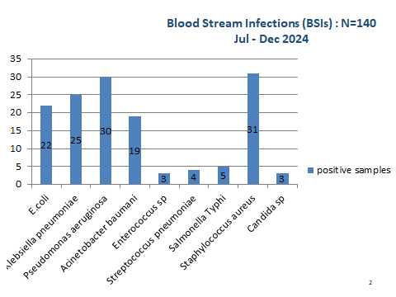

FIGURE 2
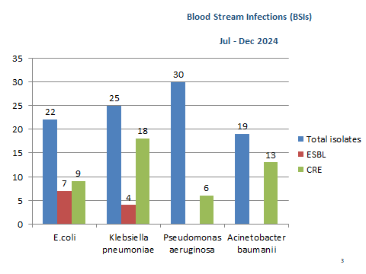

FIGURE 3
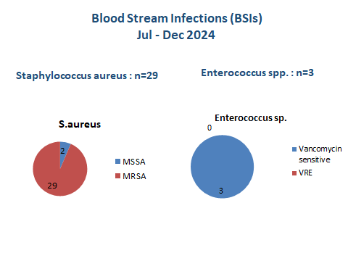

FIGURE 4
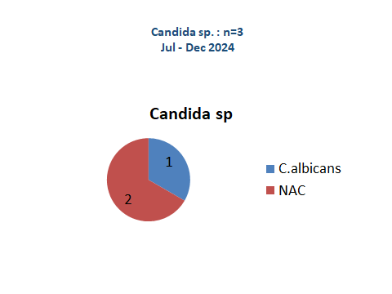

Discussion
Bloodstream infections (BSIs) remain a major cause of morbidity and mortality worldwide, particularly among hospitalized and critically ill patients. Early identification of causative organisms and their antimicrobial susceptibility patterns is essential for prompt treatment and improved clinical outcomes. In the present study, the blood culture positivity rate was 29.7%, which is comparable with findings reported from similar tertiary care hospital–based studies in India and other developing countries^{(8,9)}. Variations in positivity rates across studies may be attributed to differences in patient population, infection control practices, prior antibiotic exposure, and blood culture techniques⁽¹⁰⁾.
In the current study, Gram-negative bacilli predominated among the isolates, with Pseudomonas aeruginosa being the most frequently isolated Gram negative organism. This finding is consistent with several hospital-based studies where Gram-negative pathogens were predominant causes of nosocomial bloodstream infections. The higher prevalence of these organisms may be related to prolonged hospital stay, invasive procedures, intensive care unit admissions, use of indwelling medical devices, and widespread empirical antibiotic therapy⁽¹¹⁻¹³⁾.
A significant level of antimicrobial resistance was observed among Gram-negative isolates, particularly Klebsiella pneumoniae and Acinetobacter baumannii. High rates of carbapenem resistance among these pathogens are alarming because carbapenems are often considered last-resort antibiotics for multidrug-resistant infections. The emergence of Extended Spectrum Beta-Lactamase (ESBL)-producing Enterobacterales in the present study further highlights the growing burden of antimicrobial resistance and emphasizes the need for rational and judicious antibiotic use^{(14,15)}.
Among Gram-positive organisms, a considerable proportion of Staphylococcus aureus isolates were identified as Methicillin-Resistant Staphylococcus aureus (MRSA), indicating the continued importance of MRSA as a major healthcare-associated pathogen. However, all Enterococcus isolates remained sensitive to vancomycin, and no Vancomycin-Resistant Enterococci (VRE) isolates were detected during the study period. This finding may reflect effective antimicrobial stewardship and infection control measures within the institution⁽¹⁶⁾.
Fungal bloodstream infections were also identified, with non-albicans Candida species being more common than Candida albicans. Similar epidemiological trends have been increasingly reported worldwide. The rising prevalence of non-albicans Candida species is clinically significant because many of these species exhibit reduced susceptibility to commonly used antifungal agents, thereby complicating treatment strategies(¹⁷⁾.
The findings of the present study underscore the importance of continuous microbiological surveillance and periodic monitoring of antimicrobial susceptibility patterns. Such surveillance data are essential for guiding empirical therapy, developing institutional antibiotic policies, strengthening antimicrobial stewardship programs, and implementing effective infection prevention and control practices.
Limitations of the Study
The study was retrospective in nature and dependent on available laboratory records. Clinical correlation and patient outcome analysis could not be performed. Molecular characterization of resistant isolates was not carried out due to resource limitations. Being a single-center study, the findings may not be generalizable to all healthcare settings.

Conclusion
The present study demonstrates that Gram-negative bacilli are the predominant causes of bloodstream infections, with an alarming rise in multidrug-resistant organisms including carbapenem-resistant isolates and MRSA. Continuous surveillance, strict infection control practices, and rational antibiotic use are crucial to reduce the burden of antimicrobial resistance and improve patient outcomes.

References
- Timsit J-F, Ruppé E, Barbier F, Tabah A, Bassetti M. Bloodstream infections in critically ill patients: an expert statement. Intensive care medicine. 2020;46(2):266-84.
- Gohel K, Jojera A, Soni S, Gang S, Sabnis R et al. Bacteriological Profile and Drug Resistance Patterns of Blood Culture Isolates in a Tertiary Care Nephrourology Teaching Institute. BioMed Res Int 20014; 5.
- Asrat D, Amanuel YW. Prevalence and Antibiotic Susceptibility Pattern of Bacterial isolates from Blood Culture in Tikur Anbessa Hospital, Addis Ababa Ethiopia. Ethiop Med J 2001; 2: 97-104.]
- Forbes BA, Sahm DF and Weissfeld AS. In (ed). Bailey and Scott’s Diagnostic Microbiology: A textbook for isolation and identification of pathogenic microorganisms,11th ed., The Mosby Company, St. Louis 2002 pp. 378 -422.
- Giacobbe DR, Battaglini D, Ball L, Brunetti I, Bruzzone B, Codda G, et al. Bloodstream infections in critically ill patients with COVID‐19. European journal of clinical investigation. 2020;50(10):e13319.
- Marchello CS, Dale AP, Pisharody S, Rubach MP, Crump JA. A systematic review and meta-analysis of the prevalence of community-onset bloodstream infections among hospitalized patients in Africa and Asia. Antimicrob Agents Chemother. 2019;64:e1974–2019. doi: 10.1128/AAC.01974-19.
- Banik A, Lyngdoh VW, Durairaj E, Phukan AC, Kotal R. Ecology of bloodstream infections and temporal trends of their antibiograms with respect to source and duration of incubation: A 5-year retrospective observational analysis. J Lab Physicians. 2020;12:56–67. doi: 10.1055/s-0040-1714199.
- Ejaz A, Khawaja A, Arshad F, Tauseef A, Ullah R, Ahmad I. Etiological profile and antimicrobial patterns in blood culture specimens in a tertiary care setting. Cureus. 2020;12:e11000. doi: 10.7759/cureus.11000.
- Parihar RS, Agrawal R, Khatri PK, Soni P, Duggal S, Dhoundyal R. Rapid identification of clinically important aerobic microorganisms by automated blood culture system and their antimicrobial resistance pattern at tertiary care hospital at Western Rajasthan India. J Med Sci Clin Res 2015;3:6359-66.
- Lee A, Mirrett S, Reller LB, Weinstein MP. Detection of bloodstream infections in adults: How many blood cultures are needed? J Clin Microbiol. 2007;45:3546–8. doi: 10.1128/JCM.01555-07.
- Vijay Prakash Singh, Abhishek Mehta, Bacteriological profile of blood stream infections at a Rural tertiary care teaching hospital of Western Uttar Pradesh, Indian Journal of Basic and Applied Medical Research; June 2017: 6(3), P. 393-401.
- Vanitha RN, Kannan G, Venkata NM, Vishwakanth D, Nagesh VR, Yogitha M, et al. A retrospective study on blood stream infections and antibiotic susceptibility patterns in a tertiary care teaching hospital. Int J Pharm Sci 2012;4:543-8.
- Devi V, Sahoo B, Damrolien S, Praveen S, Lungran P, Devi M. A study on the bacterial profile of bloodstream infections in Rims Hospital. J Dent Med Sci 2015;14:18-23.
- Wasihun AG, Wlekidan LN, Gebremariam SA, Dejene TA, Welderufael AL, Haile TD, et al. Bacteriological profle and antimicrobial susceptibility patterns of blood culture isolates among febrile patients in Mekelle Hospital Northern Ethiopia. Springerplus. 2015;4:314. doi: 10.1186/s40064-015-1056-x.
- Thakur S, Thakur K, Sood A, Chaudhary S. Bacteriological profile and antibiotic sensitivity pattern of neonatal septicaemia in a rural tertiary care hospital in North India. Indian J Med Microbiol. 2016;34:67–71. doi: 10.4103/0255-0857.174108.
- Banik A, Bhat SH, Kumar A, Palit A, Snehaa K. Bloodstream infections and trends of antimicrobial sensitivity patterns at Port Blair. J Lab Physicians 2018;10:332-7.
- Chakrabarti A, Chatterjee SS, Rao KL, Zameer MM, Shivaprakash MR, Singhi S, et al. Recent experience with fungaemia: Change in species distribution and azole resistance. Scand J Infect Dis 2009;41:275-84.

