Original article:
Prevalence of knee cartilage degeneration between obese and non-obese menopausal women
Dr.Hafiza Ibadasuk Syiem* , Dr Ekta Chitkara ,Mukul Kaushik

Department of Physiotherapy
Manav Rachna International Institute of Research and Studies, Faridabad, Haryana.
Corresponding author*

ABSTRACT
AIM: The aim of this study is to find the relationship between obesity and osteoarthritis in menopausal women through KOOS questionnaire.
METHOD: 70 samples of menopausal women between the age of 45-55 were taken. It was divided into two groups: obese and non-obese groups with 35 subjects each group. Data was collected using KOOS scale questionnaire. The data was being analyzed in an IASP software.
RESULTS: The observed mean is 50.083 for obese and 64.980 for non-obese. Median is 41.310 and 69.050 for obese and non-obese respectively. Skewness of symmetry for obese and non-obese is 1.859 and 1.053 respectively. Similarly, the variance is 1793.688 and 1845.540 for obese and non-obese respectively with kurtosis of 4.250 and 3.190 respectively for obese and non-obese. Therefore through the KOOs scoring scale, it is found that Pain, ADL functions and Sports and Recreation functions will increase in obese group representing the prevalence of knee OA and the other two dimensions, i.e, Symptoms and knee- Based Quality of life will be deteriorated in obese group and for non-obese group, it is vice versa.
CONCLUSION: Subjects with obesity have the high tendency of developing knee cartilage degeneration as compared to the non-obese subjects. Therefore it is necessary to provide awareness about the importance of physical fitness not only to prevent from OA but also to prevent from many other complications or diseases.

INTRODUCTION
Cartilage Degeneration also known as Osteoarthritis is a progressive and degenerative disease of the joints that results from the combined factors such as the age of the person, genes, trauma, alignment of knee and obesity, etc.^{[3]}. The symptoms includes joint pain, crepitus, tenderness, limited movements with some degree of inflammation leading to the major cause of physical disability and impaired quality of life leading to chronic pain, joint destruction, disability and even depression^{[2]}. By 2020, OA has been estimated as the fourth leading cause of disability. It is common in the middle-aged and elderly people and the prevalence increases with the increase in age. Before the age of 45, OA is more common in men as compared to women but after the age of 45, it is more common in women. There are evidences indicating the major risk of OA which includes age, female, obesity, genetic factors, vitamin D deficiency, occupational knee-bending and physical labor. When there is lack of exercises, diabetes and obesity, it also aggravates the degeneration^{[7]}.
Obesity which is one of the global health challenges is a chronic disease which results due to the imbalance between the energy ingested in the food and the energy that has been expended. The excess energy is being stored in the fat cells which enlarges or get increased in number^{[23]}. BMI > 30 kg/m² is considered as obese.^{[24]}. Obesity is known as the risk factor of osteoarthritis because the increased body weight is said to have an impact on the joints by putting excess load and forces on the weight-bearing joints^{[1]}. BMI plays a very significant role in the pathological changes of the subchondral bone during the development of osteoarthritis. Subchondral bone along with its plate and trabecular bone, exerts a function that usually absorbs stress and supports the metabolism of healthy joints. So, during the process of OA development, these plates and trabecular bone becomes thinner and decreased in bone volume respectively^{[14]}.
Menopause is the cessation of menstruation which results from the functional loss of ovarian follicular activity and therefore transforming the female’s body from fertile into infertile state^{[27]}. During the menopausal stage, various changes takes place in the female’s body and mostly there is skeletal as well as cardiovascular system changes. The signs and symptoms includes disorders related to Central Nervous System, Cardiovascular System, Musculoskeletal changes, Metabolic, Weight, Urogenital and Skin atrophy and Sexual Dysfunction^{[25]}. Females in the menopausal age, is said to face these problems because at this point, they tend to gain weight, loses the protection of estrogen and they become less active^{[7]}.
Cassandra Et. Al in 2006, conducted a study to determine the effect of weight and physical activity on the prevalence of Radiological Knee Osteoarthritis (OA) in middle aged women where the result shows that there is increase in average weight by 4kg with 29% of women have osteophytes and 42% had evidence of JSN (Joint Space Narrowing)^{[10]}. Another study by Eiji Sasaki Et et al Hirosaki university in 2016, aimed to investigate the relationship between menopausal conditions, bone mineral density (BMD) and KOA (knee osteoarthritis). 518 female volunteers enrolled in cohort-study and was divided into groups (pre and post-menopausal). Antimullerian Hormone (AMH) was measured as a predictive marker for menopause in pre-menopausal subjects. Weight bearing anterior-posterior knee radiographs were classified by Kellgren-Lawrence Grade. Grade ≥ 2 is defined as Definitive KOA (DKOA). Early KOA (EKOA) was defined by Luyten’s criteria and BMD was measured at distal radius. Results of study found that 50 participants (10%) were diagnosed with EKOA and 204 (39.4%) with DKOA. 393 (75.9%) females began menopause and prevalence of DKOA was up to 48.1% and > 12% in pre-menopause females. Study analysis showed that lower AMH was related to EKOA and DKOA, and lower BMD and high turn over bone metabolism were correlated to DKOA^{[18]}. A study by Bhaskar A et al. Int J community Med Public Health, in 2016, aims to find out the prevalence of knee OA in middle aged women along with its associated factors and the results came out with the prevalence of knee OA was 41.6% (95% CI- 41.6 ±1.25%). Among them, 66.2% had bilateral knee OA, 64.7% had knee stiffness, 43.6% locking, 39.1% crepitus. 38.5% clicking of joint, 26.2% joint swelling and 22.1% bony outgrowths. Joint restriction of knee on movement was found in 63.5%. When the study population is being categorized as per their BMI as obese and non-obese according to WHO, it was found that OA was statistically associated with BMI>30 (54.7% vs 39.4%, Chi square value -4.371 and p value -0.027 (OR= 1.68 (1.03 – 3.33)^{[7]}. Ray Marks et al 7 July 2007, stated that 80% of all cohorts present were obese saying that those with higher BMIs have reported more pain compared to those with lesser BMIs (p < 0.05) and the pain is perceived due to physical exertion (p < 0.05)^{[21]}. Huaqing Zheng et al 2014, says that subjects who are overweight and obese have the tendency in having a higher risk of developing knee osteoarthritis at 2.45(95% Cl 1.88 to 3.20, p<0.001) and 4.55 (95% Cl 2.90 to 7.13, p<0.001) respectively^{[3]}. Leena Sharma et al 2000, concluded the study saying that, BMI relates to the severity of knee OA in patients with varus knee but it does not relate with people having valgus knee^{[12]}. Felson et al. 2000 states that a person who is overweight can reduce their weight in order to lessen the risk for osteoarthritis because an overload on the knee causes the knee to become week and therefore, breaking down of the cartilage. It also leads to a support failure of the ligaments and surrounding structures of the knee joint^{[4]}.
MATERIALS AND METHODS

Since the study took place during the covid -19 pandemic, this study was conducted online. A total of 75 menopausal women between the age of 45-55 years old were included in the study and they were divided into two groups- obese group and non-obese group with 35 subjects in each group after their BMI was calculated. A consent form was given and made them aware about the study and therefore explaining them about the benefits of the study and then KOOS questionnaire was being shared. Data was collected along with others factor like weight(kg), height(cm), height(m) and BMI. Responses were recorded and their data was being analysed in the IASP software. Descriptive statistics was used for the analysis of KOOS score of the different five dimensions into two groups, i.e, obese and non-obese.
INCLUSION CRITERIA
- Obese and non-obese menopausal women
- Age- 45 – 55 years old
- Ability to understand questionnaire

EXCLUSION CRITERIA
- Subjects who are not willing to participate in the study
- Males
- Psychological patients
- Knee deformities
- Malignancy
- Knee replacement
- Hormonal replacement therapy
- Hyperthyroidism

INSTRUMENTATION AND TOOLS
- KOOS Scale questionnaire.

PROCEDURE:

Since the study took place during the covid -19 pandemic, this study was conducted online. A total of 75 menopausal women between the age of 45-55 years old were included in the study and they were divided into two groups- obese group and non-obese group with 35 subjects in each group after their BMI was calculated. A consent form was given and made them aware about the study and therefore explaining them about the benefits of the study and then KOOS questionnaire was being shared. Data was collected along with others factor like weight(kg), height(cm), height(m) and BMI. Responses were recorded and their data was being analysed in the IASP software. Descriptive statistics was used for the analysis of KOOS score of the different five dimensions into two groups, i.e., obese and non-obese.

RESULT-

The observed mean is 50.083 for obese and 64.980 for non-obese. Median is 41.310 and 69.050 for obese and non-obese respectively. Skewness of symmetry for obese and non-obese is 1.859 and 1.053 respectively. Similarly, the variance is 1793.688 and 1845.540 for obese and non-obese respectively with kurtosis of 4.250 and 3.190 respectively for obese and non-obese. Therefore, through the KOOs scoring scale, it is found that Pain, ADL functions and Sports and Recreation functions will increase in obese group representing the prevalence of knee OA and the other two dimensions, i.e., Symptoms and knee- Based Quality of life will be deteriorated in obese group and for non-obese group, it is vice versa.

Descriptive Statistics
 |  | V1 |  | obese | Nonobese
Valid |  | 9 |  | 9 |  | 9
Missing |  | 0 |  | 0 |  | 0
Mean |  |  |  | 50.083 |  | 64.982
Std. Error of Mean |  |  |  | 14.117 |  | 14.320
Median |  |  |  | 41.310 |  | 69.050
Mode | ᵃ |  |  | 1.499 |  | 1.559
Std. Deviation |  |  |  | 42.352 |  | 42.960
Variance |  |  |  | 1793.688 |  | 1845.540
Skewness |  |  |  | 1.859 |  | 1.053
Std. Error of Skewness |  |  |  | 0.717 |  | 0.717
Kurtosis |  |  |  | 4.250 |  | 3.190
Std. Error of Kurtosis |  |  |  | 1.400 |  | 1.400
Minimum |  |  |  | 1.499 |  | 1.559
Maximum |  |  |  | 149.914 |  | 159.460
Sum |  |  |  | 450.744 |  | 584.839
25th percentile |  |  |  | 34.430 |  | 59.850
50th percentile |  |  |  | 41.310 |  | 69.050
75th percentile |  |  |  | 42.660 |  | 69.750

TABLE NO-1:
There were 70 subjects in total, which was divided into two groups as 35 obese and 35 non-obese group. There is V1 group showing the different five dimensions of KOOS Scale along with the inclusion of BMI (Body Mass Index), height (in cm), height (in metres) and weight (in kg).

Frequencies for V1
V1 | Frequency |  | Percent |  | Valid Percent |  |  | Cumulative Percent
ADL Functions |  | 1 |  | 11.111 |  | 11.111 |  |  | 11.111
Knee based -QOL |  | 1 |  | 11.111 |  | 11.111 |  |  | 22.222
Pain |  | 1 |  | 11.111 |  | 11.111 |  |  | 33.333
Sport and Recreation Function |  | 1 |  | 11.111 |  | 11.111 |  |  | 44.444
Symptoms |  | 1 |  | 11.111 |  | 11.111 |  |  | 55.556
BMI |  | 1 |  | 11.111 |  | 11.111 |  |  | 66.667
Height in metre |  | 1 |  | 11.111 |  | 11.111 |  |  | 77.778
Height in cm |  | 1 |  | 11.111 |  | 11.111 |  |  | 88.889
Weight n kg |  | 1 |  | 11.111 |  | 11.111 |  |  | 100.000
Missing |  | 0 |  | 0.000
Total |  | 9 |  | 100.000

TABLE NO-2

Scatter Plots

Obese - Non obese

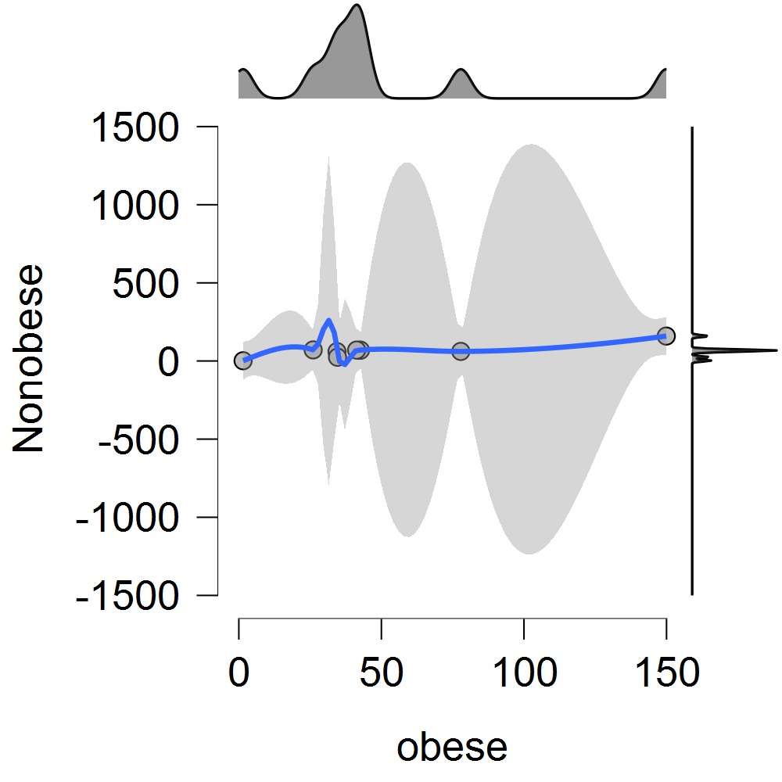

GRAPH NO-1 Prior and Posterior

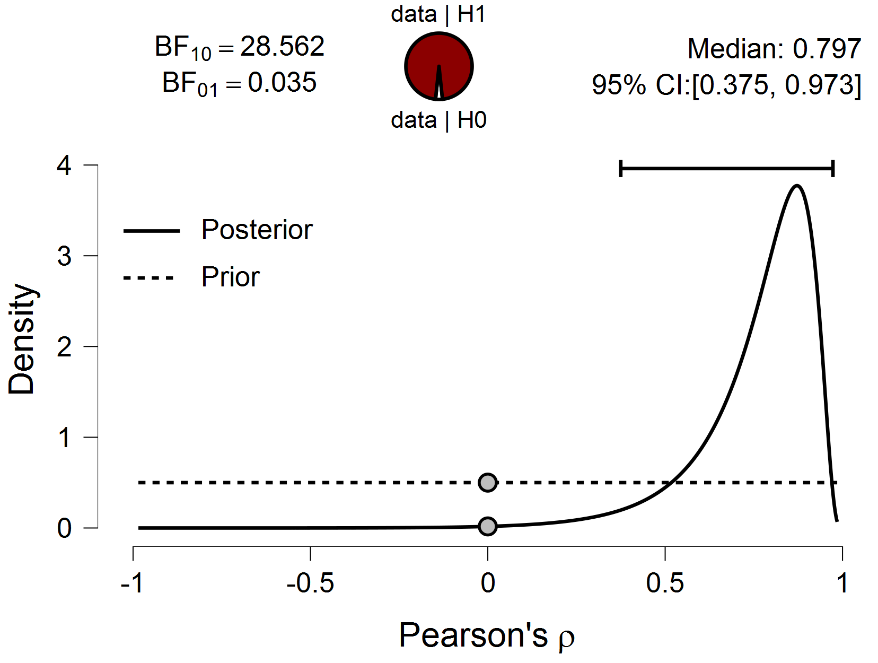

GRAPH NO-2 Bayes Factor Robustness Check
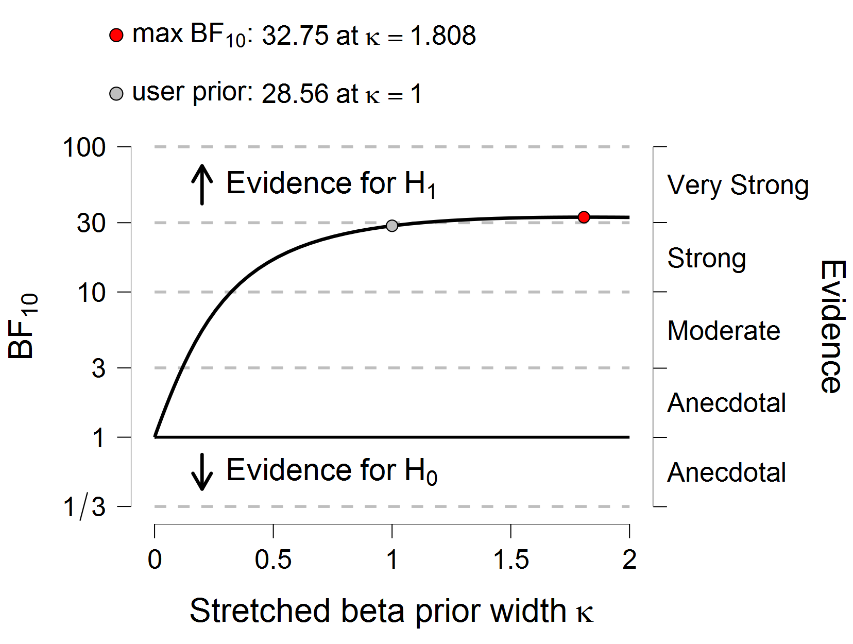

GRAPH NO-3

TABLE:- KOOS SCORING

 | Pain | Symptoms | ADL function | Sports and recreation | QOL
Obese  KOOS Score | 42.39 | 42.66 | 41.31 | 34.43 | 26.08
Non-obese KOOS score | 69.05 | 69.08 | 69.75 | 59.85 | 70.9

DISCUSSION
The purpose of the study was to check out the statistical relationship between obesity and cartilage degeneration of knee using the KOOS questionnaire in obese and non-obese menopausal women.After the questionnaire was shared and their responses were recorded, every subject gained their scoring points according to the scoring rule of the KOOS questionnaire. After analysing the score with BMI (Body Mass Index), height (in cm), height (in metres) and weight (in kg), the observed mean according to the descriptive statistics is 50.083 for obese and 64.980 for non-obese respectively.
With the reference of the Table No- 1, median is 41.310 and 69.050 respectively for both obese respectively and the measure for skewness of symmetry is 1.859 and1.053 for obese as well as for non-obese respectively.
Similarly, the variance for obese is 1793.688 and for non-obese is1845.540 with kurtosis of 4.250 and 3.190 for obese and non-obese respectively. With the reference of frequency table no 5.2, the frequency of V1 shows the five dimensions of KOOS scale questionnaire which includes (1) Activity of Daily Life functions (ADL- functions), (2) Knee based Quality of Life (QOL), (3) Pain, (4) Sports and Recreation Function and the 5th dimension is the symptoms with other four dimensions like BMI, Height (in m), Height ( in cm) and Weight (in kg).
As per the graph no 1- Scatter Plots- obese and non-obese, shows the value relations between obese and non-obese respectively which represents the direct proportional relations between obese and non-obese groups respectively.
Therefore, the study of these two groups shows that the three of the KOOS dimension that is, Pain, ADL Functions and Sports and Recreation Functions will increase in the obese group which represents the prevalence of developing a knee cartilage degeneration in the obese group and vice versa.
In summary, it seems that the potential of the current analysis of obese group is that the Pain, ADL functions and Sports and Recreation function will increase with the increase in obesity and it will result in developing a knee cartilage degeneration which is more prone in obese group as compared to the non-obese group. The other two dimensions that is, Symptoms and Knee-based Quality of Life will be deteriorated in the obese group and it will be well performed in the non-obese group in this particular study.
CONCLUSION:
This study concluded that, subjects with obesity have the chances of developing knee cartilage degeneration more comparing to the non-obese set. So, there is a statistical relationship between obesity and cartilage degeneration, Therefore it is necessary to provide awareness about the importance of physical fitness not only to prevent from OA but also to prevent from many other complications or diseases.

REFERENCE:

- Hakan Nur, Tiraje Tuncer, Department of Physical Medicine and Rehabilitation, Medical Faculty of Akdeniz University, Antalya, Turkey: The relationship between body composition and knee oateoarthritis in post-menopausal women. Received: March 17, 2017, Accepted: July 18, 2017, Published online: March 03, 2018.
- Makundan Attur, Svetlana Krasnokutsky- Samuels, Jonathan Samuels,and Steven B. Abramson, New York University of Medecine, and Hospital for Joint Diseasees at NYU Langone Medical Center, New York, USA: Progostic Biomakers in Osteoarthritis, Curr Opin Rheumatol. 2013 January; 25 (1) :136-144.
- Huaqing Zheng, Changhong Chen: Body MassIndex and risk of knee osteoarthritis: a systemic review and meta analysis of prospective studies, 2014.
- David Felson, Paul Dieppe, Nancy E Lane, Yuqing Zhang et al. Osteoarthritis: New insights, Part 1: The disease and its risk factors. Annals of Internal Medicine, 133, 635-646, November 2000.
- Cassandra Szoeke, Lorraine Dennerstein, Jannet Guthrie, Margaret Clark, and Flavia Cicuttini et al. The relationship between Prosective Assessed Body Weight and Physical activity and Prevalence of Radiological Knee Osteoarthritis in Postmenopausal women, accepted for publication May 9, 2006.
- Anandacoomarasamy A, Caterson I, Sambrook P, Fransen M, March L. The impact of obesity on the musculoskeletal system. Int J Obes (Lond) 2008;32:211–22.
- Anitha B, Binu A, Bindhu V, Ajith R, Surekh R, Suraj S et al Osteoarthritis ofknee and factors associated with it in middle aged women in a rural area of Central Kerala, India: Int. J Community Med. Public Health. 2016 oct; 3(10): 2926-2931.
- MaryFran S¹, Marc H², Jeffrey P. C³, Anthony M¹, Mary C¹, and Sharon U¹ et al Association of Bone Mineral Density and sex Hormone evels with osteoarthritis of the Hand and Knee in Premenopausal women. American J Epidemiol 1996; 143:38-47.
- Harshal S¹, Vivek G², C Palanivel¹, Kapil Y², Bir Singh³ et al Prevalence of Knee Osteoarthritis amngst perimenopausal women in an urban resettlement colony in South Delhi, volume 54, 2010.
- Cassandra El S, Flavia Maria C, James R.G, Malcolm S.C, Lorraine et al. Factors affecting the prevalence of osteoarthritis in healthy middle-middle aged women: Bone 39(5), 1149-1155, 2006.
- Flavia M. Cicuttini, Juliet R. Barker and Tim D. Spector et al The Association of Obesity with Osteoarthritis of the Hand and Knee: A twin study, J Rheumatol 1996; 23:1221-6).
- Leena S, Congrong L, September C, and Dorothy D. Dunlop: The mechanism of the effect of obesity in Knee Osteoarthritis et al. March 2000, Volume 3, American College of Rheumatology.
- Muhammad Navaid I,¹Fakhir R.H,² Balchand M,³Abdul M⁴ et al Liaquat National Hospital,^{1,4} Karachi: Frequency of factors associated with knee osteoarthritis, Vol 61, No.8, August 2011.
- Lianzhi Chen ª , Jessica Jun Yi Zheng ^{b} , Guangyi Li ^{c} , Jun Yuan ^{a,d} , Jay R. Ebert ^{e}, Hengyuan Li ^{f}, John Papadimitriou ^{a,g} , Qingwen Wang ^{h} , David Wood ª , Christopher W. Jonesi,^{j},**, Minghao Zheng ^{a,d},*: Pathogenesis and clinical management of obesity-related knee osteoarthritis: Impact of mechanical loading, Received 27 November 2019; Received in revised form 28 April 2020; Accepted 2 May 2020.
- Przemyslaw T.P,^{1,2} Stefan B,³ Anne S.L⁴, L Stefan L¹, and Eva M. Roos^{*1,3}: Knee complaints vary with age and gender in the adult population, BMC Musculoskeletal disorders, 02 May 2006.
- MaryFran S¹, Mary L.J¹, Mellisa G², Carrie A. Karvonen- Gutierrez¹, Riann M.P².Mary C¹, and Kerry Richards-Mc Cullough¹: Performance based Physical functioning in African-American and Cuscasian women at midlife. Am J Epidemiol 2006; 163: 950-958.
- MaryFran R. Sowers and Carrie A. Karvonen-Gutierrez Department of Epidemiology, Unversity of Michigan School of Public Health, Ann Arbor, Michigan, USA: The evolving role of obesity in knee osteoarthritis, Curr Opin Rheumatol. 2010 September ; 22(5): 533–537.
- Eiji S, Daisuke C, Seiya O, Yuka K,Shizuka S, Yuji Y, Maika O, Kaori I, Masataka A, Mika K , Eiichi T, Yasuyuki I et al Hirosaki University Graduate School of Medicine: Epidemiological study on the relationship among menopausal condition, bone fragility, and knee osteoarthritis.
- Andrew J. T^{1,2}, Anita E. W² , Pushpika W², Yuanyuan W² , Ali Ghasem-Zadeh³ Flavia M. Cicuttini^{2*}:Wolff’s law in action: a mechanism for early knee osteoarthritis, Teichtahl et al. Arthritis Research & Therapy (2015) 17:207.
- Jorge A Roman-B^{1,2}, Santos C³, Raquel L¹ and Gabriel Herrero-Beaumon¹ et al. Osteoarthritis associated with estrogen deficiency, Arthritis Research & Therapy 2009, 11:241.
- Ray Marks et al: obesity profiles with knee osteoarthritis: correlation with pain, disability, disease progression, 26th December 2016.
- Min Zhou et al. BMC Public Health: combined effects of reproductive and hormone factors and obesity on the prevalence of knee osteoarthritis and knee pain among middle-aged or older Chinese women. 2018.
- GEORGE A. BRAY Pennington Biomedical Research Center, Baton Rouge, Louisiana 70808: Medical Consequences of Obesity:The Journal of Clinical Endocrinology & Metabolism 89(6):2583–2589: 2004.
- Ryan T. Hurt, MD, PhD, Christopher Kulisek, MD, Laura A. Buchanan, MD, and Stephen A. McClave, MD: The Obesity Epidemic: Challenges, Health Initiatives, and Implications for Gastroenterologists; Gastroenterology & Hepatology Volume 6, Issue 12 December 2010.
- Anna Fenton & Nick Panay (2016) Estrogen, menopause and joints, Climacteric, 19:2, 107-108, DOI: 10.3109/13697137.2016.1151151.
- Mahbubur Rahman, MD, PhD, MPH and Abbey B. Berenson, MD, MMS: Accuracy of current body mass index obesity classification for white, black and Hispanic reproductive-age women: Obstet Gynecol. 2010 May ; 115(5): 982–988.
- I. M. P. S. Ilankoon¹*, K. Samarasinghe² and C. Elgán²: Menopause is a natural stage of aging: a qualitative study: Ilankoon et al. BMC Women’s Health (2021) 21:47.

Author Declaration: Source of support: Nil, Conflict of interest: Nil
Was informed consent obtained from the subjects involved in the study? YES
For any images presented appropriate consent has been obtained from the subjects: NA
Plagiarism Checked: Urkund Software
Author work published under a Creative Commons Attribution 4.0 International License
DOI: 10.36848/IJBAMR/2020/29215.55875

