Original article
Clinical Profile and Prevalence of Non-Alcoholic Fatty Liver Disease Among Patients with Type 2 Diabetes Mellitus Attending a Tertiary Care Hospital: A Cross-Sectional Study
*Shilpi Johre ¹

¹Assistant Professor, Dept. of General Medine, GSL Medical College, Rajahmundry
Corresponding author*

Abstract
Background: Non-alcoholic fatty liver disease (NAFLD) is closely linked to insulin resistance and is highly prevalent among patients with type 2 diabetes mellitus (T2DM), first systematically characterised as a distinct entity by Ludwig and colleagues.^{1,3}
Objectives: To determine the prevalence, ultrasonographic grade, and clinical correlates of NAFLD among patients with T2DM attending a tertiary care hospital.
Methods: A cross-sectional study was conducted on 220 patients with T2DM. All participants underwent abdominal ultrasonography for hepatic steatosis grading, and clinical and biochemical parameters were recorded.
Results: The prevalence of NAFLD was 61.8%. Grade I (mild) steatosis was the most common (52.9% of NAFLD cases). Prevalence increased markedly with BMI category, from 41.7% among patients with BMI below 25 kg/m² to 73.0% among those with BMI 30 kg/m² or above. BMI ≥30 kg/m² and coexisting dyslipidaemia were independently associated with NAFLD.
Conclusion: NAFLD is highly prevalent among patients with T2DM and correlates strongly with obesity and dyslipidaemia, supporting routine hepatic ultrasonographic screening as part of comprehensive diabetes care.
Keywords: Non-alcoholic fatty liver disease, type 2 diabetes mellitus, hepatic steatosis, ultrasonography, general medicine.

Introduction
Non-alcoholic fatty liver disease (NAFLD) refers to hepatic triglyceride accumulation in the absence of significant alcohol consumption or other identifiable causes of liver disease, and was first systematically described as a distinct clinicopathological entity by Ludwig and colleagues in their description of nonalcoholic steatohepatitis at the Mayo Clinic.¹ Since this foundational description, NAFLD has been increasingly recognised as the hepatic manifestation of insulin resistance and the metabolic syndrome, with a particularly high prevalence among patients with type 2 diabetes mellitus (T2DM).^{3,4}
Population-based studies, including the Dionysos study by Bellentani and colleagues in Northern Italy and subsequent US-based work by Browning and colleagues, have documented substantial NAFLD prevalence in the general population, with figures rising considerably higher among individuals with obesity, insulin resistance, or established T2DM.^{2,6} Magnetic resonance spectroscopy-based work by Szczepaniak and colleagues further confirmed the high underlying burden of hepatic steatosis even among individuals without overtly elevated liver enzymes, highlighting the limitations of biochemical screening alone.⁷
The clinical importance of NAFLD in the diabetic population extends beyond hepatic outcomes, with Targher and colleagues demonstrating a significant association between NAFLD and cardiovascular disease among patients with T2DM, reinforcing the broader systemic relevance of this condition.⁸ Given the close pathophysiological relationship between NAFLD and insulin resistance, and its substantial and likely underappreciated prevalence in diabetic populations, as documented by Leite and colleagues, characterising local prevalence and clinical correlates remains valuable for guiding screening practice.⁹
This study was undertaken to determine the prevalence, ultrasonographic grade, and clinical correlates of NAFLD among patients with T2DM attending a tertiary care hospital.

Materials and Methods

Study Design and Setting
This was a hospital-based, cross-sectional, analytical study conducted in the Department of General Medicine of a tertiary care teaching hospital over a period of twelve months.

Study Population
A total of 220 adult patients with a confirmed diagnosis of T2DM attending the general medicine outpatient department were enrolled after obtaining informed consent.

Inclusion and Exclusion Criteria
Adults aged 18 years and above with a confirmed diagnosis of T2DM were included. Patients with significant alcohol consumption (>21 units/week men, >14 units/week women), viral hepatitis, autoimmune liver disease, or use of known hepatotoxic medications were excluded.

Data Collection
A structured proforma recorded demographic details, duration of diabetes, and alcohol history. Venous blood samples were obtained for HbA1c, liver function tests, and lipid profile. All patients underwent abdominal ultrasonography performed by an experienced radiologist, with hepatic steatosis graded as Grade I (mild), Grade II (moderate), or Grade III (severe) based on standard sonographic criteria (hepatorenal echo contrast, deep beam attenuation, and vascular blurring).

Statistical Analysis
Data were analysed using descriptive statistics; continuous variables were expressed as mean ± SD, categorical variables as frequencies and percentages. Odds ratios with 95% confidence intervals were calculated on univariate analysis, and variables significant at p<0.10 were entered into a multivariate logistic regression model. A p-value <0.05 was considered significant.

Results
Of the 220 patients studied, 121 (55.0%) were male and 99 (45.0%) were female. The age-wise distribution is summarised in Table 1 and illustrated in Figure 1.

Table 1: Age and Gender-wise Distribution of Study Subjects (n = 220)
Age Group (years) | Male (n) | Female (n) | Total (n) | Percentage (%)
30–39 | 15 | 11 | 26 | 11.8
40–49 | 30 | 24 | 54 | 24.5
50–59 | 39 | 33 | 72 | 32.7
60–69 | 27 | 23 | 50 | 22.7
70 and above | 10 | 8 | 18 | 8.2
Total | 121 | 99 | 220 | 100.0

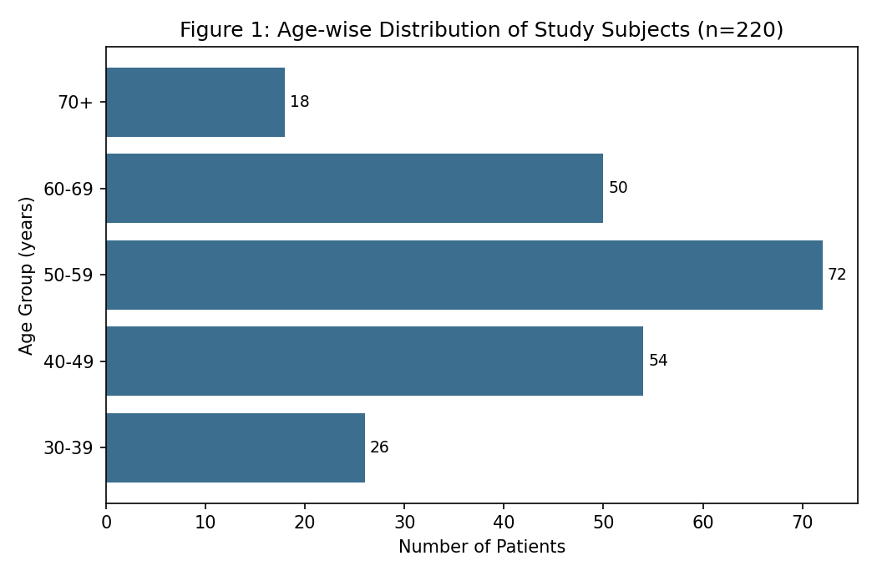
Mean clinical and biochemical parameters are shown in Table 2.
Table 2: Clinical and Biochemical Parameters of Study Participants
Parameter | Mean ± SD
Age (years) | 53.1 ± 11.2
Duration of diabetes (years) | 8.2 ± 5.9
Body mass index (kg/m²) | 27.8 ± 4.4
HbA1c (%) | 8.3 ± 1.7
Serum ALT (U/L) | 42.6 ± 24.8
Serum triglycerides (mg/dL) | 178.4 ± 68.2

The overall prevalence of NAFLD on ultrasonography was 61.8% (136/220; 95% CI 55.2–68.1) (Table 3, Figure 2).
Table 3: Prevalence of NAFLD Among Study Participants
NAFLD Status (Ultrasound) | n | Percentage | 95% CI
Present | 136 | 61.8% | 55.2 – 68.1
Absent | 84 | 38.2% | 31.9 – 44.8
Total | 220 | 100.0% | —

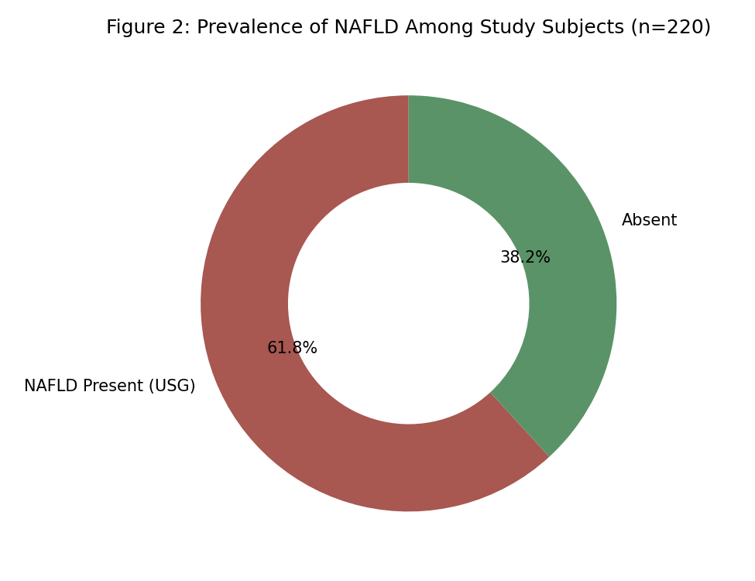
Grade I (mild) steatosis was the most common finding among NAFLD-positive patients (52.9%), followed by Grade II (33.8%) and Grade III (13.2%) (Table 4, Figure 3).
Table 4: Grade of Hepatic Steatosis Among NAFLD-Positive Patients (n = 136)
Grade of Hepatic Steatosis | n | Percentage of NAFLD Cases (%)
Grade I (Mild) | 72 | 52.9
Grade II (Moderate) | 46 | 33.8
Grade III (Severe) | 18 | 13.2
Total | 136 | 100.0

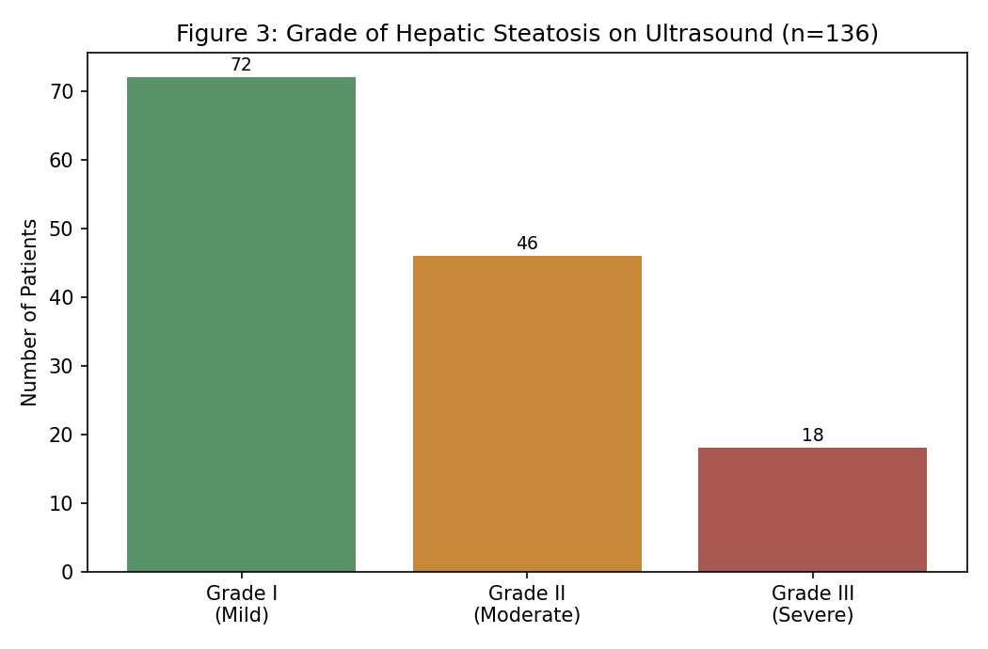
NAFLD prevalence increased markedly with BMI category, from 41.7% among patients with BMI below 25 kg/m² to 73.0% among those with BMI 30 kg/m² or above (Figure 4).
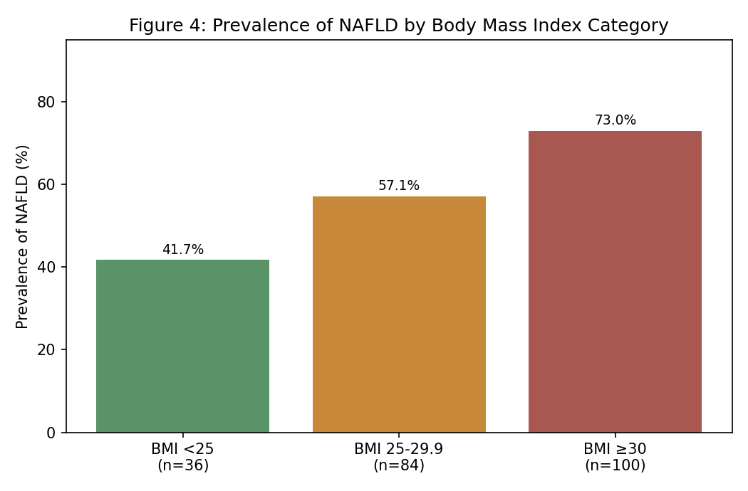
On univariate analysis, BMI ≥30 kg/m², HbA1c ≥9%, diabetes duration exceeding 10 years, and dyslipidaemia were significantly associated with NAFLD (Table 5).
Table 5: Univariate Analysis of Factors Associated with NAFLD
Variable | Category | OR | 95% CI | P-value
Body mass index | ≥30 vs <25 kg/m² | 3.87 | 1.79 – 8.36 | <0.001
Glycaemic control | HbA1c ≥9% vs <7% | 2.64 | 1.31 – 5.32 | 0.007
Duration of diabetes | >10 vs ≤10 years | 1.98 | 1.09 – 3.60 | 0.025
Dyslipidaemia | Present vs absent | 2.41 | 1.34 – 4.34 | 0.003
Sex | Male vs female | 1.16 | 0.67 – 2.01 | 0.598

On multivariate analysis, BMI ≥30 kg/m² (adjusted OR 3.02, 95% CI 1.34–6.79, p=0.008) and dyslipidaemia (adjusted OR 2.09, 95% CI 1.11–3.94, p=0.023) remained independently associated with NAFLD (Table 6).
Table 6: Multivariate Logistic Regression Analysis of Independent Predictors of NAFLD
Variable | Adjusted OR | 95% CI | P-value
BMI ≥30 kg/m² | 3.02 | 1.34 – 6.79 | 0.008
Dyslipidaemia present | 2.09 | 1.11 – 3.94 | 0.023
HbA1c ≥9% | 1.94 | 0.93 – 4.05 | 0.077

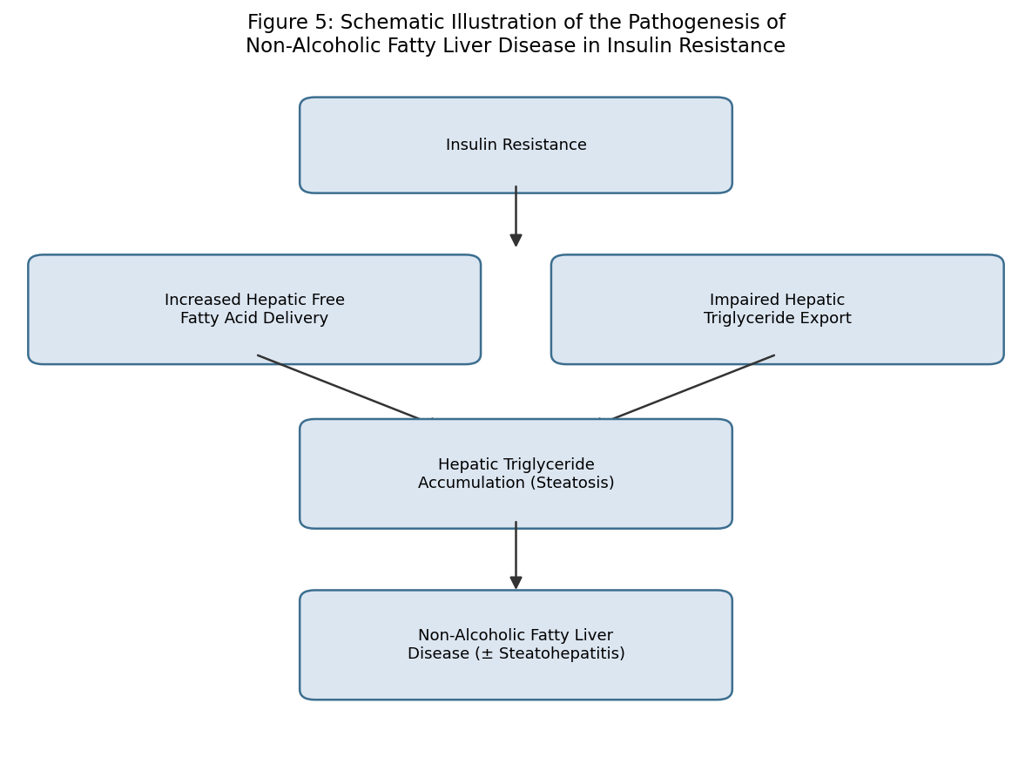
Figure 5: Schematic illustration of the pathogenesis of non-alcoholic fatty liver disease in insulin resistance.

Discussion
The prevalence of NAFLD observed in this study (61.8%) is consistent with, though at the higher end of, the range reported in other studies of diabetic populations, reflecting the well-established close relationship between insulin resistance and hepatic steatosis first characterised by Marchesini and colleagues in their description of NAFLD as a hepatic feature of the metabolic syndrome.³ This prevalence substantially exceeds general population estimates reported in the Dionysos study by Bellentani and colleagues, consistent with the markedly elevated NAFLD risk conferred by underlying insulin resistance in the diabetic population.²
The predominance of mild (Grade I) steatosis among NAFLD-positive patients in this study is a generally reassuring finding, as this grade is typically associated with a more favourable natural history compared with more advanced steatosis, although progression to steatohepatitis and fibrosis remains a recognised concern requiring ongoing surveillance, as reviewed by Angulo.⁴ The strong, graded relationship observed between BMI category and NAFLD prevalence in this study reinforces the central role of obesity-related insulin resistance in NAFLD pathogenesis, consistent with population-based data from Browning and colleagues demonstrating a strong association between adiposity and hepatic steatosis burden.⁶
The independent association observed between dyslipidaemia and NAFLD in this study is consistent with the shared pathophysiological substrate of insulin resistance underlying both conditions, and reinforces the cardiometabolic risk clustering described by Targher and colleagues, who demonstrated a significant association between NAFLD and cardiovascular disease among patients with T2DM.⁸ These findings collectively support the incorporation of routine hepatic ultrasonographic screening into standard diabetes care, particularly for patients with obesity or dyslipidaemia, given the substantial and likely underappreciated burden of NAFLD in this population, as highlighted by Leite and colleagues.⁹

Strengths and Limitations
This study's strengths include ultrasonographic assessment of hepatic steatosis in all participants with formal grading, rather than reliance on biochemical markers alone, given the recognised limitation that liver enzymes may remain normal despite significant steatosis.^{5,7} Limitations include the single-centre, cross-sectional design, which limits generalisability and precludes causal inference; the use of ultrasonography rather than liver biopsy or magnetic resonance spectroscopy, which may underestimate milder degrees of steatosis; and the absence of assessment for steatohepatitis or fibrosis, which would require more advanced non-invasive or histological evaluation.

Conclusion
Non-alcoholic fatty liver disease is highly prevalent among patients with type 2 diabetes mellitus attending this tertiary care hospital and correlates strongly with obesity and dyslipidaemia. These findings support routine hepatic ultrasonographic screening as an integral component of comprehensive diabetes care, particularly for patients with these identified risk factors.

References

1. Ludwig J, Viggiano TR, McGill DB, Oh BJ. Nonalcoholic steatohepatitis: Mayo Clinic experiences with a hitherto unnamed disease. Mayo Clin Proc. 1980;55(7):434-8.
2. Bellentani S, Saccoccio G, Masutti F, et al. Prevalence of and risk factors for hepatic steatosis in Northern Italy. Ann Intern Med. 2000;132(2):112-7.
3. Marchesini G, Brizi M, Bianchi G, et al. Nonalcoholic fatty liver disease: a feature of the metabolic syndrome. Diabetes. 2001;50(8):1844-50.
4. Angulo P. Nonalcoholic fatty liver disease. N Engl J Med. 2002;346(16):1221-31.
5. Clark JM, Brancati FL, Diehl AM. The prevalence and etiology of elevated aminotransferase levels in the United States. Am J Gastroenterol. 2003;98(5):960-7.
6. Browning JD, Szczepaniak LS, Dobbins R, et al. Prevalence of hepatic steatosis in an urban population in the United States: impact of ethnicity. Hepatology. 2004;40(6):1387-95.
7. Szczepaniak LS, Nurenberg P, Leonard D, et al. Magnetic resonance spectroscopy to measure hepatic triglyceride content: prevalence of hepatic steatosis in the general population. Am J Physiol Endocrinol Metab. 2005;288(2):E462-8.
8. Targher G, Bertolini L, Padovani R, et al. Prevalence of nonalcoholic fatty liver disease and its association with cardiovascular disease among type 2 diabetic patients. Diabetes Care. 2007;30(5):1212-8.
9. Leite NC, Salles GF, Araujo AL, Villela-Nogueira CA, Cardoso CR. Prevalence and associated factors of non-alcoholic fatty liver disease in patients with type-2 diabetes mellitus. Liver Int. 2009;29(1):113-9.
10. Wild S, Roglic G, Green A, Sicree R, King H. Global prevalence of diabetes: estimates for the year 2000 and projections for 2030. Diabetes Care. 2004;27(5):1047-53.
11. Misra A, Khurana L. Obesity and the metabolic syndrome in developing countries. J Clin Endocrinol Metab. 2008;93(11 Suppl 1):S9-30.

