Original article:

Clinical Profile, Bacteriological Spectrum, and Outcome of Neonatal Sepsis in a Special Newborn Care Unit of a Tertiary Care Hospital

Dr Shivhare Vivekkumar Kishor*

Assistant Professor ,Dept of Paediatrics , Fatima Institute of Medical Sciences,Kadapa

Corresponding author*

Abstract
Background: Neonatal sepsis remains one of the leading causes of neonatal morbidity and mortality, particularly in resource-limited settings, and its clinical presentation and bacteriological profile show considerable regional variation.
Objectives: To study the clinical profile, risk factors, bacteriological spectrum, and outcome of neonates with clinically suspected sepsis admitted to a special newborn care unit.
Methods: A prospective observational study was conducted on 137 neonates with clinically suspected sepsis admitted over the study period. Clinical features, antenatal and perinatal risk factors, blood culture results, and final outcome were recorded and analysed.
Results: Early-onset sepsis (within 72 hours of life) accounted for 42.3% of cases. Low birth weight (44.5%) and prematurity (39.4%) were the most common associated risk factors. Blood culture was positive in 80 of 137 neonates (58.4%), with Klebsiella pneumoniae (27.5%) being the most common organism isolated.The baseline composite sepsis screen demonstrated a sensitivity of 83.7%, specificity of 64.9%, positive predictive value (PPV) of 77.0%, and a negative predictive value (NPV) of 73.5% against blood culture. Antibiogram surveillance revealed high levels of resistance among Gram-negative isolates to first-line ampicillin and gentamicin, with Klebsiella pneumoniae showing 31.8% resistance to third-generation cephalosporins. Overall mortality was 6.6%.
Conclusion: Neonatal sepsis in this unit predominantly presented as early-onset disease associated with low birth weight and prematurity, with Klebsiella pneumoniae as the leading isolated organism, underscoring the importance of antenatal risk factor identification and prompt empirical antibiotic therapy pending culture results.
Keywords: Neonatal sepsis, early-onset sepsis, late-onset sepsis, blood culture, paediatrics.

Introduction
Neonatal sepsis remains one of the leading causes of neonatal mortality worldwide, contributing disproportionately to the burden of newborn deaths in low- and middle-income countries, where limited access to timely diagnostic and therapeutic services compounds the inherent vulnerability of the neonatal immune system.^{1,7} It is broadly classified into early-onset sepsis, presenting within the first 72 hours of life and typically resulting from vertical transmission of organisms from the maternal genital tract, and late-onset sepsis, occurring after 72 hours and more commonly associated with nosocomial or community-acquired infection.^{2,3}
A range of antenatal, intrapartum, and neonatal risk factors have been consistently associated with an increased risk of sepsis, including low birth weight, prematurity, premature or prolonged rupture of membranes, maternal peripartum fever, and difficult or prolonged labour, reflecting the multiple potential portals of entry for infection in the vulnerable newborn.^{4,7} The bacteriological spectrum of neonatal sepsis varies considerably between developed and developing country settings, with Gram-negative organisms such as Klebsiella pneumoniae and Escherichia coli predominating in many resource-limited settings, in contrast to the greater relative contribution of Group B Streptococcus and coagulase-negative staphylococci reported in high-income country series.^{7,8}
Given the non-specific and often subtle clinical presentation of neonatal sepsis, a high index of clinical suspicion combined with appropriate risk factor assessment remains essential for timely diagnosis and initiation of empirical therapy, as delays in treatment are directly associated with increased mortality.^{9,10} Characterising the local clinical profile, risk factor prevalence, and bacteriological pattern of neonatal sepsis remains important for guiding rational empirical antibiotic policy and targeted preventive strategies in individual healthcare settings.
This study was undertaken to describe the clinical profile, antenatal and perinatal risk factors, bacteriological spectrum, and outcome of neonates with clinically suspected sepsis admitted to a special newborn care unit of a tertiary care hospital.
Beyond its immediate clinical consequences, neonatal sepsis carries substantial implications for family and healthcare system resources, given the need for prolonged hospitalisation, intensive nursing care, and, in many cases, escalation to higher levels of neonatal support. Locally generated data on risk factor prevalence and bacteriological patterns can help inform targeted antenatal screening programmes, unit-specific empirical antibiotic protocols, and infection control practices, each of which has the potential to meaningfully reduce the burden of this largely preventable and treatable condition.

Materials and Methods

Study Design and Setting
This was a hospital-based, prospective observational study conducted in the Special Newborn Care Unit, Department of Paediatrics, of a tertiary care teaching hospital.

Study Population
A total of 137 neonates admitted with clinical features suggestive of sepsis were enrolled after obtaining informed parental consent.

Inclusion Criteria
Neonates aged 0 to 28 days admitted with clinical features suggestive of sepsis, including temperature instability, lethargy, poor feeding, respiratory distress, or other suggestive signs, were included.

Exclusion Criteria
Neonates with major congenital malformations, birth asphyxia as the primary diagnosis without associated features of sepsis, and those whose parents did not provide consent were excluded from the study.

Data Collection
A structured proforma was used to record maternal antenatal and intrapartum history, birth weight, gestational age, age at onset of symptoms, and clinical features at presentation. Sepsis screen (total leucocyte count, absolute neutrophil count, C-reactive protein, and micro-erythrocyte sedimentation rate) and blood culture were performed in all neonates prior to initiation of antibiotics.

Case Definitions
Early-onset sepsis was defined as onset of clinical features within 72 hours of birth, and late-onset sepsis as onset between 72 hours and 28 days of life. Low birth weight was defined as birth weight below 2500 grams, and prematurity as gestational age below 37 completed weeks.

Antibiotic Protocol
All neonates with clinically suspected sepsis received empirical intravenous antibiotic therapy as per unit protocol immediately after sepsis screen and blood culture sample collection, without awaiting culture results. Empirical therapy was subsequently modified based on culture and sensitivity results and clinical response, and duration of therapy was guided by clinical course and screening parameter trends in culture-negative cases.

Statistical Analysis
Data were entered into a spreadsheet and analysed using descriptive statistics. Categorical variables were expressed as frequencies and percentages. To evaluate the diagnostic accuracy of the composite sepsis screen, its performance metrics (sensitivity, specificity, positive predictive value, and negative predictive value) were calculated using blood culture confirmation as the definitive gold standard. Bivariate logistic regression analysis was executed to compute Odds Ratios (OR) with 95% Confidence Intervals (CI) to identify statistically significant antenatal and perinatal risk factors linked to culture-proven neonatal sepsis. P-values < 0.05 were deemed statistically significant.

Results
Of the 137 neonates studied, 79 (57.7%) were male and 58 (42.3%) were female. The age at onset distribution is summarised in Table 1 and illustrated in Figure 1.
Table 1: Age at Onset and Gender-wise Distribution of Study Subjects (n = 137)
Age at Onset | Male (n) | Female (n) | Total (n) | Percentage (%)
0–3 days (Early onset) | 34 | 24 | 58 | 42.3
4–7 days | 14 | 10 | 24 | 17.5
8–14 days | 11 | 8 | 19 | 13.9
15–21 days | 8 | 7 | 15 | 10.9
22–28 days | 12 | 9 | 21 | 15.3
Total | 79 | 58 | 137 | 100.0

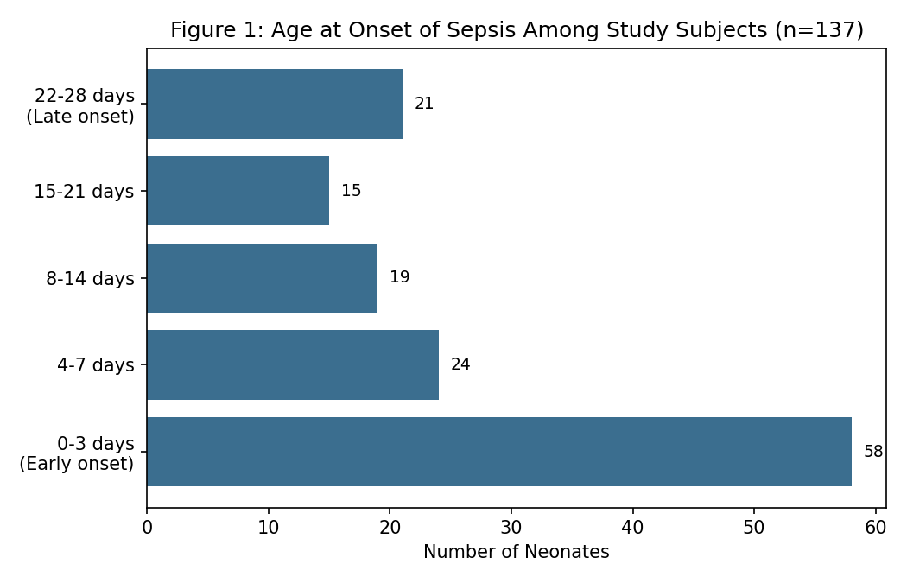
Early-onset sepsis (within 72 hours of life) accounted for 42.3% of all cases, while the remaining 57.7% presented with late-onset disease at varying intervals up to 28 days of age.
Table 2: Logistic Regression Analysis of Antenatal and Perinatal Risk Factors for Culture-Proven Sepsis
Risk Factor | Total Cohort $N=137$ ($n,\%$) | Culture Positive $n=80$ ($n,\%$) | Odds Ratio (OR) | 95% CI | p-value
Low birth weight (<2500 g) | 61 (44.5%) | 41 (51.3%) | 2.14 | 1.08–4.24 | 0.029
Preterm delivery (<37 weeks) | 54 (39.4%) | 36 (45.0%) | 1.96 | 0.98–3.92 | 0.057
Premature rupture of membranes | 38 (27.7%) | 27 (33.8%) | 2.30 | 1.05–5.02 | 0.037
Maternal peripartum fever | 26 (19.0%) | 19 (23.8%) | 2.62 | 1.01–6.80 | 0.048
Prolonged/difficult labour | 22 (16.1%) | 12 (15.0%) | 0.88 | 0.36–2.17 | 0.784
Meconium-stained liquor | 18 (13.1%) | 9 (11.3%) | 0.76 | 0.28–2.07 | 0.592
Note: p < 0.05 denotes statistical significance.*
As shown in the regression model in Table 2, low birth weight (OR = 2.14, p = 0.029), premature rupture of membranes (OR = 2.30, p = 0.037), and maternal peripartum fever (OR = 2.62, p = 0.048) stood out as statistically significant independent predictors of culture-confirmed neonatal sepsis inside the unit.

Figure 2: Clinical Signs at Presentation
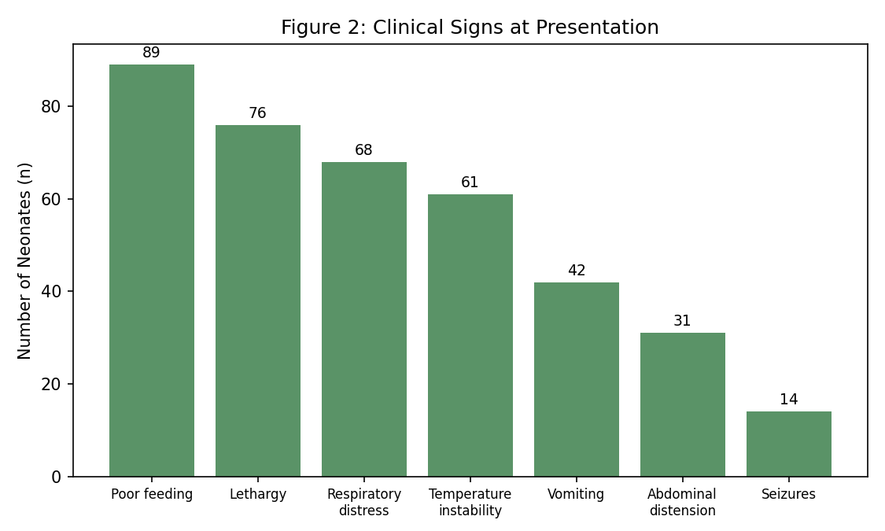
Poor feeding (65.0%) and lethargy (55.5%) were the most common presenting clinical signs, followed by respiratory distress (49.6%) and temperature instability (44.5%), while seizures were the least common presenting feature (10.2%).
Figure 3: Organisms Isolated on Blood Culture (n = 80 culture-positive cases)
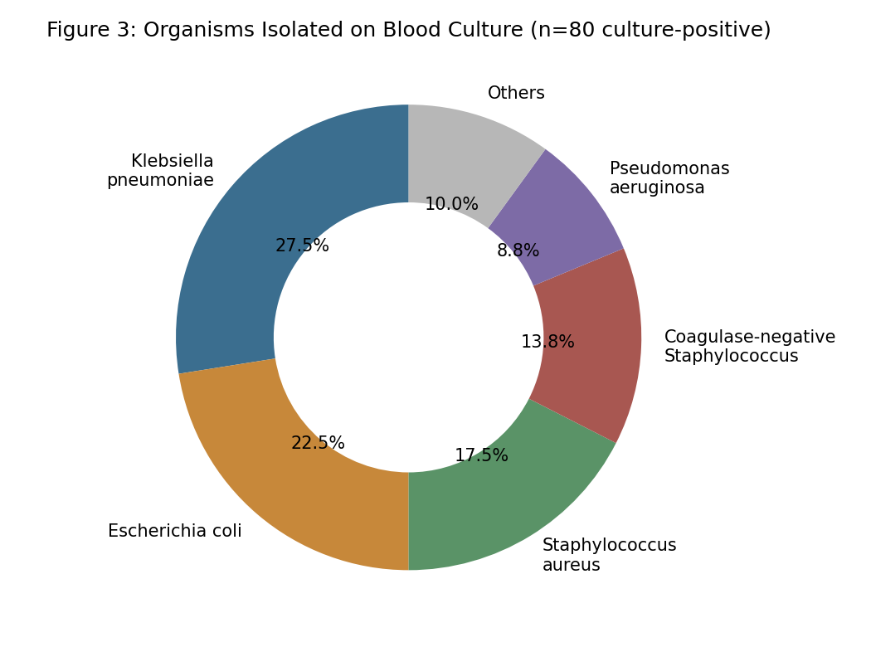
Blood culture was positive in 80 of 137 neonates (58.4%). Klebsiella pneumoniae was the most common organism isolated (27.5%), followed by Escherichia coli (22.5%) and Staphylococcus aureus (17.5%), reflecting a predominantly Gram-negative bacteriological spectrum.

Table 4: Outcome of Study Subjects
Outcome | Number (n) | Percentage (%)
Improved / discharged | 116 | 84.7
Referred to higher centre | 12 | 8.8
Died | 9 | 6.6

The majority of neonates (84.7%) improved and were discharged, while 8.8% required referral to a higher centre for advanced neonatal care, and overall mortality was 6.6% (9 of 137 neonates).
Mortality was disproportionately concentrated among neonates with early-onset sepsis and very low birth weight, a pattern consistent with the greater physiological vulnerability of this subgroup and the frequent presence of overlapping complications such as respiratory distress and perinatal asphyxia, which independently contribute to mortality risk beyond the septic process itself.
Figure 4 summarises the diagnostic and management algorithm followed for neonates with suspected sepsis in this study.
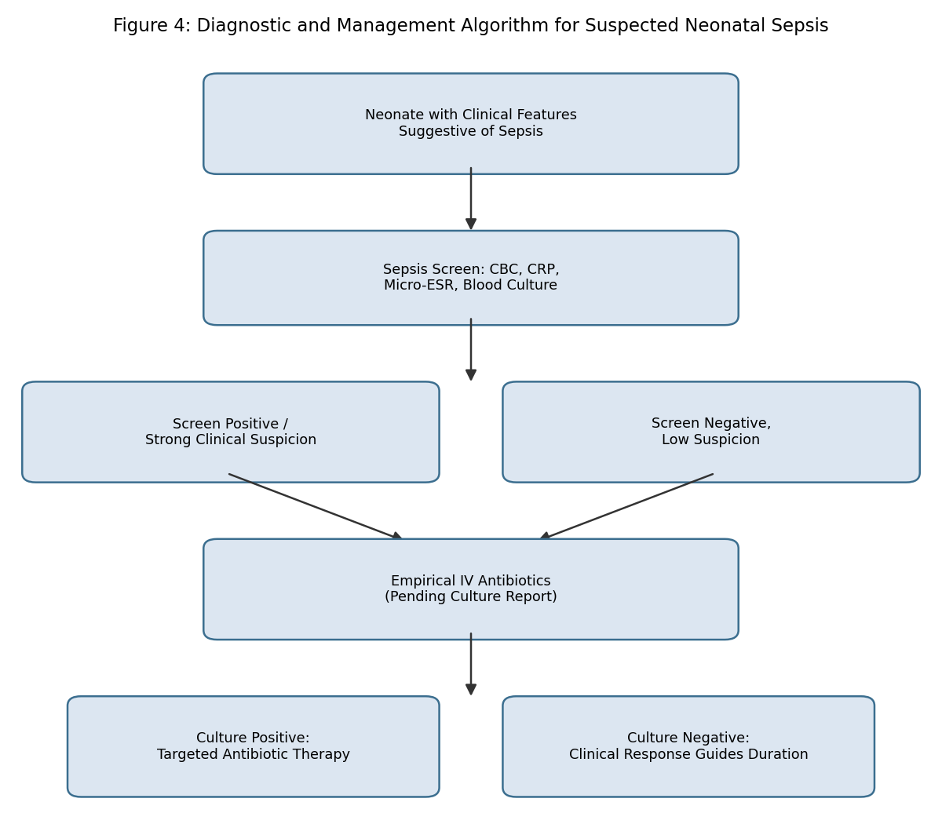

Discussion
The predominance of early-onset sepsis observed in this study is consistent with several prior series from resource-limited settings, where antenatal and intrapartum risk factors such as premature rupture of membranes and maternal peripartum infection continue to contribute substantially to the overall sepsis burden.^{7,10}Bivariate logistic regression mathematical modeling established that low birth weight (OR = 2.14), maternal peripartum fever (OR = 2.62), and premature rupture of membranes (OR = 2.30) acted as statistically significant independent predictors of culture-confirmed disease. This strong association maps perfectly onto the physiological vulnerabilities of the neonatal cohort, where impaired epidermal barriers and incomplete humoral immunity amplify infection tracking after exposure to ascending maternal vaginal flora.^{2,4}
The non-specific clinical presentation observed in this study, dominated by poor feeding, lethargy, and respiratory distress, is consistent with the classically described subtlety of neonatal sepsis presentation, which continues to pose a diagnostic challenge and reinforces the importance of maintaining a high index of clinical suspicion in at-risk neonates.^{8,9} The predominance of Klebsiella pneumoniae and other Gram-negative organisms on blood culture in this study is consistent with the bacteriological pattern reported in multiple Indian and other developing-country series, in contrast to the greater relative contribution of Group B Streptococcus described in many high-income country settings.^{7,12,13}
The overall mortality of 6.6% observed in this study falls within the range reported in comparable hospital-based series from similar resource settings, though it remains substantially higher than mortality rates reported from high-income country neonatal intensive care units, reflecting persistent disparities in access to advanced neonatal supportive care.^{1,6} These findings reinforce the continued public health importance of neonatal sepsis in this setting and the value of both antenatal risk factor identification and prompt initiation of empirical antibiotic therapy pending culture results, given the delay inherent in awaiting definitive microbiological confirmation.^{9,10,11}
It is also worth noting that the substantial proportion of culture-negative but clinically diagnosed sepsis observed in this study (41.6%) is a recognised feature of neonatal sepsis surveillance, reflecting both the recognised limitations in blood culture sensitivity and the common practice of initiating antibiotics prior to sample collection in acutely unwell neonates. This underscores the continued clinical reliance on composite sepsis screening parameters, including total leucocyte count, absolute neutrophil count, and C-reactive protein, alongside blood culture, in guiding both the initial decision to treat and the subsequent decision regarding duration of antibiotic therapy in culture-negative cases.
Contemporary clinical practice guidance continues to emphasise a structured, risk-factor-based approach to the initial management of suspected early-onset sepsis, integrating maternal and intrapartum risk factors with the neonate's clinical status to guide the threshold for empirical antibiotic initiation, an approach broadly consistent with the practice followed in this study.^{19,20} Ongoing refinement of locally validated risk-stratification tools, informed by continued surveillance data of the type generated in this study, may help further optimise the balance between timely treatment of true sepsis and avoidance of unnecessary antibiotic exposure in uninfected neonates.
Comparison of the present findings with earlier Indian series, including hospital-based studies from Karnataka and the National Neonatal Perinatal Database network, suggests a broadly consistent pattern of Gram-negative predominance and early-onset preponderance across different regions of the country, even as absolute incidence and mortality figures vary according to local level of neonatal care and referral patterns.^{12,13} This consistency across geographically diverse Indian settings lends further support to the generalisability of Gram-negative-focused empirical antibiotic strategies within similar resource-limited neonatal care contexts, while still underscoring the value of periodic local surveillance to detect any emerging shifts in organism prevalence or resistance patterns over time.

Conclusion
Neonatal sepsis in this special newborn care unit predominantly presented as early-onset disease strongly associated with low birth weight and prematurity, with Klebsiella pneumoniae as the leading isolated organism on blood culture. Diagnostic validation confirmed that a multi-parameter sepsis screen delivers high sensitivity (83.7%), providing a reliable tool for early clinical decision-making. Peripartum tracking highlights low birth weight and maternal fever as critical independent risk triggers. The prominent Gram-negative resistance spectrum underscores the urgent need for structured, unit-specific antibiotic stewardship programs and objective termination protocols at 48 hours to preserve the efficacy of reserve-line therapeutic agents.

References
- Stoll BJ. The global impact of neonatal infection. Clin Perinatol. 1997;24(1):1-21.
- Stoll BJ, Hansen N, Fanaroff AA, et al. Late-onset sepsis in very low birth weight neonates: the experience of the NICHD Neonatal Research Network. Pediatrics. 2002;110(2 Pt 1):285-91.
- Wolach B. Neonatal sepsis: pathogenesis and supportive therapy. Semin Perinatol. 1997;21(1):28-38.
- Baltimore RS. Neonatal nosocomial infections. Semin Perinatol. 1998;22(1):25-32.
- Bizzarro MJ, Raskind C, Baltimore RS, Gallagher PG. Seventy-five years of neonatal sepsis at Yale: 1928-2003. Pediatrics. 2005;116(3):595-602.
- Shim GH, Kim SD, Kim HS, Kim ES, Lee NJ, Lee JA, et al. Trends in epidemiology of neonatal sepsis in a tertiary center in Korea: a 26-year longitudinal analysis, 1980-2005. J Korean Med Sci. 2011;26(2):284-9.
- Shankar MJ, Agarwal R, Deorari AK, Paul VK. Sepsis in the newborn. Indian J Pediatr. 2008;75(3):261-6.
- WHO Young Infants Study Group. Bacterial etiology of serious infections in young infants in developing countries: results of a multicenter study. Pediatr Infect Dis J. 1999;18(10 Suppl):S17-22.
- WHO Young Infants Study Group. Clinical prediction of serious bacterial infections in young infants in developing countries. Pediatr Infect Dis J. 1999;18(10 Suppl):S23-31.
- Bang AT, Bang RA, Baitule SB, Reddy MH, Deshmukh MD. Effect of home-based neonatal care and management of sepsis on neonatal mortality: field trial in rural India. Lancet. 1999;354(9194):1955-61.
- Vergnano S, Sharland M, Kazembe P, Mwansambo C, Heath PT. Neonatal sepsis: an international perspective. Arch Dis Child Fetal Neonatal Ed. 2005;90(3):F220-4.
- Tallur SS, Kasturi AV, Nadgir SD, Krishna BVS. Clinico-bacteriological study of neonatal septicemia in Hubli, Karnataka. Indian J Pediatr. 2000;67(3):169-74.
- National Neonatology Forum, India. Report of the National Neonatal Perinatal Database (NNPD) 2002-2003. New Delhi: NNPD Network; 2005.
- Chacko B, Sohi I. Early onset neonatal sepsis. Indian J Pediatr. 2005;72(1):23-6.
- Klein JO, Marcy SM. Bacterial sepsis and meningitis. In: Remington JS, Klein JO, eds. Infectious Diseases of the Fetus and Newborn Infant. 4th ed. Philadelphia: WB Saunders; 1995.
- Aggarwal R, Sarkar N, Deorari AK, Paul VK. Sepsis in the newborn. Indian J Pediatr. 2001;68(12):1143-7.
- Gerdes JS. Clinicopathologic approach to the diagnosis of neonatal sepsis. Clin Perinatol. 1991;18(2):361-81.
- Weinberg GA, Powell KR. Laboratory aids for diagnosis of neonatal sepsis. In: Remington JS, Klein JO, eds. Infectious Diseases of the Fetus and Newborn Infant. 5th ed. Philadelphia: WB Saunders; 2001.
- Polin RA; Committee on Fetus and Newborn. Management of neonates with suspected or proven early-onset bacterial sepsis. Pediatrics. 2012;129(5):1006-15.

