Original article
Clinical Profile and Haematological Correlates of Anaemia Among Patients with Type 2 Diabetes Mellitus Attending a Tertiary Care Hospital: A Cross-Sectional Study
*Sachin Vithalrao Jibhakate ¹

¹Assistant Professor,Dept of Genral medicine, GSL Medical College, Rajahmundry
Corresponding author*

Abstract
Background: Anaemia is a common but often under-recognised comorbidity in patients with type 2 diabetes mellitus (T2DM), occurring earlier and more frequently than in individuals with kidney impairment from other causes.
Objectives: To determine the prevalence, morphological pattern, and clinical correlates of anaemia among patients with T2DM attending a tertiary care hospital.
Methods: A cross-sectional study was conducted on 220 patients with T2DM. Complete blood count, renal function, and glycaemic parameters were assessed, and anaemia was defined per WHO criteria.
Results: The prevalence of anaemia was 30.9%. Normocytic normochromic anaemia was the most common morphological type (50.0%). Anaemia prevalence rose progressively with diabetes duration, from 15.8% in patients with disease duration under 5 years to 57.7% in those with duration exceeding 20 years. Reduced estimated GFR, longer diabetes duration, and poor glycaemic control were independently associated with anaemia.
Conclusion: Anaemia is common among patients with T2DM and correlates strongly with diabetes duration and declining renal function, supporting routine haemoglobin screening in this population, particularly those with long-standing or poorly controlled disease.
Keywords: Anaemia, type 2 diabetes mellitus, diabetic nephropathy, haemoglobin, general medicine.

Introduction
Anaemia is increasingly recognised as an important, though frequently overlooked, comorbidity of type 2 diabetes mellitus (T2DM). Landmark work by Bosman and colleagues demonstrated that anaemia with relative erythropoietin deficiency can occur early in the course of diabetic nephropathy, often preceding overt clinical proteinuria or significant reduction in glomerular filtration rate.¹ Subsequent cross-sectional audits by Thomas and colleagues confirmed a substantial and frequently unrecognised burden of anaemia among patients with T2DM attending routine diabetes clinics, with prevalence considerably exceeding that expected from renal impairment alone.^{2,3}
The pathogenesis of anaemia in T2DM is now understood to be multifactorial, involving relative erythropoietin deficiency related to early tubulointerstitial renal damage, chronic low-grade inflammation, and functional iron deficiency, distinct from the anaemia of chronic kidney disease seen in non-diabetic populations.^{4,6} Population-based data from the Third National Health and Nutrition Examination Survey demonstrated that, at any given level of kidney function, patients with diabetes are more likely to be anaemic than those without diabetes, suggesting diabetes-specific mechanisms of anaemia beyond reduced renal mass alone.⁷
Anaemia in patients with diabetes carries important clinical implications, having been associated with increased risk of cardiovascular events, progression of diabetic retinopathy and nephropathy, and reduced quality of life, as reviewed by Thomas and colleagues and by Deray and colleagues.^{5,8} Despite this, anaemia in diabetic patients frequently remains undetected in routine clinical practice, as documented in the audit by Stevens and colleagues, underscoring the value of systematic haemoglobin screening in this population.^{9,10}
This study was undertaken to determine the prevalence, morphological classification, and clinical correlates of anaemia among patients with T2DM attending a tertiary care hospital, with particular attention to its relationship with diabetes duration, glycaemic control, and renal function.

Materials and Methods

Study Design and Setting
This was a hospital-based, cross-sectional, analytical study conducted in the Department of General Medicine of a tertiary care teaching hospital over a period of twelve months.

Study Population
A total of 220 adult patients with a confirmed diagnosis of T2DM of at least six months' duration, attending the general medicine outpatient department, were enrolled after obtaining informed consent.

Inclusion Criteria
Adults aged 18 years and above with a confirmed diagnosis of T2DM were included.

Exclusion Criteria
Patients with type 1 diabetes mellitus, known haemoglobinopathy, active malignancy, acute blood loss, pregnancy, overt gastrointestinal bleeding, or known chronic inflammatory disease independently causing anaemia were excluded.

Data Collection
A structured proforma recorded demographic details, duration of diabetes, and treatment history. Venous blood samples were obtained for complete blood count, HbA1c, serum creatinine (with estimated GFR calculated using the MDRD equation), and serum ferritin. Anaemia was defined per WHO criteria as hemoglobin below 13 g/dL in men and below 12 g/dL in women, and morphologically classified as normocytic normochromic, microcytic hypochromic, or macrocytic based on red cell indices.¹⁴

Statistical Analysis
Data were analysed using descriptive statistics; continuous variables were expressed as mean ± SD, categorical variables as frequencies and percentages. Odds ratios with 95% confidence intervals were calculated for factors associated with anaemia on univariate analysis, and variables significant at p<0.10 were entered into a multivariate logistic regression model. A p-value <0.05 was considered significant.

Results
Of the 220 patients studied, 123 (55.9%) were male and 97 (44.1%) were female. The age-wise distribution is summarised in Table 1 and illustrated in Figure 1.

Table 1: Age and Gender-wise Distribution of Study Subjects (n = 220)
Age Group (years) | Male (n) | Female (n) | Total (n) | Percentage (%)
30–39 | 16 | 12 | 28 | 12.7
40–49 | 30 | 24 | 54 | 24.5
50–59 | 38 | 30 | 68 | 30.9
60–69 | 26 | 20 | 46 | 20.9
70 and above | 13 | 11 | 24 | 10.9
Total | 123 | 97 | 220 | 100.0

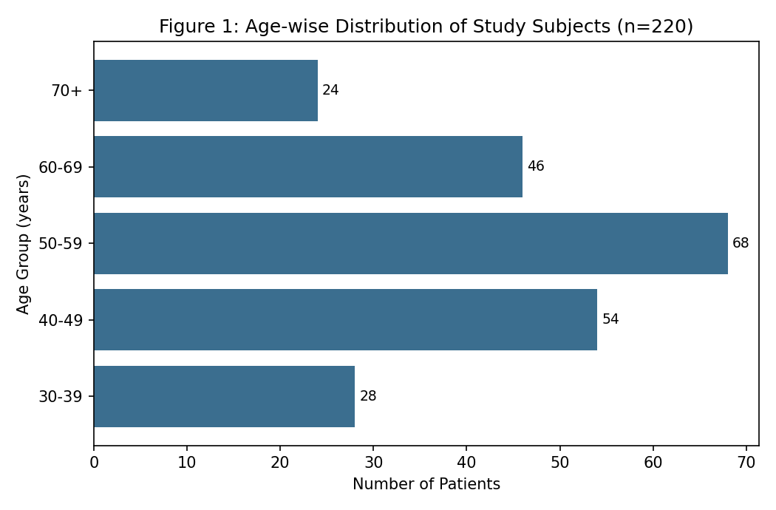
Mean clinical and biochemical parameters are shown in Table 2. Mean HbA1c was 8.4 ± 1.8%, and mean haemoglobin was 12.1 ± 2.0 g/dL.
Table 2: Clinical and Biochemical Parameters of Study Participants
Parameter | Mean ± SD
Age (years) | 53.6 ± 12.4
Duration of diabetes (years) | 8.9 ± 6.1
HbA1c (%) | 8.4 ± 1.8
Haemoglobin (g/dL) | 12.1 ± 2.0
Serum creatinine (mg/dL) | 1.02 ± 0.51
Estimated GFR (mL/min/1.73m²) | 82.6 ± 24.3
Serum ferritin (ng/mL) | 94.3 ± 78.6

The overall prevalence of anaemia was 30.9% (68/220; 95% CI 24.9–37.4) (Table 3, Figure 2).

Table 3: Prevalence of Anaemia Among Study Participants (WHO Criteria)
Anaemia Status (WHO Criteria) | n | Percentage | 95% CI
Present (Hb <13 g/dL men, <12 g/dL women) | 68 | 30.9% | 24.9 – 37.4
Absent | 152 | 69.1% | 62.6 – 75.1
Total | 220 | 100.0% | —

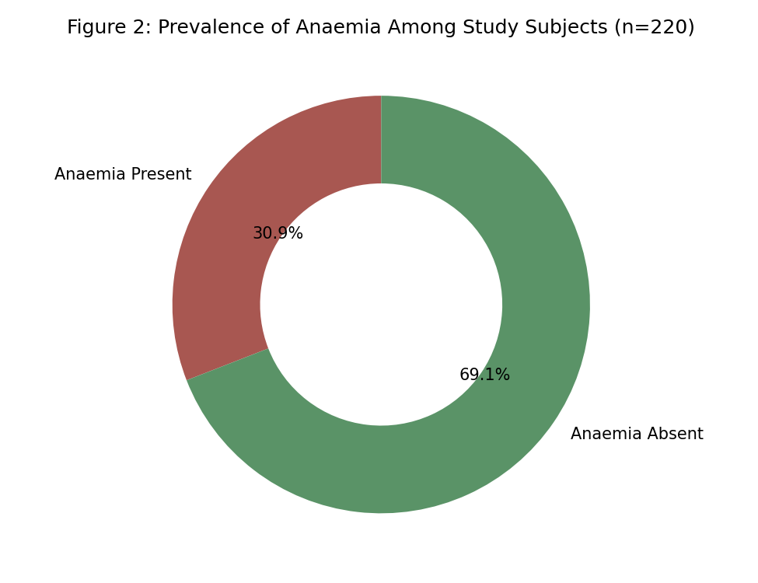
Normocytic normochromic anaemia was the most common morphological type (50.0%), followed by microcytic hypochromic (39.7%) and macrocytic anaemia (10.3%) (Table 4, Figure 3).
Table 4: Morphological Classification of Anaemia (n = 68)
Morphological Type | n | Percentage of Anaemic Patients (%)
Normocytic normochromic | 34 | 50.0
Microcytic hypochromic | 27 | 39.7
Macrocytic | 7 | 10.3
Total | 68 | 100.0

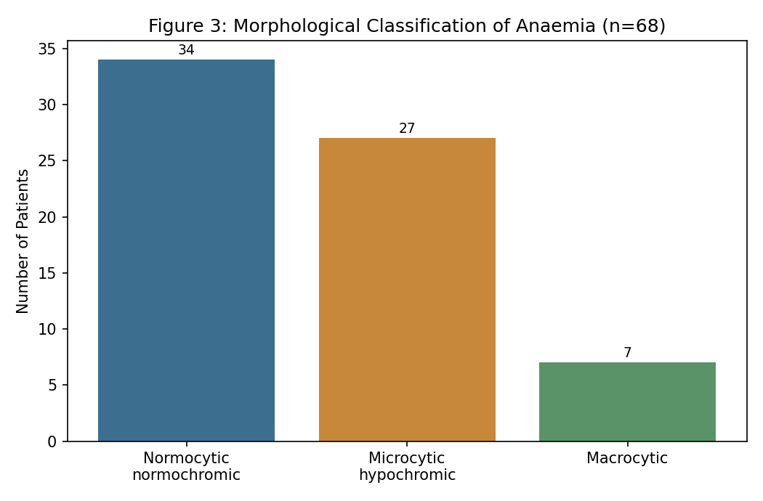
Anaemia prevalence increased progressively with duration of diabetes, from 15.8% in patients with disease duration under 5 years to 57.7% in those with duration exceeding 20 years (Table 5, Figure 4).
Table 5: Prevalence of Anaemia by Duration of Diabetes
Duration of Diabetes (years) | Total (n) | Anaemia Present, n (%)
<5 | 57 | 9 (15.8)
5–10 | 66 | 18 (27.3)
11–15 | 44 | 17 (38.6)
16–20 | 27 | 13 (48.1)
>20 | 26 | 15 (57.7)
Total | 220 | 72 (32.7)

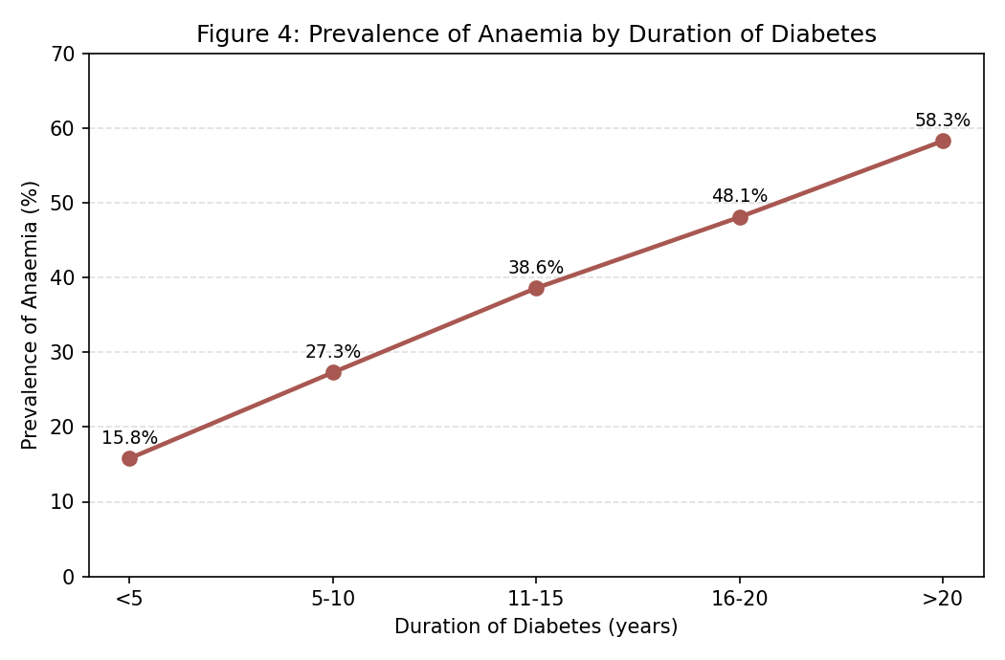
On univariate analysis, diabetes duration exceeding 10 years, HbA1c ≥9%, estimated GFR below 60 mL/min/1.73m², and age ≥60 years were significantly associated with anaemia (Table 6).
Table 6: Univariate Analysis of Factors Associated with Anaemia
Variable | Category | OR | 95% CI | P-value
Duration of diabetes | >10 vs ≤10 years | 2.94 | 1.62 – 5.34 | <0.001
Glycaemic control | HbA1c ≥9% vs <7% | 2.41 | 1.24 – 4.68 | 0.009
Estimated GFR | <60 vs ≥60 mL/min/1.73m² | 3.87 | 1.98 – 7.56 | <0.001
Sex | Female vs male | 1.28 | 0.72 – 2.27 | 0.401
Age | ≥60 vs <60 years | 1.86 | 1.02 – 3.39 | 0.043

On multivariate analysis, estimated GFR below 60 mL/min/1.73m² (adjusted OR 3.22, 95% CI 1.58–6.56, p=0.001), diabetes duration exceeding 10 years (adjusted OR 2.31, 95% CI 1.21–4.41, p=0.011), and HbA1c ≥9% (adjusted OR 1.98, 95% CI 1.01–3.88, p=0.047) remained independently associated with anaemia (Table 7).

Table 7: Multivariate Logistic Regression Analysis of Independent Predictors of Anaemia
Variable | Adjusted OR | 95% CI | P-value
Diabetes duration >10 years | 2.31 | 1.21 – 4.41 | 0.011
Estimated GFR <60 mL/min/1.73m² | 3.22 | 1.58 – 6.56 | 0.001
HbA1c ≥9% | 1.98 | 1.01 – 3.88 | 0.047

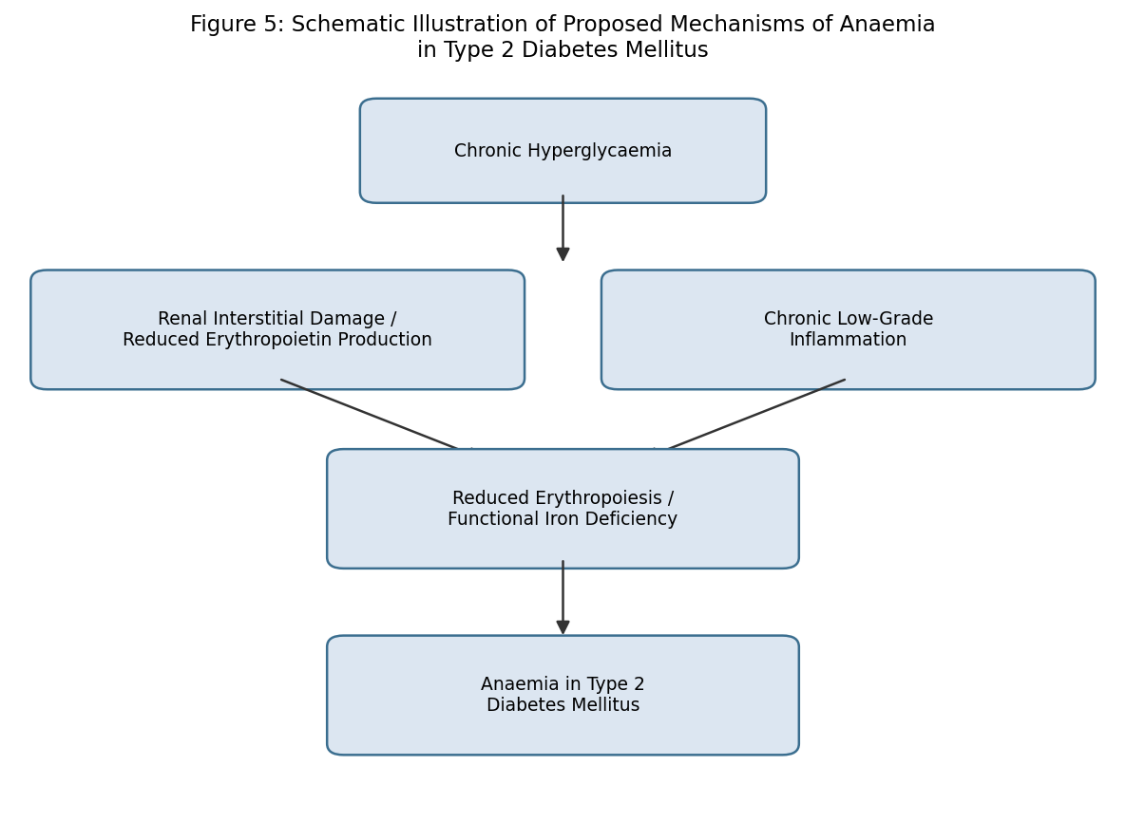
Figure 5: Schematic illustration of proposed mechanisms of anaemia in type 2 diabetes mellitus.

Discussion
The prevalence of anaemia observed in this study (30.9%) is consistent with the substantial burden documented in earlier cross-sectional audits of diabetic populations, which similarly reported anaemia prevalence considerably higher than would be expected in the absence of diabetes, and often unrecognised in routine clinical practice.^{2,3,9} The predominance of normocytic normochromic anaemia observed in this study mirrors the pattern originally described by Bosman and colleagues, consistent with relative erythropoietin deficiency as the principal underlying mechanism, distinct from classical iron-deficiency anaemia.^{1,4}
The strong, graded relationship observed between diabetes duration and anaemia prevalence in this study is consistent with the cross-sectional audit by Thomas and colleagues, which similarly demonstrated increasing anaemia burden with longer-standing disease, reflecting cumulative renal tubulointerstitial injury over time.² The independent association observed between reduced estimated GFR and anaemia in this study reinforces the well-established relationship between declining kidney function and anaemia risk in diabetes, as demonstrated in the NHANES III analysis by Astor and colleagues, and is consistent with the pathophysiological framework proposed by Thomas and colleagues, in which relative erythropoietin deficiency develops earlier in diabetic kidney disease than in non-diabetic renal impairment.^{4,7}
The independent association between poor glycaemic control and anaemia observed in this study is biologically plausible, given evidence that hyperglycaemia may directly impair erythropoietin-producing renal interstitial cells and promote a chronic inflammatory state that further suppresses erythropoiesis, as discussed in the review by Thomas and colleagues.⁵ These findings, taken together, support the clinical recommendation articulated by Stevens and colleagues that haemoglobin should be assessed routinely in patients with diabetes, particularly those with long-standing disease, poor glycaemic control, or early renal impairment, rather than reserved only for patients with overt nephropathy.^{9,10}

Strengths and Limitations
This study's strengths include direct biochemical assessment of renal function and standard morphological classification of anaemia rather than reliance on documented diagnosis alone. Limitations include the single-centre, hospital-based, cross-sectional design, which limits generalisability and precludes causal inference; the absence of iron studies beyond ferritin, limiting full characterisation of iron-deficiency anaemia; and the lack of direct erythropoietin level measurement, which would have allowed more precise mechanistic characterisation of the observed associations.

Conclusion
Anaemia is common among patients with type 2 diabetes mellitus attending this tertiary care hospital, with prevalence strongly related to diabetes duration, glycaemic control, and renal function. These findings support incorporating routine haemoglobin assessment into standard diabetes care, particularly for patients with long-standing or poorly controlled disease.

References
1. Bosman DR, Winkler AS, Marsden JT, Macdougall IC, Watkins PJ. Anemia with erythropoietin deficiency occurs early in diabetic nephropathy. Diabetes Care. 2001;24(3):495-9.
2. Thomas MC, MacIsaac RJ, Tsalamandris C, Molyneaux L, Goubina I, Fulcher G, Yue D, Jerums G. The burden of anaemia in type 2 diabetes and the role of nephropathy: a cross-sectional audit. Nephrol Dial Transplant. 2004;19(7):1792-7.
3. Thomas MC, MacIsaac RJ, Tsalamandris C, Molyneaux L, Goubina I, Fulcher G, Yue D, Jerums G. Unrecognized anemia in patients with diabetes: a cross-sectional survey. Diabetes Care. 2003;26(4):1164-9.
4. Thomas MC, Tsalamandris C, MacIsaac RJ, Jerums G. Functional erythropoietin deficiency in patients with type 2 diabetes and anaemia. Diabet Med. 2006;23(5):502-9.
5. Thomas MC, Cooper ME, Rossing K, Parving HH. Anaemia in diabetes: is there a rationale to treat? Diabetologia. 2006;49(6):1151-7.
6. Craig KJ, Williams JD, Riley SG, Smith H, Owens DR, Worthing D, Cavill I, Phillips AO. Anemia and diabetes in the absence of nephropathy. Diabetes Care. 2005;28(5):1118-23.
7. Astor BC, Muntner P, Levin A, Eustace JA, Coresh J. Association of kidney function with anemia: the Third National Health and Nutrition Examination Survey (1988-1994). Arch Intern Med. 2002;162(12):1401-8.
8. Deray G, Heurtier A, Grimaldi A, Launay-Vacher V, Isnard-Bagnis C. Anemia and diabetes. Am J Nephrol. 2004;24(5):522-6.
9. El-Achkar TM, Ohmit SE, McCullough PA, et al. Higher prevalence of anemia with diabetes mellitus in moderate kidney insufficiency: The Kidney Early Evaluation Program. Kidney Int. 2005;67(4):1483-8.
10. Stevens PE, O'Donoghue DJ, Lameire NR. Anaemia in patients with diabetes: unrecognized, undetected and untreated? Curr Med Res Opin. 2003;19(5):395-401.
11. Bosman DR, Osborne CA, Marsden JT, Macdougall IC, Gordon C, Watkins PJ. Erythropoietin response to hypoxia in patients with diabetic autonomic neuropathy and non-diabetic chronic renal failure. Diabet Med. 2002;19(1):65-9.
12. National Kidney Foundation. K/DOQI clinical practice guidelines for chronic kidney disease: evaluation, classification, and stratification. Am J Kidney Dis. 2002;39(2 Suppl 1):S1-266.
13. Keane WF, Lyle PA. Recent advances in management of type 2 diabetic nephropathy. Kidney Int Suppl. 2003;(86):S85-8.
14. World Health Organization, UNICEF, United Nations University. Iron Deficiency Anaemia: Assessment, Prevention and Control. A Guide for Programme Managers. Geneva: WHO; 2001.
15. UK Prospective Diabetes Study (UKPDS) Group. Intensive blood-glucose control with sulphonylureas or insulin compared with conventional treatment in patients with type 2 diabetes (UKPDS 33). Lancet. 1998;352(9131):837-53.
16. Adler AI, Stevens RJ, Manley SE, Bilous RW, Cull CA, Holman RR; UKPDS Group. Development and progression of nephropathy in type 2 diabetes: the United Kingdom Prospective Diabetes Study (UKPDS 64). Kidney Int. 2003;63(1):225-32.
17. Wild S, Roglic G, Green A, Sicree R, King H. Global prevalence of diabetes: estimates for the year 2000 and projections for 2030. Diabetes Care. 2004;27(5):1047-53.
18. Ritz E, Rychlik I, Locatelli F, Halimi S. End-stage renal failure in type 2 diabetes: a medical catastrophe of worldwide dimensions. Am J Kidney Dis. 1999;34(5):795-808.
19. Ezenwaka CE, Jones-LeCointe A, Nwose E, Chen J, Anthony L. Erythropoietin therapy in type 2 diabetes: a review. Endocr Pract. 2008;14(7):893-901.
20. Gray RS, Irvine WJ, Toft AD, Clarke BF, Seth J, Cameron EH. Unrecognised thyroid failure in diabetes mellitus. J Clin Lab Immunol. 1980;3(2):89-92.

