Original article
The role of portable cardiac Ultrasound in understanding the anatomy and Physiology of heart: Indian scenario
¹Dr Avinash S. Ingle, ²Dr Soumitra Trivedi, ³Dr Kiran R. Bagale, ⁴Dr Tej Prakash Sinha

¹Additional Professor, Department of Physiology, AIIMS-Raipur, CG, India.
²Additional Professor, Department of Anatomy, AIIMS Raipur, CG, India.
³Associate professor, Department of Biochemistry, Raipur Institute of medical sciences, Godhi village, Raipur, CG, India.
⁴Associate Professor, Department of T & E, JPN Apex Trauma Center, AIIMS, New Delhi.
Corresponding author: Dr Tej Prakash Sinha

Abstract:
Background: We predict that if medical students are introduced earlier to Ultrasound (US) techniques and their images, it might be helpful to understand the various physiological mechanisms. So our objective was to study the utility of ultrasound to teach cardiac Anatomy and physiology to first and second-year medical graduates and to assess their response to this novel technique.
Methods: The study was conducted in two batches, including the first year (66) and second-year (38) medical graduates. After the brief introduction of the US machine and the static and dynamic images of the heart in suitable views, the students were asked to observe the cyclical changes occurring during each heartbeat and correlate them with ECG waves recorded continuously and the heart sounds auscultated simultaneously. Then the response was assessed with the help of a five-point Likert scale dedicated to their interpretation of various events of the cardiac cycle and their correlation with ECG waves and heart sounds.
Results: Almost all students could appreciate the mechanical events of the cardiac cycle within the stipulated time, but the correlation of mechanical events with ECG waves and heart sounds auscultation required a little more time for most of them. The performance was better in the case of second-year students for all events of the cardiac cycle, excepting the correlation of ECG waves with mechanical events.
Keywords: medical education; ultrasound; medical undergraduates; cardiac cycle

Introduction
All of us know that Physiology is a branch of medicine which deals with understanding the various mechanisms taking place in our body. In medical colleges in India, Physiology is considered a non-clinical or preclinical subject, taught at the start of a medical curriculum. Unlike Anatomy, Physiology is a dynamic subject, so cadaveric use has a limited value in understanding Physiology. In the past, animals were widely used to explore and teach various mechanisms and correlate them with human Physiology. Still, now because of animal ethics issues, the use of animals has been stopped completely (at least for teaching purposes), leading to a reduction of actual student’s participation in learning physiology [1]. So it can be of great help to use clinical diagnostic techniques for teaching purposes.
Although clinicians have used ultrasound (since the 1960s) for diagnostic purposes, it has not been used for teaching physiology to undergraduate medical students[2]. On the other hand, it has been a common practice to teach Anatomy by using X-rays, CT, and MRI scans in Indian medical colleges. Recently in many Western countries US is also being used for teaching anatomy and Physiology[3,4]. But in India, its use in teaching Physiology has not been tried by medical educationists, despite recent guidelines regarding ‘vertical integrated teaching’and ‘early clinical exposure,’ issued by the Medical Council of India (MCI), which is a governing body for medical education in India [5].
US is a safe, non-invasive, portable, and convenient method of clinical investigation used mainly in Radiology, Cardiology, Medicine, Obstetrics, Gynecology, and many other clinical fraternities. Now in many renowned universities, it’s being used as a teaching modality also in preclinical and paraclinical subjects resulting in early exposure to the knowledge of US which anyway was supposed to be learned in the final year and practiced throughout life for patient care [6, 7]. There are reports that this early exposure is generating great interest among medical students particularly in preclinical subjects [4]. So the objectives of this study were to assess the utility of portable US in understanding the Anatomy and Physiology of the heart and also to compare the utility of this method between the first year and second-year medical graduates in India.
Methodology
The study was conducted at AIIMS-Raipur, Chhattisgarh, India. The module dedicated to teaching the anatomy of the heart and understanding the prominent Physiologicchanges during the cardiac cycle by utilizing US was developed. The subjects were 104 medical students out of which 66 were from the first year and 38 were from the second year. The course was conducted separately for each batch of the first and second-year MBBS students who were informed about the course and motivated to participate in the ultrasound workshop but it was not at all compulsory to attend the same. Then US session was conducted for all participants by using a predesigned ultrasound module of one and half hour duration by using a portable ultrasound machine i.e. Sonosite, connected to the LCD projector. The departmental male servant of age 25 yrs was used as a volunteer with prior informed consent. Using the two-dimensional mode, the parasternal long axis, parasternal short axis, and apical four-chamber views were presented to the students on an LCD projector connected to the sonography machine.
The anatomy of the structures like atria, ventricles, atrioventricular & semilunar valves, chordae tendinae, papillary muscles, prominent vessels, and the related rhythmical movements was shown to the students during various phases of the cardiac cycle (Fig 1). The color doppler views were not shown to avoid confusion, as that was their first time to come across US. The ECG probe (bipolar lead II) was connected to the US machine to correlate the occurrence of various ECG waves with the mechanical events taking place in the heart visualized on the LCD screen. They were asked to watch for the repetitive movements occurring in the right atrium and right ventricle, left atrium and left ventricle, and the valves on either side. After this 20 minutes session of watching the movements of heart walls, valves, each one was asked to auscultate the precordium and correlate heart sounds with valvular movements as shown in fig.1. The time duration was restricted to three minutes for each individual for auscultation.
Then the participants were asked to complete the questionnaire to assess their quality of learning of the Physiology of the cardiac cycle by this innovative method. The questionnaire was designed as per a five-point Likert scale (immediately convinced=1 to not at all convinced=5) as shown in table 1. The average score was determined from the answers of all questions for the first year, second year, and the whole group, including all participants. Finally, the response was analyzed from the collected qualitative data.
Results
The descriptive statistical method was used to find out means by using Microsoft-excel (windows-7). The opinions were very positive, with a response rate of 100% for first and second-year students in terms of all excepting correlation of heart sound with valvular movements. Comparatively, the score for this correlation was lower in first-year students (first heart sound:67.16%, second heart sound: 62.68%, both heart sounds simultaneously:59.7% ). The fig 2 shows the comparison between the scores for the first year, second year students along with their collective scores. It was observed that the average score was much lower in second-year students than that of first-year students for all events except for P and T waves of ECG, which were correlated better by first-year students with US. So it can be ascertained that the appreciation and correlation of all mechanical events with US were better by second-year students than the first-year students except for the correlation of P and T waves on ECG with the mechanical events of the cardiac cycle.
Discussion
US technology is being used in medical practice to diagnose heart diseases since the 1950s. It has progressed to such a level that US is being considered the stethoscope of the 21st century. So, many European universities have started introducing this technique to first-year medical undergraduates [3, 4, 6]. We studied the effectiveness of 'US-based teaching' and compared the first and second-year student's understanding of various aspects of the cardiac cycle. Our study noted that there was not much difference in understanding cardiac physiology by both groups.
The lower response rate of first-year students for auscultation might be because it was their first time auscultating the heart sounds. In contrast, the second-year students had a chance to practice the auscultation of heart sounds on patients in their clinical postings. The better score of first-year students for appreciation and correlation of the electrical activities with mechanical events might be because the ECG was very recently taught during the theory lectures for first-year students, which was learned much earlier (one and half year before) by the other group.
Also, the appreciation of various structures and their mechanical events was less than two, which means the students were very well convinced about those events. But the score for heart sounds and electrical events between two and three suggests that they would have appreciated the same if more time would have been given.
Several studies abroad focused mainly on student’s perception, feasibility and opinion about the US-based learning of Anatomy and Physiology. They noted that the method is very innovative, effective, and interesting in understanding the preclinical subjects.[8, 9]. It has been studied that a longitudinal ultrasound curriculum improves long-term retention in the students [10]. However, the utility of this method in teaching Anatomy and Physiology to Medical undergraduates in the Indian scenario has to be studied.
In our preliminary study, as only basic morphology of the heart, primary mechanical and electrical events were evaluated by using 2-D ECHO mode. As per the observations, many researchers believe that the ultrasound can be helpful to understand many more physiological mechanism Ex hemodynamics, cardiac and pulmonary functions, etc.[11,12,13] So we feel that further studies using the 3D mode, color doppler, angiography, etc., might also be helpful to understand the Physiological mechanisms compared to the conventional methods. However, we are satisfied with the student’s overall positive performance and interest, so we recommend this method to teach other Physiological mechanisms to develop an ultrasound-based vertical curriculum in India as like some European countries.
Finally, we also understand that even though the method is practical, engaging, and feasible for students, it is not practically possible for all institutes in India to provide these costly US machines to preclinical departments like Physiology. But suppose animal experiments are banned or restricted. The cost of those animal labs can be diverted to clinical labs for such innovative methods that could help understand preclinical subjects like Physiology.
Conclusion:
We can conclude that US-based teaching is instrumental and can be used in conjunction with the traditional ones. We can also emphasize that this non-invasive method can replace animal experiments with understanding the hemodynamics in various physiological and pathological conditions. Also, in addition, it can be used to strengthen the relationship of Physiology with its clinical counterparts like General medicine and Cardiology.

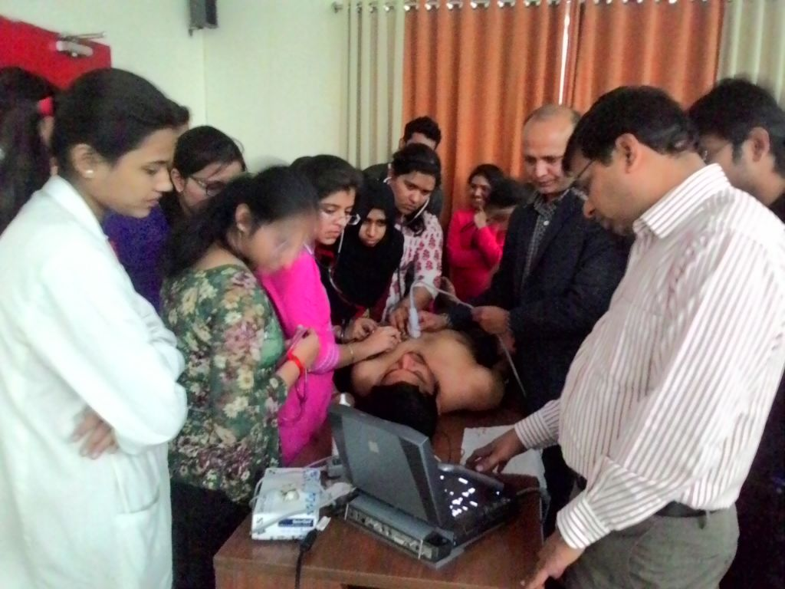
Figure. 1: Students auscultating while watching the valvular movements on the screen.

Table 1: The student’s response to various events of the cardiac cycle
Sr.  No | Events of the cardiac cycle | Immediately convinced (%) | Took bit more time (%) | Not entirely confident (%) | Need more time (%) | Not possible at all (%) | Not responded (%)
1. | LA walls | 83 (79.80) | 15 (14.42) | 3 (2.88) | 0 (0.00) | 3 (2.88) | 0 (0.00)
2 | LV walls | 90 (86.53) | 10 (9.61) | 4 (3.84) | 0 (0.00) | 0 (0.00) | 0 (0.00)
3 | RA walls | 66 (63.46) | 11 (10.57) | 7 (6.73) | 3 (2.88) | 7 (6.73) | 0 (0.00)
4 | RV walls | 72(69.23) | 19 (18.26) | 10 (9.61) | 0 (0.00) | 3 (2.88) | 0 (0.00)
5 | LA-CR | 72 (69.23) | 20 (19.23) | 8 (7.69) | 0 (0.00) | 4 (3.84) | 0 (0.00)
6 | RA-CR | 88 (84.61) | 6 (84.61) | 8 (7.69) | 2 (1.92) | 0 (0.00) | 0 (0.00)
7 | LV-CR | 57 (54.80) | 21 (20.19) | 14 (13.46) | 2 (1.92) | 9 (8.65) | 1 (0.96)
8 | RV-CR | 68 (65.38) | 21 (20.19) | 10 (9.61) | 2 (1.92) | 3 (2.88) | 0 (0.00)
9 | MV-M | 91 (87.5) | 7 (6.73) | 3 (2.88) | 1 (0.96) | 3 (2.88) | 0 (0.00)
10 | AV-M | 78 (75.00) | 14 (13.46) | 7 (6.73) | 1 (0.96) | 2 (1.92) | 2 (1.92)
11 | S1-MV | 48 (46.15) | 13 (12.5) | 11(10.57) | 5 (4.80) | 7 (6.73) | 20 (19.23)
12 | S2-AV | 38 (36.53) | 14(13.46) | 11(10.57) | 4 (3.84) | 12 (11.53) | 23 (22.11)
13 | S1,S2-US | 28 (26.92) | 6 (5.76) | 10(9.61) | 10 (9.61) | 24 (23.07) | 16 (15.38)
14 | P-ECG | 68 (65.38) | 11 (10.57) | 9(8.65) | 5 (4.80) | 10 (9.61) | 1 (0.96)
15 | QRS-ECG | 74 (71.15) | 11 (10.57) | 6(5.76) | 3 (2.88) | 9 (8.65) | 1 (0.96)
16 | T-ECG | 63 (60.57) | 15 (14.42) | 8(7.69) | 3 (2.88) | 13 (12.5) | 2 (1.92)

LA; left atrium, LV; Left ventricle, RA; Right ventricle, CR; Contraction and relaxation, MV-M; mitral valve movement, AV-M; aortic valve movement, S1-MV; correlation first heart sound with mitral valve closure, S2-AV; correlation of second heart sound with the aortic valve, S1,2 US; correlation of first and second heart sounds with ultrasonography images, PW; P wave on ECG, QRS; QRS complex on ECG and T W; T waves on ECG.
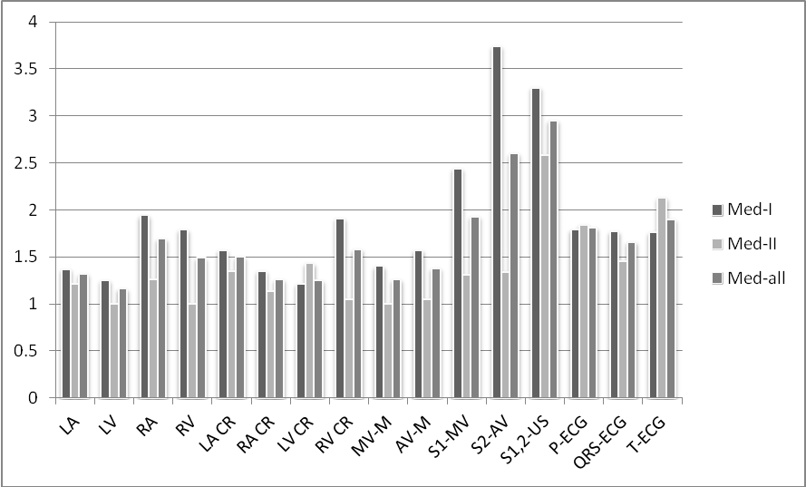
Figure 2: Average score values of all groups.

Med-I; First-year medical students, Med-II; Second-year medical students, Med-all; All medical students, LA; left atrium, LV; Left ventricle, RA; Right ventricle, CR; Contraction and relaxation, MV-M; mitral valve movement, AV-M; aortic valve movement, S1-MV; correlation first heart sound with mitral valve closure, S2-AV; correlation of second heart sound with the aortic valve, S1,2 US; correlation of first and second heart sounds with ultrasonography images, PW; P wave on ECG, QRS; QRS complex on ECG and T W; T waves on ECG.

Table 2: The average score regarding the appreciation of various mechanical events.
Groups | LA | LV | RA | RV | LA CR | RA CR | LV CR | RV CR | MV-M | AV-M | Total No.
First year | 1.37 | 1.25 | 1.94 | 1.79 | 1.57 | 1.35 | 1.21 | 1.91 | 1.40 | 1.57 | 66
Second year | 1.21 | 1 | 1.26 | 1 | 1.35 | 1.13 | 1.43 | 1.05 | 1 | 1.05 | 38
All students | 1.32 | 1.16 | 1.69 | 1.49 | 1.50 | 1.26 | 1.25 | 1.58 | 1.26 | 1.38 | 104
LA; left atrium, LV; left ventricle, RA; right ventricle, CR; contraction and relaxation, MV-M; mitral valve movement, AV-M; aortic valve movement.

Table 3: The average score of various groups regarding the correlation of heart sounds and ECG waves with cardiac events.
Groups | S1 & MV | S2 & AV | S1,2 & US | P-US | QRS-US | T-US | Total Number
First year | 2.44 | 3.74 | 3.3 | 1.79 | 1.77 | 1.76 | 66
Second year | 1.31 | 1.34 | 2.58 | 1.84 | 1.45 | 2.13 | 38
All students | 1.93 | 2.6 | 2.95 | 1.81 | 1.66 | 1.90 | 104

S1 & MV; First heart sound and mitral valve closure, S2 & AV; Second heart sound with the aortic valve, S1,2 & US; First and second heart sounds with ultrasonography images, P-US: P wave to Ultrasound, QRS-US: QRS complex with Ultrasound, T-US: T wave with Ultrasound.

Acknowledgements:
We acknowledge head of the department trauma and emergency AIIMS Raipur, CG India for providing the potable ultrasound machine for the conduction of the study.

References:
- The Gazette of India, part III-section 4, No. 88, New Delhi, March 19, 2014: REGD. No. 33004/99.
- R. Dustan Sarzan and Karl T. R. Schweitz. Standing on the shoulders of giants: Dean Franklin and his remarkable contributions to physiological measurements in animals. Adv Physiol Educ 2009;33: 144-156.
- Jason Ivanusic, Brian Cowie, Michel Barrington, Undergraduate study perceptions of the use of ultrasonography in the study of “living Anatomy”. 24/09/2010 in Wiley online library, Anat Sci Educ 3:318-322, DOI 10.1002/ase.180.
- Nadgib Hammoudi, Dimitry Arangalage, Lila Boubrit, Marie Christine Renaud, Richard Isnard, Jean-Philippe Collet, Ariel Cohen, Alexandre Duguet Ultrasound based teaching of cardiac anatomy and physiology to undergraduate medical students. Archives of Cardiovascular disease 2013;106:487-91.
- Vision-2015, Medical council of India, Dwarka, New Delhi. March 2011;11-12. Available on wileyonlinelibrary.com
- David P Bahner, Eric J Adkins, Daralee Hughes, Michael Barrie, Creagh T Boulger, and Nelson A Royall. Integrated medical school ultrasound: development of an ultrasound vertical curriculum. Critical Ultrasound Journal 2013;5(6). Available on http://www.critical ultrasoundjournal.com/content/5/1/6
- Thomas R. Cawthorn, Curtis Nickel, Michael O’Teilly, Henryk Kafka, James W. Tam, Lynel C Jackson, Anthony J. Sanfilippo et all. Focused Cardiac Ultrasound, Development and Evaluation of Methodologies for teaching-focused cardiac ultrasound Skills to Medical Students. Journal of American Society of Echocardiography March 2014; Volume27(3):302-09.
- Gueorgui Mouratev, Duncan Howe, Richard Hoppmann, Mary Beth Poston, Rodney Reid et all. Teaching medical students ultrasound to measure liver size: Comparison with experienced clinicians using physical examination alone. Teaching and learning in medicine 2013;25(1):84-88.
- Meenakshi Swamy and Roger F Searle. Anatomy teaching with portable ultrasound students. BMC Medical Education 2012; Available on http://www.biomedcentral.com/14726920/12/99
- Diana J. Kelm, John T. Ratelle, Nabeel Azeem, Sara L. Bonnes, Andrew J. Halvorsen et all. Longitudinal ultrasound curriculum improves long-term retention among internal medicine residents. Journal of graduate medical education, September 2015; Available on http://dx.doi.org/10.4300/JGME-14-00284.1
- Andrew T. Lovering and Michael K. Stickland. Not hearing is believing: novel insight into the cardio-pulmonary function using agitated contrast and ultrasound. J Appl Physiol 2010;109:1290-91.
- Mirian J. Starmans-Kool, Alice V. Stanton, Shunzhi Zhao, X. Yun Xu, Simon A. M. Thom, and Alun D. Hughes. Measurement of hemodynamics in human carotid artery using ultrasound and computational fluid dynamics. J Appl Physiol 2002;92:957-961.
- Zhenwei Lu and Ramkrishna Mukkamala. Continuous cardiac output monitoring in humans by invasive and non-invasive peripheral blood pressure waveform analysis. J Appl Physiol 2006;101:598-608.

Date of Publication: 25 June 2021
Author Declaration: Source of support: Nil, Conflict of interest: Nil
Was informed consent obtained from the subjects involved in the study? YES
For any images presented appropriate consent has been obtained from the subjects: NA
Plagiarism Checked: Urkund Software
Author work published under a Creative Commons Attribution 4.0 International License
DOI: 10.36848/IJBAMR/2020/29215.55855

