Original article:
Study of comparison of effect of calf muscles release and affirmation in alleviating hypertension in middle aged women
*Dr N. Akumtola Sanglir , Dr Priyanka Sethi, Dr Preeti Saini, Mukul Kaushik

Department of Physiotherapy
Manav Rachna International Institute of Research and Studies, Faridabad, Haryana.

Corresponding author*

ABSTRACT
INTRODUCTION: MFR it is a specialized physical and manual therapy which is used in a wide range of settings and this technique appears to be a useful in physical therapy for alleviating muscles stiffness, reducing pain, and improving range of motion. Stretching is a physical exercise where a specific muscles or tendons is flexed or stretched with the aim of improving the muscles elasticity and achieving muscles tone, and thus it helps in increasing muscles control, muscles flexibility and range of motion.
METHODOLOGY: Thirty subjects were taken between the age of 25 -35 years. And they were divided into two groups, of fifteen each. One group was treated with MFR and the other with passive stretching. Pre ROM and Post ROM was measured on both legs of ankle dorsiflexion and blood pressure was measured Pre and Post treatment.
RESULT: The result of the study was evaluated by taking mean± SD of ranges and comparing among the two groups. This study was conducted on 30 participants with MFR group ,N= 15 And in Passive stretching N= 15 between the age group of 25-35 years. Mean± SD of MFR group of post value of right leg is 18 ±3.6 and left leg is 19.46 ± 2.18 and for blood pressure diastolic is 154 ± 10.51 and systolic is 84.86 ± 9.32 . And the Mean ± SD of Passive stretching group of post value of right leg is 16.53 ± 2.70 and left leg is 17.86 ± 3.28 and for blood pressure diastolic is 153 ± 7.94 and systolic is 84 ±8.
CONCLUSION: MFR technique and passive stretching technique, both the group showed significant difference. But when both these group were compared, MFR shows better results than passive stretching on alleviating hypertension with improving ROM.

INTRODUCTION
The calf muscles are called the secondary heart of the human body, because it plays a role within the circulatory system that is similar to the heart . The calf muscles on the back of the lower leg is made up of two muscles i.e. the gastrocnemius & soleus. This muscles lies superficial of the soleus muscles. The two heads of gastrocnemius and soleus are together referred as gastrosoleus. The gastrocnemius is the larger calf muscles forming the bulge visible beneath the skin. The gastrocnemius has two parts of ‘heads’ which together create its diamond shaped. The soleus is a smaller, flat muscles that lies underneath the gastrocnemius. The soleus muscles, which is the middle muscles in the lower legs, they are responsible for pumping the blood back to the heart. Both the gastrocnemius and the soleus run the entire length of the lower leg, connecting behind the knee at the heel. A third muscle, the plantaris muscle, extends two-to-four inches down from the knee and lies between the gastrocnemius and the soleus. The soleus muscles work like a secondary heart of our body and thus pump blood back to the heart. The veins in our calf act like a reservoir for blood and which the body does not need in circulation at any given time. These reservoir veins are called muscle venous sinuses. When the calf muscle contracts, blood is squeezed out of the veins and pushed along the venous system. One-way valves in the leg veins keep the blood flowing in the correct direction toward the heart. These valves also prevent gravity from pulling blood back down your legs veins in the wrong direction .When we walk, our foot plays a role in the pumping mechanism as well. The foot also has a (smaller) venous reservoir. During the early motion of taking a step, as you put weight on your foot, the foot venous reservoir blood is squeezed out and ‘primes’ the calf reservoir. Then, in the later stages of a step, the calf muscle contracts and pumps the blood up the leg, against gravity. The valves keep the blood flowing in the right direction and prevents gravity from pulling the blood right back down also that when the muscles get tight its keeping compressing the veins and also compress the artery that mean the blood flow increase towards the body so it’s may cause High Bp problems because the venous return increases.
What is hypertension? (high blood pressure)
Hypertension, which is simply known as “high blood pressure” which is very common, however can lead to many significant complications if it is left uncontrolled. When the blood pressure is elevated the force of the blood puts on the walls of the arteries is high and can lead to artery damage. Also, when the heart muscle has to pump blood against a high blood pressure, it thickens and enlarge, just like any other muscles does when it has to do more work.
Globally the prevalence of hypertension differs between sexes (mell et al 6) conducted a systemic analysis of population based studies from 90 countries with 968419 individuals to estimate the prevalence of hypertension in various countries grouped by income. Women in middle low-income countries, across all age groups, had a higher-prevalence of hypertension compared with high income countries. Rate were higher in women that in man in both income countries, 72% women versus 62% men and middle low-income countries (45% women versus 31% men) furthermore, women is both high income countries (36% women versus 22% men).
Globally, an estimated 26% of the world’s population (972 million people) has hypertension, and the prevalence is expected to increase to 29% by 2025, which is driven largely by increase in economically developing nations.
Blood pressure and muscle contractility-
As we know the calf muscles is the secondary heart of human body its pump blood back to heart the blood vessels of the body carry the blood to every types of tissues and organs there are general class if vessels – arteries , veins , arteries carry the blood away from heart to the body , and veins carry the blood towards the body, arteries are elastics vessels they carry blood in high pressure , when the calf muscles mainly the soleus muscles get tight then veins and arteries compress that’s means they increase in venous returns ,that may also cause the high bp so in this study we did the calf muscles release in high BP patients and check its goes down or not, so it’s because if the muscles is tight its cause this problem after lengthen the muscles the arteries and veins release with compression and the blood flow normal the valve of the veins work properly and blood pump back in the normal pressure.
MFR (DEEP TISSUE RELASE)
Deep tissue Release is a specialised physical and manual therapy used for the effective treatment and rehabilitation of soft tissues and fascial tension and restriction.
Myofascial therapy can be defined as “the facilitation of mechanical, neural and psycho physiological adaptive potential as interfaced by myofascial system. The purpose of deep myofascial release (MFR) technique are utilized in a wide range of settings and diagnosis, pain, movement restriction spasm, spasticity and neurological dysfunction i.e cerebral palsy, scoliosis etc.
Moreover, there are few studies done on myofascial release to reduce spasticity which showed immediate & short term effect. Many approaches of manual therapy focus treatment on fascia. MFR is one such technique, and it appears useful in physical therapy for alleviating muscles stiffness, reducing pain, and improving range of motion (ROM).
PASSIVE STRETCHING:
Passive stretching is characterised by the addition of stretch stimulation on muscles contraction independent on the subject. This stretching can enhance mobility, flexibility and range of motion. It also help to boost the performance and risk of injury. Its benefits the people who may not be able to stretch on its own. Passive stretching in a kind of stretching that restore muscles growth and prevent weakening of the muscle.
The effect of passive stretching permits the excitability reduction of alpha motor neuron for low speed providing better adaptations of muscles and connective tissue, and promotes the mechanical properties.
Regular stretching also reduces the chances of injury, promotes flexibility and increase range of motion. It benefits muscle function, allowing movements with greater ease and comfort throughout the activities of daily life.
When we give a passive stretch to the muscles, the force given during stretch elongates the muscle fibres and help the muscles to attain full length and increase flexibility.
METHODOLGY:
SAMPLE SIZE:
Thirty subjects age between 25-35 years of age associated with hypertension

INCLUSION CRITERIA:
- Patient between 25-35 years with high blood pressure and calf muscle tightness
- No any other medical condition
EXCLUSION CRITERIA:
- DVT
- Skin disease
- Low blood pressure
- Heart disease
- Vascular disease

Subjects between the age of 25-35 years with hypertension were included in the study. All subject signed the informed consent prior to the participation, and the rights of these subjects were protected. Treatment procedure were also explained to the subjects.
A total number of 30 subjects was taken between the age of 25-35 years who met the inclusion criteria and were divided into two groups i.e passive stretching and MFR group with 15 participants in each group.
Range of motion of ankle joint was measured using a goniometer and measurement was recorded both pre and post treatment.

1. USE OF PASSIVE STRECTCHING ON CALF MUSCLES
- Passive stretching.
- Thirty seconds hold, three repetitions
- Patient position; supine lying
- Therapist position: walk standing on the treated side
- Procedure: The hand of the therapist is cupped with the heel and the sole of the subject should be in contact with the therapist’s forearm. The leg of the subject s hould be kept straight and supported. Then the toes are stretched towards the head
- for thirty seconds and it is repeated for the contralateral limb.
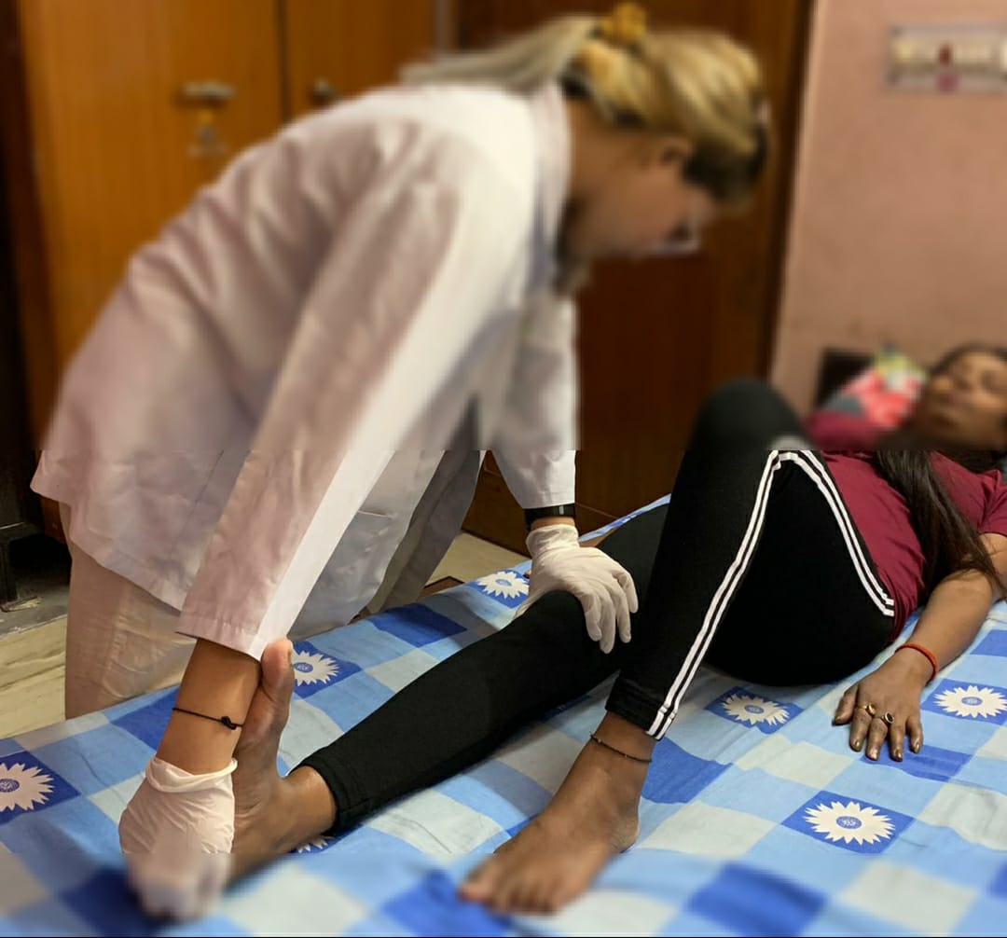
MFR:
- Patient’s position: prone lying
- Therapist position: walk standing on the treated side
Procedure: placing the both thumb on muscles remove the slack of skin and goes origin to insertion deep to the muscles, the position of the leg plantarflexion and slight knee flexion, first we release the soleus muscles by removing the upper muscles slack the we release the both heads of gastrocnemius muscle give the 5 strokes of deep tissues releases in each muscles after that take the post data.
RESULT
- All subject’s average data were analyzed together, with the mean of each group shown. In Table 1 showing mean and standard deviation of different in pre and post rom of ankle dorsi flexion and BP, With the help of graph 1, we plotted mean and standard deviation of pre and post ROM and BP of MFR technique and graph 2 showing mean and standard deviation of pre and post ROM and BP of passive stretching. Table one showing the effect of MFR and the graph one showing MFR values, Table 2 and graph 2 is showing the values of passive stretching and in table 3 we have the post values of both groups to compare the values which is more effective in this study, In the study we find it out the MFR gives the more effective results as compare to the passive stretching.
VALUES | Pre rom rt | Post rom rt | Pre rom lt | Post rom lt | Pre BP | Post BP
Mean ± SD | 14.26±2.43 | 18±3.36 | 15.2±1.68 | 19.46±2.18 | 166±8.79 | 154±10.51
 |  |  |  |  | 100±10.10 | 84.86±9.32
.
Table 1 ) Mean ± SD

Graph 1 is showing the difference in MFR group.

Values | Pre rom rt | Post rom rt | Pre rom lt | Post rom lt | Pre Bp | Post BP
mean±SD | 13.73±2.43 | 16.53±2.70 | 14.4±2.67 | 17.86±3.28 | 162.2±8.02 | 153±7.94
 |  |  |  |  | 96.06±11.25 | 84±8
Table 2 is showing stretching rom and BP pre post difference

Graph 2 is showing the pre and post values

TABLE - 3 POST VALUES OF BOTH TECHNIQUE
POST VALUES | MFR GROUP | STRETCHING GROUP
RIGHT | 18±3.6 | 16.53±2.70
LEFT | 19.46±2.18 | 17.86±3.28
BP | 154±10.51 | 153±7.94
BP | 84.86±9.32 | 84±8

There is a significant result to increase ROM and decreases the BP by both technique but the MFR shows more significantly.

DISCUSSION
This study was done to check the effectiveness of MFR and Passive stretching on calf muscles with hypertension in middle aged women. The aim of the study is to find out which out of these technique can provide more effective result in reducing hypertension in the middle aged women. In this study, we have used two technique- MFR and Passive stretching which have shown to be beneficial in reducing hypertension and increasing flexibility of the calf muscles. The calf muscles is called the secondary heart of the human body and it pumps back the blood to the heart.
Billi L et al did the study and according to the study when we release the soft tissues and found Arterial venous pressure is increases due to the tightness of muscles because the shunting of arteriovenous anastomoses valved connections when we give the stretched its lengthen up the fibres and elongation of the muscles that release the pressure against the artery and veins and its lower down the blood pressure.
With the help of MFR deep tissue release technique we released the muscles and that alleviating the BP because the tight muscles adhesion's break and the pressure around the artery and veins decreases so due to this and also with the proper function of the soleus muscles to pumping back to heart its normalized.
The pathophysiology of the both techniques is same both works to release the muscles and lengthen up the fascia and decrease the pressure around the arteries and veins but the MFR gives more effective results compare to passive stretching, because with help mechanical force of myofascial released it’s due to the sustain pressure into the colloidal/ viscoelastic fascial tissues and restoring length and release the pressure around the sub structure M.F Brens et al.
We need more study to establish how long the effect is maintain for both technique and in innervation which is more effective .in this study we find out the MFR is more effective to alleviating the BP as compare to passive stretching.
CONCLUSION
MFR technique and Passive stretching technique, both the groups showed significant difference. But when both these groups were compared, MFR shows better results than passive stretching on alleviating the hypertension (high blood pressure) with improving the ROM.

REFERENCES:
1.Blood pressure and the contractility of a human leg muscle Billy L. Luu and Richard C .Fitzpatrick 2013
2.Effectiveness of compressive Myofascial Release Vs Instrument Assisted Soft Tissue Mobilization in Subjects with Active Trigger Points of the Calf muscles Limiting Ankle Dorsiflexion .Dr.M. Vijayakumar1, Aishwarya Jaideep2, Rashi Khankal 2, Dr. Preeti Gazbare3, Blessy Abraham2.
3.The effect of Strength Training of the calf muscles pump on cardiovascular parameters. Andrew Lalchhuanawma, Divya Sanghi1.
4.Effect of Myofascial Release and Stretching Technique on Range of Motion and Reaction Time. Hironobu Kuruma,PT.PhD,OMT1, Hitoshi Takei,PT,PhD.OMT,1 Osamu Nitta,PT,PhD,1 Yorimitsu Furukawa,PT,PhD1,Nami Shida,PT, MS1, Hiroyo Kamio, PT,MS1, Ken Yanagisawa, PT,PhD1.Oct 19.2012
5.Cardiovascular response to human calf muscles stretch during varying levels of muscles metaboreflex activation. James P.Fisher, Martin P.D.Bell and Micheal J.White. published on 27 july 2005.
6.Blood pressure and calf muscles oxygen extraction during plantar flexion exercise in peripheral artery disease . J.Carter luck1, Amanda J. Miller1, Faisal Aziz1, John F. Radtka III, David N.Proctor,2 Urs A.Leurenberger ,1 Lawrence I.Sinoway,1and Matthew D.Muller1. J Appl Physiol 123: 2-10, 2017 First published April 6, 2017; doi:10.1152/japplphysiol.01110.2016.
7.Effects of repeated ankle stretching on calf muscle- tendon and ankle biomechanical properties in stroke survivors. Fan Gao,1 Yupeng Ren2, Elliot J. Roth2,3, Richard Harvey2,3 and Li-Qun Zhang2,5. Pulished in 2011 june ;26(5):516-522, doi:10.1016/j.clinbiomech.2010.12.003.
8. Blood pressure and exercise failing the acid test. Michael J. Joyner.
9. How physiotherapeutic and yogic interventions can be used for the treatment of primary hypertension. Mayank Shukla ,Assistant professor ,Amity Institute of physiotherapy. Volume 5 August 2019.
10.Combined effects of stretching and resistance training on ankle joint flexibility. E.Kato,1 T.Kurihara2, H.Kanehisa,3 T.Fukunaga,3 and Y.Kawakami4. 20 November 2013.
11. Impact of gender on calf muscles tightness. A Comparative and Normotive Study. Aparna Sarkar , Nitika Gupta. Volume 1.
12.Cardiovascular response to passive static flexibility exercises are influenced by the stretched muscles mass Valsalva maneuver. Paulo T.v. Farinatti, Pedro P.S. Soares, Walace D. Monteiro, Antonio F.A. Duarte Luis A. Viveiros de Castro.
13.Relations between cardiac and vascular structure in patients with primary aand secondary hypertension. Damiano R, MD, Maria L, MD, Enzo P, MD, Massimo S, MD, Maurizio C, MD, Giorgio B, MD, Guido T, MD, Stefano M, MD, Cristina M, MD, Guido G, MD, Enrico Agabiti-Rosei.MD. Volume 32, October 1998:985-92.
14.Lowe, Dr. John C. The purpose and practice of myofascial therapy , Houston, McDowell Publishing Co, 1989.
15. John F. Barnes, Myofascial release: the search for excellence, 10th edition. Myofascial release treatment center .1990.
16. Barenes, John F.1990. Myofascial Release: The Search for excellence, 10th edition.
17.Deep soft –tissue massage applied to healthy calf muscles has no effect on passive Fmechanical properties: A randomized, single- blind, cross over study. Daniel Thomson1,2*, Amitabh Gupta1, Jesica Arundell2 and Jack Crosbie1.(2015)
18.Yoga and hypertension: A Systemic review. Anupama Tagi1, MD, PhD (C), and Marc Cohen1 , MBBS (Hons)
19.Application of Passive Stretching and its Implications of muscles fibers. Patrick G De Deyne. Volume 81. February 2001.
20.Four weeks of regular static stretching reduces arterial stiffness in middle-aged men. Masato Nishiwaki1*, Haruka Yonemura 2, Kazumichi Kurobe3, and Naoyuki Matsumoto2. (2015).
21.The basic science of Myofascial release: morphologic change in connective tissue. Mark F. Barnes MPT. Journal of body work and movement therapist july 1997.

Author Declaration: Source of support: Nil, Conflict of interest: Nil
Was informed consent obtained from the subjects involved in the study? YES
For any images presented appropriate consent has been obtained from the subjects: NA
Plagiarism Checked: Urkund Software
Author work published under a Creative Commons Attribution 4.0 International License
DOI: 10.36848/IJBAMR/2020/29215.55860

