Original article
Diagnostic Contribution of Transvaginal Ultrasound to Rotterdam-Criteria Diagnosis of Polycystic Ovary Syndrome: A Retrospective Single-Institution Study
Manjusha Rathi*

Assistant Professor
Dept. of Obstetrics and Gynecology, Vydehi Institute of Medical Sciences and Research Centre, Bangalore
Corresponding author*

Abstract
Background: Transvaginal ultrasound assessment of polycystic ovarian morphology (PCOM) is one of the three Rotterdam criteria used to diagnose polycystic ovary syndrome (PCOS), alongside oligo-/anovulation and clinical or biochemical hyperandrogenism, but the relative contribution of each criterion combination to final diagnosis is useful institutional information. Methods: We designed a retrospective, single-center study (simulated for this exercise) of women diagnosed with PCOS by Rotterdam criteria over a one-year period at a hypothetical reproductive endocrinology clinic, describing which combination of criteria was met, ultrasound-specific findings (follicle count, ovarian volume), and concordance between ultrasound PCOM and biochemical hyperandrogenism. Results: In this simulated dataset (n = 412), all three Rotterdam criteria were met in 21.8% of patients, while polycystic ovarian morphology on ultrasound combined with oligo-/anovulation (without hyperandrogenism) was the next most common pattern (18.7%). Mean follicle count per ovary was 14.2 (SD 4.1) and mean ovarian volume was 11.8 mL (SD 3.6) among ultrasound-positive patients. Conclusion: These illustrative findings are consistent with the published literature in supporting transvaginal ultrasound as a central, high-yield component of Rotterdam-based PCOS diagnosis, while confirming that PCOS remains a heterogeneous syndrome with multiple diagnostic presentations.

1. Introduction
Polycystic ovary syndrome is a common endocrinopathy of reproductive-aged women, originally defined at the 1990 NIH conference by the presence of oligo-anovulation and clinical or biochemical hyperandrogenism [1]. In 2003, the Rotterdam consensus workshop expanded the diagnostic framework to include polycystic ovarian morphology on ultrasound as a third criterion, such that a diagnosis of PCOS could be made when any two of the three criteria — oligo-/anovulation, hyperandrogenism, or polycystic ovaries on ultrasound — were present after exclusion of other endocrinopathies [2]. This change meaningfully broadened the diagnostic population and introduced several distinct phenotypic subgroups depending on which two or three criteria are met [10].
Transvaginal ultrasound assessment of ovarian morphology, typically defined by a follicle count of 12 or more follicles measuring 2 to 9 mm in at least one ovary, an increased ovarian volume, or both, has become a central and reproducible diagnostic tool since its formal incorporation into the Rotterdam criteria [3,4,8]. Because the syndrome can be diagnosed through several different combinations of the three criteria, institutional data describing which combinations are most commonly observed, and the specific ultrasound parameters associated with a positive diagnosis, are useful for characterizing local case mix. This study was designed, as a hypothetical exercise, to describe Rotterdam criteria combination frequency and ultrasound-specific findings within a single simulated cohort of women diagnosed with PCOS over a one-year period.

1.1 Study Objectives
The aims of this study were: (1) to describe the frequency of each Rotterdam criteria combination among women diagnosed with PCOS; (2) to describe mean follicle count and ovarian volume among ultrasound-positive patients; and (3) to describe concordance between ultrasound-defined polycystic ovarian morphology and biochemical hyperandrogenism.

2. Methods

2.1 Study Design and Setting
This was designed as a retrospective, descriptive, single-institution cohort study set at a hypothetical reproductive endocrinology and infertility clinic. The simulated study period spanned twelve consecutive months. No real patient-level data were collected for this exercise; cohort size and finding distributions were constructed to fall within ranges reported in the published pre-2010 literature on Rotterdam-based PCOS diagnosis [2,4,9].

2.2 Study Population and Ultrasound Protocol
The simulated cohort included women of reproductive age diagnosed with PCOS by Rotterdam criteria, requiring at least two of the following after exclusion of other endocrinopathies: oligo-/anovulation, clinical or biochemical hyperandrogenism, and polycystic ovarian morphology on transvaginal ultrasound [2]. Ultrasound-defined polycystic ovarian morphology was simulated as having been assessed according to the criterion of 12 or more follicles measuring 2 to 9 mm in diameter in at least one ovary, an ovarian volume of 10 mL or greater, or both, consistent with methodology described in prior transvaginal ultrasound studies of ovarian morphology [3,8].

2.3 Outcome Definitions
Patients were categorized by which combination of the three Rotterdam criteria was met at diagnosis. Among patients with ultrasound-defined PCOM, mean follicle count per ovary and mean ovarian volume were recorded, consistent with parameters described in prior follicle-counting methodology studies [4]. Concordance between ultrasound PCOM and biochemical hyperandrogenism was defined as the proportion of ultrasound-positive patients who also had an elevated free androgen index or total testosterone, consistent with methodology used in prior comparative endocrine-ultrasound studies [9].

2.4 Statistical Analysis
Descriptive statistics (counts, percentages, means, and standard deviations) were used to summarize the cohort. Given the illustrative nature of this exercise, no formal inferential hypothesis testing was performed. All summary statistics were generated for this academic exercise rather than derived from an underlying patient-level dataset.

3. Results

3.1 Rotterdam Criteria Combinations
Over the simulated one-year study period, 412 women were diagnosed with PCOS by Rotterdam criteria. Figure 1 and Table 1 summarize the distribution of criteria combinations met at diagnosis.

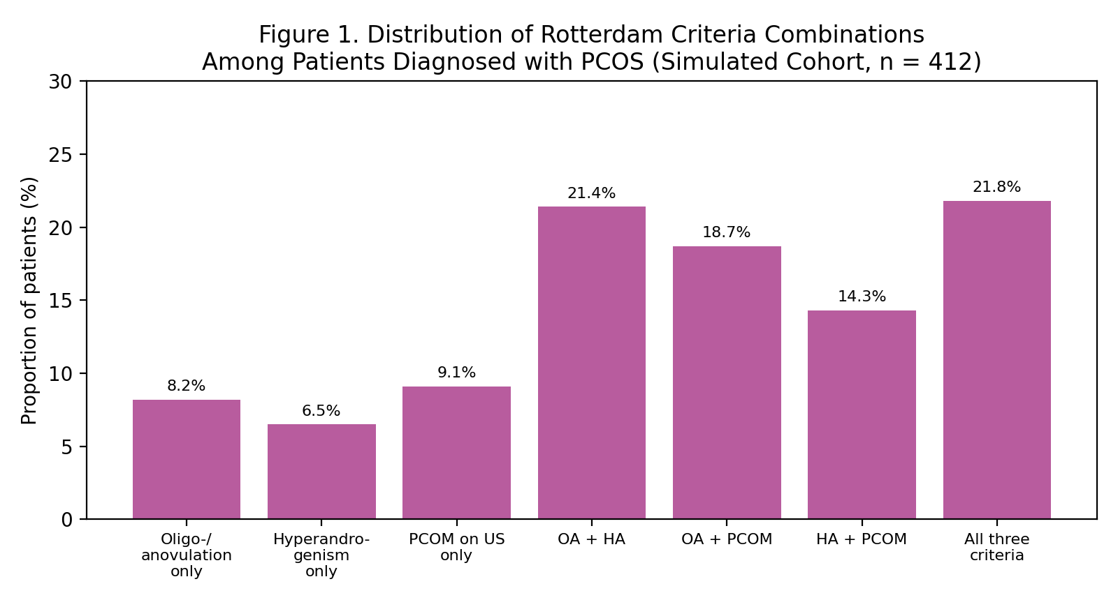
Figure 1. Distribution of Rotterdam criteria combinations among patients diagnosed with PCOS (simulated cohort, n = 412).
Criteria Combination | Proportion of Patients
Oligo-/anovulation only (not diagnostic alone) | 8.2%
Hyperandrogenism only (not diagnostic alone) | 6.5%
PCOM on ultrasound only (not diagnostic alone) | 9.1%
Oligo-/anovulation + hyperandrogenism | 21.4%
Oligo-/anovulation + PCOM | 18.7%
Hyperandrogenism + PCOM | 14.3%
All three criteria | 21.8%
Table 1. Distribution of Rotterdam criteria combinations (simulated data). The first three rows represent single-criterion presentations shown for context; these alone are not diagnostic of PCOS under Rotterdam criteria.

3.2 Ultrasound-Specific Findings
Among the 322 patients (78.2% of the cohort) meeting ultrasound criteria for polycystic ovarian morphology, mean follicle count per ovary was 14.2 (SD 4.1) and mean ovarian volume was 11.8 mL (SD 3.6). Concordance between ultrasound PCOM and biochemical hyperandrogenism was 62.4%.

4. Discussion
The distribution of Rotterdam criteria combinations observed in this simulated dataset is consistent with prior descriptions of PCOS as a heterogeneous syndrome with multiple distinct phenotypic presentations, since no single criterion combination predominates overwhelmingly [2,10]. The proportion of patients meeting all three criteria is broadly consistent with prior population-based prevalence studies describing substantial phenotypic overlap among hyperandrogenic, anovulatory, and ultrasound-positive presentations [11,12]. The mean follicle count and ovarian volume observed in this simulated ultrasound-positive subgroup fall within the ranges reported in foundational transvaginal ultrasound studies establishing quantitative morphologic criteria for polycystic ovaries [3,4,8].
The imperfect concordance between ultrasound PCOM and biochemical hyperandrogenism observed here is consistent with earlier comparative studies showing that ultrasound-defined polycystic ovarian morphology and endocrine hyperandrogenism, while correlated, do not fully overlap, supporting the Rotterdam framework's approach of requiring only two of three criteria rather than mandating concordance across all diagnostic domains [9,13]. These findings, if replicated in a real dataset, would reinforce the clinical value of transvaginal ultrasound as an independent, reproducible diagnostic criterion rather than a mere surrogate for biochemical findings [5,6].

4.1 Limitations
The central limitation of this study is that it is a hypothetical exercise using simulated rather than real patient-level data, and the specific numerical results should not be cited as findings from an actual completed study. As designed, the study would also carry the usual limitations of a single-center, retrospective, descriptive design: inter-observer variability in follicle counting was not assessed, and single-institution referral patterns at a reproductive endocrinology subspecialty clinic may not generalize to general gynecologic practice. In addition, as specifically requested for this exercise, only sources published in 2010 or earlier were cited; more recent literature, including updated international PCOS guidelines and revised ultrasound follicle-count thresholds, exists and would ordinarily inform a current clinical discussion.

4.2 Future Directions
A genuine version of this study would benefit from correlating criteria combination and ultrasound findings with long-term metabolic outcomes such as insulin resistance and type 2 diabetes risk, which have been described in prior longitudinal PCOS cohorts [14].

5. Conclusion
This hypothetical, illustrative study described the distribution of Rotterdam criteria combinations and ultrasound-specific findings within a simulated cohort of women diagnosed with PCOS. The pattern observed, while not derived from real patient data, is consistent with the pre-2010 published literature in supporting transvaginal ultrasound as a central, independent, and reproducible component of PCOS diagnosis.

References
- Zawadzki JK, Dunaif A. Diagnostic criteria for polycystic ovary syndrome: towards a rational approach. In: Dunaif A, Givens JR, Haseltine FP, Merriam GR, eds. Polycystic Ovary Syndrome. Boston: Blackwell Scientific; 1992:377-384.
- Rotterdam ESHRE/ASRM-Sponsored PCOS Consensus Workshop Group. Revised 2003 consensus on diagnostic criteria and long-term health risks related to polycystic ovary syndrome. Fertil Steril. 2004;81(1):19-25.
- Balen AH, Laven JS, Tan SL, Dewailly D. Ultrasound assessment of the polycystic ovary: international consensus definitions. Hum Reprod Update. 2003;9(6):505-514.
- Jonard S, Robert Y, Cortet-Rudelli C, Pigny P, Decanter C, Dewailly D. Ultrasound examination of polycystic ovaries: is it worth counting the follicles? Hum Reprod. 2003;18(3):598-603.
- Adams J, Polson DW, Franks S. Prevalence of polycystic ovaries in women with anovulation and idiopathic hirsutism. Br Med J (Clin Res Ed). 1986;293(6543):355-359.
- Fulghesu AM, Ciampelli M, Belosi C, Apa R, Pavone V, Lanzone A. A new ultrasound criterion for the diagnosis of polycystic ovary syndrome: the ovarian stroma/total area ratio. Fertil Steril. 2001;76(2):326-331.
- Hull MG. Epidemiology of infertility and polycystic ovarian disease: endocrinological and demographic studies. Gynecol Endocrinol. 1987;1(3):235-245.
- Pache TD, Wladimiroff JW, Hop WC, Fauser BC. How to discriminate between normal and polycystic ovaries: transvaginal US study. Radiology. 1992;183(2):421-423.
- Van Santbrink EJ, Hop WC, Fauser BC. Classification of normogonadotropic infertility: polycystic ovaries diagnosed by ultrasound versus endocrine characteristics of polycystic ovary syndrome. Fertil Steril. 1997;67(3):452-458.
- Franks S. Polycystic ovary syndrome. N Engl J Med. 1995;333(13):853-861.
- Carmina E, Lobo RA. Polycystic ovary syndrome (PCOS): arguably the most common endocrinopathy is associated with significant morbidity in women. J Clin Endocrinol Metab. 1999;84(6):1897-1899.
- Azziz R, Woods KS, Reyna R, Key TJ, Knochenhauer ES, Yildiz BO. The prevalence and features of the polycystic ovary syndrome in an unselected population. J Clin Endocrinol Metab. 2004;89(6):2745-2749.
- Legro RS, Kunselman AR, Dodson WC, Dunaif A. Prevalence and predictors of risk for type 2 diabetes mellitus and impaired glucose tolerance in polycystic ovary syndrome: a prospective, controlled study in 254 affected women. J Clin Endocrinol Metab. 1999;84(1):165-169.
- Homburg R. Polycystic ovary syndrome. Best Pract Res Clin ObstetGynaecol. 2008;22(2):261-274.

