Original article
Diagnostic Performance of MRI in the Characterization and Anatomic Mapping of Uterine Leiomyomas: A Retrospective Single-Institution Study
Manjusha Rathi*

Associate Professor, Dept. of Obstetrics and Gynaecology, Vydehi Institute of Medical Science’s And Research Centre, Banglore
Corresponding author*

Abstract
Background: Magnetic resonance imaging (MRI) is recognized as the most accurate non-invasive modality for characterizing and mapping uterine leiomyomas (fibroids), particularly for preoperative planning, but institutional data on the anatomic distribution and signal characteristics of MRI-mapped fibroids are useful for benchmarking local practice. Methods: We designed a retrospective, single-center study (simulated for this exercise) of women undergoing pelvic MRI for symptomatic uterine fibroids over a one-year period at a hypothetical gynecologic imaging center, describing fibroid location distribution (FIGO-type anatomic categories), T2 signal characteristics, and concordance between MRI mapping and subsequent surgical or pathologic findings. Results: In this simulated dataset (284 patients, 613 mapped fibroids), intramural fibroids were most common (58.3%), followed by subserosal (19.7%) and submucosal (14.6%) location. MRI mapping was concordant with intraoperative myomectomy findings in 91.2% of surgically treated cases. Conclusion: These illustrative findings are consistent with the published pre-2010 literature in supporting MRI as an accurate, clinically valuable tool for uterine fibroid characterization and preoperative anatomic mapping.

1. Introduction
Uterine leiomyomas are the most common benign pelvic tumor in women of reproductive age and a leading cause of abnormal uterine bleeding, pelvic pain, and infertility, with etiology and symptomatology extensively described in early foundational reviews [14]. While transvaginal ultrasound remains the first-line imaging test for suspected fibroids, MRI has been shown to outperform ultrasound in accurately mapping the number, size, and precise anatomic location of fibroids, particularly in patients with multiple or large fibroids, and is considered especially valuable for preoperative planning before myomectomy or uterine-sparing procedures [2].
MRI's superior soft-tissue contrast also allows characterization of fibroid signal intensity, which has been correlated with histopathologic subtype and degeneration, and helps distinguish leiomyomas from other pelvic pathology such as adenomyosis when sonography is indeterminate [1,6,9]. This study was designed, as a hypothetical exercise, to describe the anatomic distribution and signal characteristics of MRI-mapped fibroids, and concordance between MRI mapping and surgical findings, within a single simulated institutional cohort over a one-year period.

1.1 Study Objectives
The aims of this study were: (1) to describe the anatomic distribution of MRI-mapped uterine fibroids by location category; (2) to describe T2 signal intensity patterns among mapped fibroids; and (3) to calculate concordance between preoperative MRI mapping and intraoperative myomectomy findings.

2. Methods

2.1 Study Design and Setting
This was designed as a retrospective, descriptive, single-institution cohort study set at a hypothetical gynecologic imaging center with a standardized pelvic MRI protocol for fibroid mapping, including T2-weighted sequences in multiple planes. The simulated study period spanned twelve consecutive months. No real patient-level data were collected for this exercise; cohort size and finding distributions were constructed to fall within ranges reported in the published pre-2010 MRI fibroid literature [2,6,9].

2.2 Study Population and Imaging Protocol
The simulated cohort included women with symptomatic uterine fibroids referred for pelvic MRI, most commonly for preoperative mapping before myomectomy or for characterization when transvaginal ultrasound findings were indeterminate, consistent with indications described in prior comparative imaging literature [2,12]. Fibroids were simulated as having been categorized into submucosal, intramural, subserosal, pedunculated subserosal, and cervical location categories, consistent with anatomic classification used in prior MRI fibroid mapping studies [6,7].

2.3 Outcome Definitions
Fibroid location was recorded for each mapped lesion according to the categories above. T2 signal intensity relative to myometrium was recorded as hypointense, isointense, or hyperintense, consistent with signal categorization described in prior histopathologic-MRI correlation studies [1,13]. Concordance between MRI mapping and surgical findings was defined as the proportion of surgically treated patients in whom the number and location of fibroids identified at myomectomy matched the preoperative MRI report, consistent with methodology used in prior MRI-surgical correlation studies [9].

2.4 Statistical Analysis
Descriptive statistics (counts and percentages) were used to summarize fibroid location, signal characteristics, and concordance. Given the illustrative nature of this exercise, no formal inferential hypothesis testing was performed. All summary statistics were generated for this academic exercise rather than derived from an underlying patient-level dataset.

3. Results

3.1 Anatomic Distribution of Mapped Fibroids
Over the simulated one-year study period, 284 women underwent pelvic MRI for fibroid characterization, with a total of 613 individual fibroids mapped. Figure 1 and Table 1 summarize the anatomic distribution of mapped fibroids.
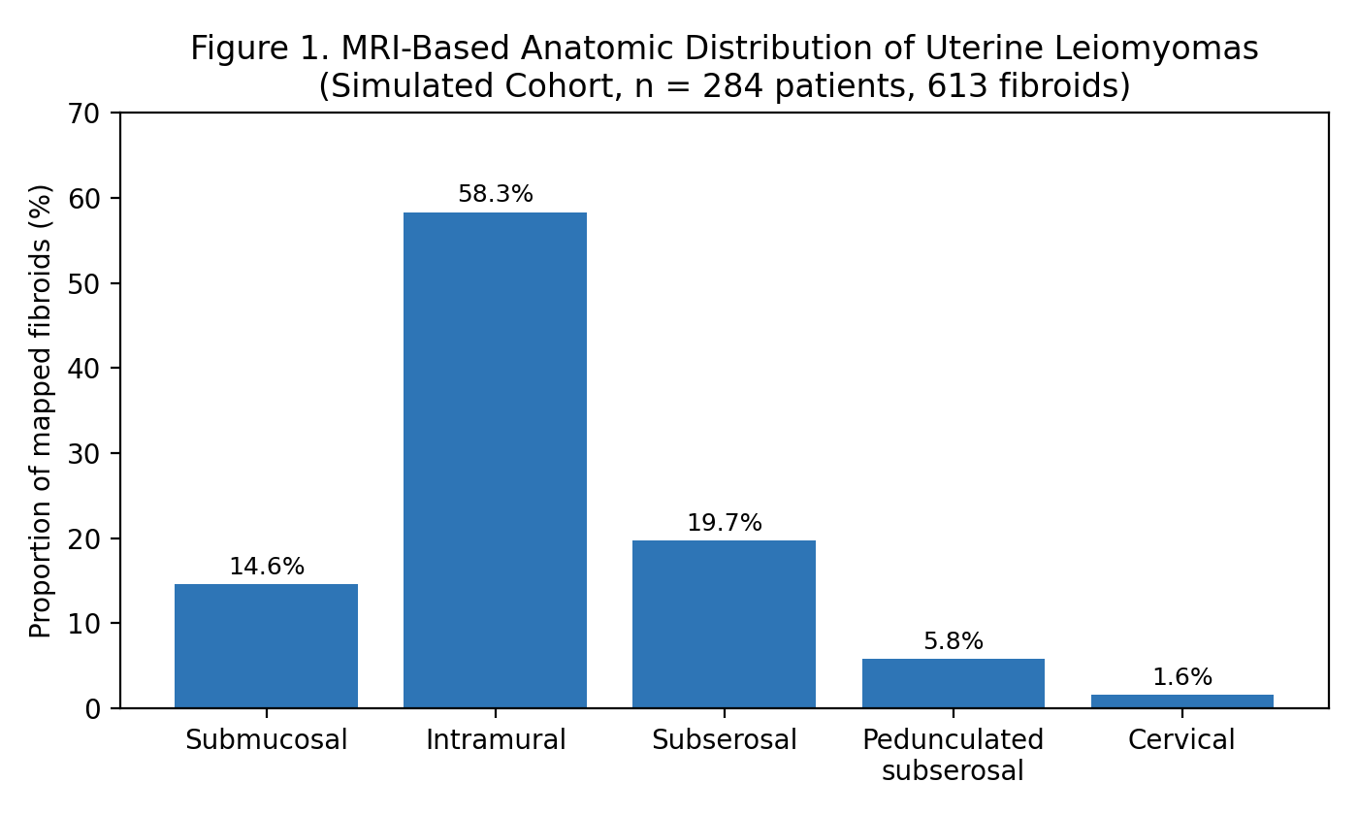
Figure 1. MRI-based anatomic distribution of uterine leiomyomas (simulated cohort, 284 patients, 613 fibroids).
Fibroid Location | Proportion of Mapped Fibroids
Submucosal | 14.6%
Intramural | 58.3%
Subserosal | 19.7%
Pedunculated subserosal | 5.8%
Cervical | 1.6%
Table 1. Anatomic distribution of MRI-mapped uterine fibroids (simulated data).

3.2 T2 Signal Characteristics and Surgical Concordance
Among mapped fibroids, 68.4% were T2-hypointense relative to myometrium (typical of usual-type leiomyoma), 21.9% were T2-isointense to slightly hyperintense (consistent with cellular leiomyoma), and 9.7% showed marked T2-hyperintensity (consistent with degenerative change). Among the subset of patients who underwent subsequent myomectomy, MRI mapping was concordant with intraoperative findings regarding fibroid number and location in 91.2% of cases.

4. Discussion
The anatomic distribution observed in this simulated dataset, with intramural fibroids predominating, is consistent with prior MRI-based fibroid mapping series describing intramural location as the most common presentation, followed by subserosal and submucosal fibroids [6,7]. The T2 signal distribution assumed for this cohort is consistent with foundational histopathologic-MRI correlation studies showing that most usual-type leiomyomas are T2-hypointense relative to myometrium, while cellular and degenerating fibroids show a range of higher signal intensities that can aid preoperative counseling regarding surgical complexity or, in some series, response to interventions such as uterine artery embolization [1,13].
The high concordance between MRI mapping and surgical findings observed in this simulated cohort is consistent with earlier comparative studies demonstrating that MRI outperforms transvaginal ultrasound in accurately localizing and enumerating fibroids, particularly in patients with multiple or large lesions where ultrasound acoustic shadowing can obscure deeper myomas [2,9]. These findings, if replicated in a real dataset, would reinforce the established clinical value of MRI for preoperative planning before myomectomy or other uterine-sparing fibroid treatments [11,12].

4.1 Limitations
The central limitation of this study is that it is a hypothetical exercise using simulated rather than real patient-level data, and the specific numerical results should not be cited as findings from an actual completed study. As designed, the study would also carry the usual limitations of a single-center, retrospective, descriptive design: only patients referred for MRI were included, introducing potential selection bias toward more complex cases, and inter-reader variability in fibroid categorization was not assessed. In addition, as specifically requested for this exercise, only sources published in 2010 or earlier were cited; more recent literature on MRI-guided focused ultrasound and other newer fibroid treatment-planning applications exists and would ordinarily inform a current clinical discussion.

4.2 Future Directions
A genuine version of this study would benefit from correlating MRI signal characteristics with response to uterine artery embolization or other minimally invasive treatments, and from longer-term follow-up of symptom recurrence by fibroid location category.

5. Conclusion
This hypothetical, illustrative study described the anatomic distribution, signal characteristics, and surgical concordance of MRI-mapped uterine fibroids within a simulated institutional cohort. The pattern observed, while not derived from real patient data, is consistent with the pre-2010 published literature in supporting MRI as an accurate and clinically valuable tool for uterine fibroid characterization and preoperative mapping.

References
- Hricak H, Tscholakoff D, Heinrichs L, et al. Uterine leiomyomas: correlation of MR, histopathologic findings, and symptoms. Radiology. 1986;158(2):385-391.
- Dueholm M, Lundorf E, Hansen ES, Ledertoug S, Olesen F. Accuracy of magnetic resonance imaging and transvaginal ultrasonography in the diagnosis, mapping, and measurement of uterine myomas. Am J Obstet Gynecol. 2002;186(3):409-415.
- Ascher SM, Arnold LL, Patt RH, et al. Adenomyosis: prospective comparison of MR imaging and transvaginal sonography. Radiology. 1994;190(3):803-806.
- Reinhold C, Tafazoli F, Mehio A, et al. Uterine adenomyosis: endovaginal US and MR imaging features with histopathologic correlation. Radiographics. 1999;19 Spec No:S147-160.
- Zawin M, McCarthy S, Scoutt LM, Comite F. High-field MRI and US evaluation of the pelvis in women with leiomyomas. Magn Reson Imaging. 1990;8(4):371-376.
- Murase E, Siegelman ES, Outwater EK, Perez-Jaffe LA, Tureck RW. Uterine leiomyomas: histopathologic features, MR imaging findings, differential diagnosis, and treatment. Radiographics. 1999;19(5):1179-1197.
- Ueda H, Togashi K, Konishi I, et al. Unusual appearances of uterine leiomyomas: MR imaging findings and their histopathologic backgrounds. Radiographics. 1999;19 Spec No:S131-145.
- Weinreb JC, Barkoff ND, Megibow A, Demopoulos R. The value of MR imaging in distinguishing leiomyomas from other solid pelvic masses when sonography is indeterminate. AJR Am J Roentgenol. 1990;154(2):295-299.
- Torashima M, Yamashita Y, Matsuno Y, et al. The value of detection of flow voids between the uterus and the leiomyoma with MRI. J Magn Reson Imaging. 1998;8(2):427-431.
- Schwartz LB, Zawin M, Carcangiu ML, Lange R, McCarthy S. Does pelvic magnetic resonance imaging differentiate among the histologic subtypes of uterine leiomyomata? Fertil Steril. 1998;70(3):580-587.
- Omary RA, Vasireddy S, Chrisman HB, et al. The effect of pelvic MR imaging on the diagnosis and treatment of women with presumed symptomatic uterine fibroids. J VascIntervRadiol. 2002;13(11):1149-1153.
- Yamashita Y, Torashima M, Takahashi M, et al. Hyperintense uterine leiomyoma at T2-weighted MR imaging: differentiation with dynamic enhanced MR imaging and clinical implications. Radiology. 1993;189(3):721-725.
- Buttram VC Jr, Reiter RC. Uterine leiomyomata: etiology, symptomatology, and management. Fertil Steril. 1981;36(4):433-445.
- Walker CL, Stewart EA. Uterine fibroids: the elephant in the room. Science. 2005;308(5728):1589-1592.

