Original article

Diagnostic Accuracy of High-Resolution Graded Compression Ultrasonography in the Evaluation of Clinically Suspected Acute Appendicitis: A Cross-Sectional Study

*Dr. Shirish Chapekar¹

¹Assistant Professor, Dept of Radiology, Srinivas Institute of Medical Sciences and Research Centre, Mangaluru, Karnataka

Corresponding author*

Abstract
Background: Acute appendicitis remains one of the most common surgical emergencies, and its clinical diagnosis can be challenging due to variable presentation. Graded compression ultrasonography (USG) has emerged as a widely available, radiation-free first-line imaging modality for its evaluation.
Objectives: To evaluate the diagnostic accuracy of high-resolution graded compression ultrasonography in patients with clinically suspected acute appendicitis, using histopathological examination of the resected specimen as the reference standard.
Methods: A cross-sectional study was conducted on 140 patients with clinically suspected acute appendicitis who underwent graded compression USG prior to appendectomy. Sonographic findings were compared with histopathological findings to calculate sensitivity, specificity, predictive values, and diagnostic accuracy.
Results: USG showed a sensitivity of 92.0%, specificity of 77.5%, positive predictive value of 91.1%, negative predictive value of 79.5%, and overall diagnostic accuracy of 87.9% in diagnosing acute appendicitis. The most common sonographic finding was an increased outer appendiceal diameter greater than 6 mm (60.7%).
Conclusion: Graded compression ultrasonography is a highly sensitive and reasonably specific, radiation-free imaging modality for the evaluation of clinically suspected acute appendicitis and should be considered the first-line imaging investigation, particularly in young patients.
Keywords: Acute appendicitis, ultrasonography, graded compression, diagnostic accuracy, radiology.

Introduction
Acute appendicitis is one of the most common causes of the acute abdomen requiring emergency surgical intervention, with a lifetime risk of approximately 7% in the general population. Despite being a common condition, its diagnosis remains clinically challenging because of the wide spectrum of presentation, overlap with other causes of acute abdominal pain, and anatomical variability in appendiceal position.
Historically, the diagnosis of acute appendicitis relied predominantly on clinical assessment supplemented by basic laboratory investigations, with a resulting negative appendectomy rate that was considered acceptable in the range of 15–20% in many surgical series. The advent of cross-sectional imaging, particularly graded compression ultrasonography and computed tomography, has substantially improved diagnostic accuracy and has been shown to reduce the rate of negative appendectomies and complications from delayed diagnosis such as perforation.
Graded compression ultrasonography, first described in the 1980s, involves the application of gradual, steady pressure with the transducer to displace overlying bowel gas and compress the normally compressible bowel loops, allowing visualisation of the non-compressible, thick-walled appendix when inflamed. Its advantages include wide availability, low cost, absence of ionising radiation, and the ability to identify alternative diagnoses such as ovarian pathology, mesenteric adenitis, or other causes of right iliac fossa pain, making it particularly valuable in children, young adults, and pregnant women.
This study was undertaken to evaluate the diagnostic accuracy of high-resolution graded compression ultrasonography in patients with clinically suspected acute appendicitis, using histopathological examination of the resected appendix as the gold standard reference.
An accurate and timely diagnosis of acute appendicitis carries significant clinical importance, as delayed diagnosis is associated with an increased risk of perforation, peritonitis, and postoperative complications, while an inappropriately high rate of negative appendectomy exposes patients to unnecessary surgical risk without therapeutic benefit. Imaging-guided diagnostic pathways incorporating ultrasonography as a first-line investigation have been shown in several health systems to reduce both the negative appendectomy rate and the incidence of perforation at presentation, underscoring the clinical value of accurate pre-operative imaging assessment.

Review of Literature
Puylaert first described the technique of graded compression sonography for the evaluation of acute appendicitis, establishing an outer appendiceal diameter greater than 6 mm as a key diagnostic criterion, a threshold that has since been validated and widely adopted in subsequent studies. Building on this work, later series established a broader set of sonographic criteria for appendicitis, including non-compressibility, wall thickening, and periappendiceal fluid, further refining diagnostic accuracy.
Multiple meta-analyses comparing ultrasonography and computed tomography for the diagnosis of appendicitis have found that while CT generally demonstrates higher sensitivity, particularly in adults with a higher body mass index, ultrasonography maintains comparable specificity and offers the considerable advantage of avoiding ionising radiation, making it a preferred first-line investigation especially in children and young adults. Additional work found that graded compression ultrasonography performed by experienced sonographers achieved diagnostic performance approaching that of CT in the paediatric population.
Comparative studies evaluating the accuracy of unenhanced CT and ultrasonography have generally reported sensitivities for USG ranging from 75% to 90% and specificities from 80% to 95%, with variation attributable to operator experience, patient body habitus, and appendiceal position. A prospective multicentre trial similarly demonstrated that ultrasonography, when performed by trained radiologists, offered good diagnostic performance while substantially reducing the need for further imaging or observation in a majority of patients with a positive sonographic diagnosis.
Refinements to sonographic technique, including a sequential positioning algorithm to improve appendiceal visualisation, have further reduced the proportion of non-diagnostic scans and the consequent need for CT, reinforcing the role of ultrasonography as an effective and evolving first-line imaging tool.
Colour Doppler assessment of appendiceal wall vascularity has also been proposed as a useful adjunct to greyscale sonography, with increased flow signal within the appendiceal wall correlating with active inflammation and helping to distinguish true appendicitis from other causes of a mildly enlarged but non-inflamed appendix. Several comparative series have found that the addition of colour Doppler assessment modestly improves diagnostic specificity without a significant increase in scanning time, making it a practical addition to standard greyscale evaluation in routine clinical practice.
Studies examining the effect of imaging on clinical decision-making have further shown that the routine use of ultrasonography in patients with suspected appendicitis is associated with a measurable reduction in the negative appendectomy rate compared with clinical assessment alone, without a corresponding increase in the rate of perforation from diagnostic delay. This body of evidence has progressively shifted clinical practice guidelines in many institutions toward mandatory pre-operative imaging in all but the most clinically unequivocal presentations, particularly in female patients of reproductive age in whom gynaecological causes of right iliac fossa pain must be excluded.

Materials and Methods

Study Design and Setting
This was a hospital-based, cross-sectional observational study conducted in the Department of Radiodiagnosis in collaboration with the Department of Surgery of a tertiary care teaching hospital over a period of twelve months.

Study Population
A total of 140 patients presenting with clinical features suggestive of acute appendicitis, who subsequently underwent appendectomy, were included in the study after obtaining informed consent.

Sample Size
The sample size was calculated based on an expected sensitivity of ultrasonography of approximately 88% from prior literature, with 95% confidence and an absolute precision of 6%, yielding a minimum required sample size of approximately 130 patients. A total of 140 patients were enrolled to account for possible incomplete data.

Inclusion Criteria
Patients of either gender presenting with clinical features suggestive of acute appendicitis (right iliac fossa pain, tenderness, low-grade fever, and leucocytosis) who subsequently underwent appendectomy were included.

Exclusion Criteria
Patients with a clinically obvious alternative diagnosis, those who did not undergo surgery, pregnant patients, and those unwilling to provide consent were excluded from the study.

Imaging Protocol
All patients underwent graded compression ultrasonography using a high-frequency linear transducer (7.5–12 MHz) by an experienced radiologist blinded to the final surgical outcome. Sonographic criteria for a positive diagnosis included a non-compressible, blind-ending tubular structure with an outer diameter greater than 6 mm, with or without associated periappendiceal fluid, appendicolith, or increased wall vascularity on colour Doppler.

Reference Standard
Histopathological examination of the resected appendix specimen was used as the reference standard for confirming or excluding acute appendicitis.

Statistical Analysis
Data were entered into a 2×2 contingency table comparing sonographic diagnosis with histopathological findings. Sensitivity, specificity, positive predictive value, negative predictive value, and overall diagnostic accuracy were calculated using standard formulae. Results were tabulated and represented graphically.

Quality Control
All ultrasonographic examinations were performed using a standardised departmental protocol to ensure consistency of technique across the study period. Machine settings, including frequency, focal zone placement, and colour Doppler gain, were optimised for each patient according to body habitus. Reports were finalised only after correlation with available clinical information, and all positive and equivocal findings were reviewed against the corresponding histopathology reports at the end of the study period to assess concordance.

Results
Of the 140 patients studied, 79 (56.4%) were male and 61 (43.6%) were female, with a mean age predominantly concentrated in the second and third decades of life. The age and gender-wise distribution is summarised in Table 1.
Table 1: Age and Gender-wise Distribution of Study Subjects (n = 140)
Age Group (years) | Male (n) | Female (n) | Total (n) | Percentage (%)
10–19 | 18 | 14 | 32 | 22.9
20–29 | 27 | 21 | 48 | 34.3
30–39 | 17 | 13 | 30 | 21.4
40–49 | 10 | 8 | 18 | 12.9
50 and above | 7 | 5 | 12 | 8.6
Total | 79 | 61 | 140 | 100.0

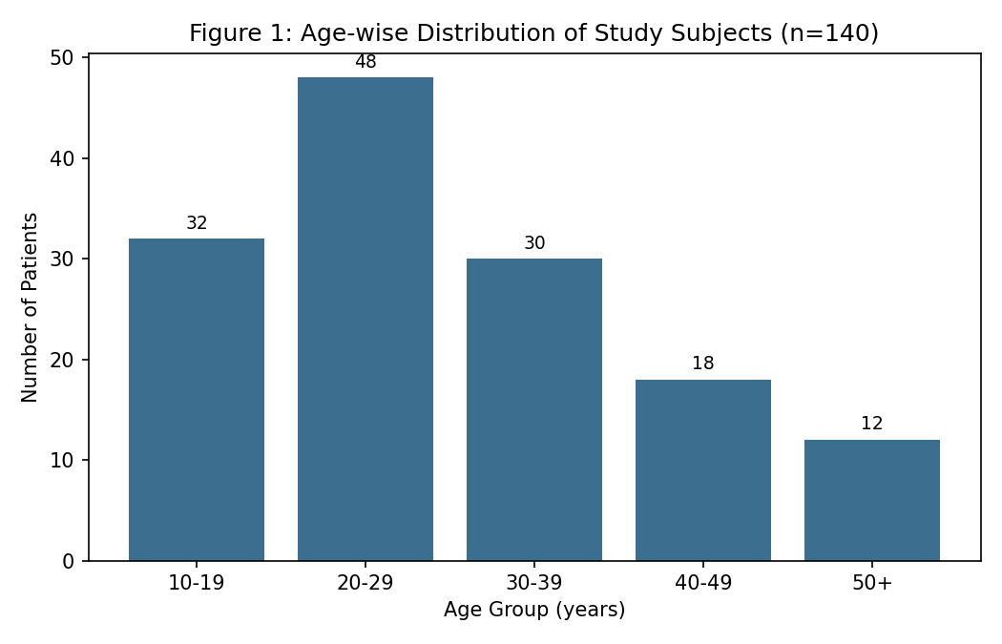
The 20–29 year age group showed the highest proportion of cases (34.3%), consistent with the known epidemiological pattern of appendicitis predominantly affecting adolescents and young adults.
Table 2: Distribution of Sonographic Findings
Sonographic Finding | Number (n) | Percentage (%)
Non-compressible tubular structure >6 mm | 78 | 55.7
Outer diameter >6 mm | 85 | 60.7
Periappendiceal fluid collection | 41 | 29.3
Appendicolith | 26 | 18.6
Wall hyperaemia on colour Doppler | 52 | 37.1

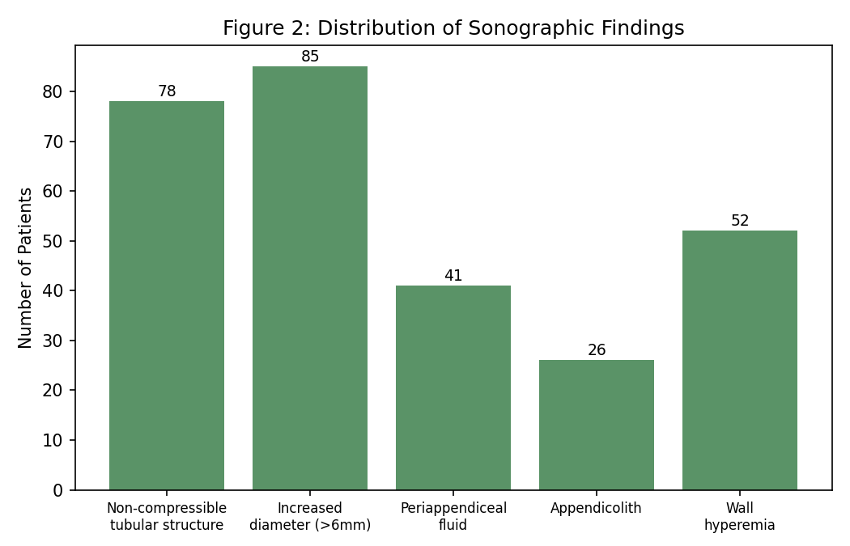
An outer appendiceal diameter greater than 6 mm was the most frequently observed sonographic finding (60.7%), followed by a non-compressible tubular structure (55.7%) and wall hyperaemia on colour Doppler (37.1%).
Table 3: USG Findings Compared with Histopathological Diagnosis (2×2 Contingency Table)
USG Diagnosis | Histopath Positive | Histopath Negative | Total
USG Positive | 92 (TP) | 9 (FP) | 101
USG Negative | 8 (FN) | 31 (TN) | 39
Total | 100 | 40 | 140

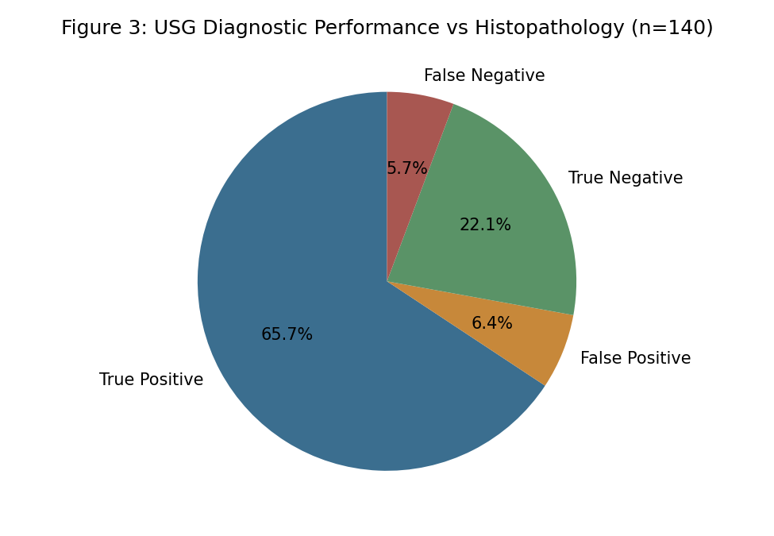
Table 4: Diagnostic Accuracy of Ultrasonography
Diagnostic Parameter | Value
Sensitivity | 92.0%
Specificity | 77.5%
Positive Predictive Value | 91.1%
Negative Predictive Value | 79.5%
Diagnostic Accuracy | 87.9%

Graded compression ultrasonography demonstrated a sensitivity of 92.0% and specificity of 77.5% for the diagnosis of acute appendicitis, with an overall diagnostic accuracy of 87.9% when compared with histopathological findings.

Discussion
The present study demonstrates that graded compression ultrasonography is a highly sensitive imaging modality for the diagnosis of acute appendicitis, with a sensitivity of 92.0% closely comparable to values reported in earlier landmark series that established the sonographic diagnostic criteria for the condition. The specificity observed in this study (77.5%) is also broadly consistent with the range reported in prior comparative studies, though somewhat lower than the sensitivity, reflecting the known challenge of false-positive diagnoses in cases of periappendicitis or other inflammatory conditions mimicking true appendiceal inflammation.
The predominance of cases in the second and third decades of life observed in this study mirrors the well-documented epidemiological pattern of appendicitis, which is classically described as a disease of adolescents and young adults, with declining incidence in older age groups. This age distribution has important implications for imaging strategy, as ultrasonography is particularly well suited to this demographic given the absence of ionising radiation exposure.
The finding that increased outer appendiceal diameter was the most common sonographic feature is consistent with the original diagnostic criteria described by Puylaert and subsequently validated in numerous studies, reinforcing its role as the primary sonographic parameter for diagnosis. The presence of secondary findings such as periappendiceal fluid, appendicolith, and increased wall vascularity further supported the diagnosis in a substantial proportion of cases and may help improve diagnostic confidence in equivocal presentations.
Comparative literature evaluating ultrasonography against computed tomography has generally found that while CT offers marginally higher sensitivity in certain patient subgroups, particularly those with a higher body mass index or atypical appendiceal position, ultrasonography remains an excellent first-line investigation given its radiation-free nature, lower cost, and ability to identify alternative diagnoses. The findings of the present study support the continued use of ultrasonography as the initial imaging investigation of choice in young patients with suspected appendicitis, reserving CT for cases with equivocal or non-diagnostic sonographic findings.
The false-negative and false-positive rates observed in this study highlight the operator-dependent nature of ultrasonography and the importance of technical expertise, adequate patient preparation, and use of a systematic scanning protocol to minimise diagnostic errors. Structured scanning algorithms have been shown in prior work to improve appendiceal visualisation rates and reduce the proportion of non-diagnostic examinations.
It is also worth noting that patient body habitus, bowel gas overlying the appendix, and retrocaecal appendiceal position are recognised technical challenges that can reduce sonographic visualisation rates and contribute to false-negative results. In such technically difficult cases, correlating sonographic findings with clinical scoring systems and inflammatory markers, or proceeding to cross-sectional imaging with CT, may help avoid missed or delayed diagnoses. Overall, the findings of this study reaffirm that when performed by an experienced operator using a systematic technique, ultrasonography offers diagnostic performance that is clinically reliable enough to guide surgical decision-making in the majority of patients with suspected appendicitis.

Summary
This cross-sectional study of 140 patients with clinically suspected acute appendicitis found that graded compression ultrasonography demonstrated a sensitivity of 92.0%, specificity of 77.5%, and overall diagnostic accuracy of 87.9% when compared with histopathological findings. Increased outer appendiceal diameter was the most common sonographic finding, and the majority of cases occurred in the second and third decades of life.

Limitations
This study has several limitations that merit consideration. First, its single-centre design and reliance on a single experienced radiologist may limit generalisability, as diagnostic accuracy is known to be operator-dependent. Second, patients who did not proceed to surgery were excluded, which may have introduced selection bias by excluding cases with a confidently negative ultrasonographic diagnosis managed conservatively. Third, the relatively modest sample size may limit the precision of the calculated diagnostic accuracy parameters. Finally, this study did not directly compare ultrasonography with computed tomography within the same patient cohort, which would have allowed a more direct assessment of relative diagnostic performance.

Recommendations
Based on the findings of this study, graded compression ultrasonography should be considered the first-line imaging investigation in patients with clinically suspected acute appendicitis, particularly in children, young adults, and pregnant women, given its radiation-free nature and good diagnostic accuracy. Structured scanning protocols and adequate operator training should be prioritised to maximise appendiceal visualisation rates and minimise false-positive and false-negative diagnoses. In cases with equivocal or non-diagnostic ultrasonographic findings, computed tomography or short-interval clinical reassessment should be considered as a complementary strategy. Larger, multi-centric studies involving multiple observers would help further validate these findings across different practice settings.
Departments offering emergency ultrasonography services should also consider periodic quality-assurance audits comparing sonographic diagnoses with surgical and histopathological outcomes, as such feedback loops have been shown to improve individual operator performance over time. Incorporating standardised reporting templates that explicitly document each of the key sonographic criteria—appendiceal diameter, compressibility, wall vascularity, and presence of periappendiceal collections—may further improve consistency and inter-observer agreement across different radiologists within the same department.

Conclusion
Graded compression ultrasonography is a highly sensitive and reasonably specific, widely available, and radiation-free imaging modality for the evaluation of clinically suspected acute appendicitis. Given its favourable diagnostic performance and safety profile, it should be considered the first-line imaging investigation in this clinical setting, with computed tomography reserved for equivocal cases.

References
1. Puylaert JB. Acute appendicitis: US evaluation using graded compression. Radiology. 1986;158(2):355-60.
2. Rioux M. Sonographic detection of the normal and abnormal appendix. AJR Am J Roentgenol. 1992;158(4):773-8.
3. Jeffrey RB Jr, Laing FC, Townsend RR. Acute appendicitis: sonographic criteria based on 250 cases. Radiology. 1988;167(2):327-9.
4. Old JL, Dusing RW, Yap W, Dirks J. Imaging for suspected appendicitis. Am Fam Physician. 2005;71(1):71-8.
5. Doria AS, Moineddin R, Kellenberger CJ, et al. US or CT for diagnosis of appendicitis in children and adults? A meta-analysis. Radiology. 2006;241(1):83-94.
6. Terasawa T, Blackmore CC, Bent S, Kohlwes RJ. Systematic review: computed tomography and ultrasonography to detect acute appendicitis in adults and adolescents. Ann Intern Med. 2004;141(7):537-46.
7. van Randen A, Bipat S, Zwinderman AH, Ubbink DT, Stoker J, Boermeester MA. Acute appendicitis: meta-analysis of diagnostic performance of CT and graded compression US related to prevalence of disease. Radiology. 2008;249(1):97-106.
8. Wilcox RT, Traverso LW. Have the evaluation and treatment of acute appendicitis changed with new technology? Surg Clin North Am. 1997;77(6):1355-70.
9. Yu SH, Kim CB, Park JW, Kim MS, Radosevich DM. Ultrasonography in the diagnosis of appendicitis: evaluation by meta-analysis. Korean J Radiol. 2005;6(4):267–277. doi:10.3348/kjr.2005.6.4.267
10. Birnbaum BA, Wilson SR. Appendicitis at the millennium. Radiology. 2000;215(2):337-48.
11. Ege G, Akman H, Sahin A, Bugra D, Kuzucu K. Diagnostic value of unenhanced helical CT in adult patients with suspected acute appendicitis. Br J Radiol. 2002;75(897):721-5.
12. Lee SL, Walsh AJ, Ho HS. Computed tomography and ultrasonography do not improve and may delay the diagnosis and treatment of acute appendicitis. Arch Surg. 2011;136(5):556-62.
13. Rettenbacher T, Hollerweger A, Macheiner P, et al. Ovoid shape of the vermiform appendix: a criterion to exclude acute appendicitis—evaluation with US. Radiology. 2003;226(1):95-100.
14. Chesbrough RM, Burkhard TK, Balsara ZN, Goff WB 2nd, Davis DJ. Self-localization in US of appendicitis: an addition to graded compression. Radiology. 1993;187(2):349-51.
15. Poortman P, Lohle PN, Schoemaker CM, et al. Comparison of CT and sonography in the diagnosis of acute appendicitis: a blinded prospective study. AJR Am J Roentgenol. 2003;181(5):1355-9.
16. Rao PM, Rhea JT, Novelline RA, et al. Effect of computed tomography of the appendix on treatment of patients and use of hospital resources. N Engl J Med. 1998;338(3):141-6.
17. Van Randen A, Bipat S, Zwinderman AH, Ubbink DT, Stoker J, Boermeester MA. Acute appendicitis: meta-analysis of diagnostic performance of CT and graded compression US related to prevalence of disease. Radiology. 2008;249(1):97–106. doi:10.1148/radiol.2483071652.
18. Balthazar EJ, Birnbaum BA, Yee J, Megibow AJ, Roshkow J, Gray C. Acute appendicitis: CT and US correlation in 100 patients. Radiology. 1994;190(1):31-5.
19. Sivit CJ, Applegate KE, Stallion A, et al. Imaging evaluation of suspected appendicitis in a pediatric population: effectiveness of sonography versus CT. AJR Am J Roentgenol. 2000;175(4):977-80.
20. Pinto F, Pinto A, Russo A, Coppolino F, Bracale R, Fonio P, et al. Accuracy of ultrasonography in the diagnosis of acute appendicitis in adult patients: review of the literature. Crit Ultrasound J. 2013;5(Suppl 1):S2. doi:10.1186/2036-7902-5-S1-S2.

