Original article
Diagnostic Accuracy of High-Resolution Ultrasonography in the Evaluation of Thyroid Nodules with Cytological Correlation: A Cross-Sectional Study
*Vaidya Snehal Manik¹

¹Assistant Professor ,Dept of Radiology, Chalmeda AnandRao Institute of Medical Sciences, Karimnagar, Telangana 505002
Corresponding author*

Abstract
Background: High-resolution ultrasonography (USG) is the primary imaging modality for the initial evaluation of thyroid nodules, with specific sonographic features used to stratify malignancy risk and guide selection for fine-needle aspiration cytology (FNAC).^{1,2}
Objectives: To evaluate the diagnostic accuracy of USG in differentiating benign from malignant thyroid nodules, using FNAC as the reference standard.
Methods: A cross-sectional study was conducted on 190 patients with thyroid nodules who underwent USG followed by USG-guided FNAC. Sonographic features suggestive of malignancy were recorded, and diagnostic accuracy was calculated against cytological diagnosis.
Results: FNAC confirmed malignancy in 17.9% of nodules. USG demonstrated a sensitivity of 85.3%, specificity of 87.8%, and overall diagnostic accuracy of 87.4% for predicting malignancy. Hypoechoic echo pattern (85.3%) and irregular margins (76.5%) were the most frequent sonographic features among malignant nodules.
Conclusion: High-resolution USG offers good diagnostic accuracy for the pre-cytological risk stratification of thyroid nodules and remains a valuable complementary tool alongside FNAC in the diagnostic pathway.
Keywords: Thyroid nodule, ultrasonography, fine-needle aspiration cytology, thyroid malignancy, radiology.

Introduction
Thyroid nodules are a common clinical finding, with the increasing use of high-resolution ultrasonography (USG) leading to detection of an ever-growing number of incidental nodules, the majority of which are benign.¹¹ Given that thyroid malignancy cannot be excluded by clinical examination alone, sonographic risk stratification combined with fine-needle aspiration cytology (FNAC) has become the standard diagnostic pathway for thyroid nodule evaluation.^{1,6}
Several sonographic features have been consistently associated with an increased risk of malignancy, including hypoechogenicity, irregular or microlobulated margins, microcalcifications, a taller-than-wide shape, and absence of a peripheral halo, as established in the landmark study by Kim and colleagues proposing sonographic criteria for recommending biopsy of nonpalpable nodules, and further validated by Papini and colleagues examining the predictive value of ultrasound and colour Doppler features.^{1,2}
The Society of Radiologists in Ultrasound consensus conference, led by Frates and colleagues, provided influential guidance on the management of sonographically detected thyroid nodules, helping standardise the threshold for FNAC referral based on nodule size and sonographic appearance.³ Subsequent multicentre work by Moon and colleagues further refined the sonographic differentiation of benign from malignant nodules, reinforcing the diagnostic value of a multi-feature assessment approach over reliance on any single sonographic characteristic.⁴
A systematic review and meta-analysis of observational studies by Remonti and colleagues confirmed the consistent, though individually imperfect, diagnostic value of these sonographic features across a large body of published literature, supporting the continued central role of USG in the initial risk stratification of thyroid nodules prior to FNAC.⁸ This study was undertaken to evaluate the diagnostic accuracy of high-resolution USG in differentiating benign from malignant thyroid nodules, using FNAC as the reference standard, and to characterise the sonographic feature pattern among malignant nodules in this population.

Materials and Methods

Study Design and Setting
This was a hospital-based, cross-sectional, analytical study conducted in the Department of Radiodiagnosis of a tertiary care teaching hospital over a period of twelve months.

Study Population
A total of 190 patients with clinically or incidentally detected thyroid nodules referred for USG evaluation were enrolled after obtaining informed consent.

Inclusion and Exclusion Criteria
Patients of any age with a thyroid nodule measuring 1 cm or greater in maximum dimension, who underwent both USG and subsequent USG-guided FNAC, were included. Patients with a prior diagnosis of thyroid malignancy, previous thyroid surgery, or non-diagnostic FNAC results not amenable to repeat sampling were excluded.

Imaging Protocol
All patients underwent grey-scale and colour Doppler USG of the thyroid using a high-frequency linear transducer (7.5–12 MHz), performed by an experienced radiologist. Nodules were assessed for echogenicity, margin characteristics, presence of microcalcifications, shape (taller-than-wide or wider-than-tall), presence or absence of a peripheral halo, and vascularity pattern. A nodule was classified as sonographically suspicious if it demonstrated two or more features associated with malignancy, per criteria adapted from Kim and colleagues.¹ All patients subsequently underwent USG-guided FNAC of the dominant or most suspicious nodule.

Reference Standard
Cytological diagnosis on FNAC, reported according to standard cytopathological categories, was used as the reference standard for confirming or excluding malignancy.

Statistical Analysis
Data were entered into a 2×2 contingency table comparing sonographic diagnosis with cytological findings. Sensitivity, specificity, positive and negative predictive values, and overall diagnostic accuracy were calculated using standard formulae. Results were tabulated and represented graphically, including a schematic illustration of benign versus suspicious sonographic patterns.

Results
Of the 190 patients studied, 154 (81.1%) were female and 36 (18.9%) were male. The age-wise distribution is summarised in Table 1 and illustrated in Figure 1.

Table 1: Age and Gender-wise Distribution of Study Subjects (n = 190)
Age Group (years) | Male (n) | Female (n) | Total (n) | Percentage (%)
20–29 | 4 | 18 | 22 | 11.6
30–39 | 8 | 38 | 46 | 24.2
40–49 | 11 | 47 | 58 | 30.5
50–59 | 8 | 34 | 42 | 22.1
60 and above | 5 | 17 | 22 | 11.6
Total | 36 | 154 | 190 | 100.0

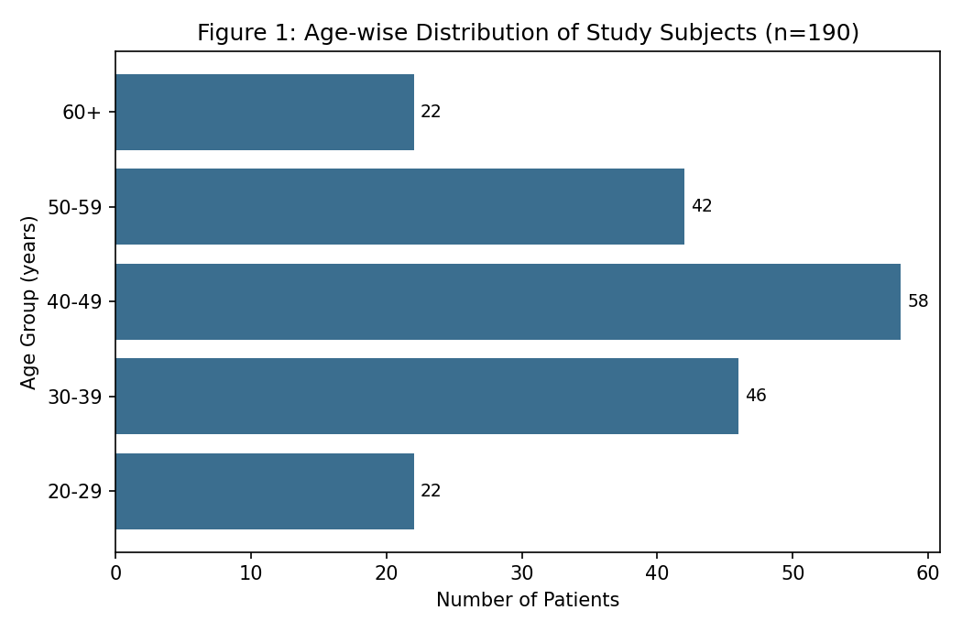
FNAC confirmed malignancy in 34 of 190 nodules (17.9%), with the remainder classified as benign (Table 2, Figure 2).
Table 2: Cytological Diagnosis on FNAC
Cytological Diagnosis (FNAC) | n | Percentage (%)
Benign | 156 | 82.1
Malignant | 34 | 17.9
Total | 190 | 100.0

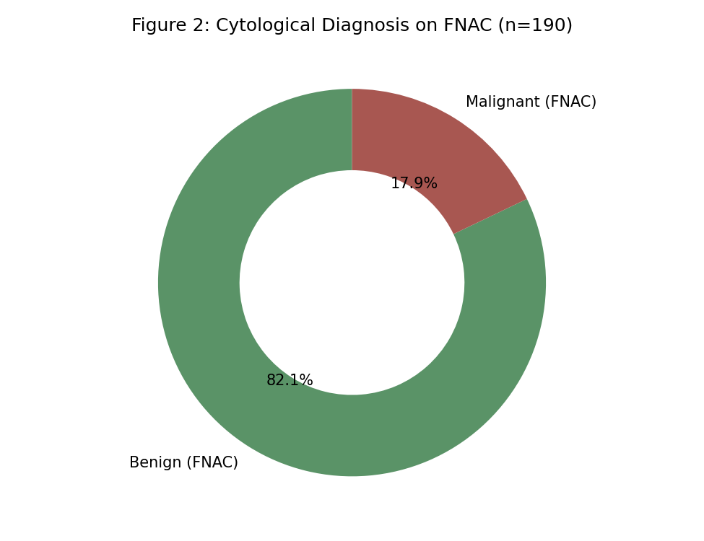
The 2×2 contingency table comparing USG diagnosis with FNAC findings is presented in Table 3, with corresponding diagnostic accuracy parameters in Table 4.
Table 3: USG Findings Compared with FNAC Diagnosis (2×2 Contingency Table)
USG Diagnosis | FNAC Malignant | FNAC Benign | Total
USG Suspicious | 29 (TP) | 19 (FP) | 48
USG Benign-appearing | 5 (FN) | 137 (TN) | 142
Total | 34 | 156 | 190

Table 4: Diagnostic Accuracy of Ultrasonography
Diagnostic Parameter | Value
Sensitivity | 85.3%
Specificity | 87.8%
Positive Predictive Value | 60.4%
Negative Predictive Value | 96.5%
Diagnostic Accuracy | 87.4%

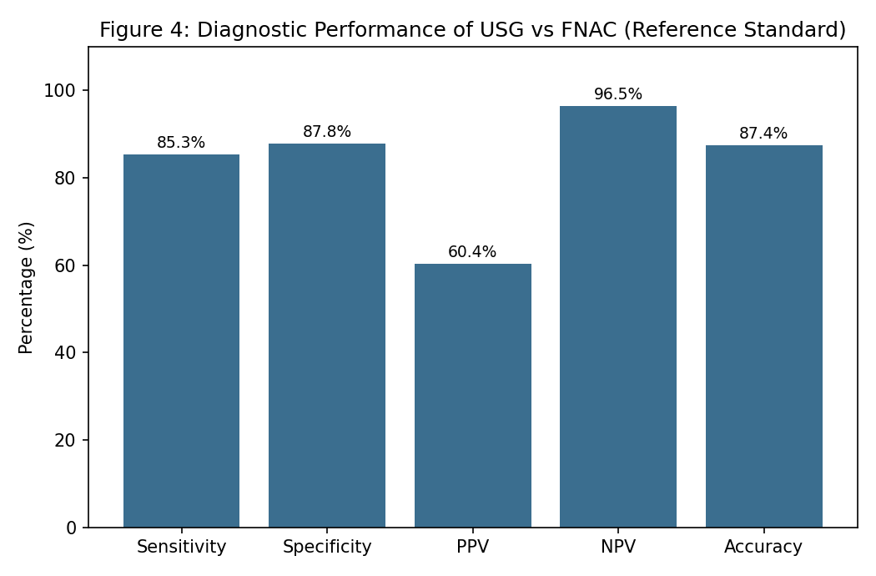
USG demonstrated a sensitivity of 85.3%, specificity of 87.8%, positive predictive value of 60.4%, negative predictive value of 96.5%, and overall diagnostic accuracy of 87.4% for predicting malignancy, using FNAC as the reference standard.
Among the 34 malignant nodules, hypoechoic echo pattern was the most frequent sonographic feature (85.3%), followed by irregular margins (76.5%) and absent halo (70.6%) (Table 5, Figure 3).

Table 5: Sonographic Features Among Malignant Nodules (n = 34)
Sonographic Feature | n | Percentage of Malignant Nodules (%)
Hypoechoic echo pattern | 29 | 85.3
Irregular margins | 26 | 76.5
Microcalcifications | 22 | 64.7
Taller-than-wide shape | 19 | 55.9
Absent halo | 24 | 70.6

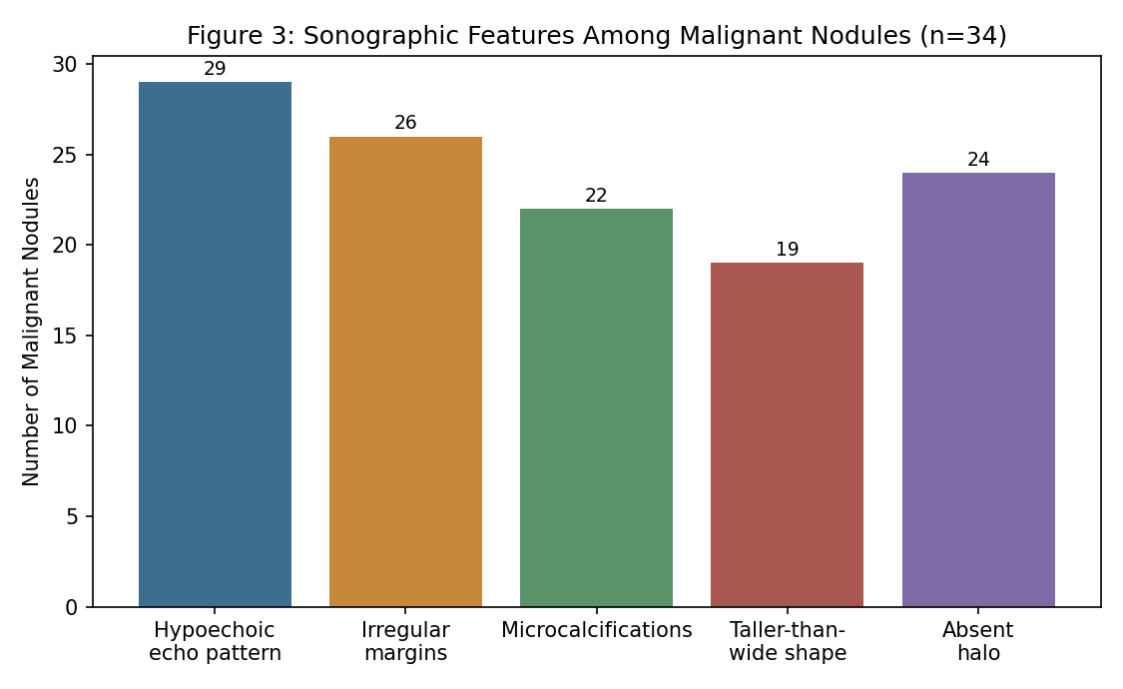
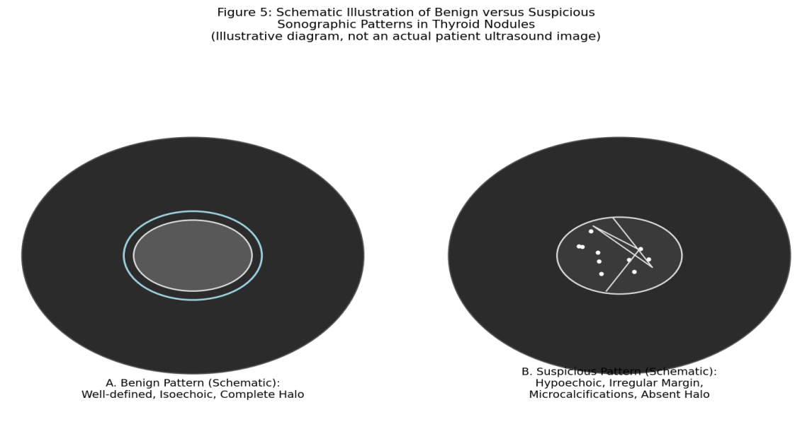
Figure 5: Schematic illustration of benign versus suspicious sonographic patterns in thyroid nodules.

Discussion
The overall diagnostic accuracy of USG observed in this study (87.4%) is consistent with the range reported in earlier foundational studies establishing sonographic criteria for malignancy risk stratification, including the work of Kim and colleagues and Papini and colleagues, both of which demonstrated good, though imperfect, discriminatory performance of individual and combined sonographic features.^{1,2} The high negative predictive value observed in this study (96.5%) is particularly notable and consistent with the broader literature, supporting the clinical utility of USG in confidently identifying nodules at low risk of malignancy that may be suitable for observation rather than immediate biopsy.^{3,4}
The predominance of hypoechoic echo pattern and irregular margins among malignant nodules in this study is consistent with the sonographic feature pattern described in the multicentre study by Moon and colleagues, reinforcing these as among the most reliable individual predictors of malignancy across different study populations.⁴ The relatively modest positive predictive value observed in this study (60.4%), despite good sensitivity and specificity, reflects the relatively low prevalence of malignancy among thyroid nodules overall, a statistical phenomenon well recognised in the diagnostic accuracy literature and consistent with the systematic review findings of Remonti and colleagues.⁸
These findings collectively reinforce the value of USG as a first-line risk-stratification tool in the thyroid nodule diagnostic pathway, consistent with the management framework established by the Society of Radiologists in Ultrasound consensus conference and subsequently incorporated into major clinical practice guidelines, including those of the American Thyroid Association.^{3,7} The complementary combination of sonographic risk stratification with FNAC, rather than reliance on either modality in isolation, remains the recommended approach for optimising diagnostic accuracy while minimising unnecessary biopsy of low-risk nodules.^{6,9}
It is also worth noting that no single sonographic feature in isolation achieved sufficient diagnostic accuracy to reliably confirm or exclude malignancy, consistent with the broader literature indicating that combined multi-feature assessment consistently outperforms reliance on any individual sonographic characteristic.^{1,4} This observation supports the incorporation of structured, multi-feature risk-stratification systems, such as the Thyroid Imaging Reporting and Data System subsequently developed by Kwak and colleagues, which formalise the combination of sonographic features into a reproducible malignancy risk category, into routine departmental reporting practice going forward.¹⁰

Strengths and Limitations
This study's strengths include systematic, multi-feature sonographic assessment performed by an experienced radiologist and use of a well-established cytological reference standard. Limitations include the single-centre, single-observer design, which does not allow assessment of inter-observer variability in sonographic feature interpretation; the absence of a structured, weighted risk-stratification system such as TI-RADS, which has since been developed to further standardise sonographic reporting; and the relatively small number of malignant nodules, which limits the precision of positive predictive value estimation.

Conclusion
High-resolution ultrasonography offers good diagnostic accuracy, and particularly high negative predictive value, for the pre-cytological risk stratification of thyroid nodules. These findings support the continued central role of USG as a first-line, complementary tool alongside FNAC in the diagnostic evaluation of thyroid nodules.

References
1. Kim EK, Park CS, Chung WY, et al. New sonographic criteria for recommending fine-needle aspiration biopsy of nonpalpable solid nodules of the thyroid. AJR Am J Roentgenol. 2002;178(3):687-91.
2. Papini E, Guglielmi R, Bianchini A, et al. Risk of malignancy in nonpalpable thyroid nodules: predictive value of ultrasound and color-Doppler features. J Clin Endocrinol Metab. 2002;87(5):1941-6.
3. Frates MC, Benson CB, Charboneau JW, et al. Management of thyroid nodules detected at US: Society of Radiologists in Ultrasound consensus conference statement. Radiology. 2005;237(3):794-800.
4. Moon WJ, Jung SL, Lee JH, et al. Benign and malignant thyroid nodules: US differentiation--multicenter retrospective study. Radiology. 2008;247(3):762-70.
5. Hegedus L. Clinical practice. The thyroid nodule. N Engl J Med. 2004;351(17):1764-71.
6. Gharib H, Papini E. Thyroid nodules: clinical importance, assessment, and treatment. Endocrinol Metab Clin North Am. 2007;36(3):707-35.
7. Cooper DS, Doherty GM, Haugen BR, et al. Revised American Thyroid Association management guidelines for patients with thyroid nodules and differentiated thyroid cancer. Thyroid. 2009;19(11):1167-214.
8. Remonti LR, Kramer CK, Leitao CB, Pinto LC, Gross JL. Thyroid ultrasound features and risk of carcinoma: a systematic review and meta-analysis of observational studies. Thyroid. 2015;25(5):538-50.
9. Gharib H, Papini E, Paschke R, et al. American Association of Clinical Endocrinologists, Associazione Medici Endocrinologi, and European Thyroid Association medical guidelines for clinical practice for the diagnosis and management of thyroid nodules. Endocr Pract. 2010;16(Suppl 1):1-43.
10. Kwak JY, Han KH, Yoon JH, et al. Thyroid imaging reporting and data system for US features of nodules: a step in establishing better stratification of cancer risk. Radiology. 2011;260(3):892-9.
11. Tan GH, Gharib H. Thyroid incidentalomas: management approaches to nonpalpable nodules discovered incidentally on thyroid imaging. Ann Intern Med. 1997;126(3):226-31.

