Original Article
Combined Effects of Kigelia africana And Garcinia kola on The Liver
Histology in Male Wistar Rats
¹Adeyemo Linda Tolulope, ²Kukoyi Boone I, ¹Olukade Baliqis Adejoke

Names of Institution: ¹Olabisi Onabanjo University, Physiology Department, Sagamu Campus, Ogun State, Nigeria ²Hallmark University, Biochemistry Department, Itele Ijebu, Ogun State, Nigeria
Corresponding Author: ¹Olukade Baliqis Adejoke

ABSTRACT
Kigelia africana is widely used throughout Africa for a variety of purposes, particularly in local medicine, and more recently in commercial applications to treat various pathological conditions. This study was conducted to investigate the combinatorial effects of Kigelia africana and Garcinia kola on the liver histology of male Wistar rats.
10 male Wister rats weighed between 120g to 200g were randomly placed into 2 groups of 5 rats each. One of these groups was the control group and they were fed with normal feed and water. The other group which represented the experimental group was fed with normal diet, water ad-libitum with 400mg/kg extract orally for 7 days with oral cannula. The body weights of the rats were monitored during the experiment daily using the weighing balance.
Findings from this study showed that dosage of 400mg/kg of combined extract showed an improvement liver tissue; portal triads (a branch of portal vein, hepatic artery and of bile duct) in the experimental rats treated with Kigelia africana and Garcinia kola. There are no adverse effects of the combined herbs on the histological architecture of the liver in the male Wistar rats when compared with the control rats.
Keywords: Kigelia Africana, Garcinia Kola, Liver histology

INTRODUCTION
In the quest for the traditional belief and customs in the cure for several diseases that affect man, there are attempts to combine several herbs for specific ailments and the choice of herbs or combination of different herbs for the treatment of metabolic disorder that characterized the ailments. So much research has been done on the herb Kigelia africana which is a genus of flowering plant in the family Bignoniaceae. The plant has various uses as described based on personal experiences by the users [1,2,3]. Few uses include application of plaster prepared from mature fruits to treat wound and rheumatism. The fruit is said to be purgative in nature.
In addition, the leaves of the Kigelia africana have been positioned as an important nutritional resource, comparable to other green leafy vegetables such as spinach [4].
Garcinia kola known as bitter kola on the other hand is specie of flowering plant which belongs to a family of tropical plants known as Clusiaceae [5]. The plant is a popular agricultural product available in large quantity in West Africa particularly in Nigeria. Bitter kola has been identified as a potent antibiotic which could be effective in the treatment of many diseases. The fruits, stems and leaves have been used in folk medicine to treat ailments from cough to fever. However, Bitter kola is considered as an effective agricultural produce in the treatment of diarrhea, tuberculosis, and other bacterial infections. Researchers have revealed that Bitter kola contains chemical compounds that will help the breakdown of glycogen in the liver and has other medicinal uses which account for its longevity in man. Since, in local African homes combinations of herbs for traditional medicines in the treatment of diseases is widely known but with limited investigation on the combinatorial effect on the internal organs, which made this study to have focus on the combinatorial effects of Kigelia africana and Garcinia kola on the liver weight and histology of male Wistar rats.
MATERIALS AND METHODS
Collection of herbal samples
Kigelia africana and Garcinia Kola were purchased from a local market, Falawo market in Sagamu, Ogun State, Nigeria.
Preparation and Extraction of herbal samples
The aqueous extract of Garcinia Kola seed and Kigelia africana stem bark was prepared as previously as described by [6]with a slight modification. Both herbal samples were grounded into powdery form and mixed in the ratio of 3:2.
Fresh Garcinia Kola seed and Kigelia africana stem bark were dried in the laboratory at room temperature crushed and soaked together (450g) in the ratio 3:2 in 9L water for 48hours. The mixture was filtered and evaporated twice under vacuum using Buchner funnel and whatman NO.1 filter paper (Whatman International Ltd. Maidstone UK) The filtrate was evaporated and under reduced pressure using a rotator evaporator and later freeze dried before appropriate doses were administered to the experimental animals.
Extraction yield in % = weight of extract of Garcinia Kola seed and Kigelia africana
weight of powdered Garcinia Kola seed and Kigelia africana
=180×100 =40%
450
Preparation of the Aqueous Extract Solution
0.4g of the extract was measured using the weighing balance and was dissolved in 5ml of distilled water. 1ml of this aqueous solution was administered to each rat in the experimental group. The body weight of rats in experimental groups are 177g, 204g, 160g, 164g, 225g respectively. Average body weight (177+204+160+164+225) g = 930g, since, 400mg of the extract=1kg of rat.
Hence, Dosage ( Xg; 930×400/1000 =0.37g of the extract ~0.4g)
For the distilled water, 1ml =1 rat
Therefore, 5ml= 5rats. e.g for experimental rat that weighed 177g, the ml of the aqueous solution administered was: (Xml of distilled water = 177×5/930=0.95ml of the aqueous solution, ~1ml of the aqueous solution)
Therefore, the volume of aqueous extract solution that was given to the experimental rat that weighed 177g was 1ml.
Experimental Animals
Ten (10) male Wister rats were purchased from Covenant farm in Oyo state, Nigeria weighed between 100-180g. They were maintained at room temperature with relative humidity on a 12-hour light/12-hour dark cycle with access to water and standard commercial feed ad libitum bought from Joyful feeds, Shagamu, Ogun State. Before, administration the Wistar rats were given 14 days acclimatization period. The handling of the animals was in accordance with the standard principles of laboratory animal care.
Experimental Design
The 10 male Wister rats were grouped into 2 groups, A and B, each group containing 5 rats.
Group A - Control: This group contains 5 rat and were fed with the normal feed and water and are representing.
Group B – Experimental: These groups contain 5 rats and were fed with normal diet, water, and the 400mg/kg extract. The aqueous extract solution was administered to the rats based on their body weight. The route of administration was oral. This was done by withdrawing a required dose using a 1ml syringe and delivering it directly into the gastrointestinal tract of the rat using oral canular attached to the syringe placing it under the tongue to enable swallowing.
The weight of all the rats were taken and recorded using the weighing balance during the acclimatization period. The weight was also taken and recorded from the onset of administration till the ends of the experimental research that is, the weight was recorded daily.
Animal Sacrifice/Liver Extraction
Wistar rats were sacrificed and the liver tissue from each group was removed and weighed using weighing balance, the tissues were kept in the sample bottles containing 10% formal saline for tissue fixation. The sample bottles were labeled for easy identification of the liver tissue for both control group and the experimental group.
Preparation of formal saline (tissue fixation)
0.5g of NaCl was dissolved in 90ml of distilled water after which 10ml formaldehyde was added to it.

Tissue Sample Processing
The tissues were then cut into thinner pieces for processing. The selected tissues were placed in the tissue cassette and were labeled appropriately. The tissues were processed using the tissue processor, after which the tissues were fixed.
HISTOLOGICAL PROCEDURES
After tissue sample fixation, they were dehydrated with 50% alcohol for 1hour, the 70% alcohol for another hour, then in another 90% alcohol the next one hour. The alcohol was cleared off the tissues using xylene.
Histological Procedures: Infiltration
Liver tissues samples were infiltrated in a liquid paraffin wax after which samples were taken into their embedding sections. They could solidify and the excess wax were trimmed out.

Histological Procedures: Sectioning
The tissue was cut with the microtome at 4microns and was placed on the slide, after which it was stained with hematoxylin and eosin and was then mounted with cover slip using DPX. The slides were viewed under the microscope and micrographs were taken.
STATISTICAL ANALYSIS
The result was expressed as mean± standard error of the mean and statistically analyzed by one-way analysis of variance followed by the student t-test, with the level of significance set at p<0.05.

RESULTS
HISTOLOGICAL PARAMETER
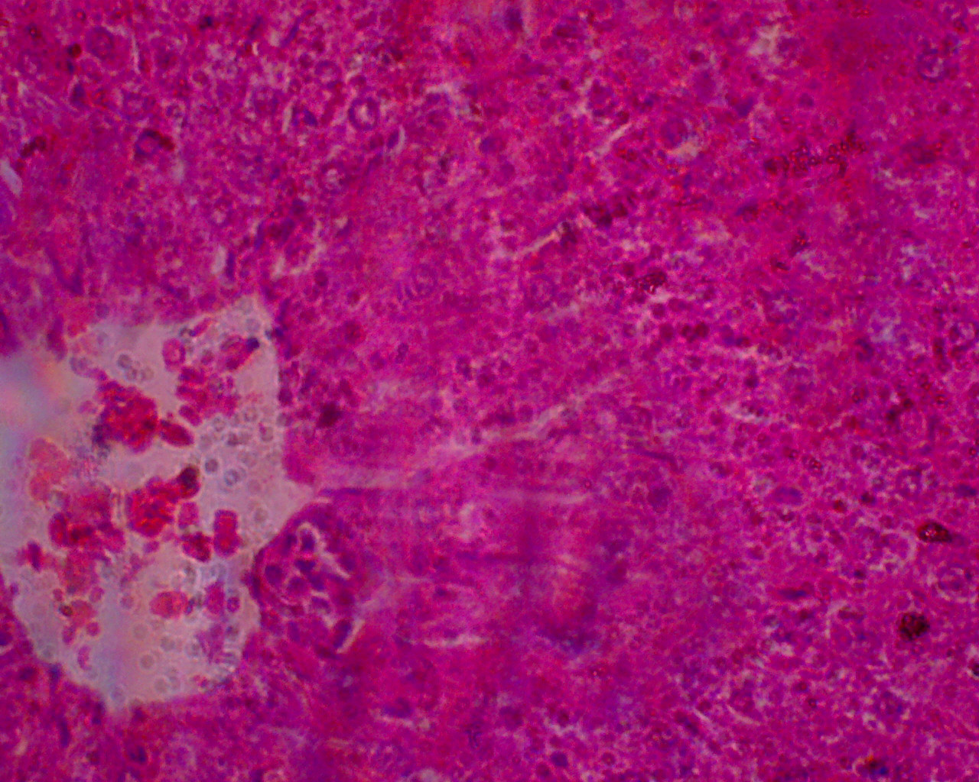
PLATE 1: Control Liver: H&E staining x400
Key Hepatocytes
Portal triads
Plate 1: Histological sections of the control liver showing the portal triads and the hepatocytes. The tissues were stained with hematoxylin and eosin and observed under high magnification (x400). The histological observations showed a liver without morphological alterations, no congestion, no Kupffer cells proliferation between the hepatocytes and there is no apoptosis.

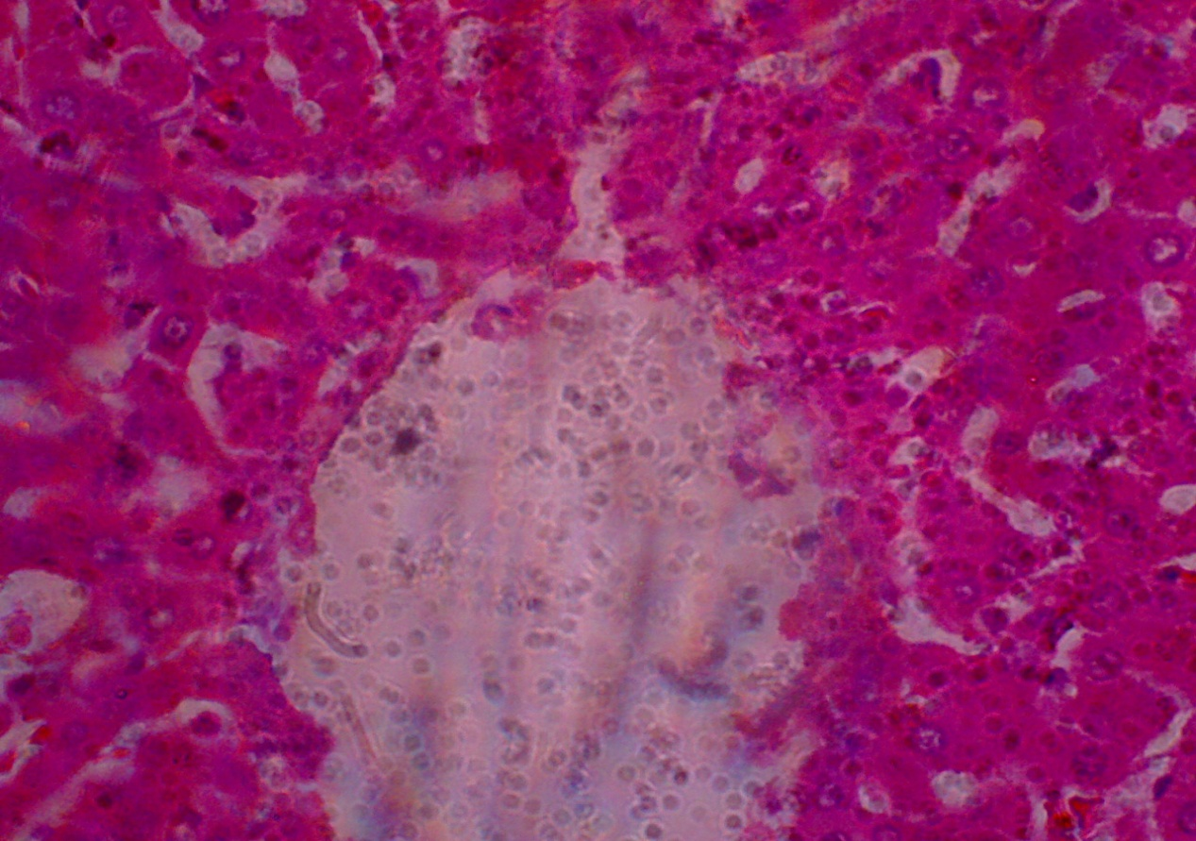
PLATE 2: Combined Kigelia africana And Garcinia kola Administered Wistar Rat Liver; H&E staining x400
Key Hepatocytes
Portal triads

Plate 2: Histological sections of the experimental rat liver that were fed with combined Kigelia africana and Garcinia Kola for a week. The tissues were stained with hematoxylin and eosin and observed under high magnification (x400). The histological observations show the hepatocytes radiating normally, an improved portal triad and enlargement in the branch of the portal vein. Fatty changes with necrosis and necrobiosis were not detected in the treated liver.

Table 1; Mean and ±Standard error of mean values of Liver weight of control and experimental group
GROUP | MEAN(g) | S.E.M | p- Value
Control | 5.0140 | ±1.469 | 0.049
Experimental | 6.3540 | ±2.556
p˂0.05 (significant level)

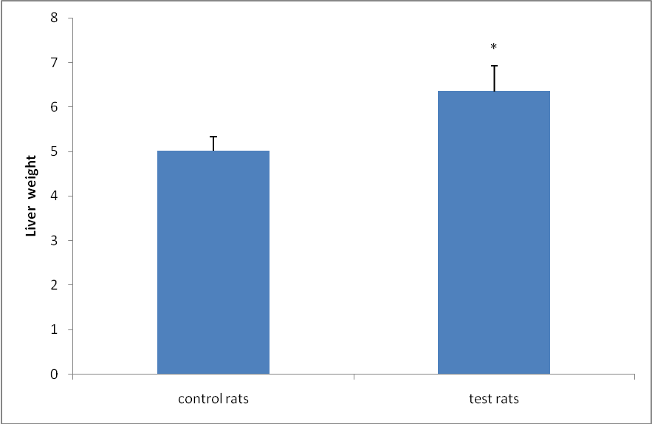
Figure 4; Mean liver weight profile
There was a significant difference (increase) in the liver weight of the experimental rats compared to control group.

DISCUSSION
Liver play a significant role in body internal regulation via various metabolic processes such as glucose and lipid metabolism and is severely affected in pathological condition [7]. This study was designed to investigate the combined effects of Kigelia africana and Garcinia Kola on the liver histology of male Wistar rats. In the control group, Plate 1 above, there was normal histological structure of the central vein surrounding the hepatocytes when viewed under x400. However, no histological structural alterations in the central vein and hepatocytes in the control group that were not treated with Kigelia africana and Garcinia kola.
Plate 2 above, experimental group showed that there are no effects of the combined herbs on the histological nomenclature of the rat liver. A significant increase (p<0.05) in liver weight suggest improvement of the portal triads. Hence, the result indicated there was no congestion as seen in the dilated central and portal vein, no dilated hepatic sinusoids with collagen proliferation, no Kupffer cells proliferation, degeneration of hepatocytes and apoptosis. The results showed that the combined herbs have no effects on histological architecture of the rat liver. Investigation revealed that combined Kigelia africana and Garcinia Kola fed experimental rats showed an improvement in portal triads and an enlargement of the branch of portal veins, similar to hepatoprotective effect disclosed by [8] and [9]. Histologically, experimental rat’s liver showed no congestion as expected and necrosis, necrobiosis was not detected in the liver cells.
CONCLUSION
This investigation revealed a most interesting information on the effects of combined herbs on the histological architecture of rat liver. There was an increase in the liver weights and an improved portal triad.

REFERENCES:
- Jackson SJ, Hougton PJ, Photiou A, Retsas S. (1996). The isolation of a novel antine oplastic compound from a bioassay guided fractionation of stem bark and fruit extracts of Kigelia pinnata (Bignoniaceae). Br J Cancer. 73 (170): 68.
- Saini S, H. Kaur, et al. (2009). Kigelia africana. Benth – An overview. (Lam). Natural products Radiance. 8 (2): 190-197.
- Saini S, Kaur H, Verma B, Ripudaman, Singh SK. (2009). Kigellia africana Lam. (Benth.) - A overview. Nat Prod Rad. 2009; 8(2):190–197.
- Glew R, Amoako- Atta B, et al. (2010). An Indigenous Plant food used by lactating mothers in West Africa: The nutrient composition of the leaves of Kigelia africana in Ghana. Ecol Food Nutr. 49: 72-83.
- Plowden CC (1972). A manual of plants names. 3rd ed, London, George Ltd, 1972, 239-245.
- Ojiako AO, Chikezie PC, Ogbuji CA (2016). Radical scavenging potentials of single and combinatorial herbal formulations in vitro. J Tradit Compl Med. 6: 153-159.
- Etuk, E.U. And Muhammed, B.J. (2010). Evidence based of chemical method of induction of diabetes mellitus in experimental animals. Asian Journal of Experimental Biological Sciences, 1(2): 331-336
- Galam N.Z, Gambo I.M, Habeeb A. A., Shugba A.I (2013).The Effect of Aqeous Extract of Gracinia Kola on the Liver Histology. Journal of Natural Sciences Research: 3:1.
- Johnson, M., Longe, A. O., Campbell, C. A. and Omotayo, M. A. (2014). Evaluation of Antidiabetic and The Effect Of Methanolic Leaf Extract Of Jatropha Curcas On Some Biochemical Parameters In Alloxaninduced Diabetic Male Albino Rats. European Journal of Medicinal Plants: 1501-1512

