Original article
Reliable muscle flap in reconstructive surgery- An anatomical study on gracilis muscle ,its motor nerve component with evaluation in the surgical approach of its tendon . Accessory band – a caution
¹Dr. Anitha Thillai , ²Dr. Preethi Ramya T , ³Dr. Anjana T.S.R., ⁴Dr. Sheela Grace Jeevamani,

¹Associate Professor, Department of Anatomy, Govt. Kilpauk Medical College, Chennai.
² Senior Lecturer, School of Medicine, Sydney campus, University of Notre Dame, Australia.
³ Associate Professor, Department of Anatomy, Govt. Thiruvarur Medical College, Thiruvarur.
⁴ Professor and Head, Department of Anatomy, Karpagam Institute of Research and Medical Sciences, Coimbatore.
Corresponding author: Dr. Anjana T.S.R.

Abstract:
Background and objectives: The gracilis muscle is one of the most reliable flaps in reconstructive surgical procedures because of easy accessibility and insignificant donor site morbidity. In the present study, we evaluate the various dimensions of muscle, tendon, accessory band and the motor nerve to gracilis.
Materials and methods: The present study was conducted in fifty cadaveric lower limbs from the Department of Anatomy, Government Kilpauk Medical College after obtaining clearance from the Institutional Ethics Committee. Apart from measuring the morphometric dimensions of the muscle, the ratio of length of the lower limb and thigh to length of gracilis muscle was observed. The motor nerve to gracilis was measured in two components.
Results: The mean length of the muscle was found to be higher in males. The accessory bands did not exceed beyond 5cm from the distal tendon. The distance of NVH from the anterior border of the muscle was observed to be as low as 0.2cm. The distance of insertion from the tibial tuberosity ranged between 1.8 – 5.6cm. The vertical component of the distal tendon was higher in females.
Conclusion: Owing to the increased utility of gracilis muscle in reconstructive surgeries, many studies have described the dimensions of the gracilis muscle. In addition to the aforementioned parameters, the present study also determined various parameters including the insertion point from tibial tuberosity, the distance of neurovascular hilus from the anterior border of muscle and measurement of the distal tendon in two components which would help the surgeons during procurement of muscle, tendon and the MNG for microsurgical procedures.
Keywords: Gracilis – neurovascular hilus – tendon – reconstruction.

Introduction:
Reconstructive surgical procedures are performed to approximate body structures following a defect produced by developmental defects, tumor resection, trauma or infection. These procedures improve functional ability and provide an aesthetic outcome to the region. Gracilis is one of the most reliable flaps in reconstructive microsurgery. Based on the type of repair, the gracilis muscle can be used as a pedicled muscle flap or together with fascia, connective tissue and skin as fascioadipocutaneous flap. Gracilis is one of the superficially located muscle in the medial compartment of thigh. The muscle takes its origin from the lower part of body of pubis close to the medial margin, inferior pubic ramus and also from a portion of ischial ramus [1,2,3]. Then the muscles descends down to a rounded tendon which takes a curved course to get inserted into the upper part of medial surface of tibia. Few fibers fan out and merge with the deep fascia of leg or with fascia over the medial head of gastrocnemius [4]. These are the accessory bands that need to be divided in order to prevent problems during harvesting of gracilis tendon.
Short gracilis muscle transfer is used in facial nerve palsy for smile reconstruction [5,6]. It is employed in facial reconstruction for smile restoration in children with congenital facial nerve palsy [7] and also following tumor ablation [8]. Extended gracilis muscle transfer with tendon is used for restoration of elbow flexion and finger movement following brachial plexus injury. The muscle is also suited for vesico vaginal fistula repair[9].The tendon is usually the choice for repair of anterior cruciate ligament injury. In tongue reconstruction following resection in oral carcinoma, the gracilis muscle with its nerve is utilized, wherein the motor nerve to gracilis (MNG) is anastomosed with hypoglossal nerve[10,11]. In breast reconstruction following mastectomy, the transverse myocutaneous (or upper) gracilis flap is preferred. Transposition of gracilis muscle over the usage of greater omentum in surgical repair of recto urethral fistula avoids the need for laporatomy with much success rate[12]. Although numerous surgical procedures have been described for the treatment of iatrogenic recto urethral fistula gracilis muscle transposition is identified to be more effective [13,14].
Quite commonly, accessory tendinous bands are found to arise from the distal portion of the tendon. But these bands are highly variable in their attachments[15]. The bands are found to get attached to the popliteal fascia, deep fascia of leg and fascia covering the gastrocnemius. These bands are usually harvested for use in anterior cruciate ligament reconstruction and care must be not to injure the distal tendon while procuring these bands. The factors that enable gracilis as the preferred choice for reconstruction include insignificant donor site morbidity and easy accessibility. Hence this study aims at providing a qualitative analysis of the morphometric dimensions of the muscle belly, tendon and the motor nerve to gracilis.
Materials and methods:
The present study was conducted in fifty cadaveric lower limb specimens at the Department of Anatomy, Government Kilpauk Medical College, Chennai. The morphologically damaged specimens were excluded from the study. The cadavers were placed in modified lithotomy position. An incision was made from the anterior superior iliac spine to the pubic tubercle and the incision is extended from that level to the tibial tuberosity[16]. Then the skin, superficial fascia and deep fascia were reflected laterally, thereby exposing the gracilis. The following dimensions of the muscle along with its tendon were measured using vernier caliper .
- Length of the proximal tendon, distal tendon (vertical and horizontal part) and muscle belly.
- Width of the muscle belly, distal tendon.
- Insertion point - distance from tibial tuberosity.
- Length of thigh (measured from the anterior superior iliac spine to base of patella) to total length of muscle ratio.
- Length of lower limb (measured from the anterior superior iliac spine to the medial malleolus) to total length of muscle ratio.
- Distance of NVH (neurovascular hilus) from the pubic tubercle and from the anterior border of muscle belly.
- Length of the motor nerve to gracilis
I- From the neurovascular hilus to the posterior border of adductor brevis.
II – From the posterior border of muscle to the point of exit at obturator foramen.
8. The presence of accessory bands.

Results:
The following observations were made in relation to the gracilis muscle and its motor nerve component. The mean length, standard deviation and the range of the proximal tendon, muscle belly, the vertical and horizontal components of the distal tendon were measured for males and females separately and shown in table 1. The mean length of thigh to the length of gracilis ratio was observed to be 1.09 in males and 1.04 in females whereas the mean length of lower limb to the length of gracilis ratio was 0.52 and 0.86 in males and females respectively.
The motor nerve to gracilis was measured in two components. The length of the first component had a range of 4.1-9.8cm while that of the second component ranged between 2.6 – 8 cm as shown in table 2.
Twelve limbs presented with accessory bands not one exceeding 5 cms proximal from its insertion (Fig 1).

Fig.1 shows A) an accessory band lying within 5cm from the distal tendon, B) an accessory band merging with the deep fascia of the leg. AB – Accessory Band

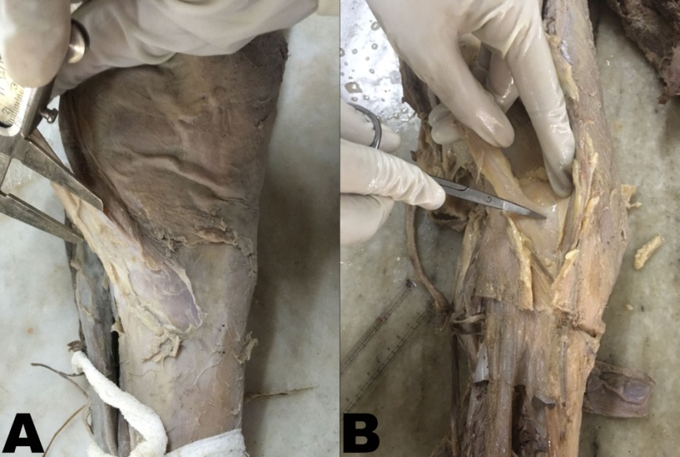

AB

Fig. 2 shows A) the vertical portion of distal tendon B) the horizontal portion of distal tendon. DT – Distal Tendon

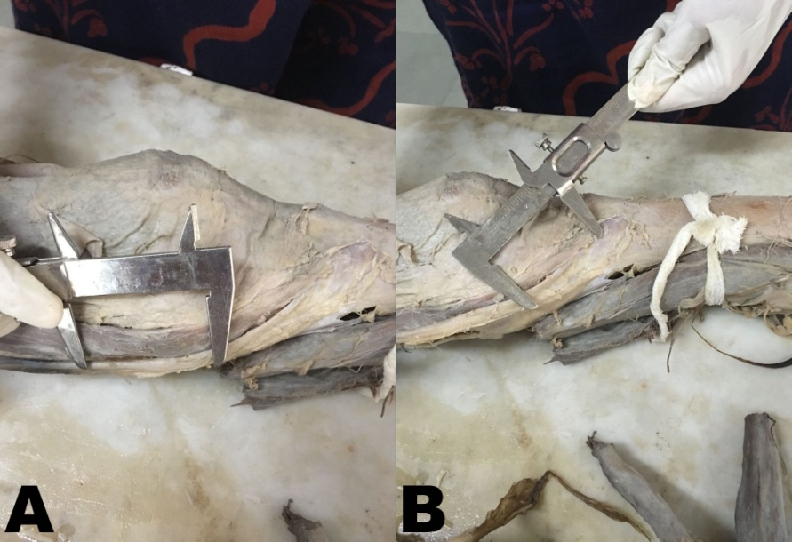
DT

Fig. 3 shows A) Broad muscle belly B) Narrow muscle belly C) Wide tendon D) Narrow tendon. MB – Muscle Belly
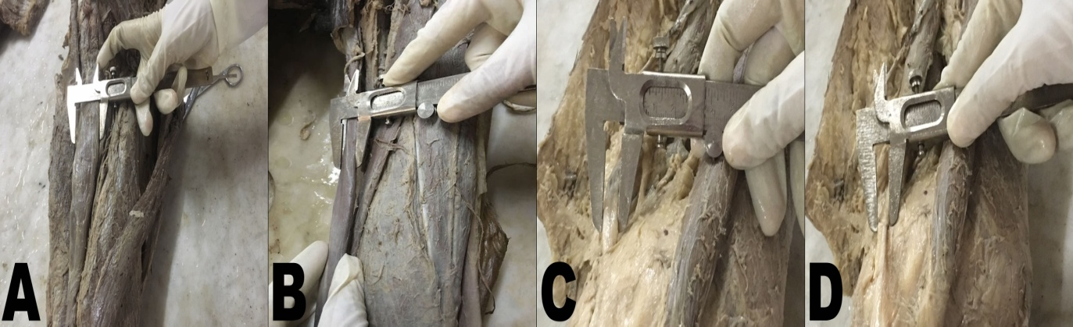

Fig. 4 shows the length of the A) First segment of MNG, from the neurovascular hilus to the posterior border of adductor brevis B) Second segment of MNG, from the posterior border of adductor brevis to the obturator foramen. ON – Obturator Nerve, MNG – Motor Nerve of Gracilis, Ad.B- Adductor Brevis.

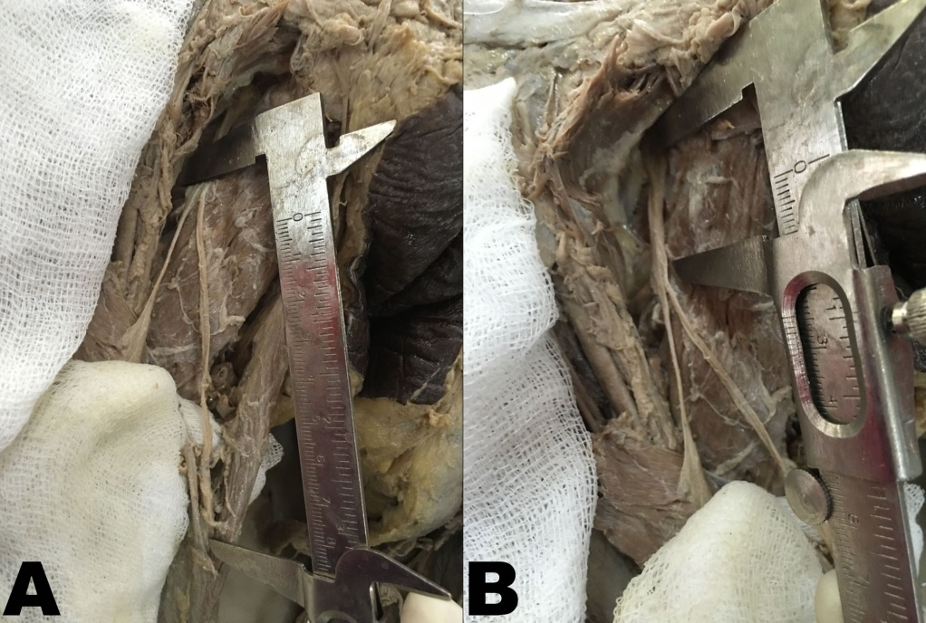
MNG
ON
Ad. B

TABLE 1: DIMENSIONS OF GRACILIS MUSCLE
S. no | Mean(cm) |  | S.D(cm) |  | Range
MUSCLE | Males | Females | Males | Females | Males | Females
- Proximal tendon | 3.23 | 2.42 | 0.96 | 0.63 | 1.5-5.3 | 1.5-3.6
- Distal tendon
- Vertical | 6.99 | 7.09 | 1.83 | 1.54 | 3.5-10.5 | 4-10
- Horizontal | 4.85 | 4.57 | 1.16 | 1.28 | 3.3-6.4 | 2.5-6.8
- Belly length | 27.75 | 25.11 | 1.85 | 2.56 | 26 – 31.5 | 20.3-30.3
- Total length | 42.82 | 39.34 | 2.45 | 1.79 | 38.9-47.9 | 36.4-43.7
- Insertion from TT | 3.84 | 3.35 | 0.85 | 0.81 | 2 - 5.6 | 1.8 – 4.7
- Belly width | 2.55 | 2.39 | 0.65 | 0.47 | 1.5-3.8 | 1.8-3.3
- Tendon width | 0.99 | 1.14 | 0.24 | 0.34 | 0.6-1.4 | 0.6-2.1

TABLE 2: DIMENSIONS OF THE MOTOR NERVE TO GRACILIS

NeuroVascular Hilus | Mean (cm) |  | S.D (cm) |  | Range
 | Males | Females | Males | Females | Males | Females
1.Distance From Pubic Tubercle | 11.0 | 10.24 | 1.52 | 1.72 | 8.6-13.6 | 8.2-13.5
2.Distance From Ant Border | 1.12 | 0.81 | 0.71 | 0.48 | 0.2-3 | 0.8-1.2
3. Nerve Length – I* | 7.13 | 6.09 | 1.44 | 1.04 | 4.6-9.8 | 4.1-7.6
II** | 5.00 | 5.05 | 1.37 | 1.23 | 3.1-8 | 2.6-7.9
Total Nerve Length | 11.95 | 11.2 | 1.86 | 1.86 | 9.6-15 | 7.1-14.7
*- Length of the nerve from neurovascular hilus to the posterior border of adductor brevis.
**- Length of the nerve from the posterior border of adductor brevis to obturator foramen.

TABLE 3: COMPARISON OF MEAN AND STANDARD DEVIATION OF THE LENGTH OF THE MUSCLE
S No | Name of the study | Mean + S.D of length of the muscle
1. | Morris et al(1999) | 44 + 2 cm
2. | Macchi et al (2008) | 41 + 2.1 cm
3. | Harban et al (2012) | 40.2 + 1.42 cm
4. | Zhou J et al (2015) | 41.8 + 3.19 cm
5. | Hussey AJ et al(2007) | 38.4 cm
6. | Present study | 41.3 + 2.12 cm

TABLE 4 : COMPARISON OF THE DISTANCE OF NVH FROM PUBIC TUBERCLE .
S No | Name of the study | Distance of NVH *from pubic tubercle
1. | Macchi et al | 10 + 1 cm
2. | Harbans et al | 8.6+ 0.49 cm
3. | Present study | 10.6 + 1.62 cm
*- Neuro Vascular Hilus

DISCUSSION:
With the evolution of myocutaneous flaps, the restoration of function and anatomical contour following paralysis or wound defect is made possible with good outcome. The use of these flaps enables coverage of shallow wounds as well as three dimensional defects. The gracilis muscle free flap is based on a constant neurovascular pedicle. The gracilis flaps are not only used in reconstruction of lower limb and perineal regional region, but also for upper limb and head and neck reconstruction. The dimensions of gracilis muscle with its motor nerve component is compared with those of the previous studies (table 3).
The measurement of mean length of the muscle correlated with the studies of Macchi et al, Harban at al and Zhouj et al [17,18,19]. Morris et al [20] study showed the mean length of the muscle to be 44 + 2 cm, which was much higher than that of the present study. The mean length was found to be much lesser in Hussey AJ et al [21] study. The mean length of the muscle in males was higher than the mean length of the muscle in females in the present study. The mean length of the proximal tendon ranged from 1.5 -5.3 in males and 1.5- 3.6 in females in the present study. It is worthwhile to mention here that while procuring Transverse Upper Gracilis (TUG) flap for reconstructive procedures that the range of the mean length of the proximal tendon should be taken into account. The distal tendon of the muscle generally had an curved course , the mean lengths of the proximal vertical component and the distal horizontal components were measured separately in our study. A noteworthy feature while observing this parameter was that the mean length of the vertical component was found to be higher in females but the mean length of the horizontal component was higher in males .The total mean length of the distal tendon was 11.84 + 2.99 in males and 11.66 + 2.82 in females(Fig.2) The value of the mean total length of the distal tendon in males correlated well with Harbans et al study[18]. The gracilis tendon was located 12.6mm from the medial edge of the knee.
The difference in the total mean length of the muscle between males and females is mainly attributed to the mean belly length, which was 27.75 + 1.8 cm in males and 25.11+2.56cm. The mean distance of the tendon’s insertion from tibial tuberosity ranged from 2-5.6 cm in males and 1.8- 4.7 cm in females. The mean belly width was 2.47 + 0 .56 cm in the present study which was much less when compared to Zhou J (3.2 +0.7) [17] and Hussey AJ et al study (6.2cm) [20]. The belly width was more in males in the present study (Fig 3). The gracilis tendon is located 14.4 mm from the medial edge of the knee according to Roussignol et al study. In the present study, the gracilis tendon was located 12.6mm from the medial edge of the knee. The knowledge of this distance is essential for minimally invasive posterior approach of harvesting gracilis tendon in popliteal fossa and stripping of saphenous nerve during this procedure. Assessing the variability and mapping of accessory bands helps the surgeon to take extra care while using a tendon stripper, in order to avoid injury to the tendon [15].
The distance of the neurovascular hilus from the pubic tubercle was measured and compared with those of previous authors (table 4). In the present study, the neurovascular hilus lay within the range of 0.2-1.8 cm from the anterior border of the muscle. The length of the nerve was measured in two components along with its total length. The motor nerve component measured by Rodriquez Lorenzo et al [22] showed that the first component measured 6.3 – 10.5cm (7.7 cm) and that of the second component ranged between 2-6 cm (3.7) cm. The total length of the nerve ranged between 9.9- 13.6(11.5)cm. In the present study, the mean length of the nerve ranged between 7.1 – 15 cm(11.5) (Fig. 4).Though the study correlated well with the findings of Rodriquez et al study, the range was extensive which would help the reconstructive surgeons to plan for a flap with adequate nerve length. The first and second components of the nerve measured ranged between 4.1 - 9.8(6.6) cm and 2.6 – 8 (5) cm respectively.

CONCLUSION:
The knowledge of morphological dimensions of the gracilis muscle is of use in various reconstructive microsurgeries. The mean distance of distal tendon’s insertion from the tibial tuberosity could be used as a surgical landmark while approaching the tendon from its distal aspect. The mean nerve length had an extensive range which can help the reconstructive surgeons to plan for surgeries with adequate nerve length. The muscle morphometric analysis using sonography or MRI prior to surgeries helps in enhancing the predictability of coverage of soft tissue defects. The presence of accessory band within 5cms proximal to the tendons insertion guides the surgeon in avoiding deviation of the tendon stripper resulting in inadequate length of the graft.

Abbreviations:
NVH – Neuro Vascular Hilus
MNG – Motor Nerve to Gracilis.
TUG – Transverse Upper Gracilis
MRI – Magnetic Resonance Imaging

REFERENCES:
- Standring S. Gray’s Anatomy. In: Thigh. 39th ed, Churchill Livingstone. 2005: 1461-70.
- Boileau Grant JC, Basmajian JV. Grant’s method of Anatomy. Seventh edition. Baltimore: The Williams and Wilkins company; 1965: 325-344.
- Hollinshead WH. Anatomy for Surgeons. 2nd ed. Newyork: Harper and Row; 1965: 760-768.
- Richard S Snell. Clinical Anatomy for medical students. 5th ed. Boston: Little Brown & Co; 1995: 554-570.
- Freilinger G. A new technique to correct facial paralysis. Plast Reconstructr Surg. 1975. 56(1): 44-8.
- Harri K. Uhmori K. Torii S. Free gracilis muscle transplantation with microneuro vascular anastomosis for the treatment of facial paralysis. A preliminary report. Plast Reconstr Surg. 1976; 57(2): 133-43.
- Hadlock TA, Malo JS, Cheney ML, Henstrom DK. Free gracilis transfer for smile in children. The Massachussets Eye and Ear infirmary excursion and quality of life changes. Arch Facial Plast Surg. 2011. 13(3): 190-4.
- Lin CH, Wallace C, Liao CT. Functioning free gracilis myocutaneous flap transfer provides a reliable single stage facial reconstruction and reanimation following tumor ablation. Plast reconstr. Surg. 2011. 128(3): 687-88.
- Sharma A, Chaudhari R, Shaik I, Desai R, Andankar M and Pathak H. Complex vesico vaginal fistula repair with gracilis muscle interposition flap-case series of five patients and review of literature. Journal of case reports and studies. 2014; 2(6): 1-3.
- Yoleri L, Mavioglu H. Total tongue reconstruction with free functional gracilis muscle transplantation: a technical note and review of literature. Ann Plast Sorg.2000; 45(2):181-6.
- Gurunluoglu R, Glasgow M, Williams SA, Gurunluoglu A, et al. Functional reconstruction of total lower lip defects using innervated gracilis flap in the setting of high energy ballistic injury to the lower face: preliminary report. J Plast Reconstr Aesthet Surg. 2012; 65(10). 1335-42.
- Nyam DC, Pemberton JH. Management of iatrogenic rectourethral fistula. Dis Colon Rectum. 1999; 42: 994-997.
- Zmora O, Fabio M.Potenti, Steven D, Wexner, Alon J Pikarsky et al., Gracilis muscle transposition for iatrogenic Rectourethral fistula. Ann Surg. 2003; 237(4): 483-487.
- Amr M, El-Hadidy MR, Hussain E, Ali Ismail. The versatility of the use of free functioning gracilis muscle flap in the reconstruction of deficient motor unit. Tanta Medical Journal. 2015; 43(3): 94-97.
- Candall- Couto JJ, Deehan DJ. Accessory bands of Gracilis and Semitendinosus: An anatomical study. Knee. 2003; 10(4): 325-8.
- Romanes GJ. Cunnungham’s manual of practical antomy. 15th ed. Newyork: Oxford University Press; 1986: 880-886.
- Macchi V, Vigato E, Porzionato A, Tiengo C et al. The gracilis muscle and its use in clinical reconstruction: an anatomical, embryological and radiological study. Clin Anat. 2008; 21(7): 696-704.
- Harbans Singh, Ramandeep Kaur, Neena Gupta. Morphometric study of gracilis muscle and its role in clinical reconstruction. J Anat Soc. India.2012; 60(2): 202-206.
- Zhou J, Hiang X, Ren C, Guo X. Applied anatomical study of the gracilis muscle flap for tongue reconstruction. Zhonghua Kou Qiang Yi Xue Zhahi. 2015; 50(4): 240-3.
- Morris SF, Yang D. Gracilis muscle: arterial and neural basis for subdivision. Ann Plast Surg. 1999; 42(6): 630-3.
- Hussey AJ, Laing AJ and Padraic James Regan. An anatomical study of the gracilis muscle and its application in groin wounds. Annals of Plastic Surgery. 2007; 59(4): 404-9.
- Rodriquez Lorenzo A, Morley S, Payne A P, Tollan CJ, Soutar DS. Anatomy of the motor nerve to gracilis muscle and its implications in a one stage microneurovascular gracilis transfer for facial reanimation. J Plast Reconstr Aesthet Surg. 2010; 63(1): 54-8.

Date of Publishing: 05 June 2021
Author Declaration: Source of support: Nil, Conflict of interest: Nil
Ethics Committee Approval obtained for this study? YES
Was informed consent obtained from the subjects involved in the study? YES
For any images presented appropriate consent has been obtained from the subjects: NA
Plagiarism Checked: Urkund Software
Author work published under a Creative Commons Attribution 4.0 International License

DOI: 10.36848/IJBAMR/2020/29215.55592

