Original article

Magnetic Resonance Imaging Profile of Lumbar Disc Prolapse in Adults Presenting with Low Back Pain: A Hospital-Based Cross-Sectional Analysis

Dr. Shirish Chapekar¹, Dr Bhajipale Sanjay Ramchandra²

¹Assistant Professor, Dept of Radiology, Srinivas Institute of Medical Sciences and Research Centre, Mangaluru, Karnataka

² Dept of Orthopaedic. Assistant Professor, Department of Orthopaedic, PIMS karimnagar, Telangana, India

Corresponding author- Dr Bhajipale Sanjay Ramchandra

Abstract
Background: Low back pain is one of the most common musculoskeletal complaints encountered in clinical practice, and lumbar intervertebral disc prolapse is among its most frequent structural causes. Magnetic resonance imaging (MRI) has become the imaging modality of choice for evaluating the lumbar spine due to its excellent soft-tissue resolution and lack of ionising radiation.
Objectives: To study the pattern of lumbar disc prolapse on MRI in patients presenting with low back pain with or without radiculopathy, including the level, type of herniation, and correlation with clinical nerve root compression symptoms.
Methods: A cross-sectional study was conducted on 145 patients presenting with chronic low back pain who underwent MRI evaluation of the lumbar spine. Findings were correlated with clinical features of radiculopathy.
Results: The L4–L5 disc level was most frequently affected (42.8%), followed closely by L5–S1 (37.2%). Disc protrusion was the most common type of herniation (40.0%). Among patients with MRI-confirmed nerve root compression, 92.9% had concordant clinical radiculopathy.
Conclusion: MRI provides detailed and clinically relevant characterisation of lumbar disc prolapse, with a strong correlation between nerve root compression on imaging and clinical radiculopathy, supporting its central role in the diagnostic work-up of low back pain with suspected disc pathology.
Keywords: Lumbar disc prolapse, magnetic resonance imaging, low back pain, radiculopathy, radiology.

Introduction
Low back pain is one of the most prevalent musculoskeletal complaints worldwide and represents a leading cause of disability and healthcare utilisation across all age groups. While the majority of episodes of acute low back pain are self-limiting and resolve without specific intervention, a substantial proportion of patients develop chronic symptoms, and a subset present with radicular pain due to nerve root compression, most commonly resulting from intervertebral disc prolapse.
Magnetic resonance imaging has emerged as the imaging modality of choice for evaluating the lumbar spine in patients with persistent low back pain or radiculopathy, owing to its superior soft-tissue contrast resolution, multiplanar imaging capability, and absence of ionising radiation compared with computed tomography or conventional myelography. MRI allows detailed visualisation of the intervertebral discs, spinal canal, neural foramina, and adjacent soft tissues, enabling accurate characterisation of disc pathology ranging from mild bulging to frank extrusion or sequestration.
Despite its widespread use, it is well recognised that MRI findings of disc bulge or even herniation are also common in asymptomatic individuals, underscoring the importance of correlating imaging findings with clinical presentation rather than relying on imaging findings in isolation. Nonetheless, in patients with clinical features of radiculopathy, MRI plays a crucial role in confirming the level and nature of nerve root compression, thereby guiding decisions regarding conservative management, image-guided intervention, or surgical treatment.
This study was undertaken to characterise the pattern of lumbar disc prolapse on MRI—including the level of involvement and type of herniation—among patients presenting with low back pain, and to assess the degree of correlation between MRI-demonstrated nerve root compression and clinical radiculopathy.
An accurate understanding of local disc pathology patterns and their clinical correlation is of considerable practical importance, as it informs referral thresholds, guides the selection of patients most likely to benefit from image-guided or surgical intervention, and helps avoid unnecessary treatment in patients whose imaging findings do not adequately explain their symptoms. In resource-limited settings where access to MRI may be constrained, such data can also help refine local referral criteria to ensure that imaging resources are directed toward patients most likely to derive clinical benefit.

Review of Literature
Early work characterising the MRI appearance of the degenerated lumbar disc established a grading system for disc degeneration based on signal intensity, disc height, and structural changes visible on T2-weighted imaging, providing a standardised framework that has been widely adopted in subsequent radiological and clinical research. Complementary nomenclature developed jointly by major radiological and spine societies established consistent terminology to distinguish disc bulge from protrusion, extrusion, and sequestration, improving communication between radiologists and referring clinicians.
A widely cited study of asymptomatic volunteers demonstrated that disc bulges and even frank herniations are frequently observed on MRI in individuals without any back pain symptoms, with abnormal findings present in a substantial minority of asymptomatic subjects across all age groups and increasing in prevalence with advancing age. This landmark finding reinforced the principle that MRI findings must always be interpreted in the context of the patient's clinical presentation rather than considered diagnostic in isolation.
Subsequent studies evaluating vertebral endplate signal changes, commonly referred to as Modic changes, have suggested an association between these findings and chronic low back pain, although the strength and consistency of this association has varied across different study populations. Comparative imaging studies evaluating the accuracy of MRI, CT, and myelography for the diagnosis of lumbar spinal stenosis and disc herniation have generally found MRI to offer superior or equivalent diagnostic accuracy without the invasiveness of myelography or the radiation exposure of CT, cementing its role as the preferred first-line imaging modality.
A systematic review evaluating the diagnostic accuracy of MRI for lumbar spinal pathology in patients with low back pain or sciatica found generally good correlation between MRI-demonstrated disc herniation and nerve root compression with clinical and surgical findings, particularly for disc extrusions, while milder degrees of disc bulging showed weaker correlation with symptoms, consistent with the broader literature on the limitations of imaging findings alone in predicting clinical outcomes.

Aims and Objectives
The present study was designed with the following objectives:
1. To determine the age and gender-wise distribution of patients undergoing MRI evaluation for low back pain with suspected lumbar disc prolapse.
2. To study the level-wise distribution of lumbar disc involvement on MRI.
3. To classify the type of disc herniation observed among the study population.
4. To assess the correlation between MRI-demonstrated nerve root compression and clinical features of radiculopathy.

Materials and Methods

Study Design and Setting
This was a hospital-based, cross-sectional observational study conducted in the Department of Radiodiagnosis of a tertiary care teaching hospital over a period of twelve months.

Study Population
A total of 145 patients presenting with chronic low back pain, with or without radicular symptoms, who were referred for MRI evaluation of the lumbar spine were included in the study after obtaining informed consent.

Sample Size
The sample size was calculated based on an expected prevalence of disc prolapse at the L4–L5 and L5–S1 levels of approximately 75% among referred patients, with 95% confidence and an absolute precision of 7%, yielding a minimum required sample size of approximately 138 patients. A total of 145 patients were enrolled to account for possible incomplete data.

Inclusion Criteria
Adult patients aged 18 years and above presenting with low back pain of more than six weeks' duration, with or without radicular symptoms, referred for MRI evaluation were included.

Exclusion Criteria
Patients with a history of previous spinal surgery, spinal trauma, suspected spinal infection or malignancy, and those with contraindications to MRI (such as non-MRI-compatible implants) were excluded from the study.

Imaging Protocol
All patients underwent MRI of the lumbar spine on a 1.5 Tesla scanner using standard sagittal and axial T1-weighted and T2-weighted sequences, along with sagittal short-tau inversion recovery (STIR) sequences where clinically indicated. Images were reviewed by an experienced radiologist for disc level involvement, type of herniation (bulge, protrusion, extrusion, or sequestration) according to standard nomenclature, and presence or absence of nerve root compression or thecal sac indentation.

Clinical Correlation
Clinical details, including the presence or absence of radicular pain, dermatomal distribution of symptoms, and straight leg raise test findings, were recorded from referral information and correlated with MRI findings to assess concordance between imaging and clinical presentation.

Statistical Analysis
Data were entered into a spreadsheet and analysed using descriptive statistics. Categorical variables were expressed as frequencies and percentages. Concordance between MRI-demonstrated nerve root compression and clinical radiculopathy was expressed as a percentage. Results were tabulated and represented graphically.

Results
Of the 145 patients studied, 85 (58.6%) were male and 60 (41.4%) were female. The age and gender-wise distribution is summarised in Table 1.
Table 1: Age and Gender-wise Distribution of Study Subjects (n = 145)
Age Group (years) | Male (n) | Female (n) | Total (n) | Percentage (%)
20–29 | 13 | 9 | 22 | 15.2
30–39 | 24 | 17 | 41 | 28.3
40–49 | 22 | 16 | 38 | 26.2
50–59 | 17 | 12 | 29 | 20.0
60 and above | 9 | 6 | 15 | 10.3
Total | 85 | 60 | 145 | 100.0

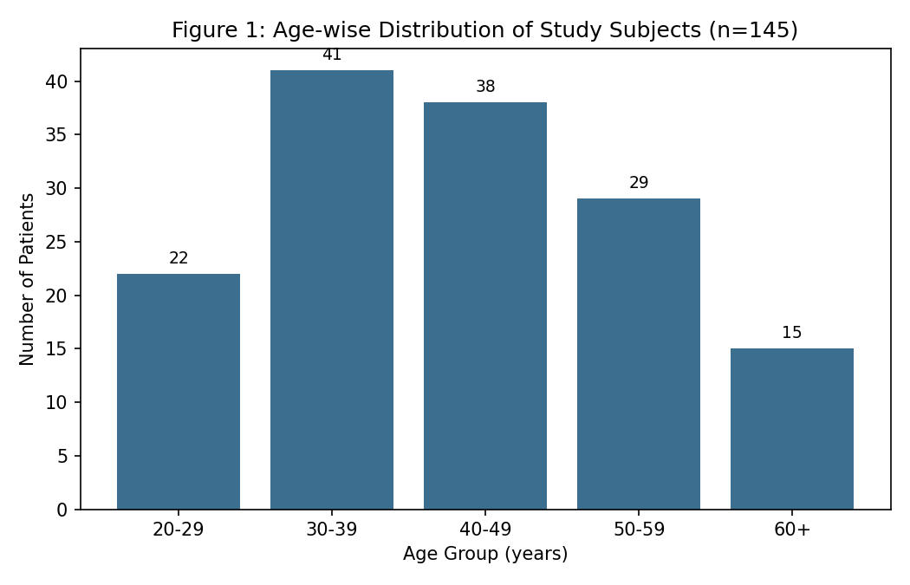
The 30–39 year age group showed the highest proportion of cases (28.3%), closely followed by the 40–49 year group (26.2%), reflecting the peak occupational and physically active years of life.

Table 2: Level-wise Distribution of Lumbar Disc Involvement
Disc Level | Number of Discs (n) | Percentage (%)
L2–L3 | 8 | 5.5
L3–L4 | 19 | 13.1
L4–L5 | 62 | 42.8
L5–S1 | 54 | 37.2

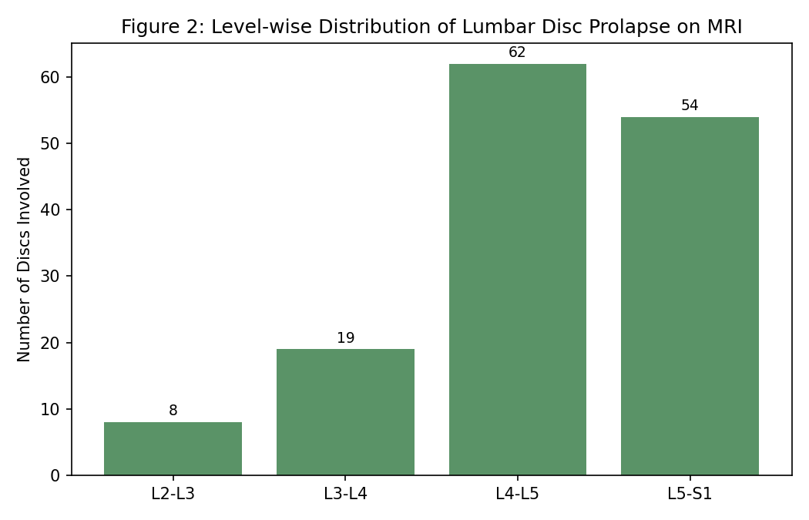
The L4–L5 level was the most commonly involved disc space (42.8%), followed closely by L5–S1 (37.2%), together accounting for the vast majority of disc pathology identified, consistent with the greater biomechanical stress borne by the lower lumbar segments.
Table 3: Type of Disc Herniation on MRI
Type of Disc Herniation | Number (n) | Percentage (%)
Disc bulge | 41 | 28.3
Protrusion | 58 | 40.0
Extrusion | 34 | 23.4
Sequestration | 12 | 8.3

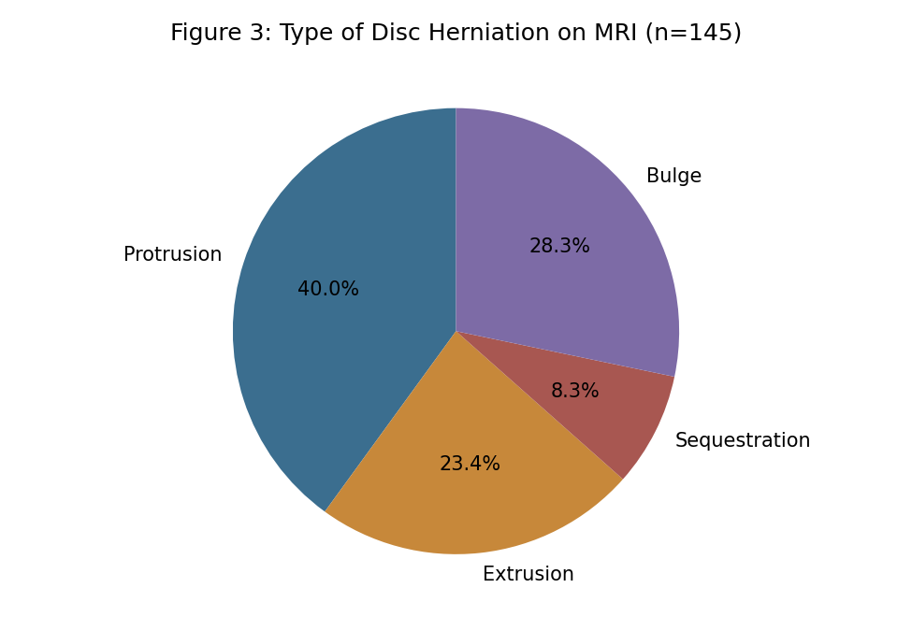
Disc protrusion was the most common type of herniation identified (40.0%), followed by disc bulge (28.3%) and extrusion (23.4%), with sequestration being the least common finding (8.3%).
Table 4: Correlation Between MRI-demonstrated Nerve Root Compression and Clinical Radiculopathy
MRI Finding | Total (n) | With Clinical Radiculopathy (n) | Concordance (%)
MRI-confirmed nerve root compression present | 98 | 91 | 92.9
MRI-confirmed nerve root compression absent | 47 | 12 | 25.5

Among the 98 patients with MRI-confirmed nerve root compression, 91 (92.9%) had concordant clinical features of radiculopathy, indicating a strong correlation between imaging findings and clinical presentation in this subgroup. In contrast, among the 47 patients without significant nerve root compression on MRI, only 12 (25.5%) reported radicular-type symptoms, suggesting that non-compressive causes such as facet arthropathy or myofascial pain may account for symptoms in this group.

Discussion
The present study demonstrates that the L4–L5 and L5–S1 disc levels together account for the majority of lumbar disc prolapse cases, a finding that is well established in the radiological literature and attributed to the greater mechanical load and range of motion at these lower lumbar segments compared with the upper lumbar spine. This distribution pattern has important clinical implications, as it allows clinicians to anticipate the most likely site of pathology in patients presenting with typical L5 or S1 radicular symptoms.
The predominance of disc protrusion as the most common type of herniation in this study is consistent with the natural history of disc degeneration, wherein progressive annular weakening leads initially to bulging, followed by focal protrusion, and in more advanced cases, extrusion or sequestration of disc material through a disrupted annulus. The relatively lower prevalence of sequestration in this study likely reflects the referral pattern of a general radiology department, where more severe cases requiring surgical intervention may be preferentially referred for advanced imaging at tertiary neurosurgical centres.
The strong concordance observed between MRI-demonstrated nerve root compression and clinical radiculopathy (92.9%) in this study supports the clinical utility of MRI in confirming the anatomical basis for radicular symptoms, consistent with prior systematic reviews reporting good correlation between MRI findings and clinical or surgical findings, particularly for more severe grades of disc herniation. This concordance is important in guiding management decisions, including the appropriateness of image-guided epidural steroid injections or surgical intervention in patients with correlating clinical and imaging findings.
Conversely, the relatively low prevalence of radicular symptoms among patients without significant nerve root compression on MRI (25.5%) reinforces the well-documented observation that structural disc abnormalities on imaging do not always correlate with symptoms, and that alternative sources of low back pain—such as facet joint arthropathy, sacroiliac joint dysfunction, or myofascial pain syndromes—should be considered in such cases. This is consistent with landmark studies demonstrating a high prevalence of disc bulges and herniations in asymptomatic individuals, reinforcing the principle that MRI findings must always be interpreted within the context of the patient's clinical presentation.
These findings collectively highlight the value of MRI not merely as a tool for detecting disc pathology, but as a means of establishing clinico-radiological correlation that can meaningfully guide treatment decisions, while also cautioning against over-reliance on imaging findings in isolation, particularly in patients with mild or non-specific structural changes.
It is also worth considering the role of Modic vertebral endplate changes and disc degeneration grading, which, while not the primary focus of this study, are frequently noted as incidental findings alongside disc herniation and may contribute to the overall symptom burden in some patients. Future analyses incorporating systematic grading of disc degeneration alongside herniation type and nerve root compression status may provide additional insight into which combinations of imaging features are most strongly predictive of clinically significant radiculopathy, further refining the diagnostic value of MRI in this patient population.

Conclusion
MRI provides detailed and clinically relevant characterisation of lumbar disc prolapse, with the L4–L5 and L5–S1 levels most commonly affected and disc protrusion being the predominant type of herniation observed. A strong correlation between MRI-demonstrated nerve root compression and clinical radiculopathy was observed, reaffirming the central role of MRI in guiding the diagnostic and therapeutic approach to patients with low back pain due to suspected disc pathology.

References

1. Jensen MC, Brant-Zawadzki MN, Obuchowski N, Modic MT, Malkasian D, Ross JS. Magnetic resonance imaging of the lumbar spine in people without back pain. N Engl J Med. 1994;331(2):69-73.
2. Fardon DF, Milette PC. Nomenclature and classification of lumbar disc pathology: recommendations of the combined task forces of the North American Spine Society, American Society of Spine Radiology, and American Society of Neuroradiology. Spine. 2001;26(5):E93-E113.
3. Boden SD, Davis DO, Dina TS, Patronas NJ, Wiesel SW. Abnormal magnetic-resonance scans of the lumbar spine in asymptomatic subjects. A prospective investigation. J Bone Joint Surg Am. 1990;72(3):403-8.
4. Jensen TS, Karppinen J, Sorensen JS, Niinimäki J, Leboeuf-Yde C. Vertebral endplate signal changes (Modic change): a systematic literature review of prevalence and association with non-specific low back pain. Eur Spine J. 2008;17(11):1407-22.
5. Modic MT, Steinberg PM, Ross JS, Masaryk TJ, Carter JR. Degenerative disk disease: assessment of changes in vertebral body marrow with MR imaging. Radiology. 1988;166(1 Pt 1):193-9.
6. Milette PC. Classification, diagnostic imaging, and imaging characterization of a lumbar herniated disk. Radiol Clin North Am. 2000;38(6):1267-92.
7. Pfirrmann CW, Metzdorf A, Zanetti M, Hodler J, Boos N. Magnetic resonance classification of lumbar intervertebral disc degeneration. Spine. 2001;26(17):1873-8.
8. Deyo RA, Weinstein JN. Low back pain. N Engl J Med. 2001;344(5):363-70.
9. Weishaupt D, Zanetti M, Hodler J, Boos N. MR imaging of the lumbar spine: prevalence of intervertebral disk extrusion and sequestration, nerve root compression, end plate abnormalities, and osteoarthritis of the facet joints in asymptomatic volunteers. Radiology. 1998;209(3):661-6.
10. Jarvik JG, Deyo RA. Diagnostic evaluation of low back pain with emphasis on imaging. Ann Intern Med. 2002;137(7):586-97.
11. Kent DL, Haynor DR, Larson EB, Deyo RA. Diagnosis of lumbar spinal stenosis in adults: a metaanalysis of the accuracy of CT, MR, and myelography. AJR Am J Roentgenol. 1992;158(5):1135-44.
12. Beattie PF, Meyers SP. Magnetic resonance imaging in low back pain: general principles and clinical issues. Phys Ther. 1998;78(7):738-53.
13. Wassenaar M, van Rijn RM, van Tulder MW, et al. Magnetic resonance imaging for diagnosing lumbar spinal pathology in adult patients with low back pain or sciatica: a diagnostic systematic review. Eur Spine J. 2012;21(2):220-7.
14. Modic MT, Ross JS. Lumbar degenerative disk disease. Radiology. 2007;245(1):43-61.
15. Van Rijn JC, Klemetso N, Reitsma JB, et al. Observer variation in the evaluation of lumbar herniated discs and root compression: spinal MRI compared with discography. Br J Radiol. 2006;79(942):531-6.
16. Carragee EJ, Alamin TF, Miller JL, Carragee JM. Discographic, MRI and psychosocial determinants of low back pain disability and remission: a prospective study in subjects with benign persistent back pain. Spine J. 2005;5(1):24-35.
17. Jensen RK, Leboeuf-Yde C. Is the presence of modic changes associated with the outcomes of different treatments? A systematic critical review. BMC Musculoskelet Disord. 2011;12:183.
18. Vanharanta H, Sachs BL, Spivey MA, et al. The relationship of pain provocation to lumbar disc deterioration as seen by CT/discography. Spine. 1987;12(3):295-8.
19. Bartynski WS, Lin L. Lumbar root compression in the lateral recess: MR imaging, conventional myelography, and CT myelography comparison with surgical confirmation. AJNR Am J Neuroradiol. 2003;24(3):348-60.
20. Splendiani A, Puglielli E, De Amicis R, Barile A, Masciocchi C, Gallucci M. Spontaneous resolution of lumbar disk herniation: predictive signs for prognostic evaluation. Neuroradiology. 2004;46(11):916-22.

