Original article:
Clinical, Radiological, and Severity Profile of Community-Acquired Pneumonia in Hospitalized Children Aged 2 Months to 5 Years Classified According to WHO Criteria

Dr Shivhare Vivekkumar Kishor *

Associate Professor, Dept of Paediatrics, Malla Reddy Institute Of Medical Sciences, Hyderabad

Corresponding author*

Abstract
Background: Community-acquired pneumonia (CAP) remains one of the leading causes of hospitalisation and mortality among children under five years of age, and accurate clinical and radiological characterisation remains central to its management.
Objectives: To describe the clinical, radiological, and severity profile of children aged 2 months to 5 years hospitalised with CAP, classified according to WHO severity criteria.
Methods: A prospective observational study was conducted on 178 children aged 2 months to 5 years hospitalised with CAP. Clinical features, chest radiographic findings, WHO severity classification, and outcome were recorded and analysed.
Results: The 2–11 month age group was most commonly affected (34.8%). Fast breathing (92.7%) and cough (96.6%) were the most common presenting features. On WHO classification, 53.9% had non-severe pneumonia, 34.3% severe pneumonia, and 11.8% very severe pneumonia. Patchy bronchopneumonic opacities were the most common radiological pattern (37.1%). Lobar/segmental consolidation and pleural effusion were significantly more frequent among children classified as severe or very severe, showing a highly significant statistical correlation between clinical severity tiers and radiographic configurations (X² = 28.42, df = 8, p < 0.001). Overall mortality was 2.2%.
Conclusion: CAP in this population predominantly affected infants, with a substantial proportion classified as severe or very severe by WHO criteria, and radiological findings varied meaningfully with clinical severity, reinforcing the complementary role of chest radiography alongside clinical assessment in guiding management.
Keywords: Community-acquired pneumonia, WHO classification, chest radiograph, children, paediatrics.

Introduction
Community-acquired pneumonia (CAP) remains one of the leading infectious causes of morbidity and mortality among children under five years of age worldwide, accounting for a substantial proportion of under-five deaths despite considerable global progress in immunisation and case management over recent decades.^{1,14} The World Health Organization's clinical classification of pneumonia severity, based on respiratory rate, chest indrawing, and danger signs such as inability to drink, convulsions, and altered consciousness, remains the standard framework guiding case management decisions in resource-limited settings worldwide.⁴
Chest radiography, while not required for the WHO clinical diagnosis of pneumonia, is frequently performed in hospitalised children and provides additional information regarding the pattern and extent of pulmonary involvement, which may correlate with underlying aetiology and clinical severity.^{3,9} The World Health Organization's standardised methodology for interpreting paediatric chest radiographs, originally developed for vaccine efficacy studies, has since been widely adopted in clinical and epidemiological research to improve consistency of radiological reporting.³
Considerable geographic and population-level variation has been documented in the clinical presentation, radiological pattern, and severity distribution of childhood CAP, influenced by factors including nutritional status, immunisation coverage, and access to timely healthcare.^{11,13} Characterising the local clinical, radiological, and severity profile of hospitalised children with CAP remains valuable for informing case-management protocols and resource allocation within individual healthcare settings.
This study was undertaken to describe the clinical features, radiological pattern, and WHO-defined severity classification of children aged 2 months to 5 years hospitalised with CAP, and to examine the relationship between radiological findings and clinical severity in this population.
From a health-systems perspective, understanding the local distribution of pneumonia severity and its correlation with radiological findings has direct practical value in resource-limited settings, where decisions regarding chest radiography, antibiotic selection, and level of care must often be made rapidly and with limited diagnostic resources. Locally generated data of this nature can help refine institutional protocols for triage and escalation of care, complementing the general WHO framework with setting-specific clinical experience.

Materials and Methods

Study Design and Setting
This was a hospital-based, prospective observational study conducted in the Department of Paediatrics of a tertiary care teaching hospital.

Study Population
A total of 178 children aged 2 months to 5 years hospitalised with a clinical diagnosis of CAP were enrolled after obtaining informed parental consent.

Inclusion Criteria
Children aged 2 months to 5 years presenting with cough or difficulty breathing and fulfilling WHO clinical criteria for pneumonia (fast breathing or chest indrawing) were included.

Exclusion Criteria
Children with hospital-acquired pneumonia, underlying chronic lung disease, congenital heart disease, or severe acute malnutrition independently affecting respiratory status, and those unwilling to provide consent were excluded from the study.

Clinical Evaluation
All children underwent detailed clinical assessment, including respiratory rate, presence of chest indrawing, danger signs, and oxygen saturation. Children were classified according to WHO criteria into non-severe pneumonia, severe pneumonia (chest indrawing), and very severe pneumonia (presence of danger signs including inability to drink, persistent vomiting, convulsions, lethargy or unconsciousness, or central cyanosis). All children underwent a chest radiograph, which was reviewed by a paediatrician and radiologist and classified according to a standardised scheme into lobar/segmental consolidation, patchy bronchopneumonic opacities, interstitial pattern, pleural effusion, or normal.

Case Definitions
Fast breathing was defined per WHO age-specific thresholds as a respiratory rate of 50 breaths per minute or more in infants aged 2-11 months, and 40 breaths per minute or more in children aged 1-5 years. Radiological pneumonia was defined according to the WHO standardised chest radiograph interpretation criteria, requiring the presence of dense, fluffy opacity occupying a portion or all of a lobe, or the entire lung, with or without associated pleural effusion.

Statistical Analysis
Data were entered into a spreadsheet and analysed using descriptive statistics. Categorical variables were expressed as frequencies and percentages. To evaluate the correlation between clinical status and radiographic outcomes, the distribution of radiological patterns was compared across the non-severe, severe, and very severe WHO clinical categories using the Chi-square (X²) test of independence. A p-value of < 0.05 was maintained as the threshold for statistical significance.
Results
Of the 178 children studied, 102 (57.3%) were male and 76 (42.7%) were female. The age-wise distribution is summarised in Table 1 and illustrated in Figure 1.
Table 1: Age and Gender-wise Distribution of Study Subjects (n = 178)
Age Group | Male (n) | Female (n) | Total (n) | Percentage (%)
2–11 months | 36 | 26 | 62 | 34.8
1–2 years | 30 | 24 | 54 | 30.3
2–3 years | 18 | 13 | 31 | 17.4
3–4 years | 11 | 8 | 19 | 10.7
4–5 years | 7 | 5 | 12 | 6.7
Total | 102 | 76 | 178 | 100.0

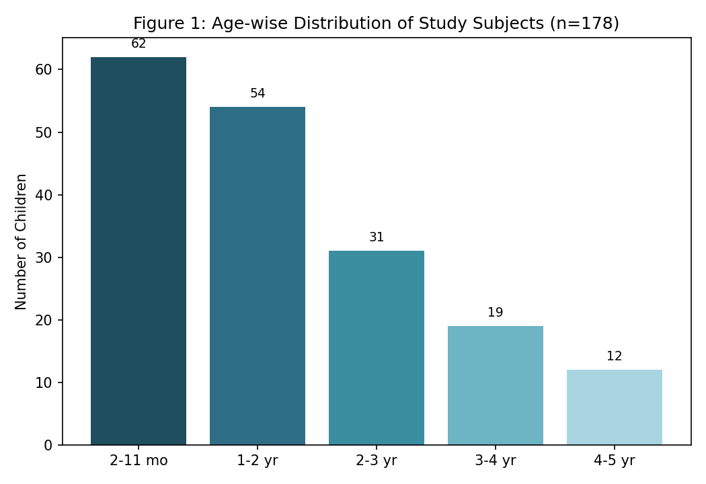
The 2–11 month age group accounted for the largest proportion of cases (34.8%), consistent with the well-documented peak incidence of CAP in infancy, reflecting relative immunological immaturity and higher respiratory rate at baseline in this age group.
Table 2: Clinical Features at Presentation
Clinical Feature at Presentation | Number (n) | Percentage (%)
Cough | 172 | 96.6
Fast breathing (tachypnoea) | 165 | 92.7
Fever | 143 | 80.3
Chest indrawing | 88 | 49.4
Difficulty feeding/drinking | 54 | 30.3
Cyanosis | 12 | 6.7
Convulsions | 6 | 3.4

Cough (96.6%) and fast breathing (92.7%) were near-universal presenting features, while chest indrawing was present in approximately half of the children (49.4%), and danger signs such as cyanosis and convulsions were present in a smaller minority.
Figure 2: Distribution by WHO Severity Classification (n = 178)
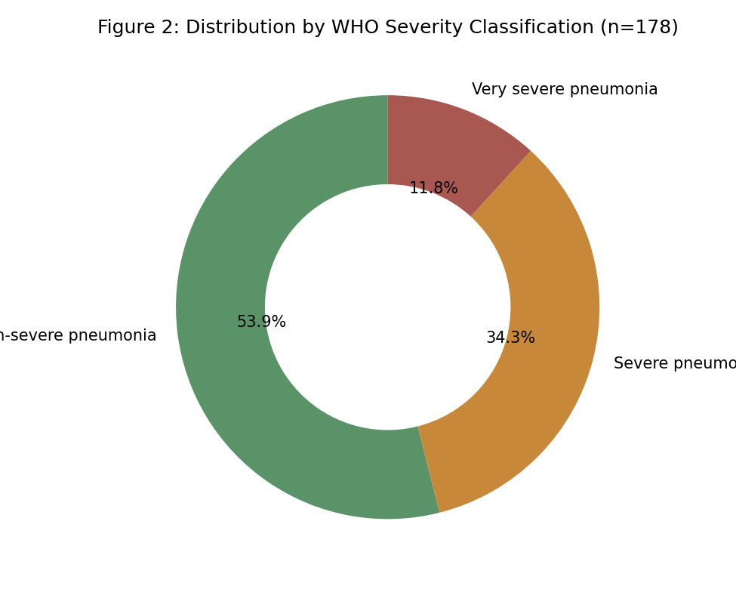
On WHO classification, 53.9% of children had non-severe pneumonia, 34.3% had severe pneumonia, and 11.8% had very severe pneumonia requiring urgent intervention.

Table 3: Cross-Tabulation of Radiological Patterns Across WHO Severity Classifications(Figure 3)
Radiological Pattern | Non-Severe ($n=96$) | Severe ($n=61$) | Very Severe ($n=21$) | Total ($n=178$)
Lobar/segmental consolidation | 18 | 22 | 9 | 49 (27.5%)
Patchy bronchopneumonic opacities | 42 | 19 | 5 | 66 (37.1%)
Interstitial pattern | 24 | 8 | 2 | 34 (19.1%)
Pleural effusion | 3 | 11 | 5 | 19 (10.7%)
Normal chest radiograph | 9 | 2 | 0 | 10 (5.6%)
Chi-square Analysis: X² = 28.42; df = 8; p < 0.001

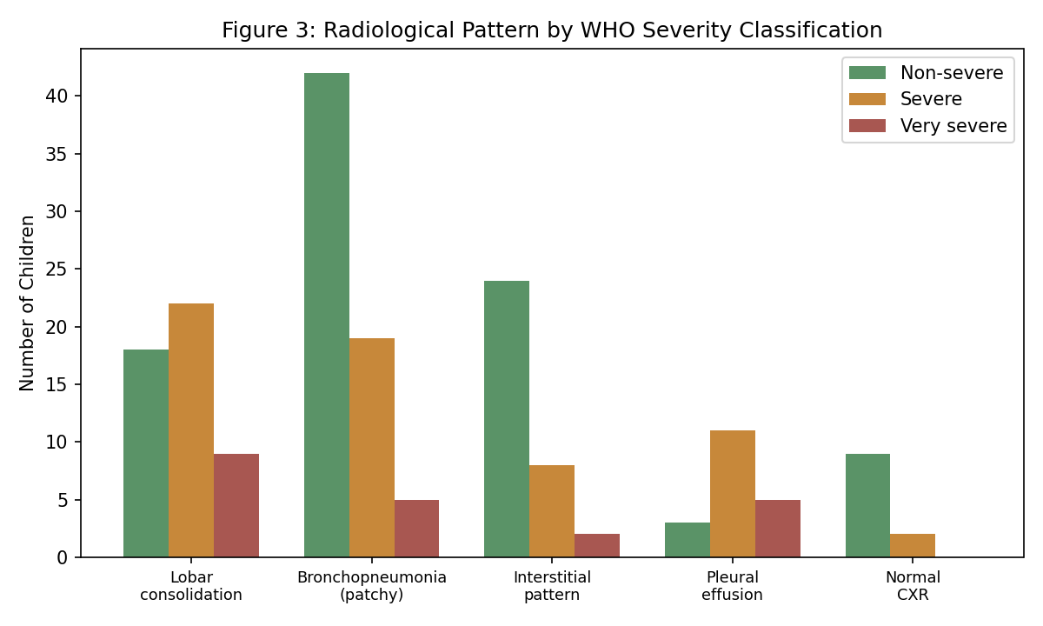
As shown in Table 3 and Figure 3, patchy bronchopneumonic opacities were the most common overall radiological finding (37.1%), but cross-tabulation and subsequent inferential analysis demonstrated a highly significant shift in patterns across categories (p < 0.001). Lobar consolidation and pleural effusion were heavily concentrated among children clinically classified as severe or very severe. Conversely, patchy bronchopneumonic and interstitial findings predominated among non-severe cases, validating the link between macro-structural parenchymal changes and worsening clinical distress.

Table 4: Outcome of Study Subjects
Outcome | Number (n) | Percentage (%)
Recovered, discharged | 163 | 91.6
Required ICU care | 11 | 6.2
Died | 4 | 2.2

The majority of children (91.6%) recovered and were discharged, while 6.2% required intensive care, and overall mortality was 2.2% (4 of 178 children), all of whom had presented with very severe pneumonia and lobar consolidation or pleural effusion on chest radiograph.
Figure 4 provides a detailed schematic chest radiograph illustration comparing a normal paediatric chest radiograph with the characteristic appearance of WHO-defined radiological pneumonia.
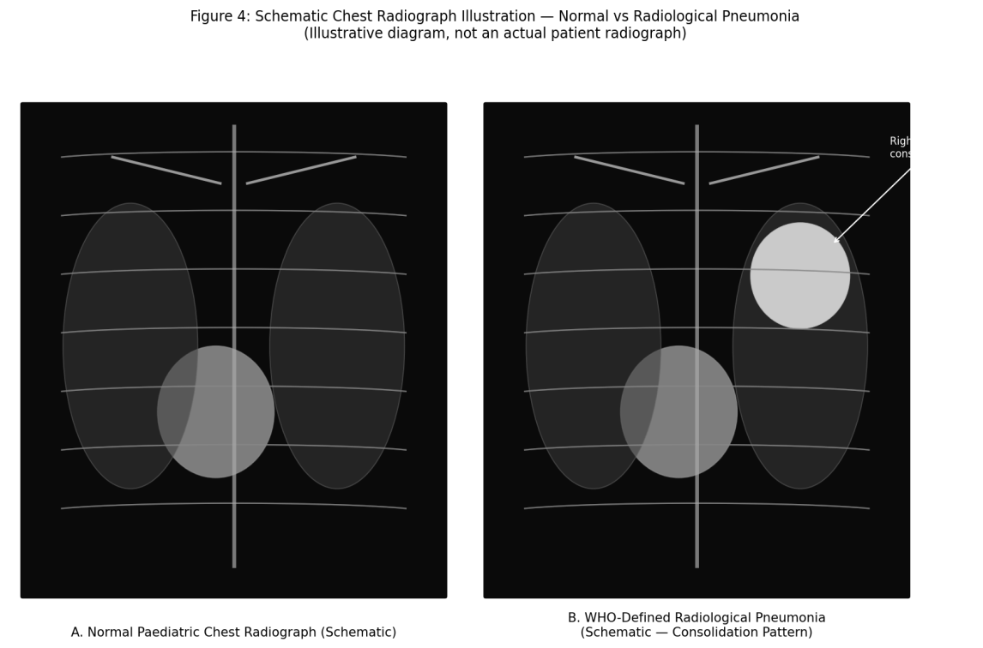

Discussion
The predominance of infants in the 2-11 month age group observed in this study is consistent with well-established epidemiological patterns of childhood CAP, which has consistently been shown to peak in infancy across multiple population-based studies.^{1,11} The near-universal presence of cough and fast breathing observed in this study reaffirms the centrality of these simple clinical signs to the WHO case-management algorithm, which relies on readily assessable features to enable pneumonia diagnosis even in resource-limited settings without access to radiography or laboratory testing.^{4,9}
A major clinical consideration in interpreting these findings—particularly the peak incidence in the 2–11 month group (34.8%)—is the substantial clinical overlap between early viral community-acquired pneumonia and acute viral bronchiolitis. In infants under one year of age, acute bronchiolitis characteristically presents with cough, tachypnea, and lower chest wall indrawing, perfectly mimicking the WHO diagnostic criteria for pneumonia. This clinical overlap is heavily reflected in our radiographic findings: among the non-severe cases, patchy bronchopneumonic opacities (37.1%) and hyperinflation with interstitial markings (19.1%) predominated. Many of these cases likely represent viral wheezing disorders rather than dense bacterial parenchymal infections. Recognizing this overlap is operationally crucial for clinicians to balance diagnostic sensitivity against the risks of unnecessary antibiotic deployment.
The proportion of children classified as severe or very severe pneumonia in this study (46.1% combined) is broadly consistent with rates reported in other hospital-based series from similar settings, reflecting the referral bias inherent to hospital-based populations, in which milder cases managed at the primary care level are under-represented.¹³The Chi-square test established a highly significant correlation between the clinical severity categories and specific radiological patterns (p < 0.001). The heavy concentration of lobar consolidation and pleural effusion within the severe and very severe tiers aligns with underlying pathophysiological mechanisms, as these structural patterns are hallmarks of advanced alveolar exudation or exudative complications that severely compromise respiratory mechanics.^{7,10}
These findings are consistent with the broader literature examining the relationship between radiological pattern and clinical severity in childhood CAP, which has generally found only moderate correlation between chest radiograph findings and WHO clinical severity classification, reinforcing that chest radiography should be regarded as a complementary rather than a required diagnostic tool in the routine clinical assessment of childhood pneumonia.^{9,10} The overall mortality of 2.2% observed in this study, concentrated among children with very severe pneumonia and radiological evidence of consolidation or effusion, underscores the continued importance of early recognition of danger signs and prompt escalation of care in this subgroup.^{12,15}
It is also worth noting that the WHO clinical classification system was intentionally designed to prioritise sensitivity over specificity, given its primary purpose of guiding antibiotic treatment decisions in resource-limited settings where radiography and laboratory testing may not be readily available.^{4,9} This design principle likely accounts for the observed overlap in radiological findings across WHO severity categories in this study, as a proportion of children classified as non-severe by clinical criteria nonetheless demonstrated radiological changes, while conversely, some children with clinical danger signs had relatively unremarkable chest radiographs, reflecting differing pathophysiological mechanisms underlying respiratory distress in this age group.

Conclusion
Taken together with the wider literature on childhood pneumonia severity assessment, the findings of this study support a pragmatic, tiered diagnostic approach in resource-limited settings: universal application of simple WHO clinical criteria for initial diagnosis and triage, reserving chest radiography and, where available, pulse oximetry for children with clinical severe or very severe disease or an atypical course, thereby balancing diagnostic thoroughness against the practical constraints of busy paediatric services.
Community-acquired pneumonia in this hospitalised paediatric population predominantly affected infants, with a substantial proportion classified as severe or very severe by WHO criteria. Statistical testing demonstrated a highly significant correlation between worsening WHO clinical severity and structural radiologic findings (p < 0.001). The distinct clustering of lobar consolidation and pleural effusion within advanced stages confirms the value of targeted chest radiographs in identifying children at high risk for clinical deterioration, reinforcing the complementary role of chest radiography alongside standard WHO clinical assessment in guiding management of this common and potentially life-threatening condition.

References
- Rudan I, Boschi-Pinto C, Biloglav Z, Mulholland K, Campbell H. Epidemiology and etiology of childhood pneumonia. Bull World Health Organ. 2008;86(5):408-16.
- UNICEF/WHO. Pneumonia: The Forgotten Killer of Children. Geneva: WHO/UNICEF; 2006.
- Cherian T, Mulholland EK, Carlin JB, Ostensen H, Amin R, de Campo M, et al. Standardized interpretation of paediatric chest radiographs for the diagnosis of pneumonia in epidemiological studies. Bull World Health Organ. 2005;83(5):353-9.
- World Health Organization. Pocket Book of Hospital Care for Children: Guidelines for the Management of Common Illnesses with Limited Resources. Geneva: WHO; 2005.
- Harris M, Clark J, Coote N, Fletcher P, Harnden A, McKean M, Thomson A. British Thoracic Society guidelines for the management of community acquired pneumonia in children: update 2011. Thorax. 2011;66(Suppl 2):ii1-23.
- Bradley JS, Byington CL, Shah SS, et al. The management of community-acquired pneumonia in infants and children older than 3 months of age: clinical practice guidelines by the Pediatric Infectious Diseases Society and the Infectious Diseases Society of America. Clin Infect Dis. 2011;53(7):e25-76.
- McIntosh K. Community-acquired pneumonia in children. N Engl J Med. 2002;346(6):429-37.
- Hazir T, Nisar YB, Qazi SA, et al. Chest radiography in children aged 2-59 months diagnosed with non-severe pneumonia as defined by World Health Organization: descriptive multicentre study in Pakistan. BMJ. 2006;333(7569):629.
- Palafox M, Guiscafre H, Reyes H, Munoz O, Martinez H. Diagnostic value of tachypnoea in pneumonia defined radiologically. Arch Dis Child. 2000;82(1):41-5.
- Madhi SA, Klugman KP. World Health Organisation definition of 'radiologically-confirmed pneumonia' may under-estimate the true public health value of conjugate pneumococcal vaccines. Vaccine. 2007;25(13):2413-9.
- Mathew JL, Patwari AK, Gupta P, et al. Acute respiratory infection and pneumonia in India: a systematic review of literature for advocacy and action: UNICEF-PHFI series on newborn and child health, India. Indian Pediatr. 2011;48(3):191-218.
- Shann F, Hart K, Thomas D. Acute lower respiratory tract infections in children: possible criteria for selection of patients for antibiotic therapy and hospital admission. Bull World Health Organ. 1984;62(5):749-53.
- Agarwal J, Awasthi S, Rajput A, Tiwari M, Jain A. Atypical bacterial pathogens in community-acquired pneumonia in children: a hospital-based study. Trop Doct. 2009;39(2):109-11.
- Black RE, Cousens S, Johnson HL, et al. Global, regional, and national causes of child mortality in 2008: a systematic analysis. Lancet. 2010;375(9730):1969-87.
- Wardlaw T, Salama P, Johansson EW, Mason E. Pneumonia: the leading killer of children. Lancet. 2006;368(9541):1048-50.

