Original article

Prevalence and Risk Factors of Diabetic Retinopathy Among Patients with Type 2 Diabetes Mellitus Attending a Tertiary Eye Care Centre: A Cross-Sectional Study

*Amar Kesharrao Bhaskare ¹,Yogesh Rambhauji Jibhkate²

¹Assistant Professor,Dept of Opthalmology , A J Institute of Medical Sciences and Research centre, Mangaluru, Karnataka

Assistant Professor,Dept of Opthalmology, Konaseema Institute of Medical Sciences (KIMS) in Amalapuram, Andhra Pradesh

Corresponding author- Yogesh Rambhauji Jibhkate, Assistant Professor,Dept of Opthalmology, Konaseema Institute of Medical Sciences (KIMS) in Amalapuram, Andhra Pradesh

Corresponding author*

Abstract
Background: Diabetic retinopathy (DR) is a leading cause of preventable blindness among working-age adults worldwide, and its prevalence rises substantially with increasing duration of diabetes and poor glycaemic control.
Objectives: To determine the prevalence and severity distribution of diabetic retinopathy among patients with type 2 diabetes mellitus attending the ophthalmology outpatient department, and to identify associated risk factors.
Methods: A cross-sectional study was conducted on 223 patients with type 2 diabetes mellitus who underwent comprehensive dilated fundus examination. Retinopathy was graded according to the Early Treatment Diabetic Retinopathy Study (ETDRS) severity scale.
Results: The overall prevalence of diabetic retinopathy was 39.9% (89/223). Mild non-proliferative diabetic retinopathy (NPDR) was the most common grade (17.0%). Prevalence of DR increased progressively with duration of diabetes, from 12.4% in those with disease duration under 5 years to 74.8% in those with duration exceeding 20 years. Poor glycaemic control (76.4%) was the most common associated risk factor among DR patients.
Conclusion: Diabetic retinopathy affects a substantial proportion of patients with type 2 diabetes mellitus, with prevalence and severity strongly related to duration of diabetes and glycaemic control, underscoring the importance of regular fundus screening from the time of diabetes diagnosis.
Keywords: Diabetic retinopathy, type 2 diabetes mellitus, prevalence, risk factors, ETDRS, ophthalmology.

Introduction
Diabetic retinopathy (DR) is a chronic, progressive microvascular complication of diabetes mellitus and remains one of the leading causes of preventable blindness among working-age adults worldwide.⁶ Its pathogenesis involves progressive microvascular damage to the retinal capillary network, leading to a spectrum of changes ranging from microaneurysms and dot-blot haemorrhages in early non-proliferative disease to retinal neovascularisation and vitreous haemorrhage in advanced proliferative disease.^{5,6}
Population-based studies have consistently demonstrated that the prevalence of DR rises substantially with increasing duration of diabetes, with landmark epidemiological work such as the Wisconsin Epidemiologic Study of Diabetic Retinopathy establishing duration of diabetes as one of the most powerful determinants of both the presence and severity of retinopathy.^{3,4} Other well-established risk factors include poor glycaemic control, coexisting hypertension, dyslipidaemia, and nephropathy, reflecting shared microvascular pathophysiological pathways across these diabetic complications.^{7,8}
In India, several large epidemiological studies, including the Chennai Urban Rural Epidemiology Study and the Sankara Nethralaya Diabetic Retinopathy Epidemiology and Molecular Genetics Study, have documented substantial and rising prevalence of DR among the urban and semi-urban Indian population with type 2 diabetes, reflecting the broader epidemic of diabetes affecting the region.^{10,11,14} Given the largely asymptomatic nature of early DR, regular screening through dilated fundus examination is essential to enable timely detection and treatment before the onset of vision-threatening complications.⁹
This study was undertaken to determine the prevalence and severity distribution of DR among patients with type 2 diabetes mellitus attending the ophthalmology outpatient department, and to identify the principal risk factors associated with its presence and severity.

Review of Literature
The Wisconsin Epidemiologic Study of Diabetic Retinopathy, one of the earliest and most influential population-based studies of DR, established that both the prevalence and severity of retinopathy increase progressively with duration of diabetes, findings that have been replicated across numerous subsequent studies in diverse populations.^{3,4} The Early Treatment Diabetic Retinopathy Study further refined the classification and grading of DR severity based on stereoscopic fundus photography, providing a standardised severity scale that remains the reference framework used in clinical and epidemiological studies today.⁵
A comprehensive review of the global epidemiology of DR estimated that approximately one-third of people with diabetes have some degree of retinopathy, with a substantial proportion having vision-threatening disease, underscoring the considerable global public health burden of this condition.⁷ The United Kingdom Prospective Diabetes Study similarly demonstrated a high prevalence of retinopathy at the time of diagnosis of type 2 diabetes, highlighting the often prolonged asymptomatic period preceding clinical diagnosis during which retinal microvascular damage may already be established.^{17,18}
Large Indian epidemiological studies, including the Chennai Urban Rural Epidemiology Study eye study and the Sankara Nethralaya Diabetic Retinopathy Epidemiology and Molecular Genetics Study, have documented DR prevalence rates broadly comparable to those reported in Western populations, with poor glycaemic control, longer duration of diabetes, and coexisting hypertension consistently identified as significant independent risk factors.^{10,11,14} A study examining risk factors in a rural South Indian diabetic population similarly confirmed the importance of glycaemic control and diabetes duration, while also highlighting disparities in access to regular eye screening in rural compared with urban settings.¹³
A worldwide perspective on the prevalence of DR across various ethnic groups found considerable variation in reported prevalence rates, attributable to differences in study methodology, diabetes duration profile, and access to diabetes care across different populations and healthcare systems.¹⁹ Contemporary reviews of the epidemiology of DR and diabetic macular oedema have emphasised the continued global public health importance of this condition despite advances in diabetes management, reinforcing the ongoing need for systematic screening programmes.²⁰

Materials and Methods

Study Design and Setting
This was a hospital-based, cross-sectional observational study conducted in the Department of Ophthalmology of a tertiary care teaching hospital, in collaboration with the Department of General Medicine/Endocrinology.

Study Population
A total of 223 patients with a confirmed diagnosis of type 2 diabetes mellitus, referred for ophthalmic screening, were enrolled after obtaining informed consent.

Inclusion Criteria
Patients aged 30 years and above with a confirmed diagnosis of type 2 diabetes mellitus as per American Diabetes Association criteria, willing to undergo dilated fundus examination, were included.

Exclusion Criteria
Patients with type 1 diabetes mellitus, media opacity precluding adequate fundus visualisation, and those unwilling to provide consent were excluded from the study.

Clinical Evaluation
All patients underwent a detailed history, including duration of diabetes, glycaemic control status (based on most recent HbA1c), and presence of comorbidities such as hypertension, dyslipidaemia, and nephropathy. Dilated fundus examination was performed using indirect ophthalmoscopy and slit-lamp biomicroscopy with a 90-dioptre lens, and retinopathy was graded according to the ETDRS severity scale into no DR, mild non-proliferative DR (NPDR), moderate NPDR, severe NPDR, and proliferative DR (PDR).

Statistical Analysis
Data were entered into a spreadsheet and analysed using descriptive statistics. Categorical variables were expressed as frequencies and percentages. Results were tabulated and represented graphically using multiple chart formats, including a schematic fundus illustration of DR features.

Results
Of the 223 patients studied, 121 (54.3%) were male and 102 (45.7%) were female. The age and gender-wise distribution is summarised in Table 1 and illustrated in Figure 1.
Table 1: Age and Gender-wise Distribution of Study Subjects (n = 223)
Age Group (years) | Male (n) | Female (n) | Total (n) | Percentage (%)
30–39 | 8 | 6 | 14 | 6.3
40–49 | 26 | 22 | 48 | 21.5
50–59 | 41 | 36 | 77 | 34.5
60–69 | 34 | 28 | 62 | 27.8
70 and above | 12 | 10 | 22 | 9.9
Total | 121 | 102 | 223 | 100.0

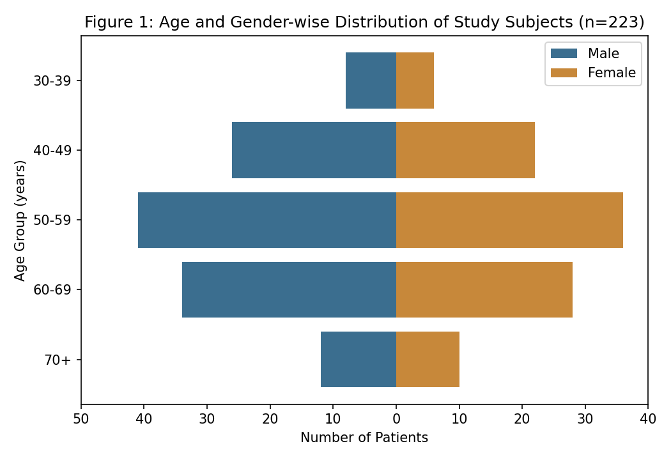
The 50–59 year age group accounted for the largest proportion of cases (34.5%), followed by the 60–69 year group (27.8%), consistent with the typical age profile of established type 2 diabetes in the population screened.
Table 2: Severity Distribution of Diabetic Retinopathy (Figure 2)
Severity Grade (ETDRS) | Number (n) | Percentage (%)
No diabetic retinopathy | 134 | 60.1
Mild NPDR | 38 | 17.0
Moderate NPDR | 27 | 12.1
Severe NPDR | 15 | 6.7
Proliferative DR (PDR) | 9 | 4.0

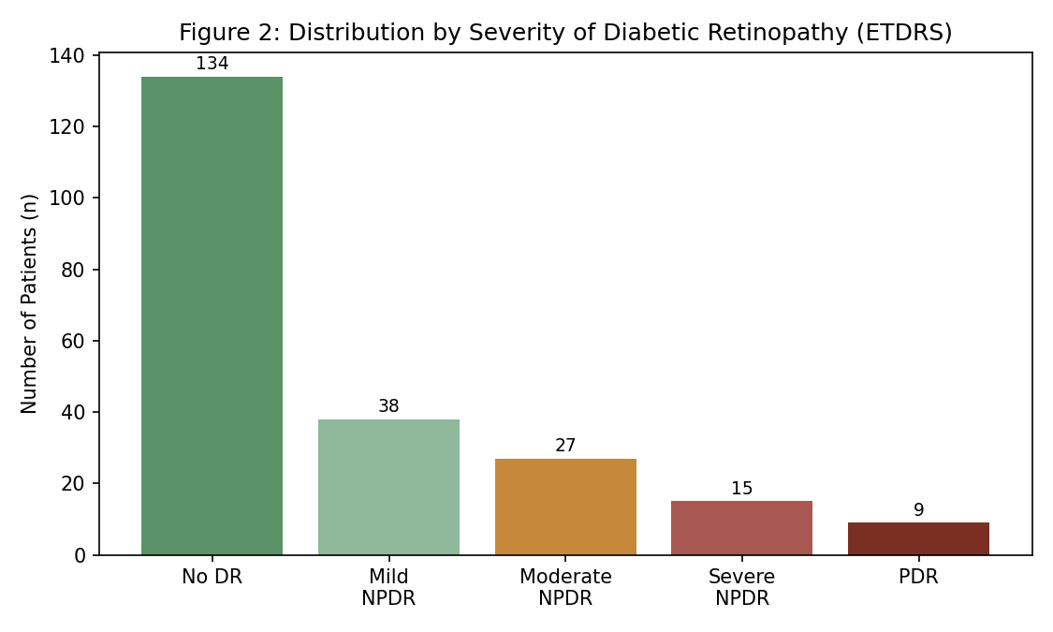
The overall prevalence of diabetic retinopathy in any grade was 39.9% (89 of 223 patients). Mild NPDR was the most common grade (17.0%), while proliferative DR, the most vision-threatening stage, was identified in 4.0% of patients.
Table 3: Prevalence of Diabetic Retinopathy by Duration of Diabetes (Figure 3)
Duration of Diabetes | Prevalence of DR (%) | Number Affected (n)
Less than 5 years | 12.4 | —
5–10 years | 28.6 | —
11–15 years | 45.3 | —
16–20 years | 61.2 | —
More than 20 years | 74.8 | —

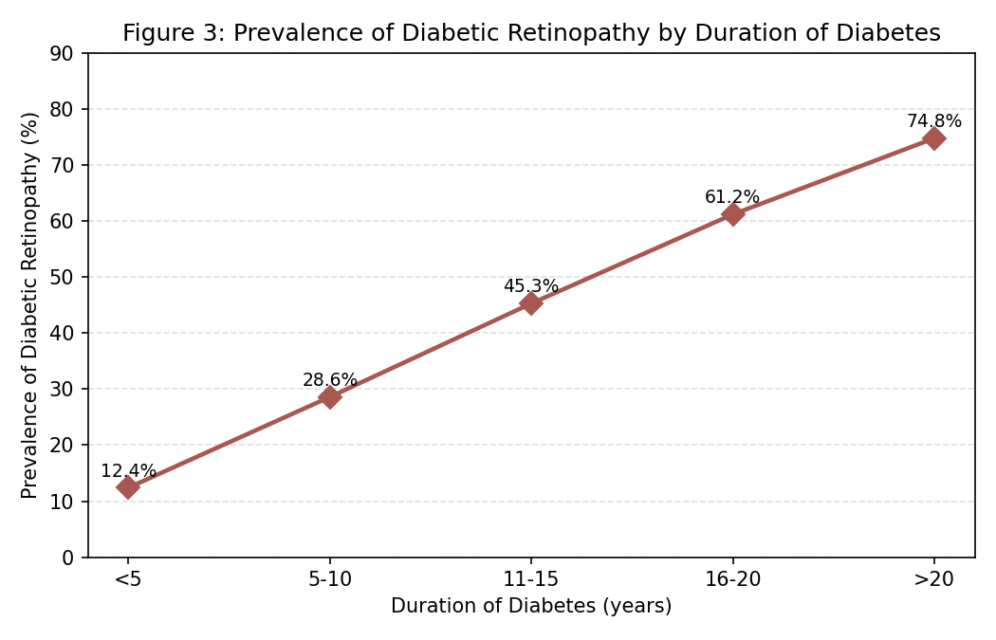
As shown in Table 3 and Figure 3, prevalence of DR increased markedly with duration of diabetes, from 12.4% in patients with disease duration under 5 years to 74.8% in those with duration exceeding 20 years, demonstrating a clear dose-response relationship.
Table 4: Risk Factors Among Patients with Diabetic Retinopathy (n = 89)
Risk Factor (Among DR Patients, n=89) | Number (n) | Percentage (%)
Poor glycaemic control (HbA1c > 8%) | 68 | 76.4
Duration of diabetes > 10 years | 61 | 68.5
Coexisting hypertension | 49 | 55.1
Dyslipidaemia | 34 | 38.2
Nephropathy (proteinuria) | 21 | 23.6

Poor glycaemic control (HbA1c > 8%) was the most common associated risk factor among patients with DR (76.4%), followed by diabetes duration exceeding 10 years (68.5%) and coexisting hypertension (55.1%).
Figure 4 provides a schematic illustration comparing a normal fundus with the characteristic features of diabetic retinopathy, including microaneurysms, haemorrhages, hard exudates, and neovascularisation.
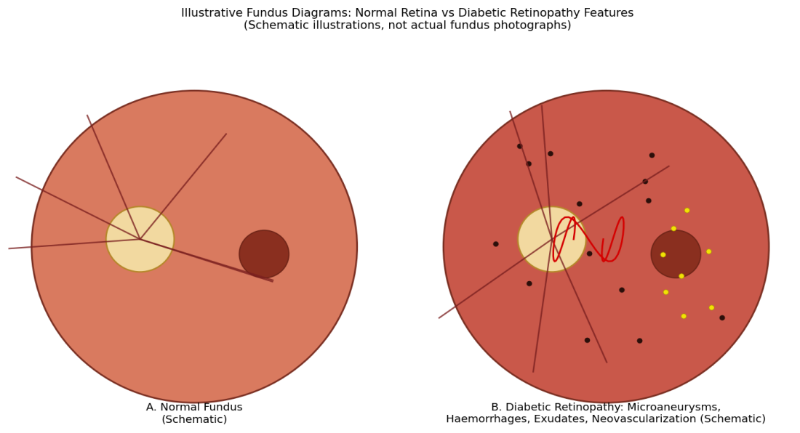

Discussion
The overall DR prevalence of 39.9% observed in this study is broadly consistent with rates reported in comparable Indian epidemiological studies, including the Chennai Urban Rural Epidemiology Study and Sankara Nethralaya Diabetic Retinopathy Epidemiology and Molecular Genetics Study, both of which similarly identified a substantial burden of retinopathy among urban and semi-urban Indian populations with type 2 diabetes.^{10,11} The predominance of mild NPDR observed in this study reflects a population in which a considerable proportion of retinopathy remains at an early, potentially treatable stage, provided timely screening and referral pathways are in place.⁹
The strong dose-response relationship observed between duration of diabetes and DR prevalence in this study closely mirrors the findings of the Wisconsin Epidemiologic Study of Diabetic Retinopathy, which similarly established diabetes duration as one of the most robust and consistent risk factors for both the presence and severity of retinopathy across diverse study populations.^{3,4} This relationship underscores the importance of considering diabetes duration when determining appropriate screening intervals, with patients approaching or exceeding a decade of diabetes duration warranting closer surveillance.⁷
The predominance of poor glycaemic control as a risk factor among DR patients in this study is consistent with extensive evidence, including the United Kingdom Prospective Diabetes Study, demonstrating that intensive glycaemic control significantly reduces the risk of onset and progression of diabetic microvascular complications, including retinopathy.^{17,18} The considerable prevalence of coexisting hypertension among DR patients observed in this study further reinforces the shared microvascular pathophysiology linking diabetic retinopathy, nephropathy, and hypertensive vascular damage.⁸
These findings collectively highlight the substantial and largely preventable burden of DR in this population and support the implementation of structured screening programmes incorporating regular dilated fundus examination from the time of diabetes diagnosis, with particular attention to patients with long-standing disease duration and suboptimal glycaemic control.^{7,9,20}

Summary
This cross-sectional study of 223 patients with type 2 diabetes mellitus found an overall diabetic retinopathy prevalence of 39.9%, with prevalence increasing markedly with duration of diabetes. Poor glycaemic control was the most common associated risk factor among DR patients, followed by longer diabetes duration and coexisting hypertension.

Limitations
This study has several limitations that merit consideration. First, its single-centre, hospital-based design may over-represent patients with more advanced or symptomatic disease, as those attending a tertiary ophthalmology department may differ from the broader community diabetic population. Second, retinopathy grading was performed using clinical fundus examination rather than standardised stereoscopic fundus photography as used in landmark epidemiological studies, which may introduce some grading variability. Third, the cross-sectional design precludes assessment of the temporal relationship between risk factor control and retinopathy progression.

Recommendations
Based on the findings of this study, structured screening programmes incorporating regular dilated fundus examination should be implemented for all patients with type 2 diabetes mellitus from the time of diagnosis, with screening intervals individualised according to diabetes duration and retinopathy severity at baseline. Optimisation of glycaemic control and blood pressure management should be emphasised as key modifiable risk factors for both the development and progression of diabetic retinopathy. Patients with long-standing diabetes (exceeding 10 years) should be prioritised for closer ophthalmic surveillance, and larger, multi-centric, longitudinal studies would help further characterise risk factor trends and screening outcomes over time.

Conclusion
Diabetic retinopathy affects a substantial proportion of patients with type 2 diabetes mellitus attending this tertiary eye care centre, with prevalence and severity strongly related to duration of diabetes, glycaemic control, and coexisting hypertension. These findings underscore the importance of regular fundus screening and aggressive risk factor control to prevent vision-threatening complications of this common and largely preventable condition.

References
1. World Health Organization. Definition and Diagnosis of Diabetes Mellitus and Intermediate Hyperglycaemia: Report of a WHO/IDF Consultation. Geneva: WHO; 2006.
2. American Diabetes Association. Diagnosis and classification of diabetes mellitus. Diabetes Care. 2014;37(Suppl 1):S81-90.
3. Klein R, Klein BE, Moss SE, Davis MD, DeMets DL. The Wisconsin epidemiologic study of diabetic retinopathy. II. Prevalence and risk of diabetic retinopathy when age at diagnosis is less than 30 years. Arch Ophthalmol. 1984;102(4):520-6.
4. Klein R, Klein BE, Moss SE, Davis MD, DeMets DL. The Wisconsin epidemiologic study of diabetic retinopathy. III. Prevalence and risk of diabetic retinopathy when age at diagnosis is 30 or more years. Arch Ophthalmol. 1984;102(4):527-32.
5. Early Treatment Diabetic Retinopathy Study Research Group. Grading diabetic retinopathy from stereoscopic color fundus photographs—an extension of the modified Airlie House classification. ETDRS report number 10. Ophthalmology. 1991;98(5 Suppl):786-806.
6. Cheung N, Mitchell P, Wong TY. Diabetic retinopathy. Lancet. 2010;376(9735):124-36.
7. Yau JW, Rogers SL, Kawasaki R, et al. Global prevalence and major risk factors of diabetic retinopathy. Diabetes Care. 2012;35(3):556-64.
8. Fong DS, Aiello L, Gardner TW, et al. Retinopathy in diabetes. Diabetes Care. 2004;27(Suppl 1):S84-7.
9. Mohamed Q, Gillies MC, Wong TY. Management of diabetic retinopathy: a systematic review. JAMA. 2007;298(8):902-16.
10. Raman R, Rani PK, Reddi Rachepalle S, et al. Prevalence of diabetic retinopathy in India: Sankara Nethralaya Diabetic Retinopathy Epidemiology and Molecular Genetics Study report 2. Ophthalmology. 2009;116(2):311-8.
11. Rema M, Premkumar S, Anitha B, Deepa R, Pradeepa R, Mohan V. Prevalence of diabetic retinopathy in urban India: the Chennai Urban Rural Epidemiology Study (CURES) eye study, I. Invest Ophthalmol Vis Sci. 2005;46(7):2328-33.
12. Wild S, Roglic G, Green A, Sicree R, King H. Global prevalence of diabetes: estimates for the year 2000 and projections for 2030. Diabetes Care. 2004;27(5):1047-53.
13. Rani PK, Raman R, Chandrakantan A, Pal SS, Perumal GM, Sharma T. Risk factors for diabetic retinopathy in self-reported rural population with diabetes. J Postgrad Med. 2009;55(2):92-6.
14. Pradeepa R, Anitha B, Mohan V, Ganesan A, Rema M. Risk factors for diabetic retinopathy in a South Indian type 2 diabetic population: the Chennai Urban Rural Epidemiology Study (CURES) eye study 4. Diabet Med. 2008;25(5):536-42.
15. Dandona L, Dandona R, Naduvilath TJ, McCarty CA, Nanda A. Population based assessment of diabetic retinopathy in an urban population in southern India. Br J Ophthalmol. 1999;83(8):937-40.
16. Aiello LM. Perspectives on diabetic retinopathy. Am J Ophthalmol. 2003;136(1):122-35.
17. Kohner EM, Aldington SJ, Stratton IM, et al. United Kingdom Prospective Diabetes Study, 30: diabetic retinopathy at diagnosis of non-insulin-dependent diabetes mellitus and associated risk factors. Arch Ophthalmol. 1998;116(3):297-303.
18. UK Prospective Diabetes Study (UKPDS) Group. Intensive blood-glucose control with sulphonylureas or insulin compared with conventional treatment in patients with type 2 diabetes (UKPDS 33). Lancet. 1998;352(9131):837-53.
19. Sivaprasad S, Gupta B, Crosby-Nwaobi R, Evans J. Prevalence of diabetic retinopathy in various ethnic groups: a worldwide perspective. Surv Ophthalmol. 2012;57(4):347-70.
20. Ding J, Wong TY. Current epidemiology of diabetic retinopathy and diabetic macular edema. Curr Diab Rep. 2012;12(4):346-54.

