Original article:

Role of thermography in detecting breast lesions and specificity in classifying benign and malignant lesions
¹Dr. A. Mohideen Ashraf, ²Dr.V.Dheebha*

¹Assistant Professor, Barnard Institute of Radiology, Madras Medical College. Chennai-600003
²Assistant Professor, Barnard Institute of Radiology, Madras Medical College. Chennai-600003
Corresponding author*

Abstract:
Objective: To assess the performance and diagnostic value of thermography in patients with suspected breast lesions .
Materials and Methods: In this prospective study, the study population consists of 250 patients with symptoms related to breast pathology, including patients sent for routine breast screening by mammography and Ultrasound.Diagnosis was confirmed for all lesions detected by thermography by Fine needle aspiration cytology (FNAC).
Results: The sensitivity and specificity of thermography in identifying malignant lesions are as follows; sensitivity was calculated as 87.61% , specificity was 83.33% , PPV 86.84%, NPV 84.27% and diagnostic accuracy of thermography was 85.47%.
Conclusion: Inferences drawn from the study shows that Thermography has high sensitivity in detecting breast abscess, BIRADS IV ,V lesions. But it shows low sensitivity in detecting BIRADS II lesions.
Keywords: BIRADS Breast Imaging Reporting and Data System, breast abscess, FNAC Fine Needle Aspiration Cytology,

Introduction:
Breast cancer is one of the main causes of death among women worldwide. There are different techniques for carrying out the diagnosis: mammography, ultrasound, MRI, biopsies, and more recently, thermography. With advances in thermal imaging technology, thermography has reappeared and is being seriously considered as a complementary tool for the diagnosis of breast cancer.Thermography is also noninvasive and non radiation , it has the advantage of using a cheaper device (an infrared camera), which is far more portable than those used in mammography, MRI, and ultrasound^{.(1)} Thermography can help determine physiologically whether a local abnormality in breast tissue temperature is present, which indicate the presence of disease^{.(2)}
Methods and methodology:
Women with symptoms related to breast pathology and for routine breast screening who are referred to our department for mammography and Ultrasound were assessed by thermographic technique using ILLUMINA360 CURA SOLUTIONS thermography machine . The diagnosis was confirmed by FNAC/ Histopathological analysis ,in all the patients who had positive ultrasound findings .

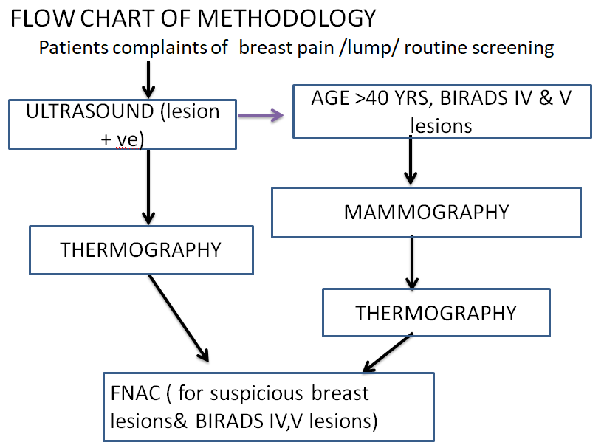

Thermography technique:
Patient is made to lie in prone position so that breast is made to suspend in a hole made in the machine.The images are acquired in closed dark chamber with the ambient temperature to the comfort level of the patient at a humidity of 60.
Image capture:
The camera is placed at a distance of 30–47 cms from the surface of the suspended breast. The procedure is repeated after reducing the ambient temperature to 26 degree by cooling system designed within the machine.

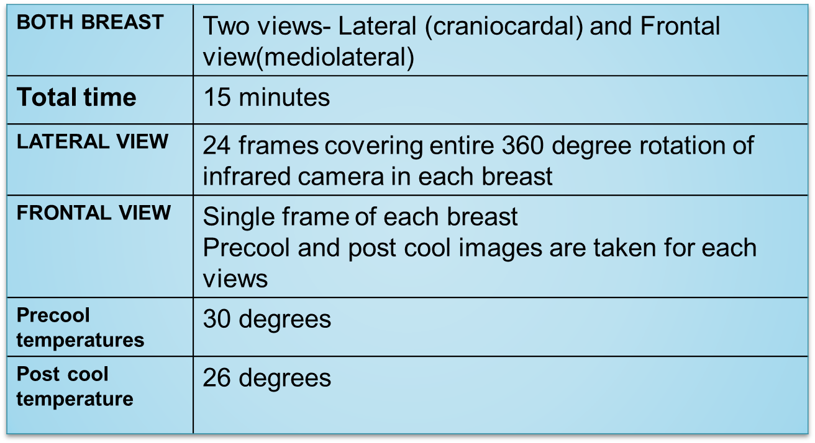

Image Display:
Reconstructed Breast images are displayed in different color shades coded for specific temperature (red, orange, green, blue and yellow) on a computer monitor for analysis. The CTI technology was designed to store the images electronically and helps in follow up.
Thermograph as a physiologic test, demonstrates heat patterns that are strongly indicative of breast abnormality by detecting subtle changes in breast temperature. Thermograph was able to identify thermal abnormality in majority of malignant lesions compared to benign cases. Thermograph shows high predictive value in categorizing malignant lesions based on precool and post cool difference in temperature.
Data Analysis:
All the data were entered into the excel sheet. The collected data were analyzed with IBM.SPSS statistics software 23.0 Version. To describe about the data descriptive statistics frequency analysis, percentage analysis were used for categorical variables and the mean & S.D were used for continuous variables. To find the significant difference between the bivariate samples in Independent groups the unpaired sample t-test was used. The Receiver Operator Characteristic (ROC) curve analysis was used to find the Sensitivity, Specificity to identify the accuracy tools. To find the significance in categorical data Chi-Square test was used. In all the above statistical tools the probability value .05 is considered as significant level.
Results:
Patient Characteristics:
We evaluated 250 female patients who came to our department for ultrasound and breast screening. On comparing age range of our study population , we found that majority of them fall under the age range of 26 to 55 years concluding that breast disease is more common in reproductive age group. Our study population included only disease or lesion positive group, there was no disease negative cases. Initial ultrasound investigation categorized the study population into 6 groups based on BIRADS score. In our study among the total 250 population, Ultrasound reported as BIRADS II in 52 subjects, 42 were categorized under BIRADS III, 52 were grouped under BIRADS IV , BIRADS V was given in 42 subjects and BIRADS VI was reported in 30 subjects. Abscess was diagnosed in 32 study population.
In our study , we analyzed post cool temperature of all thermal abnormality picked up cases and classified them as malignant if there is no significant temperature difference compared to precool thermal frames. And rest of them was classified under benign conditions.
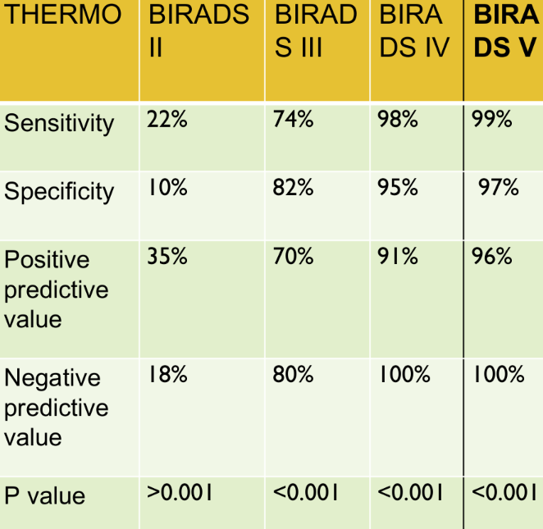

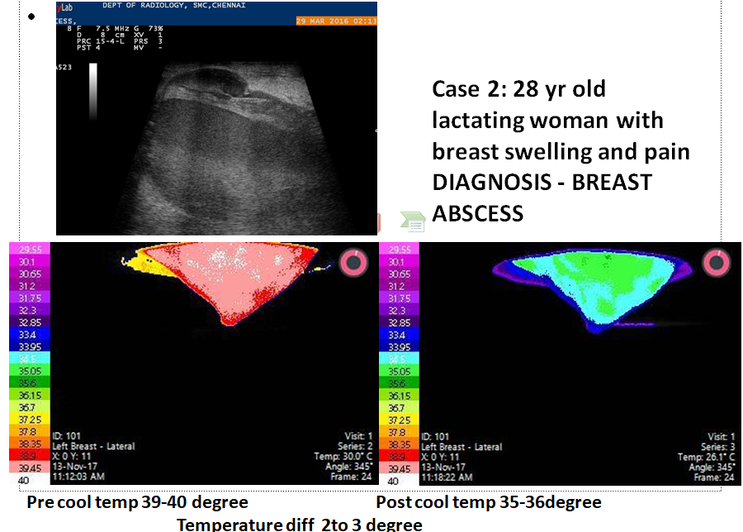

Results:
Thermography shows high sensitivity in detecting breast abscess, BIRADS IV ,V lesions. But it shows low sensitivity in detecting BIRADS II lesions. Precool and post cool breast images showed no significant difference in temperature in breast abscess,insitu and invasive carcinoma^{.(3)} Whereas fibroadenoma, phylloides , fibrocystic disease and duct ectasia showed significant temperature difference of more than 4 degree in post cool thermal frames. On analyzing correlation using Receiver Operating Characteristic curve, we found that area under the curve was 0.989, p value 0.0005 which is significant and thermography was able to diagnose breast cancer with confidence interval was 0.972 to 1.000.
Discussion:
Our study population included only disease or lesion positive group, there was no disease negative cases. In our study, 122 cases were confirmed as malignant in histopathology. With preliminary ultrasound screening, we did thermography analysis for each subject and finally Histopathological confirmation of ultrasound findings was done in all these subjects. Thermograph study analysis showed that initial imaging of breast before cooling process did not pick up focal abnormal temperature in 47 subjects representing 18.8% of total population (Table). On cross tabulation of FNAC and Thermograph we had a Pearson chi square value of 20.367 and p value of 0.0005 which is significant (table). Despite non pick up lesions, thermography showed significant correlation in picking up breast lesions.
On further analysis of thermo negative 47 cases, we found that 38 cases were diagnosed as benign cases in Histopathological diagnosis. Only 9 cases were proved malignant representing 3.6% of total population which improved the efficacy of thermography in picking up malignant lesions compared to benign cases. In our study, we calculated the efficacy of thermography in categorizing benign and malignant lesion based on degree of decrease in temperature of focal abnormality after reducing the ambient temperature of machine by cooling mechanism. ⁽⁴⁾To calculate this, we included only 203 cases which showed abnormality in thermography and we categorized them into benign and malignant lesions and compared them with Histopathological diagnosis . In identifying malignant lesions, thermography showed sensitivity of 87.61% , specificity of 83.33% , PPV of 86.84%, NPV of 84.27% and diagnostic accuracy of 85.47%. On analyzing correlation using Receiver Operating Characteristic curve, we found that area under the curve was 0.989, p value 0.0005 which is significant and thermography was able to diagnose breast cancer with confidence interval was 0.972 to 1.000.
Limitations:
The study group included only breast lesion positive patients who were diagnosed by ultrasound. Because of this, we were not able to demonstrate whether thermography shows abnormal temperature in lesion negative cases.⁽⁵⁾ Thermographic images cannot make out exact quadrant or zonal area of the breast lesion, further study is usually necessary to find the exact site of lesions.Thermograph provides only temperature color coding of images, hence Morphology and size characteristics of the lesion cannot be made out by this thermography.Lesions smaller than 5mm in size didn’t pick up abnormality in some of the cases.
Conclusion:
We evaluated 250 women presenting with symptoms of breast pain/swelling who had positive ultrasound findings and diagnosis was confirmed by FNAC/ Histopathological analysis.Thermograph as a physiologic test, demonstrates heat patterns that are strongly indicative of breast abnormality by detecting subtle changes in breast temperature.Thermograph was able to identify thermal abnormality in majority of malignant lesions compared to benign cases. Thermograph shows high predictive value in categorizing malignant lesions based on precool and post cool difference in temperature.Thermograph can be used as a complimentary tool to ultrasound or mammography for screening breast cancer, however it cannot be used solely as screening tool for breast cancer because it cannot give morphology and size characteristics of the lesion.Follow-up procedures including mammography and ultrasound are necessary to rule out or properly diagnose cancer and other breast diseases.

References:
1. E. Y. K. Ng, “A review of thermography as promising non-invasive detection modality for breast tumor,” International Journal of Thermal Sciences,vol.48,no.5,pp.849–859,2009.
2. K. R. Foster, “Thermographic detection of breast cancer,” IEEE Engineering in Medicine and Biology Magazine,vol.17,no.6,p.10, 1998.
3. G.C.Wishart,M.Campisi,M.Boswelletal.,“The accuracy of digital infrared imaging for breast cancer detection in women undergoing breast biopsy,” European Journal of Surgical Oncology,vol.36,no.6,pp.535–540,2010.
4.F. Gutierrez, J. Vazquez, L. Venegas et al., “Feasibility of thermal infrared imaging screening for breast cancer in rural communities of southern mexico: the experience of the centro de estudiosyprevencion del cancer (ceprec),” in Proceedings of the 2009 ASCO Annual Meeting, p. 1521, American Society of ClinicalOncology, 2009.
5. S. Ohsumi, S. Takashima, K. Aogi, and H. Usuki, “Prognostic value of thermographical findings in patients with primary breast cancer,” Breast Cancer Research and Treatment,vol.74, no.3,pp.213–220,2002.

