Original article
Clinical Profile and Predictors of Thyroid Dysfunction Among Patients with Type 2 Diabetes Mellitus Attending a Tertiary Care Hospital: A Cross-Sectional Study
*Sachin vithalrao Jibhakate ¹

¹Assistant Professor, Dept. of General Medicine, GSL Medical College, Rajahmundry
Corresponding author*

Abstract
Background: Thyroid dysfunction and type 2 diabetes mellitus (T2DM) are the two most common endocrine disorders encountered in clinical practice and frequently coexist, with earlier screening studies documenting a consistently higher prevalence of thyroid dysfunction among diabetic patients compared with the general population.
Objectives: To determine the prevalence, pattern, and clinical predictors of thyroid dysfunction among patients with T2DM attending a tertiary care hospital.
Methods: A cross-sectional study was conducted on 240 patients with T2DM. Serum TSH and free T4 were measured in all participants, and thyroid status was classified as euthyroid, subclinical or overt hypothyroidism, or subclinical or overt hyperthyroidism.
Results: The prevalence of thyroid dysfunction was 20.8%. Subclinical hypothyroidism was the most common pattern (48.0% of cases). Prevalence increased with diabetes duration, from 10.0% in patients with disease duration under 5 years to 35.7% in those with duration exceeding 15 years. Family history of thyroid disease and diabetes duration exceeding 10 years were independently associated with thyroid dysfunction.
Conclusion: Thyroid dysfunction, predominantly subclinical hypothyroidism, is common among patients with T2DM and increases with disease duration, supporting routine thyroid function screening in this population, particularly in patients with a family history of thyroid disease or long-standing diabetes.
Keywords: Thyroid dysfunction, hypothyroidism, type 2 diabetes mellitus, thyroid-stimulating hormone, general medicine.

Introduction
Thyroid dysfunction and type 2 diabetes mellitus (T2DM) are among the most common endocrine disorders encountered in clinical practice, and their frequent coexistence has been recognised for several decades.^{13,15} Early screening studies, including the work of Gray and colleagues and Feely and Isles, first drew attention to a substantial burden of previously unrecognised thyroid dysfunction among patients attending diabetes clinics, prompting subsequent interest in routine thyroid screening in this population.^{7,8}
Population-based data from the Whickham survey and its twenty-year follow-up established the baseline prevalence and natural history of thyroid dysfunction in the general community, providing an important comparator for subsequent studies examining diabetic populations specifically.^{2,3} Building on this foundation, Perros and colleagues conducted a large screening study of over 1,300 diabetic patients and confirmed a prevalence of thyroid dysfunction considerably exceeding that expected in a comparable non-diabetic population, providing strong support for the value of annual screening.¹ Similar findings were subsequently reported by Smithson in a community-based diabetic population, and by Celani and colleagues using sensitive thyrotropin assays.^{6,9}
The mechanistic basis for the association between T2DM and thyroid dysfunction remains incompletely understood, but proposed contributors include shared autoimmune susceptibility, particularly relevant to the hypothyroid spectrum, and direct effects of insulin resistance and hyperglycaemia on hypothalamic-pituitary-thyroid axis regulation and peripheral thyroid hormone metabolism.^{13,14} Given the recognised potential for unrecognised thyroid dysfunction to adversely affect glycaemic control and cardiovascular risk in patients with diabetes, several authors have advocated for systematic thyroid function screening as part of routine diabetes care, a recommendation reinforced by longitudinal data suggesting that baseline thyrotropin level predicts future development of overt thyroid dysfunction in biochemically euthyroid diabetic patients.^{1,12}
This study was undertaken to determine the prevalence, pattern, and clinical predictors of thyroid dysfunction among patients with T2DM attending a tertiary care hospital, with particular attention to its relationship with diabetes duration, glycaemic control, and family history of thyroid disease.

Materials and Methods

Study Design and Setting
This was a hospital-based, cross-sectional, analytical study conducted in the Department of General Medicine of a tertiary care teaching hospital over a period of twelve months.

Study Population
A total of 240 adult patients with a confirmed diagnosis of T2DM attending the general medicine outpatient department were enrolled after obtaining informed consent.

Inclusion Criteria
Adults aged 18 years and above with a confirmed diagnosis of T2DM were included.

Exclusion Criteria
Patients with a pre-existing diagnosis of thyroid disease already receiving treatment, pregnancy, acute severe illness, and those on medications known to significantly affect thyroid function tests (e.g., amiodarone, lithium) were excluded.

Data Collection
A structured proforma recorded demographic details, duration of diabetes, family history of thyroid disease, and anthropometric measurements. Venous blood samples were obtained for HbA1c, serum TSH, and free T4. Thyroid status was classified as euthyroid, subclinical hypothyroidism (elevated TSH with normal free T4), overt hypothyroidism (elevated TSH with low free T4), subclinical hyperthyroidism (suppressed TSH with normal free T4), or overt hyperthyroidism (suppressed TSH with elevated free T4), using standard laboratory reference ranges.

Statistical Analysis
Data were analysed using descriptive statistics; continuous variables were expressed as mean ± SD, categorical variables as frequencies and percentages. Odds ratios with 95% confidence intervals were calculated for factors associated with thyroid dysfunction on univariate analysis, and variables significant at p<0.10 were entered into a multivariate logistic regression model. A p-value <0.05 was considered significant.

Results
Of the 240 patients studied, 127 (52.9%) were male and 113 (47.1%) were female. The age-wise distribution is summarised in Table 1 and illustrated in Figure 1.
Table 1: Age and Gender-wise Distribution of Study Subjects (n = 240)
Age Group (years) | Male (n) | Female (n) | Total (n) | Percentage (%)
20–29 | 10 | 8 | 18 | 7.5
30–39 | 22 | 20 | 42 | 17.5
40–49 | 35 | 31 | 66 | 27.5
50–59 | 39 | 35 | 74 | 30.8
60 and above | 21 | 19 | 40 | 16.7
Total | 127 | 113 | 240 | 100.0

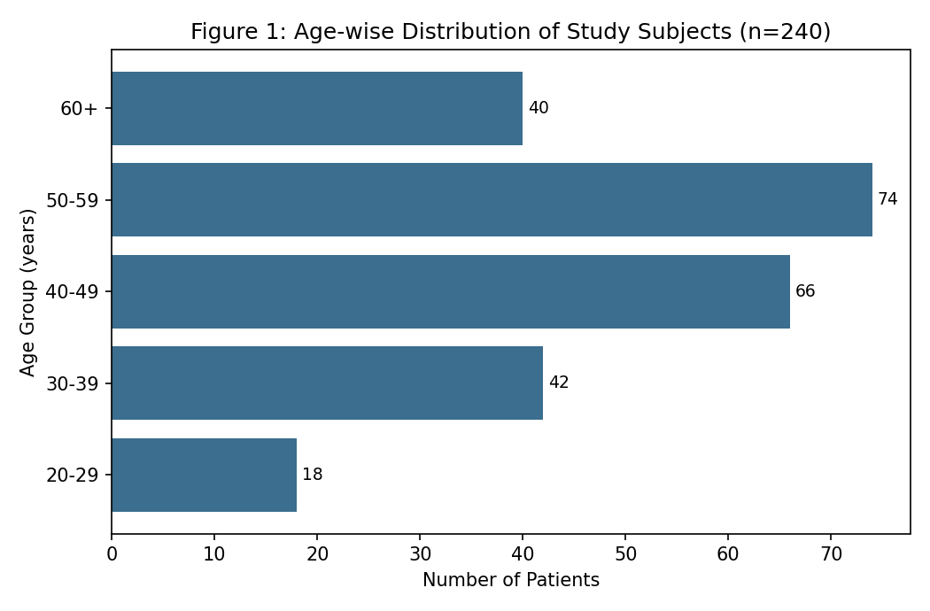
Mean clinical and biochemical parameters are shown in Table 2. Mean TSH was 4.8 ± 3.9 mIU/L across the study population.
Table 2: Clinical and Biochemical Parameters of Study Participants
Parameter | Mean ± SD
Age (years) | 49.8 ± 11.9
Duration of diabetes (years) | 7.3 ± 5.6
Body mass index (kg/m²) | 26.1 ± 4.0
HbA1c (%) | 8.2 ± 1.6
TSH (mIU/L) | 4.8 ± 3.9
Free T4 (ng/dL) | 1.1 ± 0.4

The overall prevalence of thyroid dysfunction was 20.8% (50/240; 95% CI 16.1–26.4) (Table 3, Figure 2).

Table 3: Prevalence of Thyroid Dysfunction Among Study Participants
Thyroid Status | n | Percentage | 95% CI
Thyroid dysfunction present | 50 | 20.8% | 16.1 – 26.4
Euthyroid | 190 | 79.2% | 73.6 – 83.9
Total | 240 | 100.0% | —

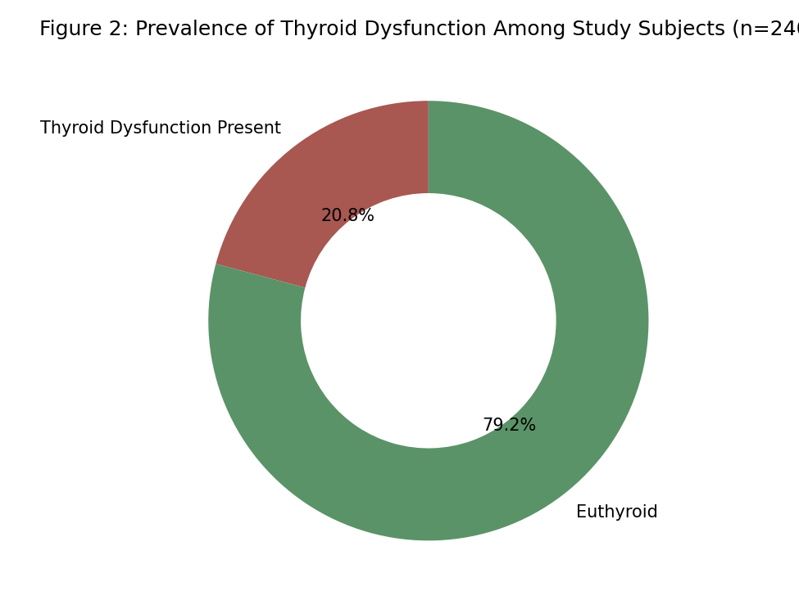
Subclinical hypothyroidism was the most common pattern (48.0% of cases), followed by overt hypothyroidism (32.0%), subclinical hyperthyroidism (12.0%), and overt hyperthyroidism (8.0%) (Table 4, Figure 3).
Table 4: Distribution by Type of Thyroid Dysfunction (n = 50)
Type of Thyroid Dysfunction | n | Percentage of Cases (%)
Subclinical hypothyroidism | 24 | 48.0
Overt hypothyroidism | 16 | 32.0
Subclinical hyperthyroidism | 6 | 12.0
Overt hyperthyroidism | 4 | 8.0
Total | 50 | 100.0

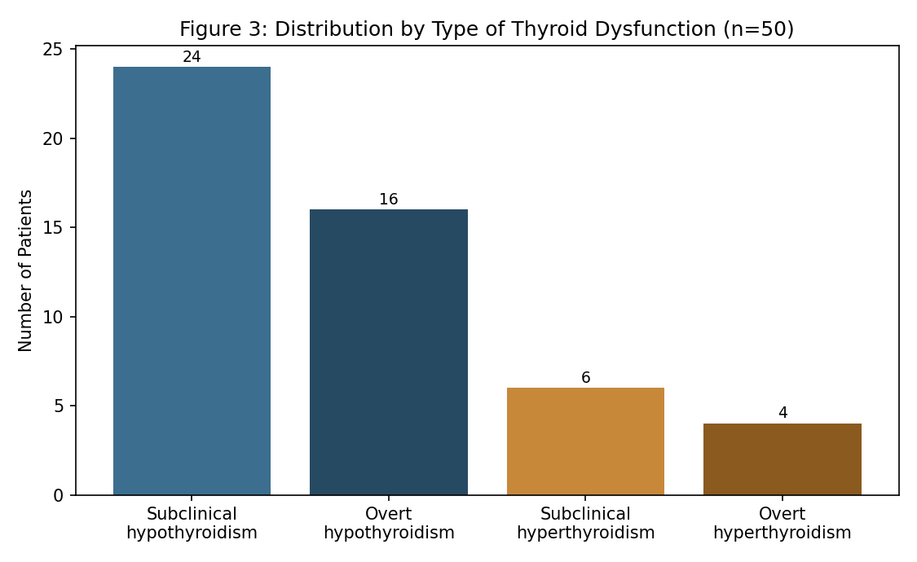
Prevalence of thyroid dysfunction increased progressively with duration of diabetes, from 10.0% in patients with disease duration under 5 years to 35.7% in those with duration exceeding 15 years (Table 5, Figure 4).

Table 5: Prevalence of Thyroid Dysfunction by Duration of Diabetes
Duration of Diabetes (years) | Total (n) | Thyroid Dysfunction, n (%)
<5 | 60 | 6 (10.0)
5–10 | 72 | 13 (18.1)
11–15 | 66 | 16 (24.2)
>15 | 42 | 15 (35.7)
Total | 240 | 50 (20.8)

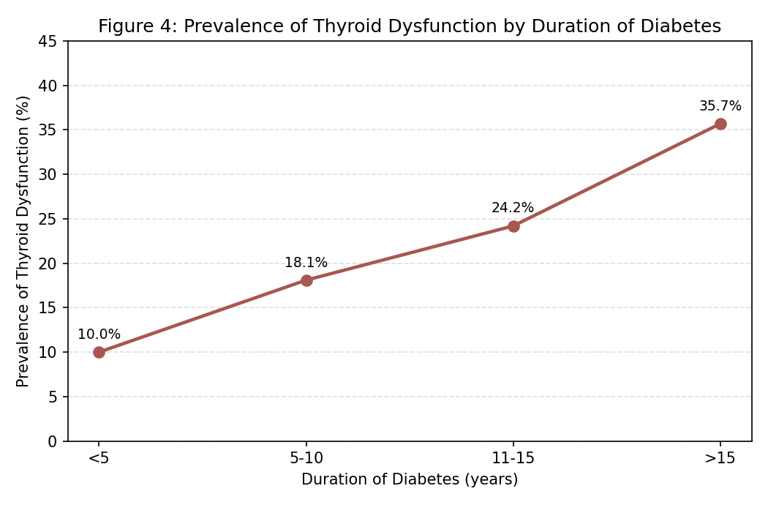
On univariate analysis, diabetes duration exceeding 10 years, HbA1c ≥9%, and family history of thyroid disease were significantly associated with thyroid dysfunction, while sex, age, and BMI showed borderline or non-significant associations (Table 6).
Table 6: Univariate Analysis of Factors Associated with Thyroid Dysfunction
Variable | Category | OR | 95% CI | P-value
Sex | Female vs male | 1.68 | 0.91 – 3.10 | 0.098
Age | ≥50 vs <50 years | 1.79 | 0.98 – 3.27 | 0.058
Duration of diabetes | >10 vs ≤10 years | 2.61 | 1.42 – 4.79 | 0.002
Glycaemic control | HbA1c ≥9% vs <7% | 2.03 | 1.06 – 3.89 | 0.033
Family history of thyroid disease | Present vs absent | 2.94 | 1.44 – 6.00 | 0.003
BMI | ≥25 vs <25 kg/m² | 1.34 | 0.72 – 2.49 | 0.354

On multivariate analysis, family history of thyroid disease (adjusted OR 2.68, 95% CI 1.28–5.61, p=0.009) and diabetes duration exceeding 10 years (adjusted OR 2.19, 95% CI 1.15–4.17, p=0.017) remained independently associated with thyroid dysfunction, while HbA1c ≥9% showed a borderline association after adjustment (Table 7).

Table 7: Multivariate Logistic Regression Analysis of Independent Predictors of Thyroid Dysfunction
Variable | Adjusted OR | 95% CI | P-value
Family history of thyroid disease | 2.68 | 1.28 – 5.61 | 0.009
Diabetes duration >10 years | 2.19 | 1.15 – 4.17 | 0.017
HbA1c ≥9% | 1.87 | 0.96 – 3.65 | 0.066

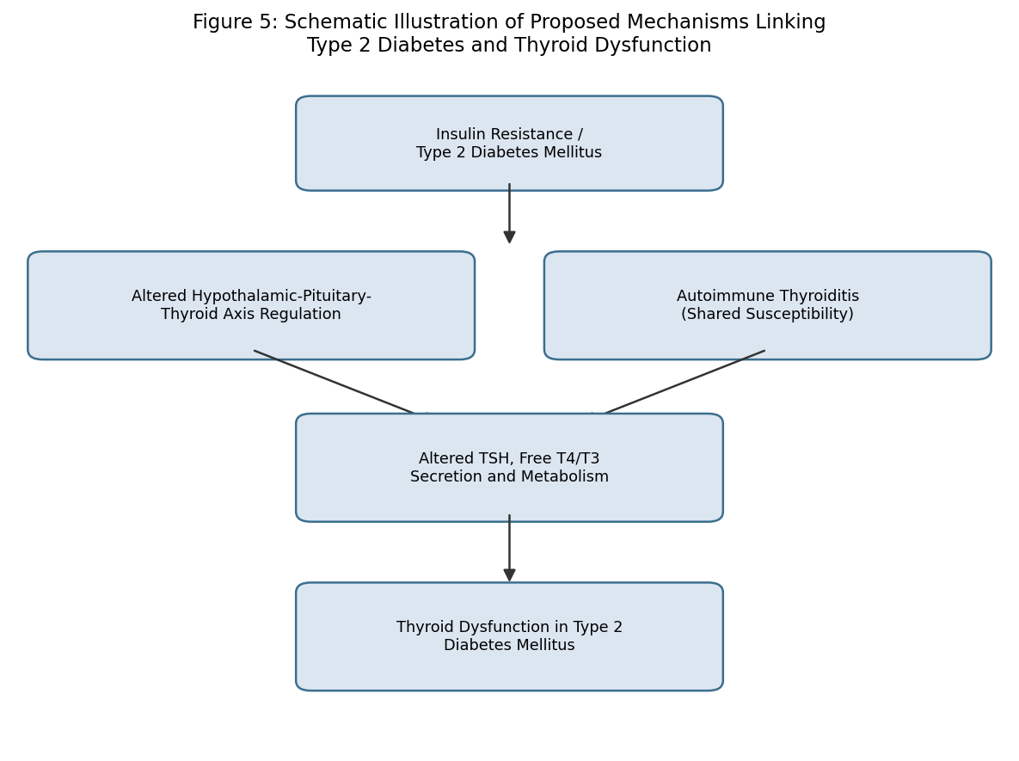
Figure 5: Schematic illustration of proposed mechanisms linking type 2 diabetes and thyroid dysfunction.

Discussion
The prevalence of thyroid dysfunction observed in this study (20.8%) is somewhat higher than, though broadly consistent with, the range reported in earlier screening studies of diabetic populations. Perros and colleagues, in a large screening study of diabetic outpatients, reported a prevalence of 13.4%, while Smithson reported a comparatively lower prevalence in a community-based diabetic population, illustrating the recognised variability in reported prevalence across different diabetic populations and screening protocols.^{1,6} The predominance of subclinical hypothyroidism observed in this study is consistent with the broader thyroid epidemiology literature, including the Whickham survey and its follow-up, both of which identified hypothyroidism, and particularly its subclinical form, as the most common pattern of thyroid dysfunction in the general population, with an even higher relative burden typically observed in diabetic cohorts.^{2,3}
The graded relationship observed between diabetes duration and thyroid dysfunction prevalence in this study is consistent with the concept of cumulative autoimmune and metabolic burden over the course of long-standing diabetes, and parallels findings from the Fremantle Diabetes Study, which similarly documented progression of subclinical hypothyroidism over time in women with type 2 diabetes.¹⁰ The independent association observed between family history of thyroid disease and thyroid dysfunction in this study reinforces the substantial genetic and autoimmune contribution to thyroid disease risk, a relationship well established since the classic description of coexisting autoimmune endocrinopathies by Nerup and Binder.¹³
The borderline independent association observed between poor glycaemic control and thyroid dysfunction after multivariate adjustment is consistent with proposed mechanisms linking insulin resistance and hyperglycaemia to altered hypothalamic-pituitary-thyroid axis regulation, though the modest strength of this association after adjustment for other factors suggests that glycaemic control may play a more modest, or partly mediating, role compared with the stronger independent contributions of family history and disease duration.^{13,14} Taken together, these findings support the recommendation, first articulated by Perros and colleagues and reinforced by subsequent longitudinal data on thyrotropin trajectories, that thyroid function screening should be incorporated as a routine component of diabetes care, particularly in patients with long-standing disease or a family history of thyroid disorders.^{1,12}

Strengths and Limitations
This study's strengths include direct biochemical measurement of both TSH and free T4 in all participants, enabling comprehensive classification of thyroid status, and a sample size adequate to detect clinically meaningful associations. Limitations include the single-centre, hospital-based, cross-sectional design, which limits generalisability and precludes causal inference; the absence of thyroid autoantibody testing, which would have allowed better characterisation of the autoimmune contribution to observed hypothyroidism; and reliance on a single thyroid function measurement, which cannot exclude transient or subsequently resolving abnormalities.

Conclusion
Thyroid dysfunction, predominantly subclinical hypothyroidism, is common among patients with type 2 diabetes mellitus attending this tertiary care hospital, with prevalence increasing significantly with diabetes duration and family history of thyroid disease. These findings support incorporating routine thyroid function screening into standard diabetes care, particularly for patients with long-standing disease or a family history of thyroid disorders.

References
1. Perros P, McCrimmon RJ, Shaw G, Frier BM. Frequency of thyroid dysfunction in diabetic patients: value of annual screening. Diabet Med. 1995;12(7):622-7.
2. Tunbridge WMG, Evered DC, Hall R, Appleton D, Brewis M, Clark F, et al. The spectrum of thyroid disease in a community: the Whickham survey. Clin Endocrinol (Oxf). 1977;7(6):481-93.
3. Vanderpump MP, Tunbridge WM, French JM, Appleton D, Bates D, Clark F, et al. The incidence of thyroid disorders in the community: a twenty-year follow-up of the Whickham Survey. Clin Endocrinol (Oxf). 1995;43(1):55-68.
4. Canaris GJ, Manowitz NR, Mayor G, Ridgway EC. The Colorado thyroid disease prevalence study. Arch Intern Med. 2000;160(4):526-34.
5. Hollowell JG, Staehling NW, Flanders WD, Hannon WH, Gunter EW, Spencer CA, Braverman LE. Serum TSH, T4, and thyroid antibodies in the United States population (1988 to 1994): National Health and Nutrition Examination Survey (NHANES III). J Clin Endocrinol Metab. 2002;87(2):489-99.
6. Smithson MJ. Screening for thyroid dysfunction in a community population of diabetic patients. Diabet Med. 1998;15(2):148-50.
7. Gray RS, Irvine WJ, Clarke BF. Screening for thyroid dysfunction in diabetics. Br Med J. 1979;2(6202):1439.
8. Feely J, Isles TE. Screening for thyroid dysfunction in diabetics. Br Med J. 1979;1(6179):1678.
9. Celani MF, Bonati ME, Stucci N. Prevalence of abnormal thyrotropin concentrations measured by a sensitive assay in patients with type 2 diabetes mellitus. Diabetes Res. 1994;27(1):15-25.
10. Chubb SA, Davis WA, Inman Z, Davis TM. Prevalence and progression of subclinical hypothyroidism in women with type 2 diabetes: the Fremantle Diabetes Study. Clin Endocrinol (Oxf). 2005;62(4):480-6.
11. Radaideh AR, Nusier MK, Amari FL, Bateiha AE, El-Khateeb MS, Naser AS, Ajlouni KM. Thyroid dysfunction in patients with type 2 diabetes mellitus in Jordan. Saudi Med J. 2004;25(8):1046-50.
12. Warren RE, Perros P, Nyirenda MJ, Frier BM. Serum thyrotropin is a better predictor of future thyroid dysfunction than thyroid autoantibody status in biochemically euthyroid patients with diabetes: implications for screening. Thyroid. 2004;14(10):853-7.
13. Nerup J, Binder C. Thyroid, gastric and adrenal auto-immunity in diabetes mellitus. Acta Endocrinol (Copenh). 1973;72(2):279-86.
14. Bilous RW, Tunbridge WMG. The epidemiology of hypothyroidism--an update. Bailliere's Clin Endocrinol Metab. 1988;2(3):531-40.
15. Mouradian M, Abourizk N. Diabetes mellitus and thyroid disease. Diabetes Care. 1983;6(5):512-20.
16. Wild S, Roglic G, Green A, Sicree R, King H. Global prevalence of diabetes: estimates for the year 2000 and projections for 2030. Diabetes Care. 2004;27(5):1047-53.
17. UK Prospective Diabetes Study (UKPDS) Group. Intensive blood-glucose control with sulphonylureas or insulin compared with conventional treatment in patients with type 2 diabetes (UKPDS 33). Lancet. 1998;352(9131):837-53.
18. Parle JV, Franklyn JA, Cross KW, Jones SC, Sheppard MC. Prevalence and follow up of abnormal thyrotropin (TSH) concentrations in the elderly in the United Kingdom. Clin Endocrinol (Oxf). 1991;34(1):77-83.
19. Fisher DA. Effectiveness of newborn screening programs for congenital hypothyroidism: prevalence of missed cases. Pediatr Clin North Am. 1987;34(4):881-90.
20. Rae P, Farrar J, Beckett G, Toft A. Assessment of thyroid status in elderly people. BMJ. 1993;307(6897):177-80.

