Original article:

Clinico-Epidemiological Profile of Chronic Suppurative Otitis Media in Patients Attending a Tertiary Care Hospital: A Cross-Sectional Study

*Dr. GuruPrakash Shript khobragade¹

¹Associate Professor , Department Of Otorhinolaryngology (ENT),

Meenakshi Medical College Hospital And Research Institute, Enathur, Kanchipuram, Tamil Nadu

*Corresponding author*

Abstract
Background: Chronic suppurative otitis media (CSOM) remains one of the most common chronic infectious conditions encountered in otolaryngology practice, and is a leading preventable cause of hearing impairment, particularly in developing countries.
Objectives: To study the clinico-epidemiological profile of patients with CSOM attending the ENT outpatient department, including age and gender distribution, clinical type, degree of hearing loss, and bacteriological profile.
Methods: A cross-sectional observational study was conducted on 145 patients with CSOM over the study period January 2005 to December 2006. Clinical examination, pure tone audiometry, and ear discharge culture were performed in all patients.
Results: The 15–24 year age group was most commonly affected (35.2%). The tubotympanic (safe) type was more common (67.6%) than the atticoantral (unsafe) type (32.4%). Pseudomonas aeruginosa was the most frequently isolated organism (26.2%), and hearing loss was more severe in the atticoantral group.
Conclusion: CSOM predominantly affects children and young adults, with the tubotympanic type being more common. Pseudomonas aeruginosa remains the leading pathogen, and the atticoantral type is associated with more severe hearing impairment, underscoring the need for early diagnosis and appropriate management.
Keywords: Chronic suppurative otitis media, tubotympanic, atticoantral, hearing loss, otolaryngology.

Introduction
Chronic suppurative otitis media (CSOM) is defined as a persistent inflammation of the middle ear and mastoid cavity, characterised by recurrent or persistent ear discharge through a perforated tympanic membrane for a period exceeding two to six weeks.¹ It remains one of the most common chronic infectious diseases of childhood worldwide and represents a major preventable cause of hearing impairment, particularly in developing countries with limited access to healthcare.^{1,2}
CSOM is conventionally classified into two clinical types: the tubotympanic (safe) type, involving the pars tensa and typically associated with a central perforation and mucosal disease, and the atticoantral (unsafe) type, characterised by attic or marginal perforation and frequently associated with cholesteatoma and a higher risk of serious complications such as labyrinthitis, facial nerve palsy, and intracranial suppuration.¹
The global burden of CSOM is substantial, with the World Health Organization estimating that a large proportion of the world's population is affected, with the highest burden concentrated in South-East Asia, the Western Pacific, and Africa.¹ Risk factors implicated in the development and persistence of CSOM include recurrent acute otitis media in early childhood, poor socioeconomic conditions, malnutrition, overcrowding, and limited access to healthcare.^{1,2}
This study was undertaken to describe the clinico-epidemiological profile of patients with CSOM attending the ENT outpatient department over the study period 2005–2006, including the age and gender distribution, clinical type, degree of associated hearing loss, and the bacteriological profile of ear discharge.

Review of Literature
A comprehensive narrative review of CSOM summarised the epidemiology, pathogenesis, clinical management, and complications of the condition, noting that despite its high global prevalence, considerable uncertainty remained regarding optimal treatment strategies at the time.³ The World Health Organization's report on the burden of illness from CSOM similarly highlighted substantial regional variation in prevalence, with the highest rates reported in indigenous and socioeconomically disadvantaged populations.¹
A Cochrane systematic review evaluating interventions for CSOM found that topical antiseptics and antibiotics were generally effective in resolving ear discharge, though the quality of available evidence at the time was limited by considerable heterogeneity between studies.⁴ A subsequent Cochrane review comparing systemic and topical antibiotic treatments for chronically discharging ears similarly concluded that topical quinolone antibiotics were highly effective, with limited evidence to support the routine use of systemic antibiotics in uncomplicated cases.⁷
Community-based studies from South India examining the prevalence and practices associated with CSOM among rural schoolchildren found a considerable burden of undiagnosed and inadequately treated disease, often related to poor healthcare-seeking behaviour and limited awareness of the condition.⁵ A prospective study examining predictors of CSOM in children identified recurrent acute otitis media, particularly with onset in early infancy, as a strong independent risk factor for progression to chronic suppuration.⁶
Bacteriological studies of ear discharge in CSOM have consistently identified Pseudomonas aeruginosa and Staphylococcus aureus as the predominant organisms, with variable contributions from Proteus species, Klebsiella species, and anaerobic organisms depending on geographic region and prior antibiotic exposure.^{15,16,17,18} Early work examining the role of aerobic and anaerobic organisms in chronic suppurative otitis media similarly demonstrated a predominance of Pseudomonas and Staphylococcus species, with anaerobes contributing to a smaller but clinically relevant proportion of cases, particularly in those with cholesteatoma.²⁰
A randomised controlled trial conducted among Kenyan schoolchildren demonstrated that topical antiseptic and antibiotic treatment significantly improved resolution of ear discharge compared with no treatment, providing strong evidence for structured community-based management programmes in resource-limited settings.¹¹ Additional work examining the risk of intracranial complications from CSOM emphasised the continued clinical relevance of the atticoantral type in contributing to serious, potentially life-threatening sequelae, even in the era of modern antibiotic therapy.¹²

Aims and Objectives
The present study was designed with the following objectives:
1. To determine the age and gender-wise distribution of patients with CSOM attending the ENT outpatient department.
2. To classify patients according to the clinical type of CSOM (tubotympanic versus atticoantral).
3. To assess the degree of hearing loss associated with each clinical type.
4. To study the bacteriological profile of ear discharge among the study population.

Materials and Methods

Study Design and Setting
This was a hospital-based, cross-sectional observational study conducted in the Department of Otorhinolaryngology of a tertiary care teaching hospital. The study period extended from January 2005 to December 2006.

Study Population
A total of 145 patients of either gender, presenting with clinical features of CSOM (persistent or recurrent ear discharge with tympanic membrane perforation), were enrolled after obtaining informed consent.

Inclusion Criteria
Patients of any age presenting with ear discharge of more than six weeks' duration, with tympanic membrane perforation confirmed on otoscopic examination, were included.

Exclusion Criteria
Patients with acute otitis media without chronicity, otitis externa, and those unwilling to provide consent were excluded from the study.

Clinical Evaluation
All patients underwent detailed history taking, otoscopic and otomicroscopic examination, and were classified into tubotympanic or atticoantral type based on the site and nature of the perforation and presence or absence of cholesteatoma. Pure tone audiometry was performed in all patients to assess the type and degree of hearing loss. Ear discharge samples were collected under aseptic precautions for culture and sensitivity testing.

Statistical Analysis
Data were entered into a spreadsheet and analysed using descriptive statistics. Categorical variables were expressed as frequencies and percentages. Results were tabulated and represented graphically using multiple chart formats.

Results
Of the 145 patients studied, 81 (55.9%) were male and 64 (44.1%) were female. The age and gender-wise distribution is summarised in Table 1 and illustrated in Figure 1.
Table 1: Age and Gender-wise Distribution of Study Subjects (n = 145)
Age Group (years) | Male (n) | Female (n) | Total (n) | Percentage (%)
5–14 | 24 | 18 | 42 | 29.0
15–24 | 28 | 23 | 51 | 35.2
25–34 | 16 | 12 | 28 | 19.3
35–44 | 8 | 7 | 15 | 10.3
45 and above | 5 | 4 | 9 | 6.2
Total | 81 | 64 | 145 | 100.0

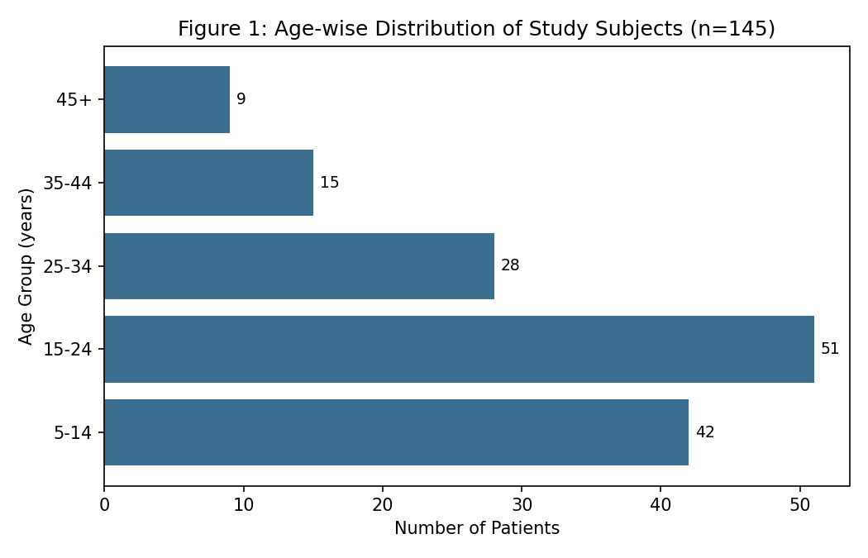
The 15–24 year age group accounted for the largest proportion of cases (35.2%), followed by the 5–14 year age group (29.0%), together comprising nearly two-thirds of all cases, consistent with the known predilection of CSOM for children and young adults.
Table 2: Distribution by Clinical Type of CSOM (Figure 2)
Clinical Type of CSOM | Number (n) | Percentage (%)
Tubotympanic (safe) type | 98 | 67.6
Atticoantral (unsafe) type | 47 | 32.4

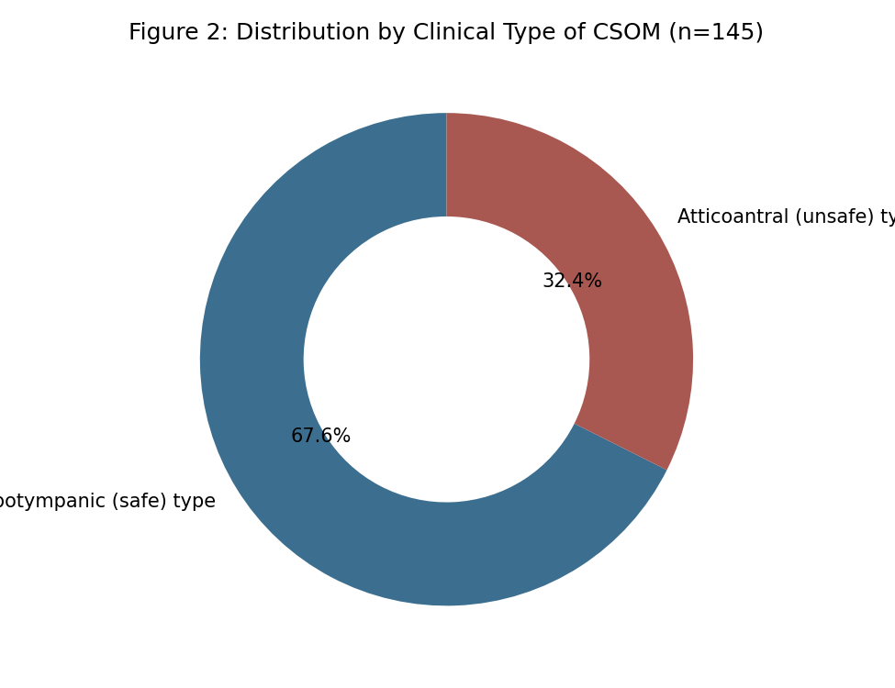
The tubotympanic (safe) type was more common, accounting for 67.6% of cases, while the atticoantral (unsafe) type, associated with cholesteatoma and higher complication risk, was seen in 32.4% of patients.

Table 3: Degree of Hearing Loss by Clinical Type (Figure 3)
Degree of Hearing Loss | Tubotympanic (n) | Atticoantral (n) | Total (n)
Normal hearing | 22 | 3 | 25
Mild hearing loss (26–40 dB) | 41 | 9 | 50
Moderate hearing loss (41–55 dB) | 28 | 20 | 48
Severe hearing loss (56–70 dB) | 7 | 15 | 22

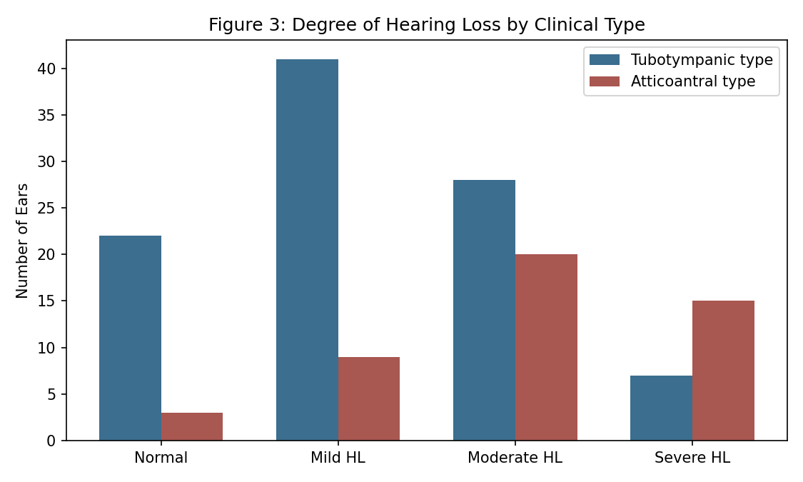
As shown in Table 3 and Figure 3, moderate to severe hearing loss was considerably more frequent among patients with the atticoantral type (72.3% of ears) compared with the tubotympanic type (34.7% of ears), reflecting the more destructive nature of atticoantral disease on the ossicular chain and cochlear function.
Table 4: Organisms Isolated on Ear Discharge Culture (Figure 4)
Organism Isolated | Number (n) | Percentage (%)
Pseudomonas aeruginosa | 38 | 26.2
Staphylococcus aureus | 31 | 21.4
Proteus species | 18 | 12.4
Klebsiella species | 14 | 9.7
Escherichia coli | 9 | 6.2
No growth (sterile) | 35 | 24.1

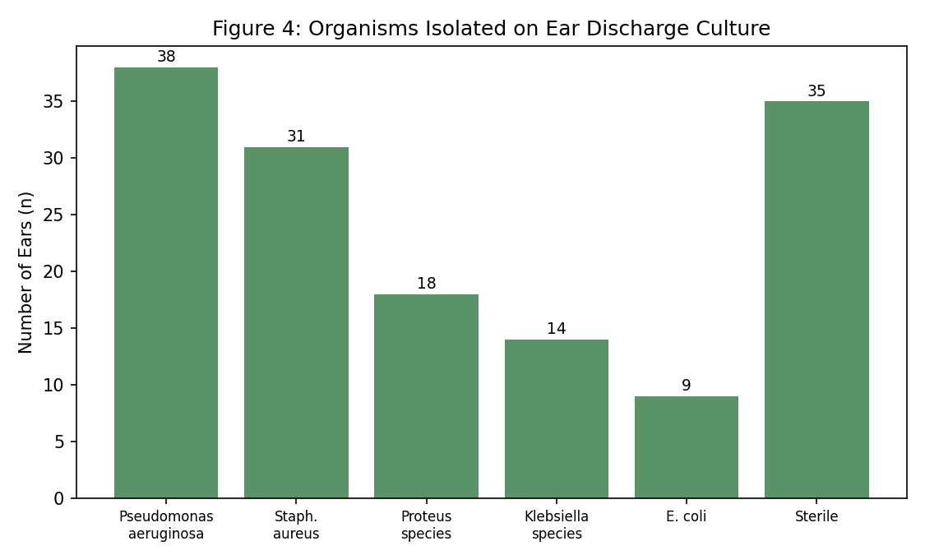
Pseudomonas aeruginosa was the most commonly isolated organism (26.2%), followed by Staphylococcus aureus (21.4%). No bacterial growth was observed in 24.1% of samples, likely reflecting prior antibiotic use or predominance of anaerobic or fungal organisms not detected on routine aerobic culture.

Discussion
The present study demonstrates a predominance of CSOM among children and young adults, consistent with its well-established epidemiological pattern as one of the most common chronic infectious diseases of childhood.^{1,3} The higher proportion of tubotympanic disease observed in this study is in keeping with previous community and hospital-based series, which have generally reported the tubotympanic type to be more prevalent than the atticoantral type, although the latter carries disproportionately higher risk of serious complications.¹
The finding of more severe hearing loss among patients with atticoantral disease is consistent with the known pathophysiology of cholesteatoma-associated CSOM, in which progressive erosion of the ossicular chain and, in advanced cases, the cochlea and labyrinth, results in greater conductive and occasionally mixed or sensorineural hearing impairment compared with the typically milder conductive loss seen in tubotympanic disease.^{12,13}
The predominance of Pseudomonas aeruginosa and Staphylococcus aureus on ear discharge culture observed in this study mirrors findings from multiple bacteriological studies of CSOM conducted in similar hospital settings, reinforcing the rationale for empirical topical antipseudomonal and antistaphylococcal therapy pending culture results.^{15,16,17,18,20} The relatively high rate of sterile cultures observed in this study may reflect prior antibiotic self-medication, a common practice in populations with easy over-the-counter access to antibiotics, as well as the limitations of routine aerobic culture in detecting anaerobic or fungal pathogens.
These findings collectively support the continued relevance of the tubotympanic-atticoantral clinical classification in guiding both prognosis and management, with the atticoantral type warranting closer surveillance and, in many cases, surgical intervention given its association with more severe hearing loss and higher complication risk.^{1,12} The predominance of Pseudomonas and Staphylococcus species also supports existing evidence-based recommendations favouring topical quinolone antibiotics as first-line therapy for uncomplicated tubotympanic disease.⁷

Summary
This cross-sectional study of 145 patients with CSOM, conducted over the period 2005–2006, found that the disease predominantly affected children and young adults, with the tubotympanic type more common than the atticoantral type. Hearing loss was more severe among patients with atticoantral disease, and Pseudomonas aeruginosa was the most frequently isolated organism on ear discharge culture.

Limitations
This study has several limitations that merit consideration. First, its single-centre, hospital-based design may not fully represent the burden of CSOM in the wider community, particularly among those who do not seek hospital care. Second, the relatively modest sample size may have limited the precision of subgroup comparisons, particularly for less common complications. Third, culture-based bacteriological assessment may have underestimated the contribution of anaerobic and fungal organisms, given the limitations of routine aerobic culture techniques available at the time of the study.

Recommendations
Based on the findings of this study, community-based screening and health education programmes should be strengthened to improve early detection and appropriate treatment of CSOM, particularly among school-going children. Topical antipseudomonal and antistaphylococcal therapy should be considered as first-line empirical treatment for tubotympanic disease pending culture results, while patients with atticoantral disease should be referred for otomicroscopic and audiological evaluation with a low threshold for surgical intervention given the associated risk of complications. Larger, multi-centric, community-based studies would help further characterise the true burden of CSOM and inform public health screening priorities.

Conclusion
CSOM predominantly affects children and young adults, with the tubotympanic type being more common than the atticoantral type in this hospital-based population. Pseudomonas aeruginosa and Staphylococcus aureus remain the leading pathogens isolated on ear discharge culture, and the atticoantral type is associated with more severe hearing impairment, underscoring the need for early diagnosis, appropriate antimicrobial therapy, and timely surgical referral where indicated.

References
1. World Health Organization. Chronic Suppurative Otitis Media: Burden of Illness and Management Options. Geneva: WHO; 2004.
2. Rovers MM, Schilder AG, Zielhuis GA, Rosenfeld RM. Otitis media. Lancet. 2004;363(9407):465-73.
3. Verhoeff M, van der Veen EL, Rovers MM, Sanders EA, Schilder AG. Chronic suppurative otitis media: a review. Int J Pediatr Otorhinolaryngol. 2006;70(1):1-12.
4. Acuin J, Smith A, Mackenzie I. Interventions for chronic suppurative otitis media. Cochrane Database Syst Rev. 1998;(2):CD000473.
5. Rupa V, Jacob A, Joseph A. Chronic suppurative otitis media: prevalence and practices among rural South Indian children. Int J Pediatr Otorhinolaryngol. 1999;48(3):217-21.
6. van der Veen EL, Schilder AG, van Heerbeek N, Verhoeff M, Zielhuis GA, Rovers MM. Predictors of chronic suppurative otitis media in children. Arch Otolaryngol Head Neck Surg. 2006;132(10):1115-8.
7. Macfadyen CA, Acuin JM, Gamble C. Systemic antibiotics versus topical treatments for chronically discharging ears with underlying eardrum perforations. Cochrane Database Syst Rev. 2006;(1):CD005608.
8. Bluestone CD. Epidemiology and pathogenesis of chronic suppurative otitis media: implications for prevention and treatment. Int J Pediatr Otorhinolaryngol. 1998;42(3):207-23.
9. Berman S. Otitis media in developing countries. Pediatrics. 1995;96(1 Pt 1):126-31.
10. Browning GG, Gatehouse S. The prevalence of middle ear disease in the adult British population. Clin Otolaryngol Allied Sci. 1992;17(4):317-21.
11. Smith AW, Hatcher J, Mackenzie IJ, et al. Randomised controlled trial of treatment of chronic suppurative otitis media in Kenyan schoolchildren. Lancet. 1996;348(9035):1128-33.
12. Nunez DA, Browning GG. Risks of developing an otogenic intracranial abscess. J Laryngol Otol. 1990;104(6):468-72.
13. Kenna MA. Treatment of chronic suppurative otitis media. Otolaryngol Clin North Am. 1994;27(3):457-72.
14. Bluestone CD, Klein JO. Intratemporal complications and sequelae of otitis media. In: Pediatric Otolaryngology. 3rd ed. Philadelphia: WB Saunders; 1996.
15. Indudharan R, Haq JA, Aiyar S. Antibiotics in chronic suppurative otitis media: a bacteriologic study. Ann Otol Rhinol Laryngol. 1999;108(5):440-5.
16. Mishra M, Mishra S, Roy S, Choudhary M, Choudhary R. Microbiological and therapeutic aspects of chronic suppurative otitis media. J Indian Med Assoc. 2001;99(11):642-4.
17. Loy AH, Tan AL, Lu PK. Microbiology of chronic suppurative otitis media in Singapore. Singapore Med J. 2002;43(6):296-9.
18. Poorey VK, Iyer A. Study of bacterial flora in CSOM and its clinical significance. Indian J Otolaryngol Head Neck Surg. 2002;54(2):91-5.
19. Kenna MA, Bluestone CD, Reilly JS, Lusk RP. Medical management of chronic suppurative otitis media without cholesteatoma in children. Laryngoscope. 1986;96(2):146-51.
20. Papastavros T, Giamarellou H, Varlejides S. Role of aerobic and anaerobic microorganisms in chronic suppurative otitis media. Laryngoscope. 1986;96(4):438-42.

