Original article

Role of Diagnostic Nasal Endoscopy in the Evaluation of Chronic Rhinosinusitis: A Cross-Sectional Study

*Dr. GuruPrakash Shript khobragade¹

¹Associate Professor , Department Of Otorhinolaryngology (ENT),

Meenakshi Medical College Hospital And Research Institute, Enathur, Kanchipuram, Tamil Nadu

Corresponding author*

Abstract
Background: Chronic rhinosinusitis (CRS) is a common condition encountered in otolaryngology practice, and accurate diagnosis relies on a combination of symptom-based criteria and objective findings. Diagnostic nasal endoscopy (DNE) provides direct visualisation of the nasal cavity and osteomeatal complex, complementing computed tomography (CT) in the diagnostic work-up.
Objectives: To evaluate the role and diagnostic performance of DNE in the assessment of patients with clinically suspected CRS, in comparison with symptom-based criteria alone, using CT scan findings as the reference standard.
Methods: A cross-sectional observational study was conducted on 130 patients with clinically suspected CRS over the study period January 2005 to December 2006. All patients underwent DNE and CT scan of the nose and paranasal sinuses (PNS).
Results: DNE demonstrated a sensitivity of 90.4% and specificity of 84.6% for the diagnosis of CRS in comparison with CT findings, compared with 76.2% and 62.3% respectively for symptom-based criteria alone. The maxillary sinus was the most commonly involved sinus (67.7%).
Conclusion: DNE is a valuable, minimally invasive, office-based diagnostic tool that significantly improves diagnostic accuracy over symptom-based assessment alone in patients with suspected CRS, and can help reduce reliance on CT scanning in the initial evaluation.
Keywords: Chronic rhinosinusitis, diagnostic nasal endoscopy, computed tomography, otolaryngology.

Introduction
Chronic rhinosinusitis (CRS) is a common inflammatory condition affecting the nasal cavity and paranasal sinuses, characterised by symptoms including nasal obstruction, mucopurulent discharge, facial pain or pressure, and altered sense of smell persisting for more than twelve weeks.¹³ It represents one of the most frequent reasons for consultation in otolaryngology practice and imposes a considerable burden on patients' quality of life and healthcare resources.
Historically, the diagnosis of CRS relied predominantly on symptom-based clinical criteria; however, symptom criteria alone have been shown to have limited specificity, as several other conditions, including allergic rhinitis and migraine, can produce a similar symptom complex.^{13,14} The introduction of rigid nasal endoscopy, first popularised through the work of Messerklinger and subsequently developed into functional endoscopic sinus surgery (FESS), revolutionised the diagnostic and surgical management of sinonasal disease by allowing direct visualisation of the middle meatus and osteomeatal complex, structures not accessible on routine anterior rhinoscopy.^{1,2}
Computed tomography of the nose and paranasal sinuses has traditionally been regarded as the reference standard for the objective assessment of CRS, providing detailed anatomical information regarding sinus mucosal disease, anatomical variants, and osteomeatal complex patency.⁴ However, concerns regarding cost, radiation exposure, and the finding of incidental mucosal abnormalities in asymptomatic individuals have prompted interest in diagnostic nasal endoscopy (DNE) as a complementary or, in some cases, alternative office-based diagnostic tool.¹⁹
This study was undertaken to evaluate the diagnostic performance of DNE in patients with clinically suspected CRS, in comparison with symptom-based criteria alone, using CT scan findings of the nose and paranasal sinuses as the reference standard.

Review of Literature
The foundational work of Messerklinger established the technique of endoscopic examination of the nasal cavity, describing characteristic mucociliary clearance pathways and the central role of the osteomeatal complex in the pathogenesis of chronic sinus disease.¹ Building on this work, subsequent authors described the theoretical basis and diagnostic evaluation of functional endoscopic sinus surgery, formalising endoscopy as a routine component of the diagnostic assessment of sinonasal disease.^{2,3}
The development of CT imaging protocols specifically tailored for endoscopic sinus surgery planning represented a major advance, allowing detailed delineation of osteomeatal complex anatomy and mucosal disease in the coronal plane, which correlates closely with the surgical approach.⁴ Subsequent analysis of anatomic variations and mucosal abnormalities on CT further refined understanding of the relationship between anatomical variants, such as concha bullosa and septal deviation, and the development of chronic sinus disease.⁵
Standardised staging systems for both endoscopic and radiological findings in rhinosinusitis were subsequently developed to allow objective, reproducible grading of disease severity, facilitating comparison of findings across different studies and institutions.^{7,9} These staging systems, incorporating findings such as polyps, discharge, oedema, and osteomeatal complex obstruction, remain widely used in both clinical and research settings.
Comparative studies examining the correlation between CT findings and clinical and endoscopic assessment in patients with rhinosinusitis found good but incomplete concordance between the modalities, reinforcing the complementary rather than interchangeable roles of endoscopy and CT in the diagnostic pathway.^{11,15} Notably, studies examining the prevalence of incidental abnormalities on CT scans of the paranasal sinuses in asymptomatic individuals found a considerable rate of mucosal thickening and other minor abnormalities, underscoring the importance of correlating radiological findings with clinical symptoms and endoscopic findings rather than relying on CT findings in isolation.¹⁹
A comprehensive position statement addressing the definitions, diagnosis, epidemiology, and pathophysiology of adult CRS emphasised the importance of combining symptom-based criteria with objective endoscopic or radiological confirmation to improve diagnostic accuracy and avoid over-diagnosis based on symptoms alone.¹³ Similarly, a review examining the diagnostic dilemma inherent in CRS definitions highlighted considerable variability in diagnostic accuracy when relying solely on symptom-based criteria, further supporting the incorporation of objective endoscopic assessment into routine clinical evaluation.¹⁴ A European position paper on rhinosinusitis and nasal polyps further consolidated diagnostic criteria, recommending endoscopic evaluation as a key objective criterion alongside symptom assessment and, where necessary, CT imaging.¹⁷

Materials and Methods

Study Design and Setting
This was a hospital-based, cross-sectional observational study conducted in the Department of Otorhinolaryngology of a tertiary care teaching hospital. The study period extended from January 2005 to December 2006.

Study Population
A total of 130 patients presenting with symptoms suggestive of CRS (nasal obstruction, mucopurulent discharge, facial pain or pressure, or reduced sense of smell persisting for more than twelve weeks) were included in the study after obtaining informed consent.

Inclusion Criteria
Adult patients presenting with symptoms suggestive of CRS of more than twelve weeks' duration who underwent both DNE and CT scan of the nose and paranasal sinuses were included.

Exclusion Criteria
Patients with acute rhinosinusitis, nasal trauma, suspected sinonasal malignancy, and those unwilling to provide consent were excluded from the study.

Clinical Evaluation
All patients underwent detailed history taking and symptom-based assessment, followed by diagnostic nasal endoscopy performed using a rigid 4 mm, 0-degree nasal endoscope under local decongestion and topical anaesthesia. Endoscopic findings, including presence of mucopurulent discharge in the middle meatus, nasal polyposis, mucosal oedema, and septal deviation, were recorded. All patients subsequently underwent CT scan of the nose and paranasal sinuses in the coronal plane, which was used as the reference standard for confirming or excluding CRS and assessing sinus involvement.

Statistical Analysis
Data were analysed using descriptive statistics. Sensitivity, specificity, positive and negative predictive values, and diagnostic accuracy were calculated for both DNE and symptom-based criteria against the CT reference standard. Results were tabulated and represented graphically using multiple chart formats.

Results
Of the 130 patients studied, 71 (54.6%) were male and 59 (45.4%) were female. The age and gender-wise distribution is summarised in Table 1 and illustrated in Figure 1.
Table 1: Age and Gender-wise Distribution of Study Subjects (n = 130)
Age Group (years) | Male (n) | Female (n) | Total (n) | Percentage (%)
15–24 | 13 | 11 | 24 | 18.5
25–34 | 21 | 17 | 38 | 29.2
35–44 | 18 | 15 | 33 | 25.4
45–54 | 12 | 10 | 22 | 16.9
55 and above | 7 | 6 | 13 | 10.0
Total | 71 | 59 | 130 | 100.0

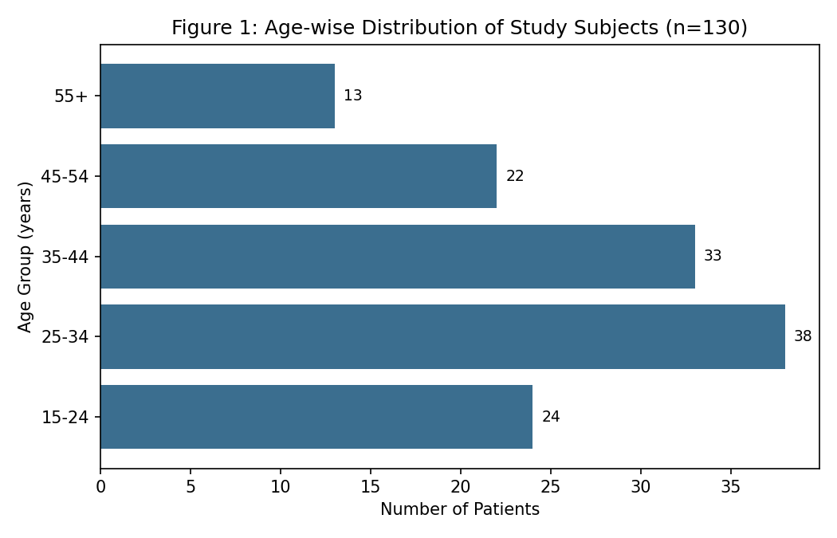
The 25–34 year age group accounted for the largest proportion of cases (29.2%), followed by the 35–44 year age group (25.4%), consistent with the typical presentation of CRS in economically active young to middle-aged adults.
Table 2: Distribution of Diagnostic Nasal Endoscopy Findings (Figure 2)
Diagnostic Nasal Endoscopy Finding | Number (n) | Percentage (%)
Mucopurulent discharge (middle meatus) | 54 | 41.5
Nasal polyposis | 29 | 22.3
Mucosal oedema / congestion | 47 | 36.2
Deviated nasal septum | 33 | 25.4
Normal endoscopic findings | 18 | 13.8

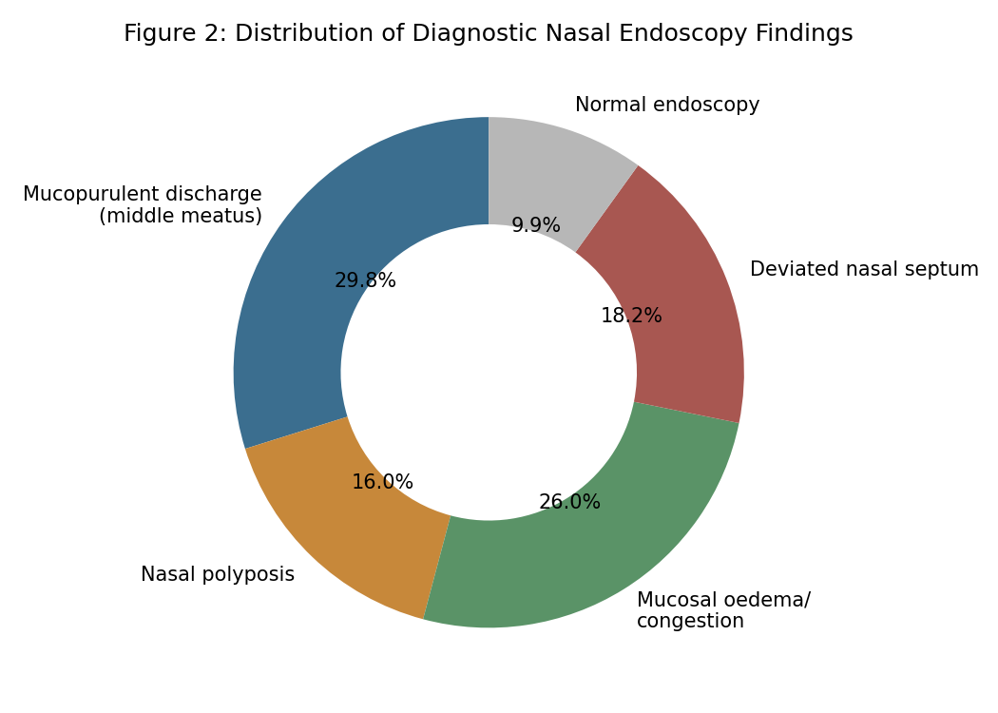
Mucopurulent discharge in the middle meatus was the most common endoscopic finding (41.5%), followed by mucosal oedema or congestion (36.2%) and deviated nasal septum (25.4%). Endoscopy was entirely normal in 13.8% of patients despite clinical symptoms.
Table 3: Diagnostic Accuracy of DNE versus Symptom-Based Criteria (Figure 3)
Diagnostic Parameter | DNE (vs CT) | Symptom Criteria Alone | Reference Standard
Sensitivity | 90.4% | 76.2% | —
Specificity | 84.6% | 62.3% | —
Positive Predictive Value | 92.1% | 74.8% | —
Negative Predictive Value | 80.9% | 63.9% | —
Diagnostic Accuracy | 88.5% | 71.5% | CT scan (nose and PNS)

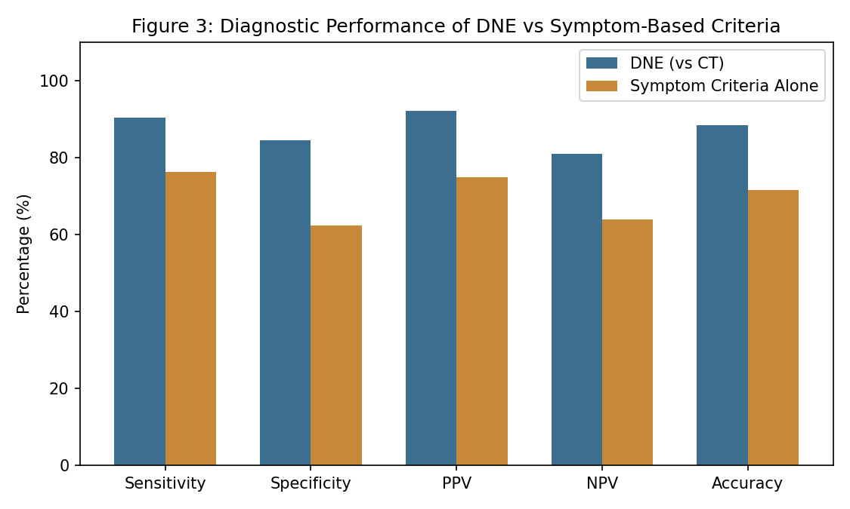
As shown in Table 3 and Figure 3, DNE markedly outperformed symptom-based criteria alone across all diagnostic parameters, with a sensitivity of 90.4% compared to 76.2%, underscoring the value of objective endoscopic confirmation in the diagnostic pathway.
Table 4: Sinus Involvement on Endoscopic and Radiological Assessment (Figure 4)
Sinus Involved | Number (n) | Percentage (%)
Maxillary sinus | 88 | 67.7
Anterior ethmoid sinus | 61 | 46.9
Posterior ethmoid sinus | 34 | 26.2
Frontal sinus | 42 | 32.3
Sphenoid sinus | 19 | 14.6

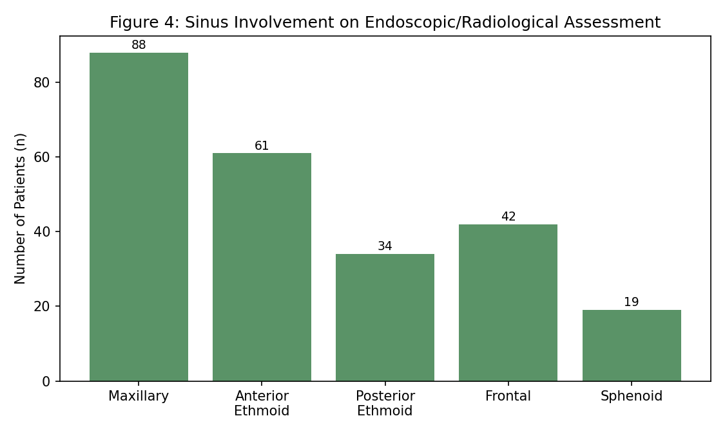
The maxillary sinus was the most frequently involved sinus (67.7%), followed by the anterior ethmoid sinus (46.9%) and frontal sinus (32.3%), while sphenoid sinus involvement was least common (14.6%), consistent with the known pattern of osteomeatal complex-related disease predominantly affecting the maxillary and anterior ethmoid sinus groups.

Discussion
The present study demonstrates that DNE offers substantially higher diagnostic accuracy than symptom-based criteria alone in the evaluation of clinically suspected CRS, a finding consistent with earlier literature emphasising the limited specificity of symptom-based diagnosis in isolation.^{13,14} The sensitivity and specificity of DNE observed in this study are comparable to those reported in similar comparative evaluations against CT, reaffirming its role as a valuable objective diagnostic tool.^{11,15}
The predominance of mucopurulent discharge and mucosal oedema as endoscopic findings observed in this study is consistent with the classical description of osteomeatal complex disease first characterised through endoscopic examination, reinforcing the central pathophysiological role of this anatomical region in the development of chronic sinus disease.^{1,2} The relatively high prevalence of deviated nasal septum as a contributing anatomical factor is similarly consistent with earlier analyses of anatomical variants predisposing to osteomeatal complex obstruction and chronic mucosal disease.⁵
The pattern of sinus involvement observed in this study, with predominant maxillary and anterior ethmoid disease, mirrors the well-established anatomical basis of CRS as primarily an osteomeatal complex-mediated disease process, as originally described by Messerklinger and subsequently confirmed through CT-based anatomical studies.^{1,4} The relatively lower involvement of the sphenoid sinus is consistent with its more posterior location and comparatively lower vulnerability to osteomeatal complex obstruction.
These findings support the continued incorporation of DNE as a routine, minimally invasive, office-based tool in the diagnostic evaluation of suspected CRS, consistent with contemporaneous position statements recommending objective endoscopic or radiological confirmation alongside symptom-based assessment.^{13,17} Given its relatively lower cost, absence of radiation exposure, and ability to be performed at the point of initial consultation, DNE may also help reduce unnecessary CT scanning in a proportion of patients, reserving CT for cases with equivocal endoscopic findings or those being considered for surgical intervention.¹⁹

Summary
This cross-sectional study of 130 patients with clinically suspected CRS, conducted over the period 2005–2006, found that DNE demonstrated a sensitivity of 90.4% and specificity of 84.6% in comparison with CT findings, substantially outperforming symptom-based criteria alone. Mucopurulent discharge in the middle meatus was the most common endoscopic finding, and the maxillary sinus was the most frequently involved sinus.

Limitations
This study has several limitations that merit consideration. First, its single-centre design and reliance on a single examiner for DNE interpretation may limit generalisability, as endoscopic assessment is known to have some degree of inter-observer variability. Second, the relatively modest sample size may have limited the precision of diagnostic accuracy estimates for less common endoscopic findings. Third, CT was used as the reference standard in this study, though it is itself an imperfect gold standard given the recognised prevalence of incidental abnormalities in asymptomatic individuals. Finally, this study did not assess symptom severity scoring systems in detail, which may provide additional diagnostic value when combined with endoscopic findings.

Recommendations
Based on the findings of this study, DNE should be incorporated as a routine component of the initial diagnostic evaluation of patients with clinically suspected CRS, given its favourable diagnostic accuracy, low cost, and minimally invasive nature. CT scanning should be reserved for patients with equivocal or normal endoscopic findings despite persistent symptoms, those with suspected complications, or those being considered for surgical intervention. Standardised endoscopic scoring systems should be adopted to improve consistency of reporting across examiners, and larger, multi-centric studies would help further validate these findings across different practice settings.

Conclusion
Diagnostic nasal endoscopy is a valuable, minimally invasive, office-based tool that significantly improves diagnostic accuracy over symptom-based assessment alone in patients with suspected CRS. Its routine incorporation into clinical practice can improve diagnostic confidence and help rationalise the use of CT imaging in the evaluation of this common condition.

References
1. Messerklinger W. Endoscopy of the Nose. Baltimore: Urban & Schwarzenberg; 1978.
2. Kennedy DW, Zinreich SJ, Rosenbaum AE, Johns ME. Functional endoscopic sinus surgery: theory and diagnostic evaluation. Arch Otolaryngol. 1985;111(9):576-82.
3. Stammberger H. Endoscopic endonasal surgery—concepts in treatment of recurring rhinosinusitis. Otolaryngol Head Neck Surg. 1986;94(2):143-7.
4. Zinreich SJ, Kennedy DW, Rosenbaum AE, Gayler BW, Kumar AJ, Stammberger H. Paranasal sinuses: CT imaging requirements for endoscopic surgery. Radiology. 1987;163(3):769-75.
5. Bolger WE, Butzin CA, Parsons DS. Paranasal sinus bony anatomic variations and mucosal abnormalities: CT analysis for endoscopic sinus surgery. Laryngoscope. 1991;101(1 Pt 1):56-64.
6. Kennedy DW. Prognostic factors, outcomes, and staging in ethmoid sinus surgery. Laryngoscope. 1992;102(12 Pt 2 Suppl 57):1-18.
7. Lund VJ, Mackay IS. Staging in rhinosinusitis. Rhinology. 1993;31(4):183-4.
8. Danielsen A, Olofsson J. Endoscopic endonasal sinus surgery: a long-term follow-up study. Acta Otolaryngol. 1996;116(4):611-9.
9. Lund VJ, Kennedy DW. Staging for rhinosinusitis. Otolaryngol Head Neck Surg. 1997;117(3 Pt 2):S35-40.
10. Marks SC, Shamsa F. Evaluation of prognostic factors in endoscopic sinus surgery. Am J Rhinol. 1997;11(3):187-91.
11. Jones NS, Strobl A, Holland I. A study of the CT findings in 100 patients with rhinosinusitis and 100 controls. Clin Otolaryngol Allied Sci. 1997;22(1):47-51.
12. Metson RB, Cosenza MJ, Cunningham MJ, Randolph GW. Physician experience with endoscopic sinus surgery: is comfort level a reliable predictor of outcome? Laryngoscope. 1999;109(1):11-6.
13. Benninger MS, Ferguson BJ, Hadley JA, et al. Adult chronic rhinosinusitis: definitions, diagnosis, epidemiology, and pathophysiology. Otolaryngol Head Neck Surg. 2003;129(3 Suppl):S1-32.
14. Stankiewicz JA, Chow JM. A diagnostic dilemma for chronic rhinosinusitis: definition accuracy and validity. Am J Rhinol. 2002;16(4):199-202.
15. Jones NS. CT of the paranasal sinuses: a review of the correlation with clinical, surgical and histopathological findings. Clin Otolaryngol Allied Sci. 2002;27(1):11-7.
16. Kennedy DW. Pathogenesis of chronic rhinosinusitis. Ann Otol Rhinol Laryngol Suppl. 2004;193:6-9.
17. Fokkens W, Lund V, Bachert C, et al. EAACI position paper on rhinosinusitis and nasal polyps executive summary. Allergy. 2005;60(5):583-601.
18. Jorissen M. Postoperative care following endoscopic sinus surgery. Rhinology. 2004;42(4):172-80.
19. Havas TE, Motbey JA, Gullane PJ. Prevalence of incidental abnormalities on computed tomographic scans of the paranasal sinuses. Arch Otolaryngol Head Neck Surg. 1988;114(8):856-9.
20. Bhattacharyya N. Do patients with chronic rhinosinusitis without polyposis have clinically distinct pathophysiology? Curr Opin Otolaryngol Head Neck Surg. 2006;14(1):17-20.

