Original article

Clinical Profile, Risk Factor Analysis, and Postoperative Outcome of Surgical Site Infection Following Emergency Exploratory Laparotomy for Perforation Peritonitis in Adult Patients

Dr Vidya sagar¹, Dr kapil kumar², *Dr Prateek vardhan³

¹General surgery , Assistant professor , Department of Surgery , Venkateshwara Institute of medical science (Gajraula)

²General surgery , Assistant professor , Department of Surgery , Venkateshwara Institute of medical science(Gajraula)

³General surgery , Assistant professor Department of Surgery , Venkateshwara Institute of medical science (Gajraula)

Corresponding Author- Dr kapil kumar,General surgery assistant professor Venkateshwara Institute of medical science (Gajraula)

Corresponding author*

Abstract
Background: Surgical site infection (SSI) remains one of the most common postoperative complications following emergency exploratory laparotomy for hollow viscus perforation, contributing significantly to morbidity, prolonged hospitalisation, and increased healthcare costs.
Objectives: To study the clinical profile, incidence, and risk factors for SSI among patients undergoing emergency exploratory laparotomy for perforation peritonitis, and to characterise the associated microbiological pattern.
Methods: A prospective observational study was conducted on 172 adult patients undergoing emergency exploratory laparotomy for perforation peritonitis. Patients were monitored for SSI according to CDC/NHSN criteria for 30 days postoperatively, and associated risk factors and culture patterns were analysed.
Results: The overall SSI rate was 26.2% (45/172), comprising superficial incisional (14.0%), deep incisional (8.1%), and organ/space (4.1%) infections. Duodenal ulcer perforation was the most common underlying cause (33.7%). Grade IV contamination, prolonged operative time, diabetes mellitus, and anaemia were significantly associated with higher SSI rates. Escherichia coli (40.0%) was the most common organism isolated.
Conclusion: SSI remains a substantial complication following emergency laparotomy for perforation peritonitis, with contamination grade, operative duration, and patient comorbidities being key modifiable and non-modifiable risk factors, highlighting the importance of targeted perioperative infection control measures.
Keywords: Surgical site infection, exploratory laparotomy, perforation peritonitis, risk factors, general surgery.

Introduction
Surgical site infection (SSI) remains one of the most frequent healthcare-associated infections and a major contributor to postoperative morbidity, prolonged hospital stay, and increased treatment cost, particularly following contaminated or dirty surgical procedures such as emergency laparotomy for hollow viscus perforation.^{1,3} The Centers for Disease Control and Prevention (CDC) classifies SSI into superficial incisional, deep incisional, and organ/space categories based on the depth and extent of tissue involvement, a classification that remains the standard framework for surveillance and reporting.²
Emergency exploratory laparotomy for perforation peritonitis is inherently associated with a high risk of SSI, given the contaminated or dirty nature of the surgical field resulting from spillage of gastrointestinal contents into the peritoneal cavity.^{1,3} In addition to the degree of intraoperative contamination, patient-related factors such as diabetes mellitus, anaemia, malnutrition, obesity, and tobacco use have been variably implicated as independent risk factors for SSI following such procedures.^{5,6}
The spectrum of underlying causes of perforation peritonitis varies considerably across geographic regions, with peptic ulcer perforation predominating in some series while typhoid ileal perforation, appendicular perforation, and traumatic bowel injury contribute variably in others, particularly in tropical and developing country settings.^{7,8} Given the considerable burden of SSI in this high-risk surgical population, characterising local incidence rates, risk factors, and microbiological patterns remains essential for guiding targeted perioperative infection prevention strategies.
This study was undertaken to describe the clinical profile of patients undergoing emergency exploratory laparotomy for perforation peritonitis, to determine the incidence and category of SSI according to CDC/NHSN criteria, and to identify associated risk factors and the predominant microbiological pattern in this population.
Beyond its direct clinical impact on individual patients, SSI following emergency laparotomy carries substantial implications for healthcare resource utilisation, including prolonged hospital stay, additional wound care and dressing requirements, extended antibiotic therapy, and in some cases, the need for further surgical intervention such as re-exploration or delayed wound closure.^{9,11} In settings with constrained healthcare resources, the cumulative burden of these complications can be considerable, underscoring the value of identifying locally relevant, modifiable risk factors that can be targeted through focused perioperative interventions.^{11,17}

Materials and Methods

Study Design and Setting
This was a hospital-based, prospective observational study conducted in the Department of General Surgery of a tertiary care teaching hospital.

Study Population
A total of 172 adult patients undergoing emergency exploratory laparotomy for suspected hollow viscus perforation with peritonitis were enrolled after obtaining informed consent.

Inclusion Criteria
Adult patients aged 18 years and above undergoing emergency exploratory laparotomy for confirmed hollow viscus perforation with generalised or localised peritonitis were included.

Exclusion Criteria
Patients undergoing elective or planned surgery, those with perforation secondary to iatrogenic causes during endoscopic procedures, and those unwilling to provide consent were excluded from the study.

Surgical and Perioperative Protocol
All patients received standardised perioperative intravenous antibiotic prophylaxis and underwent exploratory laparotomy with primary repair, resection and anastomosis, or diversion stoma formation as clinically indicated. Degree of peritoneal contamination was recorded intraoperatively and graded from I to IV based on the nature and extent of contamination encountered.

Outcome Assessment
All patients were monitored daily during hospital admission and followed up for 30 days postoperatively for the development of SSI, which was diagnosed and categorised as superficial incisional, deep incisional, or organ/space infection according to CDC/NHSN criteria. Wound swabs or pus samples were sent for culture and sensitivity in all cases with clinically evident SSI.

Operational Definitions
Contamination grading was recorded intraoperatively as clean, clean-contaminated, contaminated, or dirty/infected (Grade I-IV), based on the presence and extent of spillage of gastrointestinal contents, established peritonitis, and duration of perforation prior to surgery. Diabetes mellitus was defined as a pre-existing diagnosis or fasting blood glucose exceeding 126 mg/dL on preoperative testing. Anaemia was defined as a preoperative haemoglobin level below 10 g/dL. Prolonged operative duration was defined as total surgical time exceeding two hours from skin incision to closure.

Statistical Analysis
Data were entered into a spreadsheet and analysed using descriptive statistics. Categorical variables were expressed as frequencies and percentages. SSI rates were compared between patients with and without specific risk factors. Results were tabulated and represented graphically using multiple chart formats, including a schematic illustration of wound infection.

Results
Of the 172 patients studied, 116 (67.4%) were male and 56 (32.6%) were female. The age and gender-wise distribution is summarised in Table 1 and illustrated in Figure 1.
Table 1: Age and Gender-wise Distribution of Study Subjects (n = 172)
Age Group (years) | Male (n) | Female (n) | Total (n) | Percentage (%)
18–30 | 24 | 10 | 34 | 19.8
31–40 | 30 | 15 | 45 | 26.2
41–50 | 26 | 13 | 39 | 22.7
51–60 | 22 | 11 | 33 | 19.2
61–70 | 14 | 7 | 21 | 12.2
Total | 116 | 56 | 172 | 100.0

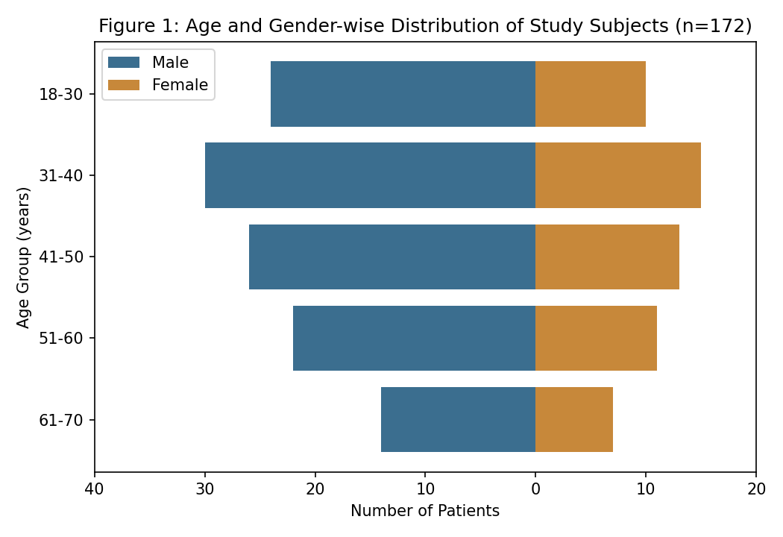
The 31–40 year age group accounted for the largest proportion of cases (26.2%), with a marked male preponderance across all age groups, reflecting the demographic pattern typically seen in emergency surgical admissions for perforation peritonitis.
Table 2: Aetiological Distribution of Perforation (Figure 2)
Cause of Perforation | Number (n) | Percentage (%)
Duodenal ulcer perforation | 58 | 33.7
Appendicular perforation | 34 | 19.8
Typhoid ileal perforation | 29 | 16.9
Traumatic bowel perforation | 24 | 14.0
Malignant perforation | 15 | 8.7
Others (Meckel's, tubercular, etc.) | 12 | 7.0

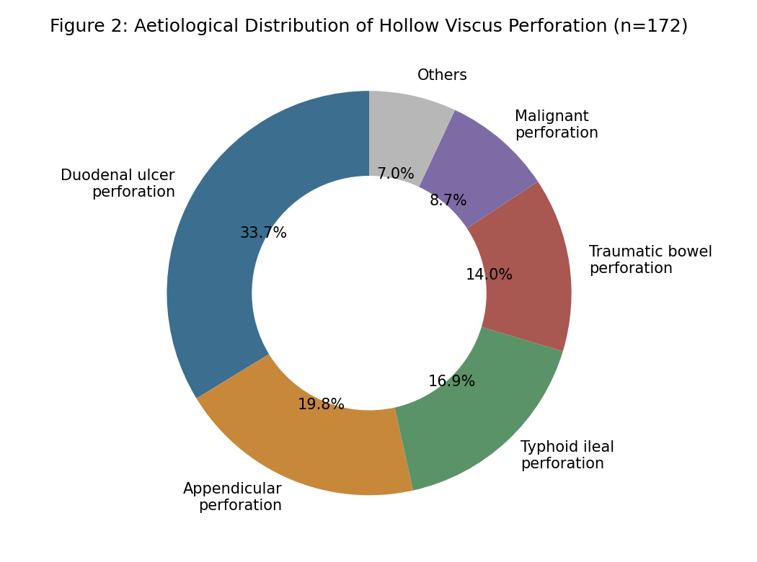
Duodenal ulcer perforation was the most common underlying cause (33.7%), followed by appendicular perforation (19.8%) and typhoid ileal perforation (16.9%), together accounting for the majority of cases in this cohort.
Table 3: Category of Surgical Site Infection
SSI Category (CDC/NHSN Criteria) | Number (n) | Percentage (%)
Superficial incisional SSI | 24 | 14.0
Deep incisional SSI | 14 | 8.1
Organ/space SSI | 7 | 4.1
No SSI | 127 | 73.8

The overall SSI rate was 26.2% (45 of 172 patients), with superficial incisional infection being the most common category (14.0%), followed by deep incisional (8.1%) and organ/space infection (4.1%).
Table 4: Organisms Isolated on Wound Culture (n = 45 culture-positive SSIs)
Organism Isolated (n=45 culture-positive SSIs) | Number (n) | Percentage (%)
Escherichia coli | 18 | 40.0
Klebsiella pneumoniae | 10 | 22.2
Staphylococcus aureus | 7 | 15.6
Pseudomonas aeruginosa | 6 | 13.3
Others / mixed growth | 4 | 8.9

Escherichia coli was the most commonly isolated organism (40.0%), followed by Klebsiella pneumoniae (22.2%) and Staphylococcus aureus (15.6%), consistent with the predominantly enteric source of contamination in this surgical population.

Table 5 / Figure 3: SSI Rate Stratified by Risk Factor Presence
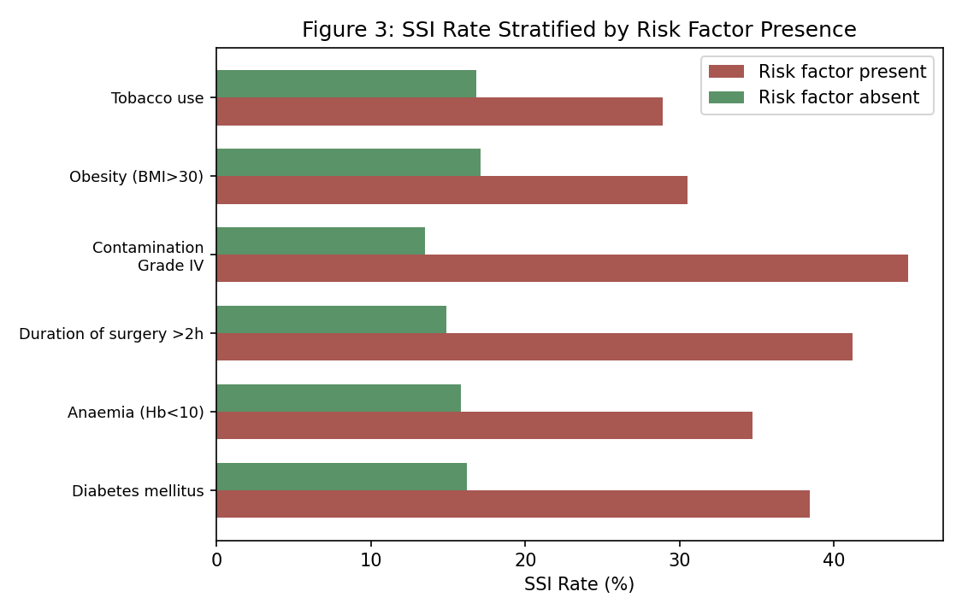
As shown in Figure 3, SSI rates were consistently and substantially higher among patients with Grade IV peritoneal contamination (44.8% vs 13.5%), operative duration exceeding two hours (41.2% vs 14.9%), diabetes mellitus (38.4% vs 16.2%), and anaemia (34.7% vs 15.8%), compared with patients without these risk factors.
Figure 4 provides a schematic cross-sectional illustration of the abdominal wound layers, comparing normal wound healing with the appearance of surgical site infection.
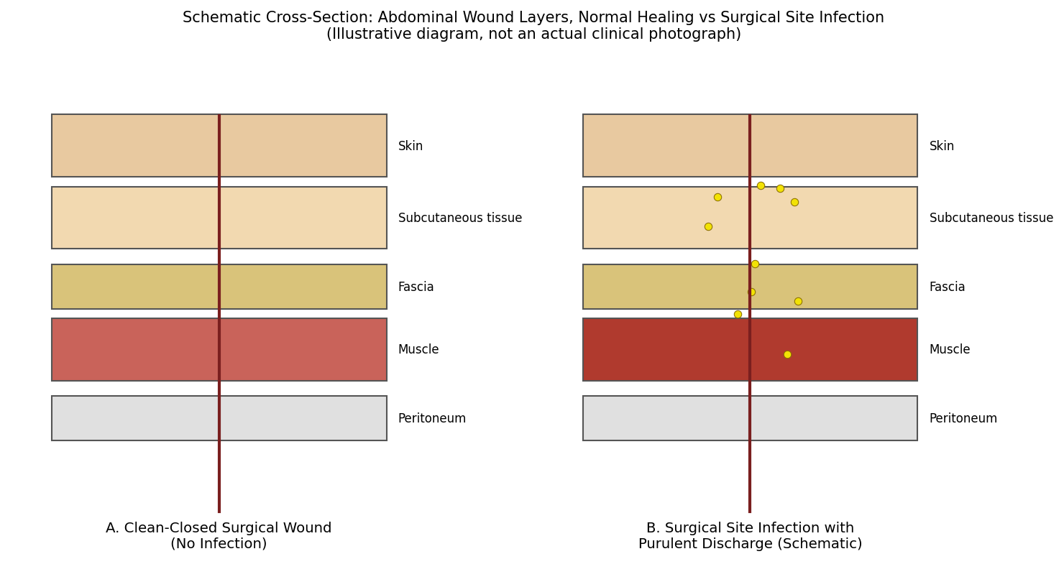

Discussion
The overall SSI rate of 26.2% observed in this study is consistent with rates reported in other series of contaminated or dirty abdominal surgery, particularly emergency laparotomy for perforation peritonitis, which carries an inherently higher infection risk than elective clean or clean-contaminated procedures.^{1,3,9} The predominance of superficial incisional infection over deep and organ/space infection observed in this study mirrors the typical distribution reported in the wider surgical site infection literature.^{2,10}
The strong association observed between Grade IV peritoneal contamination and SSI risk in this study is consistent with the well-established relationship between wound contamination class and infection risk, as originally described in the National Nosocomial Infections Surveillance System risk index and subsequently validated in numerous surgical cohorts.^{3,10} Similarly, the association between prolonged operative duration and increased SSI risk observed in this study aligns with established evidence linking longer procedures to greater tissue trauma, prolonged wound exposure, and cumulative bacterial contamination.^{3,6}
The higher SSI rates observed among patients with diabetes mellitus and anaemia in this study are consistent with extensive prior literature identifying these as significant modifiable and non-modifiable risk factors for surgical site infection, related respectively to impaired leukocyte function and tissue oxygenation, both of which are critical to effective wound healing and infection resistance.^{16,20} These findings reinforce the importance of optimising glycaemic control and correcting anaemia where feasible in the perioperative period, even in the emergency surgical setting.
The predominance of Escherichia coli and other Gram-negative enteric organisms on wound culture in this study is consistent with the expected microbiological spectrum following gastrointestinal perforation, reflecting the endogenous bowel flora responsible for peritoneal and subsequent wound contamination.^{7,9} This pattern has direct implications for empirical antibiotic selection, supporting the use of broad-spectrum agents with good Gram-negative and anaerobic coverage in this clinical setting, consistent with international and WHO guidance on surgical site infection prevention.¹⁷
The considerable proportion of SSIs classified as superficial incisional infection in this study is a generally reassuring finding, as this category is typically associated with a more favourable clinical course and lower risk of serious sequelae compared with deep incisional or organ/space infection, which more frequently necessitate re-intervention, prolonged intravenous antibiotic therapy, or management of intra-abdominal collections.^{2,10} Nonetheless, even superficial SSI contributes meaningfully to patient discomfort, delayed wound healing, and extended outpatient follow-up, reinforcing that prevention efforts should not be limited to the more severe infection categories alone.

Summary
This prospective study of 172 patients undergoing emergency exploratory laparotomy for perforation peritonitis found an overall SSI rate of 26.2%, with duodenal ulcer perforation being the most common underlying cause. Grade IV contamination, prolonged operative duration, diabetes mellitus, and anaemia were significantly associated with higher SSI rates, and Escherichia coli was the most commonly isolated organism.

Limitations
This study has several limitations that merit consideration. First, its single-centre design may limit generalisability to other practice settings with differing case-mix and infection control practices. Second, the 30-day postoperative follow-up period, while consistent with standard SSI surveillance definitions, may not capture very late-presenting deep or organ/space infections in a small proportion of patients. Third, this study did not perform multivariate regression analysis to adjust for potential confounding between the various risk factors examined, which may have independently influenced the observed associations.

Recommendations
Based on the findings of this study, perioperative optimisation of modifiable risk factors, including glycaemic control and correction of anaemia where clinically feasible, should be prioritised even in the emergency surgical setting. Judicious efforts to minimise operative duration and meticulous surgical technique to limit peritoneal contamination should be emphasised, particularly in cases with higher contamination grades. Empirical antibiotic selection should account for the predominance of Gram-negative enteric organisms in this clinical context. Larger, multi-centric studies incorporating multivariate risk factor analysis would help further refine risk stratification and targeted prevention strategies.
Institutional surgical site infection surveillance programmes should be strengthened, with regular audit and feedback of unit-specific infection rates to operating surgeons, as such structured surveillance has been shown elsewhere to drive sustained improvements in infection prevention practice. Standardised perioperative care bundles, encompassing appropriate hair removal technique, skin antisepsis, maintenance of intraoperative normothermia, and judicious wound closure technique, should be considered for routine adoption in emergency abdominal surgery, given their demonstrated benefit in reducing surgical site infection rates in comparable high-risk surgical populations.

Conclusion
Surgical site infection remains a substantial complication following emergency exploratory laparotomy for perforation peritonitis, with contamination grade, operative duration, diabetes mellitus, and anaemia identified as key associated risk factors. These findings underscore the importance of targeted perioperative risk factor optimisation and infection control measures in this high-risk surgical population.

References
1. Mangram AJ, Horan TC, Pearson ML, Silver LC, Jarvis WR. Guideline for prevention of surgical site infection, 1999. Infect Control Hosp Epidemiol. 1999;20(4):250-78.
2. Horan TC, Gaynes RP, Martone WJ, Jarvis WR, Emori TG. CDC definitions of nosocomial surgical site infections, 1992: a modification of CDC definitions of surgical wound infections. Infect Control Hosp Epidemiol. 1992;13(10):606-8.
3. Culver DH, Horan TC, Gaynes RP, et al. Surgical wound infection rates by wound class, operative procedure, and patient risk index. National Nosocomial Infections Surveillance System. Am J Med. 1991;91(3B):152S-157S.
4. Cruse PJ, Foord R. The epidemiology of wound infection: a 10-year prospective study of 62,939 wounds. Surg Clin North Am. 1980;60(1):27-40.
5. Anderson DJ, Podgorny K, Berrios-Torres SI, et al. Strategies to prevent surgical site infections in acute care hospitals: 2014 update. Infect Control Hosp Epidemiol. 2014;35(6):605-27.
6. Malone DL, Genuit T, Tracy JK, Gannon C, Napolitano LM. Surgical site infections: reanalysis of risk factors. J Surg Res. 2002;103(1):89-95.
7. Jhobta RS, Attri AK, Kaushik R, Sharma R, Jhobta A. Spectrum of perforation peritonitis in India: review of 504 consecutive cases. World J Emerg Surg. 2006;1:26.
8. Chichom-Mefire A, Fon TA, Ngowe-Ngowe M. Which cause of diffuse peritonitis is the deadliest in the tropics? A retrospective analysis of 305 consecutive patients. World J Emerg Surg. 2016;11:14.
9. Bhangu A, Ademuyiwa AO, Aguilera ML, et al. Surgical site infection after gastrointestinal surgery in high-income, middle-income, and low-income countries: a prospective, international, multicentre cohort study. Lancet Infect Dis. 2018;18(5):516-25.
10. Ortega G, Rhee DS, Papandria DJ, et al. An evaluation of surgical site infections by wound classification system using the ACS-NSQIP. J Surg Res. 2012;174(1):33-8.
11. de Lissovoy G, Fraeman K, Hutchins V, Murphy D, Song D, Vaughn BB. Surgical site infection: incidence and impact on hospital utilization and treatment costs. Am J Infect Control. 2009;37(5):387-97.
12. Weiss CA 3rd, Statz CL, Dahms RA, Remucal MJ, Dunn DL, Beilman GJ. Six years of surgical wound infection surveillance at a tertiary care center. Arch Surg. 1999;134(10):1041-8.
13. Owens CD, Stoessel K. Surgical site infections: epidemiology, microbiology and prevention. J Hosp Infect. 2008;70(Suppl 2):3-10.
14. Gupta S, Kaushik R. Peritonitis - the Eastern experience. World J Emerg Surg. 2006;1:13.
15. Sorensen LT. Wound healing and infection in surgery: the pathophysiological impact of smoking, smoking cessation, and nicotine replacement therapy: a systematic review. Ann Surg. 2012;255(6):1069-79.
16. Latham R, Lancaster AD, Covington JF, Pirolo JS, Thomas CS Jr. The association of diabetes and glucose control with surgical-site infections among cardiothoracic surgery patients. Infect Control Hosp Epidemiol. 2001;22(10):607-12.
17. World Health Organization. Global Guidelines for the Prevention of Surgical Site Infection. Geneva: WHO; 2016.
18. Dellinger EP, Hausmann SM, Bratzler DW, et al. Hospitals collaborate to decrease surgical site infections. Am J Surg. 2005;190(1):9-15.
19. Kaye KS, Schmit K, Pieper C, et al. The effect of increasing age on the risk of surgical site infection. J Infect Dis. 2005;191(7):1056-62.
20. Sorensen LT, Hemmingsen U, Kallehave F, et al. Risk factors for tissue and wound complications in gastrointestinal surgery. Ann Surg. 2005;241(4):654-8.

