Original Research Article

Awareness, knowledge, and attitude of the patients about dental implant as a treatment option for replacement of missing teeth in Mehsana district of Gujarat

¹Shaikh Rukhshana N. , ²Chauhan Chirag J. , ³Pathan Rashidkhan B.

¹MDS , PhD Scholar, Gujarat University, Assistant Professor, Siddhpur Dental College and Hospital
²MDS , Professor, Ahmedabad Dental College and Hospital
³MD . Associate Professor, Banas Medical College and Research Institute

Corresponding Author: Dr Rukhshana N Shaikh

Abstract:
Context: Lack of awareness is present in the population for dental implants, especially in some areas of Gujarat, especially towards the North side.
Aim: To assess patients’ awareness, knowledge, and attitude about the dental implant for missing teeth replacement in the Mehsana district of Gujarat, to assess their information source about the same.
Settings and Design: A self-explanatory questionnaire-based study
Methods and Material: Total 532 patients visited the dental colleges of North Gujarat were asked to fill the questionnaires, 276 patients who were from the Mehsana district of Gujarat were included in the study.
Statistical analysis used: The Pearson Chi-Square Test is used.
Results: Forty-four percent of participants knew about the dental implant treatment. From this, the age group A, that is between18 and 40 years showed more amount of awareness with the marginal difference between males and females. Only 23.1% of patients wanted the replacement of missing teeth with the treatment of dental implants.
Conclusions: We concluded that less awareness is marked about the treatment of dental implants in the population of the Mehsana district of Gujarat. It required a need provision of proper education to them. Therefore, the patients were provided an education related to the dental implant treatment that helps them in the choice about a proper treatment option for missing teeth replacement.
Key-words: Knowledge, Attitude, Questionnaire

Introduction:
The goal of modern dentistry is to restore the patient to normal function, speech, health, and aesthetics regardless of the atrophy, disease, or injury of the stomatognathic system.^{[1]} A healthy oral condition has a direct effect on the quality of a patient's life and well-being. As prosthodontists, our main motto is to restore the missing teeth of the patients and provide the best aesthetics, function with the preservation of oral structures.^{[2]} The loss of natural teeth is associated with functional, cosmetic, and psychological morbidities for a long time.^{[3]} Removable partial dentures, fixed partial dentures, and dental implants can replace missing teeth. An implant prosthesis often offers a more predictable treatment than conventional dentures and it may also return the function to the near-normal limit.^{[1]} The use of dental implants for the replacement of missing teeth has been increased since the concept of osseointegration has been accepted.^{[4]}
As dental implants become popular in different areas, the requirement arises to assess their awareness, knowledge, and attitude in the population, especially in the Northside districts of Gujarat. This study also aims for the evaluation of source of information about dental implant among them and tries to increase the awareness in the participants by the provision of education among them.

Subjects and Methods:
For the present cross-sectional study, we selected the patients who visited the department of Prosthodontics of dental colleges of North Gujarat. Among 432 patients, 276 patients were from the Mehsana district of North Gujarat included in the study while patients coming from other districts of North Gujarat were excluded from the study. The patients at and above the age of 18 years, willing to fill the questionnaire, and at least having a single missing tooth were included in the study. Patients below the age of 18 years and not willing to fill out the
questionnaires were excluded from the study. Mentally retarded patients, medically compromised patients, seriously ill patients were also excluded from the study. Written consent forms prepared in the Gujarati language were obtained from the patients. Ethical approval was taken from the institutional ethics committee.
The study was conducted in the patients by asking patients to fill out the questionnaire form that is prepared in the Gujarati language for their actual understanding. It consisted of questions related to the demographic information, questions to find the awareness, knowledge, and attitude of the patients about dental implants, questions related to evaluating the source of information about the dental implant in aware patients. The participants grouped depending on their demographic information in male and female and age group A, B, and C. Age group A notified the age of 18- 40 years; B defined the age from 41-60 years and C was the age above 61 years.
In the beginning, we asked the patients to fill the demographic information, questions related to awareness, knowledge, and source of information related to the dental implant in the questionnaire. Then the patients were made aware by educating them from the education material containing photographs to enhance their understanding and knowledge for the treatment of dental implants. Rest of the questions related to knowledge and attitude for dental implant were asked following their education.
From the completed questionnaires, data related to the responses given by the participants to various questions tabulated by using MS Excel Program and counted as per frequencies and percentages. The Pearson Chi-square test is used for statistical analysis.

Results:
The results showed that 44.2% of the patients are aware and they have knowledge about the dental implant while 55.8% of patients are not aware and they do not know about the dental implant as a treatment option for the replacement of missing teeth (Table-1) (Figure-1). There was a presence of more awareness in age group A (18 to 40 years) as stated in Table-2 (Figure-2). Approximately thirty percent participants showed willingness for dental implant treatment (Table-3). Almost ninety percent participants accepted positive and satisfactory education regarding the dental implant (Table-4).
Only four percent participants have undergone for the dental implant treatment (Figure 3) while 27% of participants know the person who have undergone the dental implant treatment (Figure 4). Sixty seven per cent of the participants agreed for the high cost of the dental implant treatment (Table 5).

Table 1: Gender wise distribution of awareness and knowledge of dental implant
(P-Value: 0.791)
Gender | Participants who are aware and knowing about dental implant |  | Participants who are not aware and do not know about dental implant |  | Total
Male | n=63 | 43.4% | n=82 | 56.6% | n=145 | 100%
Female | n=59 | 45.0% | n=72 | 55.0% | n=131 | 100%
Total | n=122 | 44.2% | n=154 | 55.8% | n=276 | 100%

Table 2: Age wise distribution of awareness and knowledge of dental Implant
P-Value: 0.001
Age group | Participants who are aware and knowing about dental implant |  | Participants who are not aware and do not know about dental implant |  | Total
A - From 18 to 40 years | n= 34 | 77.3% | n=10 | 22.7% | n=44 | 100%
B - From 41 to 60 years | n=50 | 39.7% | n=76 | 60.3% | n=126 | 100%
C - 61 years and above | n=38 | 35.8% | n=68 | 64.2% | n=106 | 100%
Total | n=122 | 44.2% | n=154 | 55.8% | n=276 | 100%

Table 3: Willingness of all the participants to opt for dental implant after education
P- Value: 0.001
Age group | Participants who are willing |  | Participants who are not willing |  | Total
A - From 18 to 40 years | n= 24 | 54.5% | n=20 | 45.5% | n=44 | 100%
B - From 41 to 60 years | n=28 | 22.4% | n=98 | 77.6% | n=126 | 100%
C - 61 years and above | n=12 | 11.3% | n=94 | 88.7% | n=106 | 100%
Total | n=64 | 23.1% | n=212 | 76.9% | n=276 | 100%

Table 4: Satisfaction Rate of all the participants about the information they have received

Satisfied participants |  | Participants who are not satisfied |  | Total |  | P-Value
n=246 | 89.2% | n=30 | 10.8% | n=276 | 100% | 0.919

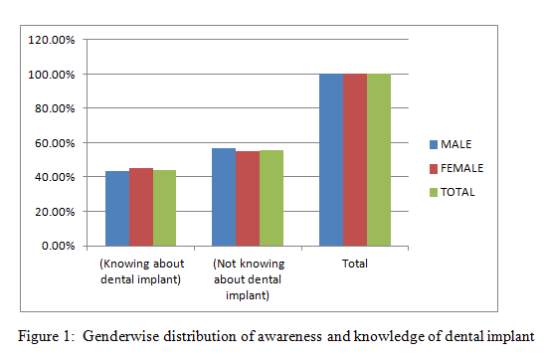
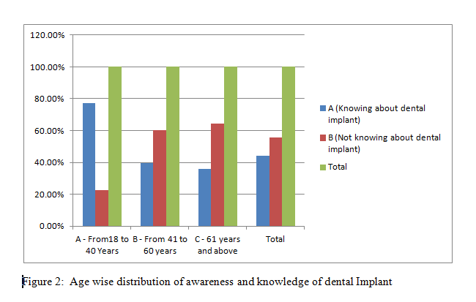
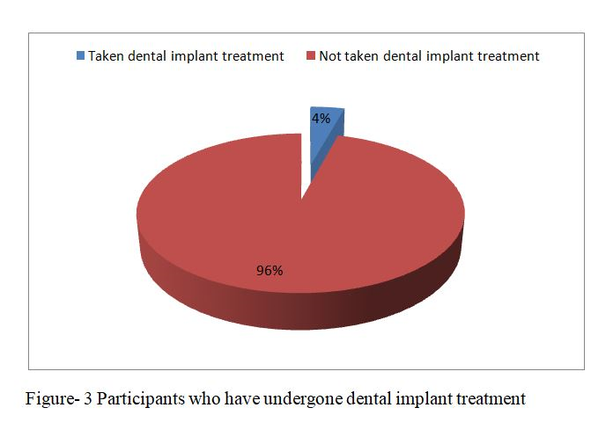

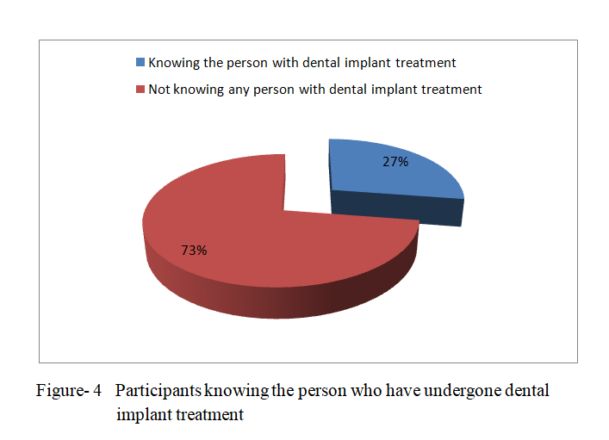
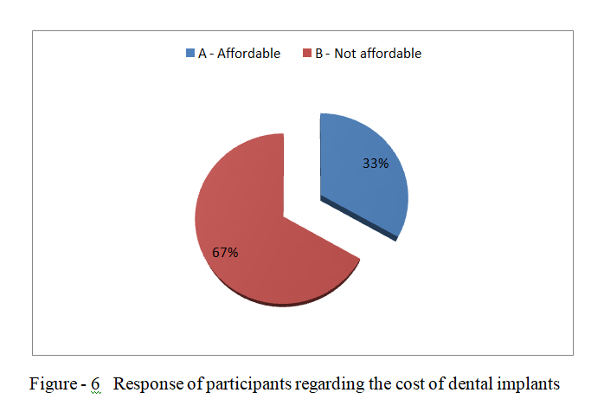

Discussion:
Lack of information is present in the patients about the dental implant as a treatment option to replace the missing teeth, especially in the population of North Gujarat districts. Therefore, the provision of proper education about dental implant treatment is necessary to help the patients in the selection of the most reliable option for the replacement of missing teeth.
Different authors carried out several studies in different areas worldwide by using different tools like questionnaires and interviews. In the present study, a cross-sectional study was conducted by using self-explanatory questionnaires in the Mehsana district of North Gujarat population to evaluate the awareness, knowledge, and attitude about dental implant treatment. Among 532 patients, 272 patients who were from the Mehsana district of North Gujarat were included in the study. From them, 44.2% of patients were aware and knew about dental implant treatment for replacement of missing teeth which is quite higher than the previous studies done by Chaudhary et al, Satpathy A et al, Bhat AM et al in the Indian population in different states. ^{[4], [5],[6]} This is because these studies had been done before around ten years of period. The previous studies reported by Suprakash B et al, Gharpure AS et al, Kaurani P et al showed less awareness than the present study.^{[2],[7],[8]} The findings of this study are similar to those cited in studies conducted by Tomruq et al, Devraj CG et al and Shah RJ et al.^{[9],[10],[11]}
Kelala-Kazadi E et al, Baqar et al and Gbadebo OS et al cited less awareness in their studies in Congolese, Karachi patients, and Nigerians respectively.^{[12],[13],[14]} However, the findings of our study are much lesser than the studies done by Zimmer et al. in Americans, Berge TI in Norwegians, Tepper, et al, Pommer et al in Austrians, and Abounq et al in Saudi Arabians. The awareness reported by them is 77, 72, 70, 79, and 60.44 percent respectively.^{[15],[16],[17],[18],[19]} India is a developing country and we have still a low level of education and awareness as compared to the foreign countries.
Similar to most of the previous studies, this study also reported a marginal difference in the awareness between males and females.^{[7],[20], [21]} Only a study done by Suprakash et al. showed more awareness in males.^{[2]}
Our study showed more awareness in the age group A that is 18 to 40 years which is similar to those studies reported by Devraj CG et al, Shah RJ et al and Divya et al.^{[ 9],[11], [22]} The reason behind it may be the inquisitiveness of the young generation.
In this study, 37 percent of patients got information about dental implants from the dentists followed by friends and then by social media. Most of the studies also stated dentists as their main information source.[2],[4],[5],[6],[7],[8],[9],[10],[11],[12],[14],[17],[18],[19][23][24]. Some previous studies which are done by Baqar A et al, Al-Johani et al and Alajlan A et al. stated friends and relatives as the main source of their information about dental implants.^{[13],[25][26]} Berge et al reported News media as a major source of information for their awareness and knowledge.^{[16]}
Just only 4.2% of patients had undergone dental implant treatment (Figure 3). Around Twenty-seven percent of patients knew a friend or relative who has undergone dental implant treatment (Figure 4). From them, 70.9 % reported that they are satisfied with the dental implant treatment. The study conducted by the Supraksh et al showed 3.4 percent and 13.3 percent respectively.^{[2]} Gharpure AS et al showed 15.91 percent of patients whom themselves had taken the treatment while 55.11% of patients knew the person who had undergone dental implant treatment. From them, 92.24 percent reported satisfaction with the treatment.^{[7]}
This variation can be due to the area included in the study being the metropolitan city, Mumbai. Other studies were done by Tepper et al and Pommer et al showed a 65% and 83% satisfaction rate in Austrian patients.^{[27],[28]}
Forty-nine per cent patients told that the dental implant treatment is not affordable because of its high cost (Figure 5). Various previous studies noted the high cost as a main barrier in opting the dental implant treatment.[2],[5],[6],[7],[8],[9][10],[11],[12],[13],[20],[20],[22],[23],[26]
Only about twenty-three percent of patients wanted to replace the missing teeth with dental implant treatment. They will think about it and will opt for the treatment in the future. Studies done by Suprakash et al, Devraj CG et al and Kaurani P et al showed similar results accordingly. ^{[2],[8][10]} The studies carried out by Gharpure et al, Satpathy et al, Shah RJ et al Bhat AM et al, Tepper et al, Pommer et al, Shakshi et al, and Thillainayagam D et al, cited quite higher percent of patients willing to opt the dental implant treatment. [7],[5],[6],[11],[27][28],[29],[30]
In the present study, eighty-nine percent of patients were satisfied by the given education of the dental implant and they felt having sufficient knowledge about dental implant.
The results of this study are influenced by the involvement of a limited population and a short period. A further detailed study is required involving more patients from the wider demographic area.

References:
- Miche CE. Rationale for dental implants. In: Contemporary implant dentistry. 3rd edn. Mosby- Elsevier, 2014
- Suprakash B, Ahammed AR, Thareja A, Kandaswamy R, Kumar N, Bhondwe S. Knowledge and Attitude of Patients toward Dental Implants as an option for replacement of missing teeth. J Contemp Dent Pract 2013; 14(1):115-118
- Maya A. D’Souza J, George AM, Shenoy K. Jodalli P, Mayya SS. Knowledge and awareness of dental implants as a treatment choice in adult population in South India: A hospital-based study. Indian J Dent Res 2018; 29:263-267
- Chaudhary R, Mankani N, Chandraker NK. Awareness of dental implants as a treatment choice in urban Indian populations. Int J Oral Maxillofac Implants.2010; 25(2):305-8
- Satpathy A, Porwal A, Bhattacharya A, Sahu PK. Patient awareness, acceptance and perceived cost of dental implants as a treatment modality for replacement of missing teeth: A survey in Bhubaneswar and Cuttack. Int J Public Health Dent 2011; 2:1-7
- Bhat AM , Prasad KD, Sharma D, Megde R. Attitude toward Desire for Implant Treatment in south Costal Karnataka population: A short team epidemiological survey. Int J Oral Implantol Clin Res. 2012; 3(2):63-66.
- Gharpure AS, Bhange PD. Awareness of dental implant treatment in an Indian Metropolitan population. J of Dental implants 2019; 15:62-68.
- Kaurani P, Kaurani M. Awareness of Dental Implant As Treatment modality Amongst People Residing in Jaipur (Rajasthan). Journal of Clinical and Diagnostic Res. 2010; 4:3622-3626.
- Tomruk CO, Ozkurt-Kayahan Z, Sencift K. Patients’ knowledge and awareness of dental implants in a Turkish subpopulation. J Adv Prosthodont 2014; 6:133-137.
- Devraj CG, Khoshya B. Awareness of dental implants as a treatment modality among people visiting Mahatma Gandhi Dental College and Hospital, Jaipur. JMR(2015);5(1):61-3
- Shah RJ, Chaturvedi A, Agarwal H. Dental Implants as a treatment modality, awareness survey among people of Ahmadabad. Int J Prosthodont Restor Dent 2014; 4(2):35-38.
- Kalala-Kazadi E, Yakini PD , Bashaba FM , Ingaya E , Milolo AM. Awareness of patient towards Dental Implants as an Alternative Treatment to replace missing teeth in Kinshasa, D.R. Congo. Open Journal of Stomatology. 2018; 8:345-353.
- Baqar A, Hakeem S, Ilyas F, Hassan F, Jarida F Awareness regarding Implant-supported dental prosthesis; A survey in tertiary care set up. JBUMDC. 2018; 8(4):250-253.
- Gbadebo OS, Ajayi DM , Lawal FB, Sulaiman AO. Dental Implants as an option for tooth replacement: Awareness of Patients at tertiary hospitals in Developing country. Contemp Clin Dent. 2014; 5(3):302-306.
- Zimmer CM, Zimmer WM, Williams, Liesener J. Public awareness & acceptance of
Implants. Int J Oral maxillofac Implants. 1922; 7(2):228-232.
- Berge TI, Public awareness, information sources and evaluation of oral implant treatment in Norway. Clin Oral Implants Res. 2000; 11(5):401-408.
- Tepper G, Haas R, Mailath G, Teller C, Zechner W, Watzak G, Representative market oriented study on implants in the Austrian population. I. Implant acceptance, patient perceived cost, and patient satisfaction. Clin Oral Implants Res. 2003; 14(5):621-633.
- Pommer B, Zechner W, Watzak G, Ulm C, Watzek G, Tepper G. Progress and trends in patients' mindset on dental implants. I: level of information, sources of information, and need for patient information. Clin Oral Impl Res. 2011; 22:223-229.
- Abouonq AO, Aswilem RO. Dental Patients' Awareness of Dental Implants as Treatment Modality: A Survey based Study at College of Dentistry, AL Jouf University. Int J Med Res Pro. 2017; 3(1):271-273.
- Reddy RN, Elaimn EI, Vempalli S, Sanabani FA. Perception and Awareness of Prosthodontics rehabilitation among Jazan Population in the Southern region of Saudi Arabia. Global Journal of Medical Research. 2016; 16(1):1-8.
- Kumar S, Chauhan A. Knowledge and Awareness of Dental Implants in Indore: Exploratory Study. Int J Oral Med Res. 2015; 2(4):29-33.
- Divya K, Shivaram G, Kumar T. Awareness is the key to acceptance of Implant therapy. Indian J Oral Sci. 2016; 7:24-27.
- Siddique EA, Bhatt PR, Kulkarni SS, Trasad VA, Thakur SL. Public Awareness Knowledge, Attitude and Acceptance of dental Implants as treatment modality Among Patients visiting SDM College of Dental Science and hospital, Dharwad. J Indian Soc Periodontal. 2019; 23:58-63.
- Hosadurga R, Tenneti S, Hegde S, Kashyap RS, Kumar A. Awareness, knowledge, and attitude of patients toward dental implants: A web-based questionnaire study. J Dent Implant 2015; 5:93-100.
- Alazan A, Alhoumaidan A, Ettesh A, Doumani N. Assessing knowledge and Attitude of dental patients regarding the use of dental Implants: A survey-based study. International Journal of Dentistry. 2019; 1-5.
- Al-johany, Al zoma, Al juhaini, Al Refear. Dental patient's awareness and knowledge in using dental implants as an option in replacing missing teeth: A survey in Riyadh, Saudi Arabia. The Saudi Dental Journal. 2010; 22:183-188.
- Tepper G, Haas R, Mailath G, Teller C. Representative marketing-oriented study on Implants in Austrian population. II. Implant acceptance, patient-perceived cost, and patient satisfaction. Clin Oral Impl Res. 2003; 14:634-642.
- Pommer B, Zechner W, Ulm C, Watzek G, Tepper G. Progress and trends in patients' mindset on dental implants II: Implant acceptance, patient-perceived costs, and patient satisfaction. Clin Oral Impl Res. 2011; 22:106-112.
- Sakshi, Kumar N, Das S. Knowledge, and awareness about dental implants for the treatment of missing teeth in patients of Bahadurgarh, Haryana. J Evolution Med Dent Sci. 2018; 7(3):294-297.
- Thillainayagam D, Venkatesan D. Awareness Among patients Regarding dental Implants as a treatment option for Replacing missing teeth in Melmaravathar population. IOSR-JDMS. 2016; 15(7):68-74.

